Zachary McNulty (1636402)

AMATH 342

HW #1

**PART 1: MATLAB Tutorial**

Exercise 4.1: If Statements

For this exercise, we practiced using if statements by creating a cumulative sum of some signal vector representing some neuronal input. When this neuronal input summed over the threshold level, something would happen. This code determines at exactly what time the cumulative sum passes the threshold. I have provided an example in the command window.

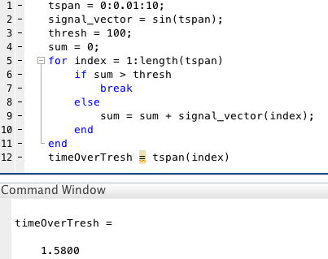

Exercise 3.2: For Loops

This code simulates neuronal signaling and signal amplification neuron to neuron. When a neuron fires, it often signals multiple downstream neurons to fire as a result, and as such we see this amplification in the number of neurons being turned on as the process progresses. In this program, it is assumed each on neuron will turn on two others, leading to an exponential increase in the number of neurons “on” at a given time, as seen in the right plot.

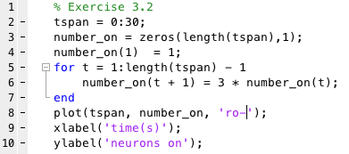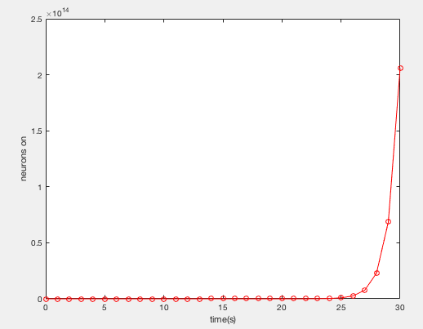

Exercise 5.1: Functions

The purpose of this program was to return a new matrix B that represents some combination of the input matrices A, S, Z. The function returns this new matrix, and I have displayed an example in the command window.

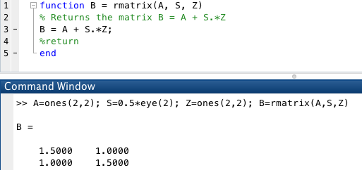

**PART 2: Spike Train Analysis and Tuning Curves**

The goal of this program was to simulate the neural response of 3 types of cricket cercal ganglion cells in response to deflections of their associated sensory hairs. In this program, the stimulus was chosen to represent an angle the deflection is approaching from. This response varies as the stimulus itself varies, and as such I will characterize the response distribution in a tuning curve. Because there is natural variation in neural activity, I will have to run many trials in order to get an averaged look at the activity of these cells, and how that response varies as the stimulus varies.

The program begins by declaring the number of trials, 300 in this case. I found this number to be sufficient for capturing the variation in neural activity, but also small enough to limit the computational work required by the program. The next major consideration is to choose the set of stimuli the cells are tested at, and I arbitrary chose this to be the angles 0 to 90 with steps of 10.

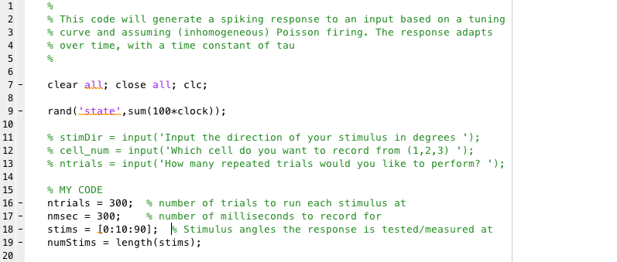

The simulation then begins! It runs a simulation for the neural activity in response to each of the given stimuli values across all 3 cell types. The purpose of trialAveRate and meanRates will become apparent later, but for now I simply allocate memory space for them.

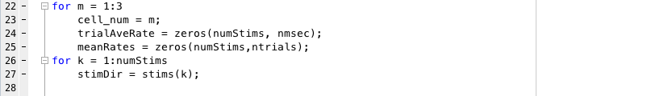

This part of the code carries out the actual simulation. At any given time, a neuron is either firing or it is not. While there is still a random element to this action (added in here using the rand command), certain cells are more likely to fire at a given time in response to a certain stimulus. Favorable conditions have a higher chance of the cell firing while unfavorable have a lower chance. Of course, a cell can still fire in unfavorable conditions, and still not fire in favorable ones, but statistically there is a higher chance the cell fires in a favorable condition rather than an unfavorable one. These uneven probabilities are taken into account when deciding whether the given cell is firing at the given time in the given trial, and spiketrain stores these results. Over the many trials, general trends should help highlight the favorable conditions.

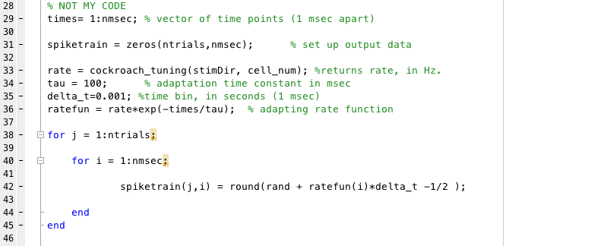

In order to get a better visualization of how the cells are responding to a given stimuli, we plot the firing information in a raster plot. Each horizontal line in the plot will represent a given trial, and yellow dots along that line represent the firing of the cell at that given time within that trial. A plot is developed for each stimulus value across all 3 cells. The raster plots are plotted together so the differences between the varying conditions become more apparent.

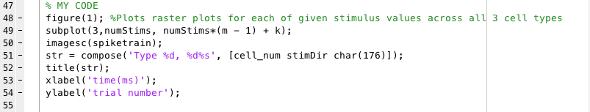

Below we see the actual raster plots. From these plots, it seems clear that each cell type responds differently to the given stimuli. Based simply off the visible number of firing events, Cell 1 seems to almost exclusively react to middle-of-the-road stimuli, ignoring some of the more extreme stimuli, while Cells 2 and 3 have much wider distributions. In all cells, stimuli that are far extremes produce little response. These plots make the random element of neural activity much clearer. Although there appears to be general trends, with many of the firings occurring near the beginning of the testing interval, we still see much variation trial to trial with no specific “on” and “off” periods. However, the clustering of the points suggests an organized aspect of this apparent randomness trial to trial, like the firings are varying around some certain mean. It appears most of the activity is occurring at the beginning of the time interval and dropping off as time goes on.

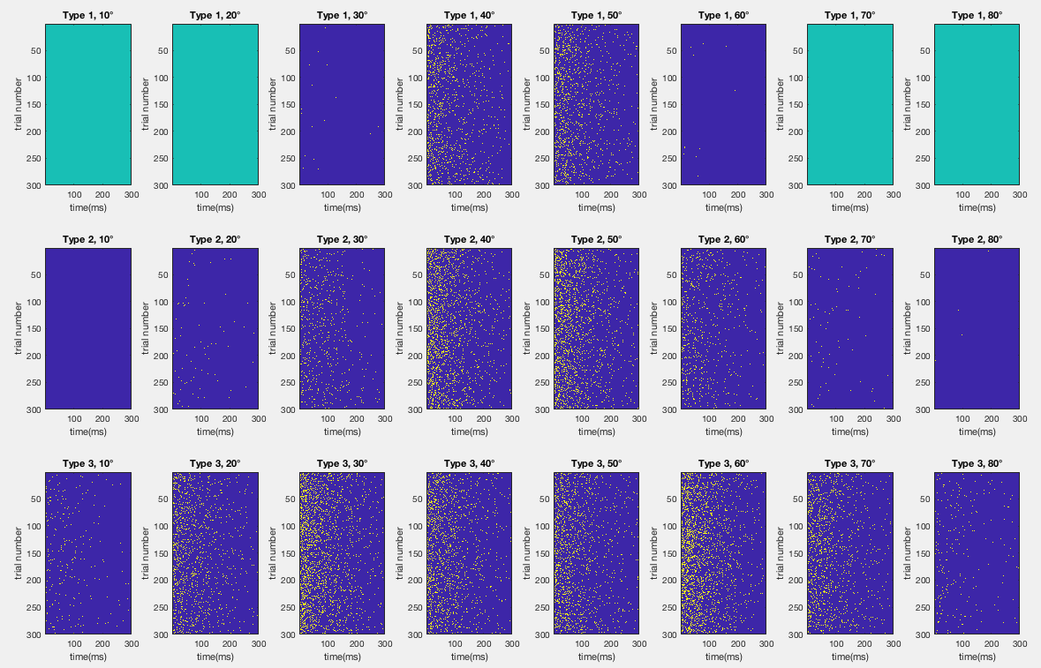

In order to take a more generic look at the behavior of these cells, we can find the trial averaged firing rate, filtering out some of the obscurity caused by all the variation trial to trial. This measure averages the number of firing events across all trials during individual time intervals (1 ms in this case) and thus we can investigate how, on average, the response to the stimulus changes over time. The mean firing rate (meanRates) on the other hand, averages in the other dimension. It finds the average firing rate across the entire 300 ms time interval for each individual trial. Dividing by the length of the time interval, delta_t, gives a measurement of the firing rate in seconds.



Now we can plot this trial average firing against the current time to see how the cell’s response to the stimuli varies as time progresses.

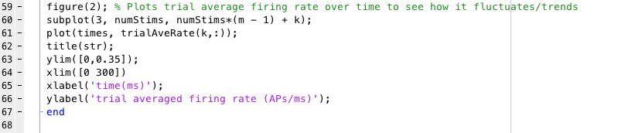

He we see how the trial averaged firing rate changes over time for each cell type and stimulus. These plots make it much clearer that the response to the stimulus quickly deteriorates as time progresses and that most of the neural activity is occurring immediately after the stimulus is received with no delay. The jaggedness of the curves highlights the trial to trial variability, but the general trend emphasizes the fact that overall this process is certainly nonrandom.

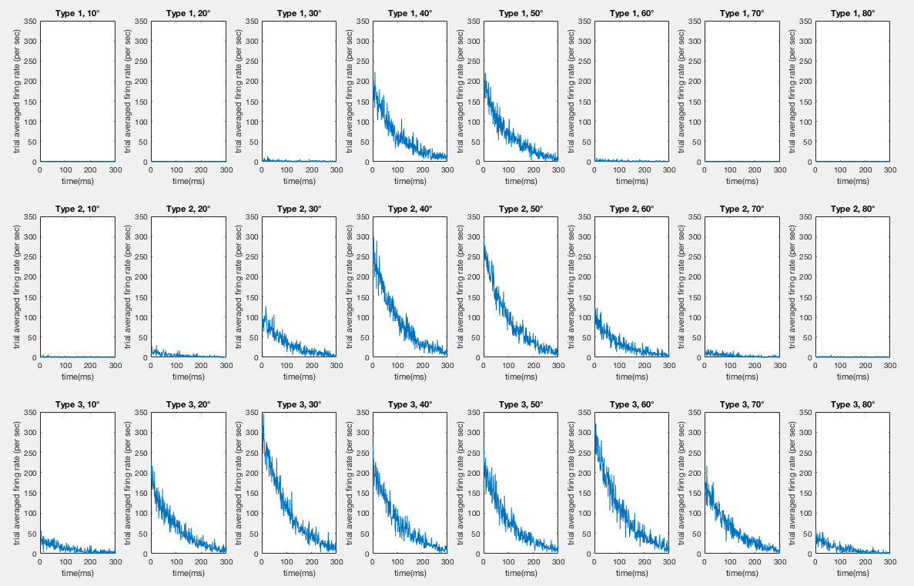

While the trial averaged firing rate graphs are great for visualizing how the neural activity changes over time, they are a bit unclear when it comes to differentiating how the response varies between different stimuli, limited mostly by the number of data points available. I wanted to get a single metric for neural response, and thus I averaged the mean firing rate across each time point, getting a single firing rate measurement. I used meanRates rather than the trial averaged rate in this case because it made more sense when calculating standard deviation to compare the variation trial to trial rather than the variation time point to time point (which has immense natural variation due to the deteriorating response mentioned previously).

I compared these metrics across different stimulus values, creating a tuning curve. For clarity, I increased the number of stimulus values being tested. The new stimulus set included angles between 0 and 90 with steps of 1, and the mean firing rate response was plotted with the standard deviation between trials.

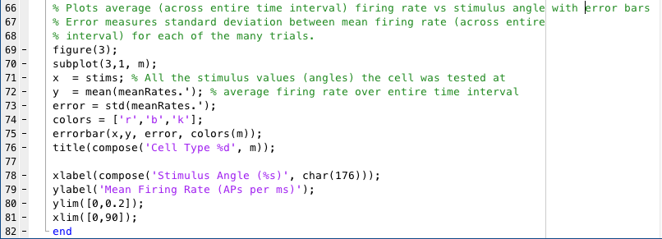

As observed in the original raster plots, Cell 1 has a much narrower distribution than either Cell 2 or Cell 3. It has no significant reaction to stimuli below 30 degrees or above 60 degrees. Additionally, Cell 1 seems to have a single peak at around 45 degrees, and thus this seems its preferred orientation, especially since all the other data points are so evenly distributed around 45. Cell 2 has a wider distribution than Cell 1, reacting significantly to any stimulus between 20 and 70 degrees, although it too seems to be centered around a single mode at 45 degrees. It, however, is much more reactive to more extreme stimuli than Cell 1 is. Interesting enough, Cell 3 appears to have a bimodal distribution, peaking at stimulus values around 30 and 60 degrees compared to the unimodal peaks of Cell 1 and Cell 2 at 45 degrees. Thus, while it could be said that Cell 1 and 2 have a preferred orientation at around 45 degrees, Cell 3 has no single preference, and reacts significantly to any stimulus value within a very wide range. In fact, Cell 3 is LESS reactive to 45 degrees stimuli than it is to other more extreme stimuli. The standard deviation is small enough that I consider these peaks to be statistically significant, as error bars more than a few degrees away from the peak do not overlap it.

