Create New Policy Record

- Go to Accounts
- Select the WC Carrier List View
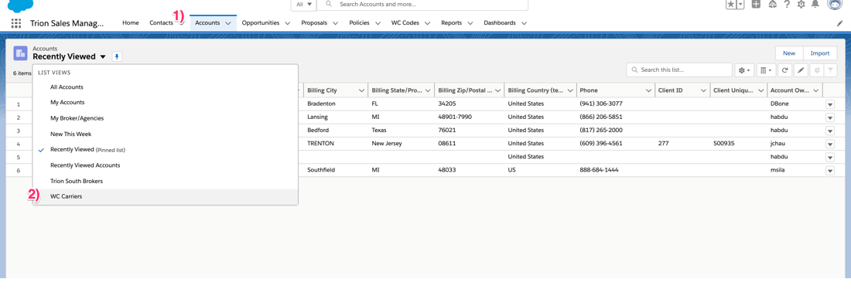
- Select the Carrier record
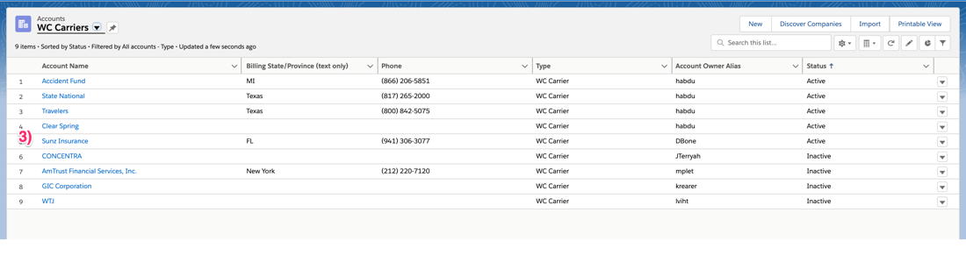
- Go to the Policy Year related list
- Click on the current policy
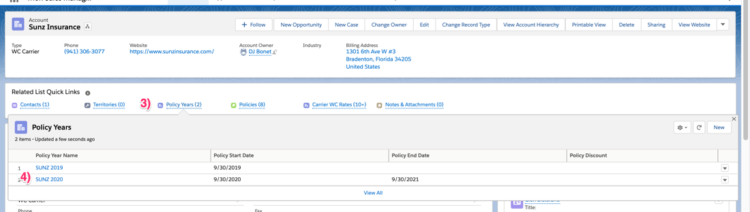
- Go to the Policy related list
- Click New
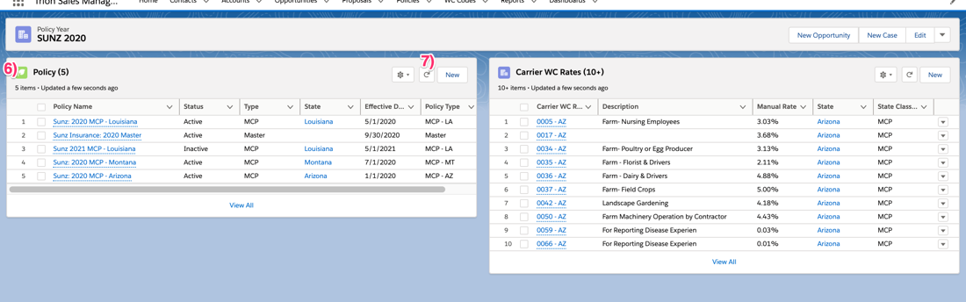
- Enter a Policy name ex. Sunz 2021 MCP – Louisiana
- Select the Policy Carrier on the Carrier field
- Select the Policy Type
- Enter the Effective Date
- Select the Status
If MCP Policy
- Select the State

If policy contains territorial rating,
- Check the Territorial Rating checkbox
- Enter the Territory mods
- Click Save
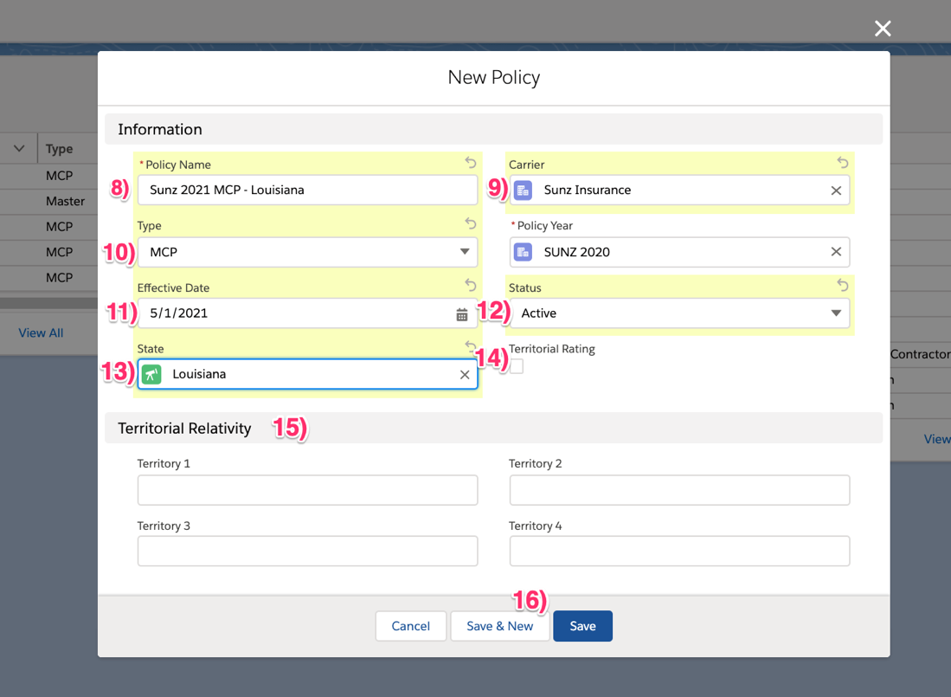

Prep the File for Import to the Carrier WC Rate Object

- Open the file received from the carrier
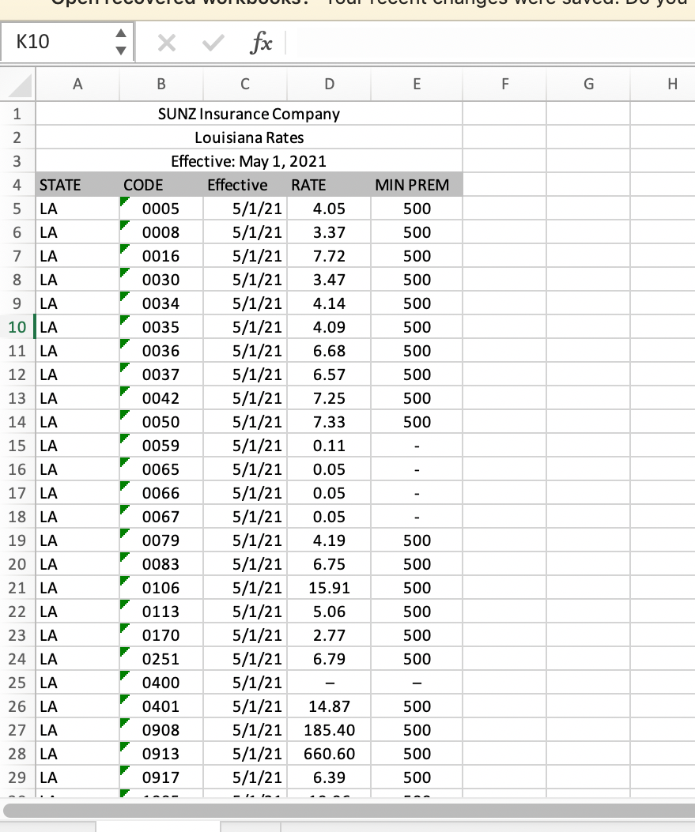
- Add a column of Carrier to the file and enter the Carrier record id
- Add a column of Policy year to the file and enter the policy year record id
- Add a column of Policy to the field and enter the policy record id
- Optional, delete the date and minimum premium columns – do not import
- Add a column of Name to the file and create a formula field to concatenate to the following format: COMP CODE – STATE ABREVIATION. EXAMPLE: 0005 - LA
- Ensure the values on the rate column are in the correct format – remove any “-“ values
- Delete any rows above the column header rows
- Save as CSV format
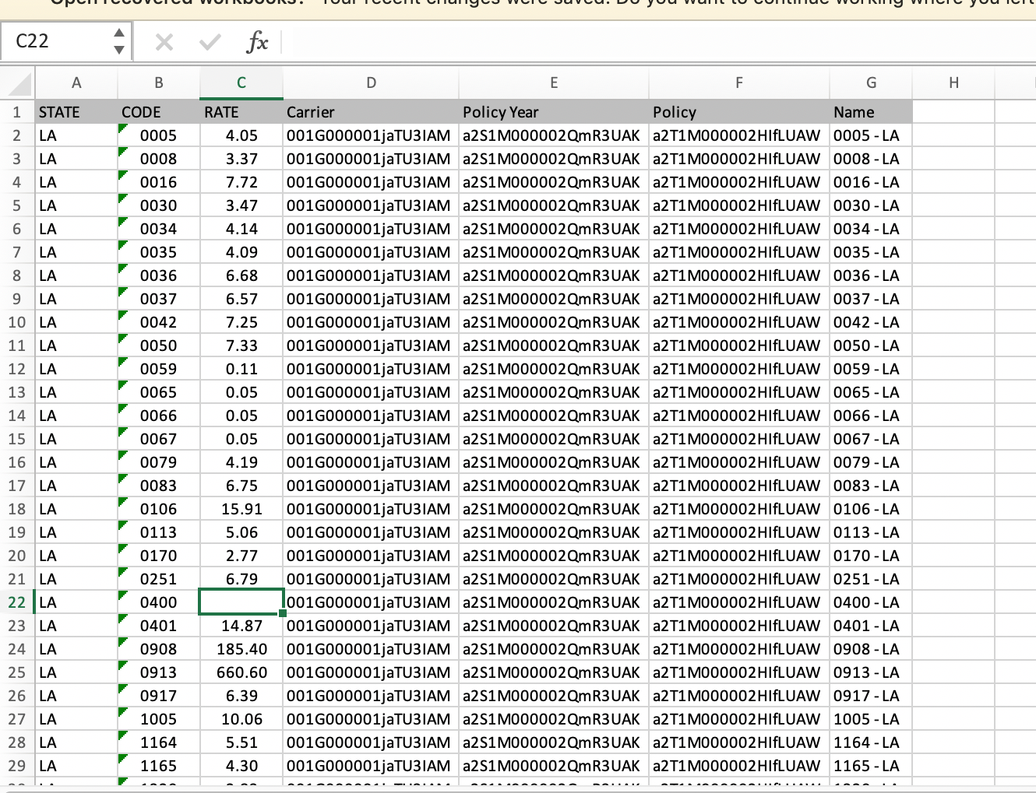

- If using data loader, import as an upsert and use the following lookup matching:
  - Policy – Salesforce.com Id
  - Carrier – Salesforce.com Id
  - Policy year – Salesforce.com Id
  - State – State Code external id
  - WC Code - Code external id
- If using Data Import Wizard, import as new records using the following lookup matching:
  - Policy – Salesforce.com Id
  - Carrier – Salesforce.com Id
  - Policy year – Salesforce.com Id
  - State – State Code external id
  - WC Code - Code external id

