SUTA 1
Create New SUTA Record 2
Edit a SUTA Record 3

SUTA
The SUTA object is used to store PEO and Client level state unemployment rates for each state and year. For states where Trion has multiple entities, a SUTA record for each entity must be created every year.

The Proposal solution will auto relate the SUTA quote to the correct SUTA record when the sales team selects a year on the Proposal. The SUTA quote record is directly related to the SUTA record. Any changes made to a SUTA record is auto passed on to all Proposal SUTA Quote records associated with the SUTA record.

Note: The SUTA Quote record is the record that stores the # of employees and gross wages for each client location.

Example:
- Company ABC is located in Florida
- Sales team selects 2021 for the Proposal tax year.
- The SUTA for 2021 in the State of Florida is set to 2.73%
- Trion employee updates the FL 2021 – Trion 2 SUTA record to reflect a new rate of 2.50.
- The next time the Proposal SUTA Quote record is edited, the new rate of 2.50 % will overwrite the previous rate.

Create New SUTA Record

- Go to the SUTA Tab
- Click New
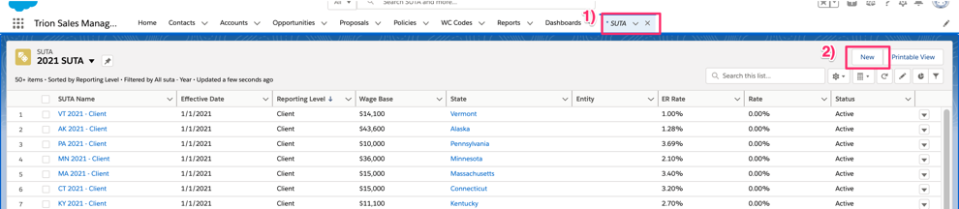
- Search and select State
- Search and select Year
Note: If first SUTA record for the new year, create the year record.
- Enter the Effective Date
- Optional, enter the new employer rate in the ER field
- Enter the SUTA Name using the following naming convention:
State Code YEAR Reporting Level
Note: Workflow rule will update to the correct naming convention if not entered correctly.
- Select the Status
- Enter the State Assessment Fees – should only be entered by person managing carrier state assessment fees not by accounting department.
- Select the Reporting Level
- Enter the Wage Base
- Enter the Rate – if reporting is client level, enter 0. Do not enter the new employer rate in the Rate field. The rate field is auto added to a client proposal for the SUTA year/state reporting level.
- Select the Entity
- Click Save
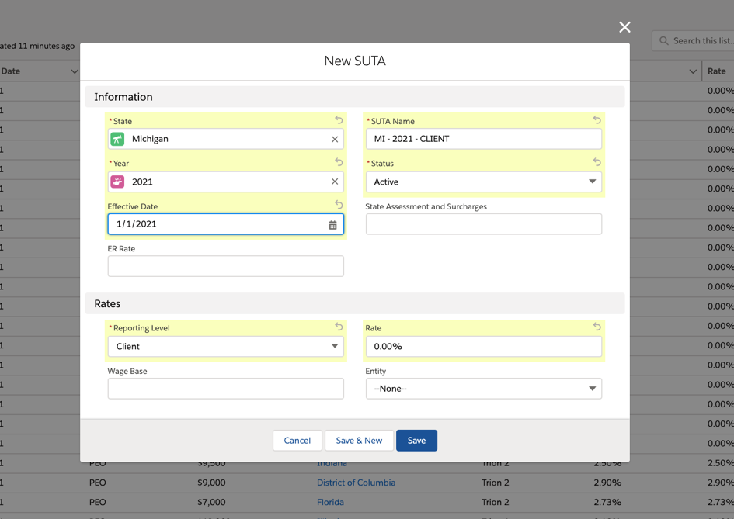

Edit a SUTA Record

- Go to the SUTA Record
- Click Edit
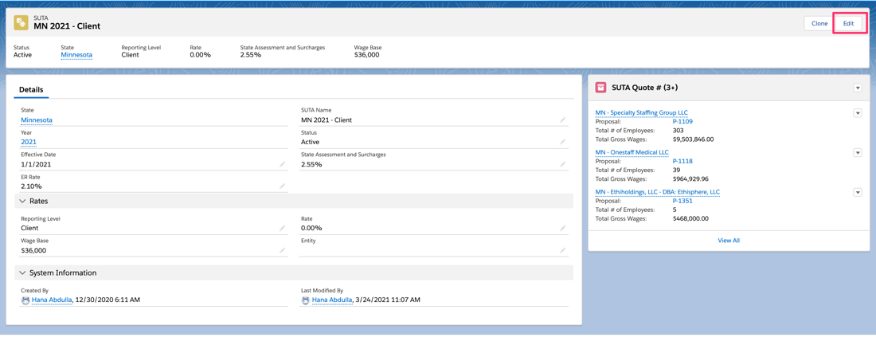
- Update the record fields
- Click Save
