Creating a New Opportunity 2
Business Information 3
Quote Type 3
Client Contact 4
Opportunity Client Contact 4
Opportunity Primary Contact 5
Officers /Owners for Included/Excluded ACORD Section 6
ACORD Contact Information 7
Edit Client Contact 8
Delete Client Contact 8
Add Client Employee Info 8
Quote Type: PEO w/o Comp or ASO 8
Quote Type: PEO 9
Client States 9
Add Client State 9
Delete Client Sate 9
Client State Locations 9
Add Client State Location 9
Edit Client State Location 10
Delete Client State Location 10
Client Location Comp Codes 11
Add State Location Employee Comp Codes 11
Edit Location Employee Comp Code 11
Delete Location Employee Comp Code 11
Documents 12
Uploading Documents 12
Viewing Documents 12
Deleting an Uploaded Document 12
ACORD Form 13
Policy Information 13
PART 2 – EMPLOYERS LIABILITY 13
OTHER COVERAGES 14
TOTAL ESTIMATED ANNUAL PREMIUM – ALL STATES 14
CONTACT INFORMATION 14
OFFICERS/OWNERS 14
STATE RATING 16
NATURE OF BUSINESS/DESCRIPTION OF OPERATIONS 16
ACORD GENERAL INFORMATION 16
Notes 17
Upload File 17

Creating a New Opportunity
- Go to the Opportunities Tab
- Click New
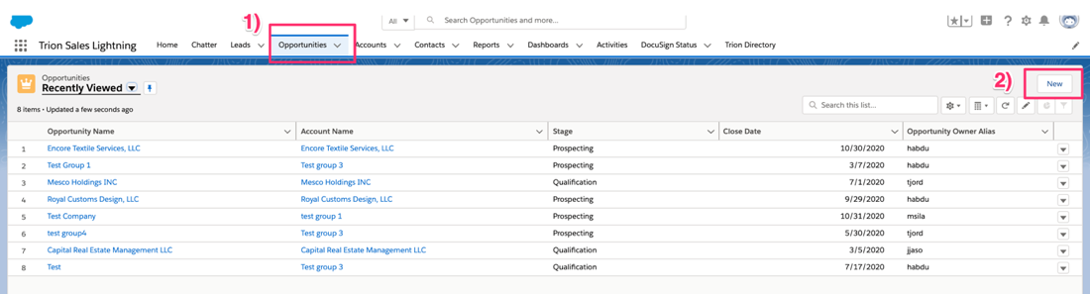
- Enter Opportunity Name
- Select Account or create a new Account
- Enter the Close Date
- Select Prospecting from the Stage picklist field
- Click Save
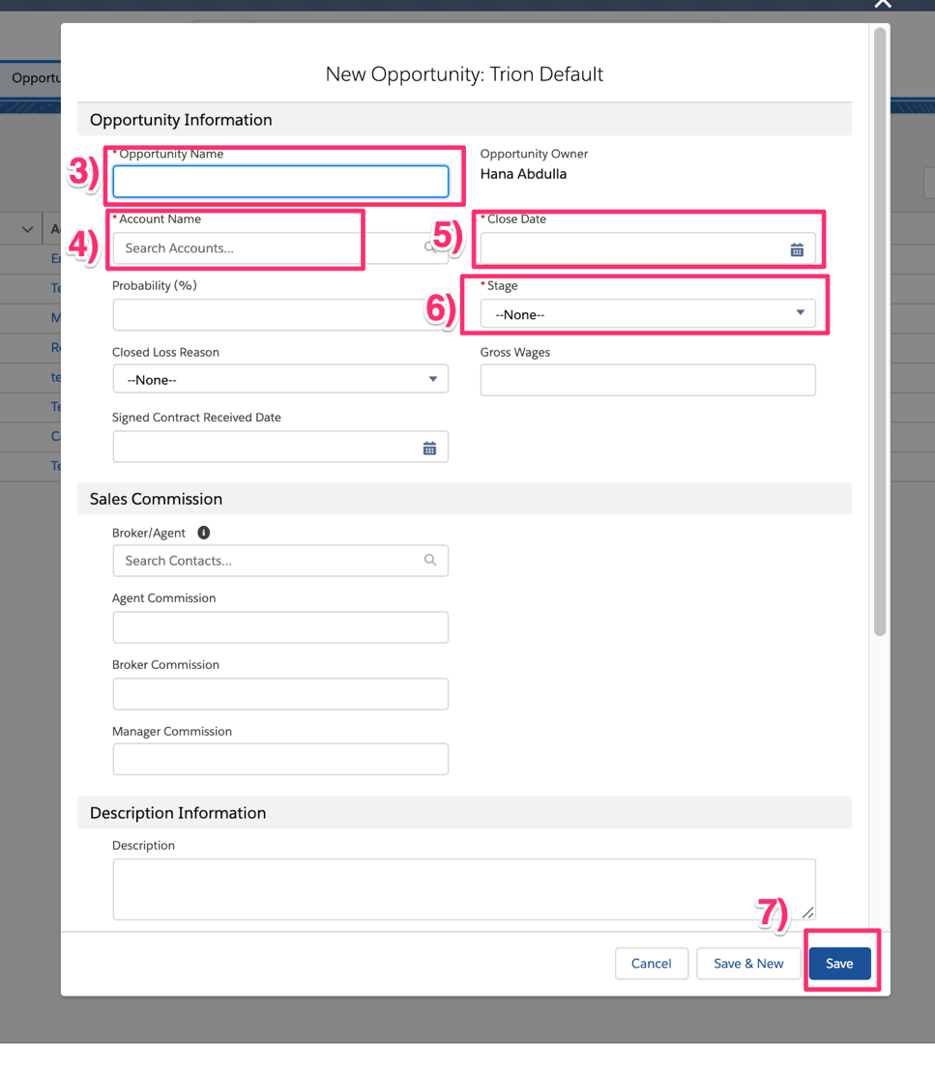

Business Information
- Go to the Business Information Tab
- Enter the DBA for the client
- Select the Entity Type
- Enter the Business Type
- Enter the Business Establishment Date – add instructions on secretary of state search
- Enter the clients Federal Id Number
- Click Save
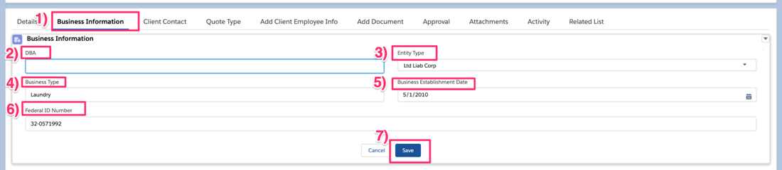

Quote Type
- Go to the Quote Type Tab
- Select a Quote Type from the picklist options
- If client is a new business, change New Business Entity to ‘Yes’
- If quote type is PEO, enter the client’s Current Policy Expiration Date
- If the client is interested in a Health Quote, change Health Quote to ‘Yes’
- If the client is in the staffing industry, change Staffing Supplement to ‘Yes’
- Enter the clients Estimated Annual HR Cost
- If Quote type is PEO, enter the clients Estimated Annual Client Premium. If quote type is not PEO enter 0.
- Click Save
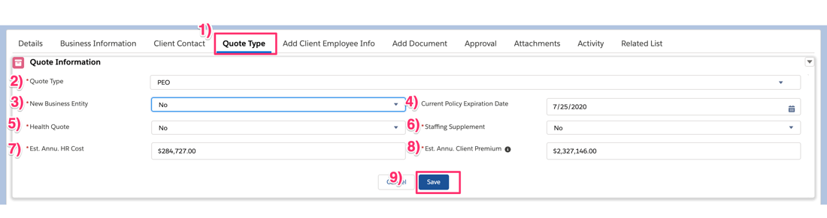

Client Contact
Client Contact section allows you to enter multiple types of Contacts. Client Contact types include:
- Client Contact – Use this option when entering the primary contact for the opportunity or any additional person(s) you would contact regarding the opportunity.
- Accting Record – Only use this for PEO Quotes. Client contact for the Accounting Records as requested on the ACORD form.
- Inspection - Only use this for PEO Quotes. Client Contact for the inspection as requested on the ACORD form.
- Claims - Only use this for PEO Quotes. Client Contact for claims info as requested on the ACORD form.

Opportunity Client Contact
- Go to the Client Contact Tab
- Click Add
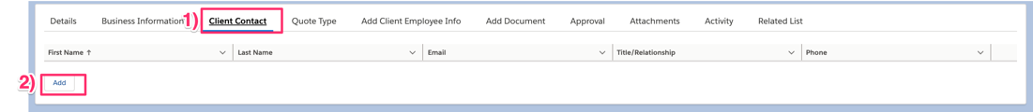
- Select ‘Client Contact’ from the Type picklist
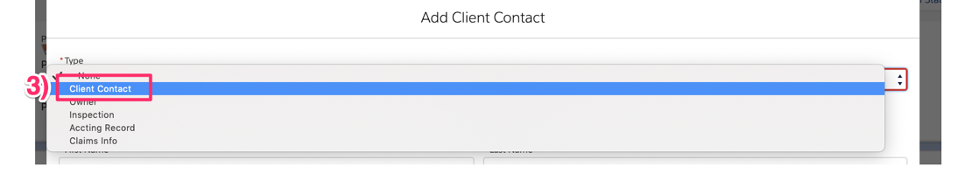
- Keep Included as unchecked
- Keep Primary as Unchecked
- Enter First Name
- Enter Last Name
- Enter the contacts Title/Relationship
- Optional, enter the contacts Email address
- Optional, enter contacts Phone number
- Click Save
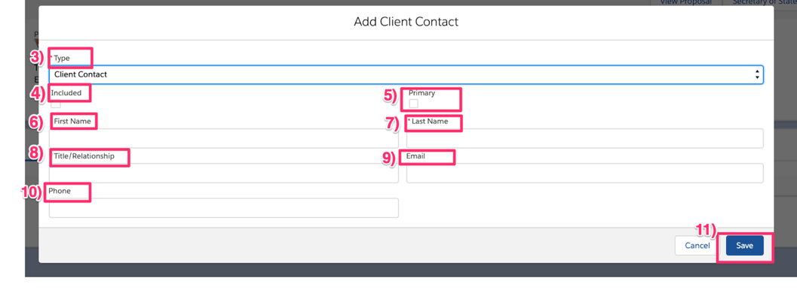

Opportunity Primary Contact
Steps below indicates the contact is the primary contact for the Opportunity but is not the owner or the ACORD client contact.
- Go to the Client Contact Tab
- Click Add

- Select ‘Client Contact’ from the Type picklist

- Keep Included as unchecked – change field name to Officer/Owner
- Check the Primary checkbox
- Enter First Name
- Enter Last Name
- Enter the contacts Title/Relationship
- Optional, enter the contacts Email address
- Optional, enter contacts Phone number
- Click Save
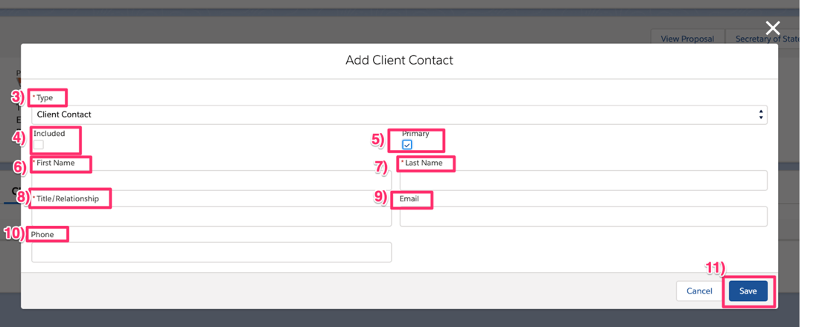

Officers /Owners for Included/Excluded ACORD Section
Only use for PEO quote types. Enter the owner’s information. If company has more than one owner, be sure to add information for each owner. – indicate fields that are optional
- Go to the Client Contact Tab
- Click Add
- Select ‘Client Contact’ from the Type Picklist. If the owner is also the client contact for the ACORD Accting Record, Inspection or Claims Info, select the appropriate Type option instead of client contact.

- Check the Included checkbox
- If the Owner is also the primary contact, check the Primary checkbox
- Enter the owner’s First Name
- Enter the owner’s Last Name
- Enter the owner’s Title/Relationship
- Optional, enter the owner’s Email address
- Optional, enter owner’s Phone number
- Optional, enter owner’s Birthdate
- Enter owner’s Ownership %
- Select the owner’s State location
- Enter owner’s annual payroll
- Select owner’s location from the Location dropdown. If match not found, click the add location icon to add a location to the State. Address must be in the state selected in the state field. If the state is California, search and select the zip code.
- Search and select the Comp Code
- Optional, enter officer/owner’s responsibilities in the Duties text box
- Click Save
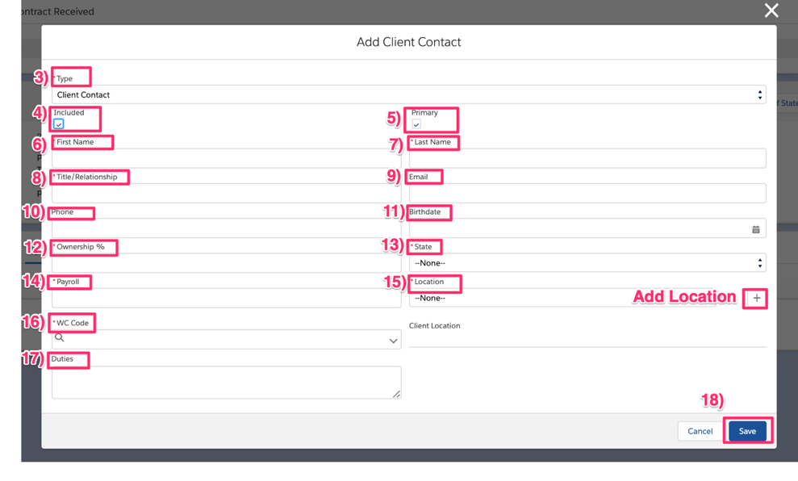

ACORD Contact Information
Add a Client Contact to the ACORD Contact Information Section to indicate the contact for the Accting record, Inspection or Claims info.
- Go to the Client Contact Tab
- Click New

- Select one of the following from the Type picklist:
  - Inspection
  - Accting Record
  - Claims Info
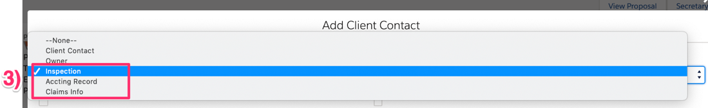
- Keep Included unchecked, unless contact is an owner
- Keep Primary unchecked unless the contact is also the primary contact for the Opportunity
- Enter contact’s First Name
- Enter contact’s Last Name
- Enter contact’s Title/Relationship
- Optional, enter contact’s Email
- Optional, enter contact’s Phone
- Optional, enter contact’s Mobile Phone
- Click Save
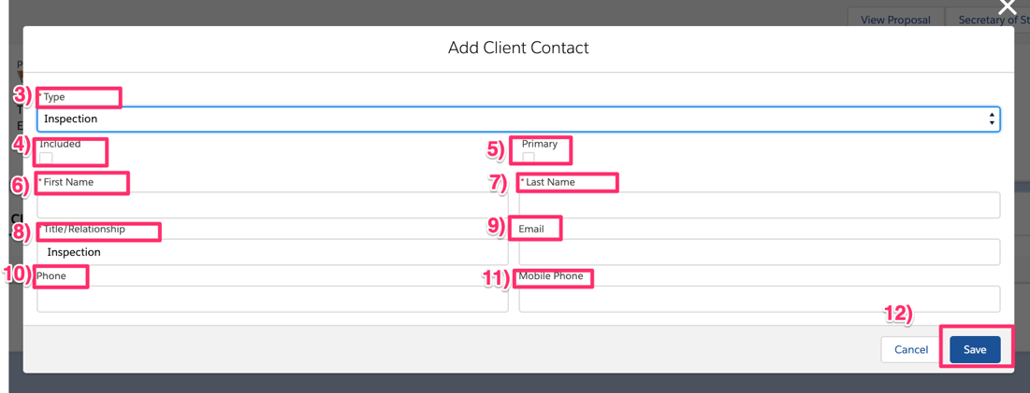

Edit Client Contact
- Go to the record you would like to edit
- Select the Edit action
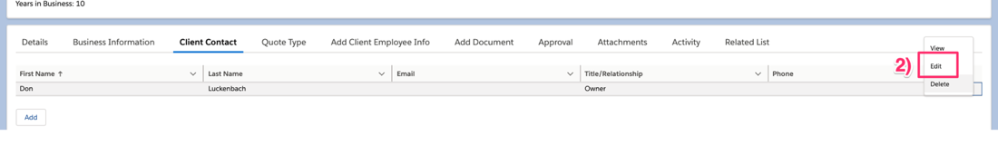
- Enter changes
- Click Save

Delete Client Contact
- Go to the record you would like to delete
- Select the Delete action
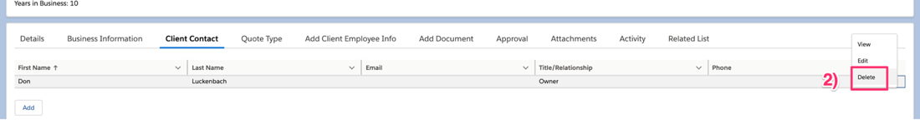

Add Client Employee Info
To add number of employees and gross wages, go to the Add Client Employee Info Tab

Quote Type: PEO w/o Comp or ASO
- Click Add
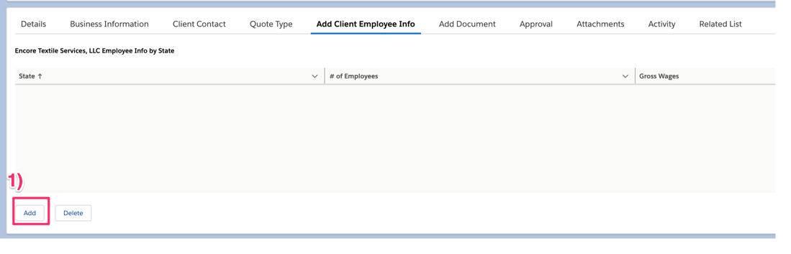
- Search for the state in the State search box
- Select the state
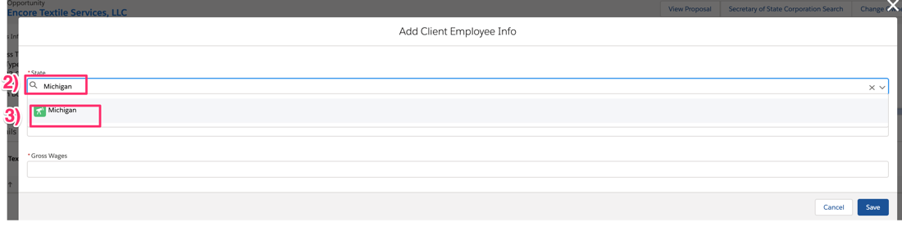
- Enter the # of Employees
- Enter the Gross Wages
- Click Save
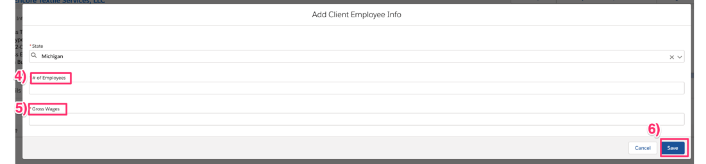

Quote Type: PEO
If quote type is PEO, user must enter each state and location address(es) the client is located at prior to entering the comp code information. Sales Agents are required to indicate the location for each comp code to populate the ACORD form.

Client States

Add Client State
- Click Add State
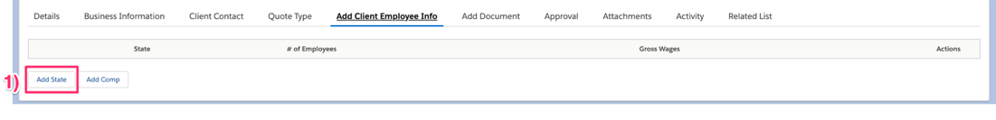
- Select State
- Click Save or Add to add save entry and add additional states
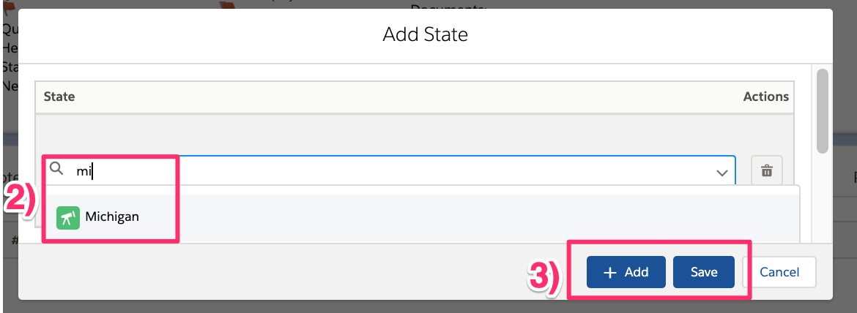

Delete Client Sate
- Scroll to the record you’d like to delete
- Click the Delete action 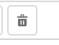

Note: Deleting the state also deletes all of the selected State’s location and WC Rate records

Client State Locations

Add Client State Location
- Click the expand icon 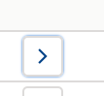 to add location to State
- Click Add Location
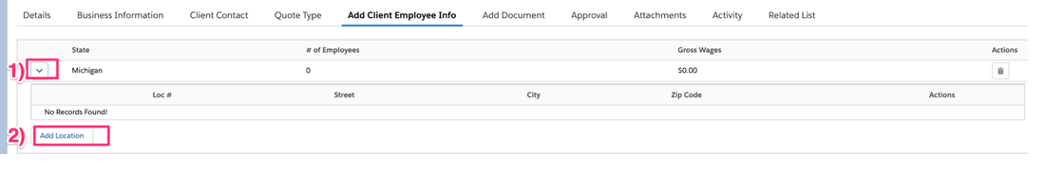
- Location # is auto assigned
- Enter the Street Address
- Enter the City
- Enter the Zip Code
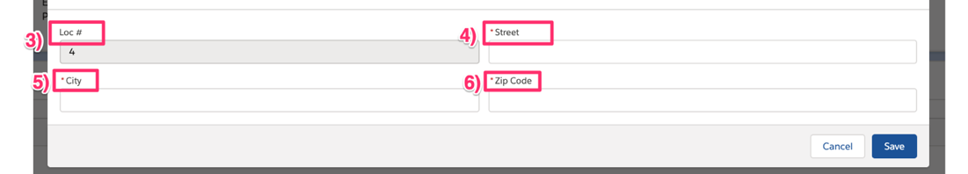
- If State is California, search and select the zip code
- Click Save
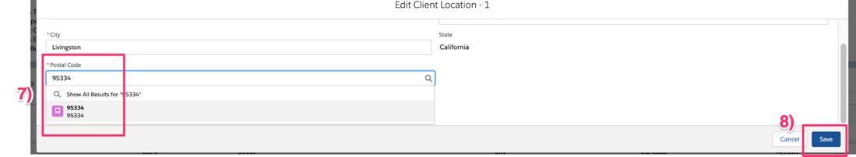
Be sure to add a location for each client state. Add additional locations for states where client has multiple locations.

Edit Client State Location
- Go to the location row you’d like to edit
- Click the Edit action 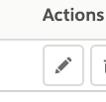
- Make your changes
- Click Save

Delete Client State Location
- Go to the location row you’d like to delete
- Click the Delete action 

Client Location Comp Codes

Add State Location Employee Comp Codes
- Click expand icon  to the state location to add comp’s. Be sure to add comp’s to the location the employees location.
- Click Add
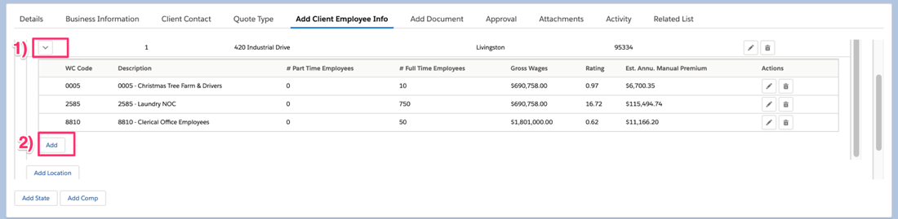
- Search for the comp code in the WC Code search box
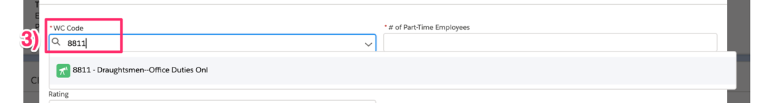
- Select the WC Code
- Enter the number of Part-Time Employees
- Enter the number of Full-Time Employees
- Enter the total Gross Wages
- Optionally, enter the Current Rate
- Click Save or Save and Add More to save the entry and add additional comp codes to the selected state location.
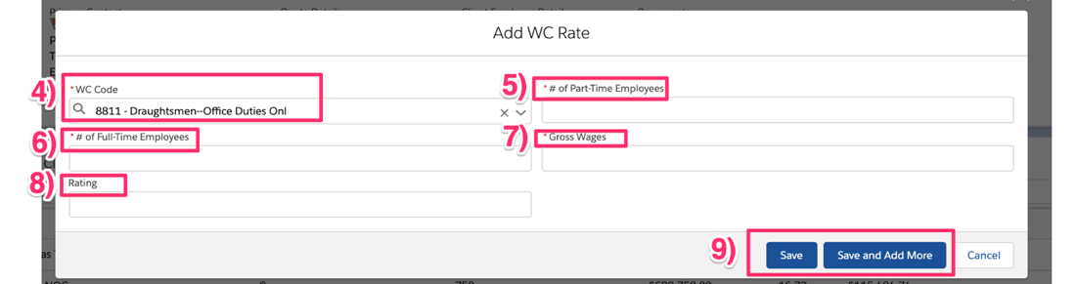

Edit Location Employee Comp Code
- Go to the Comp Code row you’d like to edit
- Click the Edit action 
- Make your changes
- Click Save

Delete Location Employee Comp Code
- Go to the Comp Code row you’d like to delete
- Click the Delete action 

Documents

Uploading Documents
- Go to the Documents Tab
- Click Upload Document
- Select a Requirement Type
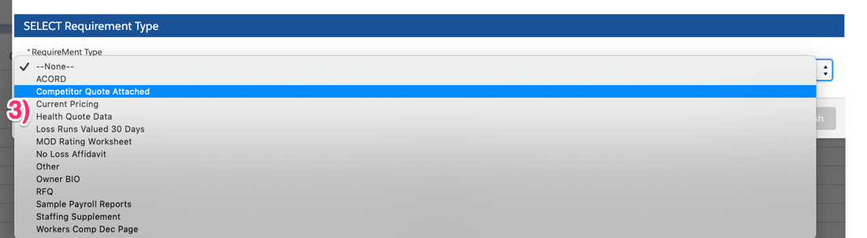
- Optional, enter a Note for the Sales Office and Underwriting team
- Click Upload File or drag and drop file
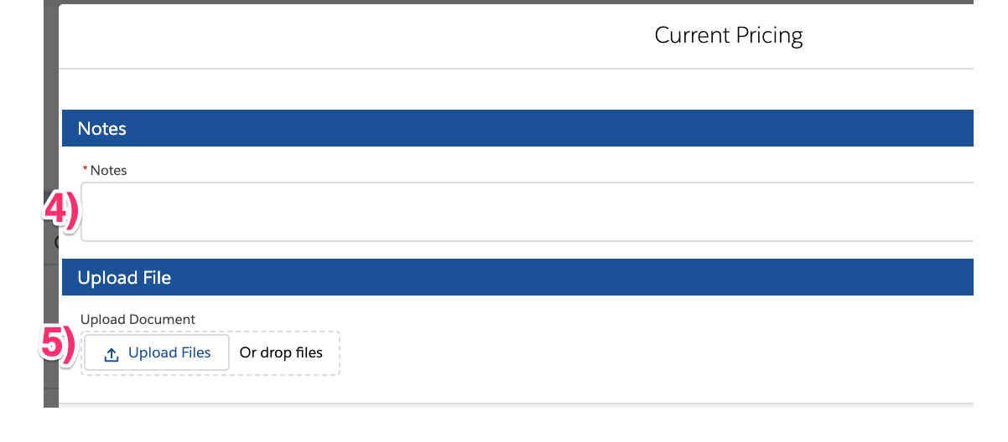
- Click Done
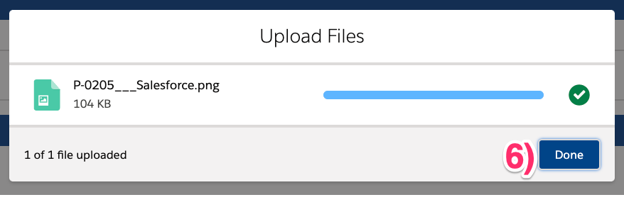
- Click Finish 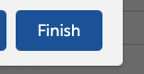

Viewing Documents
- Go to the document row you would like to view
- Select the View action
- Download the document or close the page to return to the Opportunity

Deleting an Uploaded Document
- Go to the document row you would like to delete
- Click the Delete action
- Document is deleted and status is updated to Not Started

ACORD Form
- Go to the Documents Tab
- Go to the ACORD row
- Click the Edit action for the ACORD document
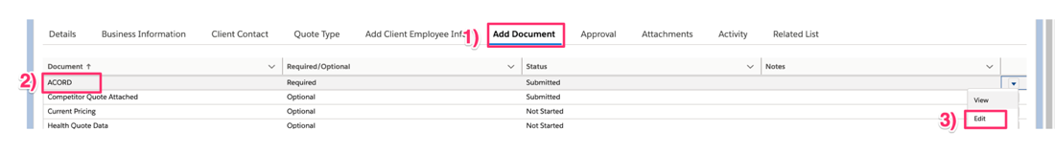
- Select an ACORD Type:
  - Trion ACORD Form – use this option if you’d to indicate to the Underwriting team the ACORD data was entered into Salesforce and to auto-generate the ACORD form
  - Uploaded ACORD – use this option to indicate to the Underwriting team that the ACORD was uploaded to Salesforce
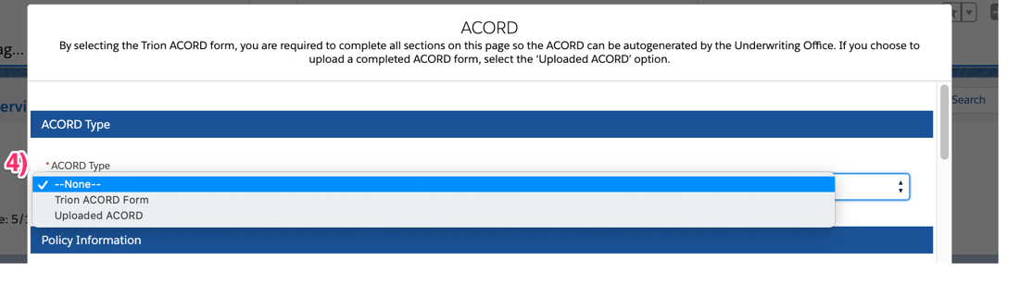

Policy Information
Policy proposed dates are auto set when the Current Policy Expiration date is set on the Quote Type section. The Proposed Effective Date defaults to the Current Policy Expiration Date and the Proposed Exp Date defaults to one year after the Proposed Effective Date. You may update the dates in the Policy Information section.
- Enter the Proposed Effective Date
- Enter the Proposed Exp Date
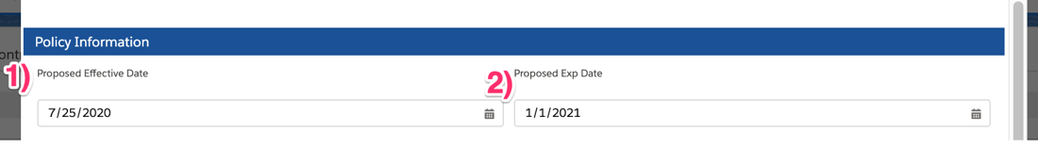

PART 2 – EMPLOYERS LIABILITY
Employer’s liability defaults to $1,000,000.00. You may update each liability in the Employer’s Liability section.
- Each Accident
- Disease Policy Limit
- Disease Each Employee
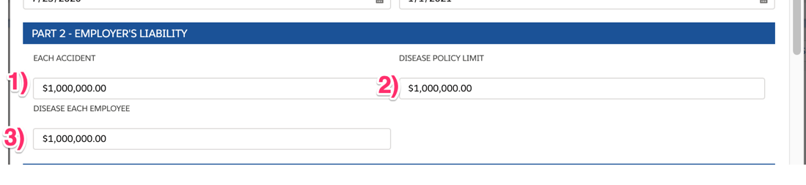

OTHER COVERAGES
- U.S.L. & H.
- VOLUNTARY COMP
- FOREIGN COV
- MANAGED CARE OPTION
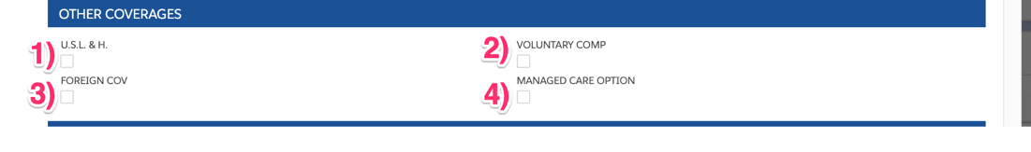

TOTAL ESTIMATED ANNUAL PREMIUM – ALL STATES
- Enter the Total Estimated Annual Premium
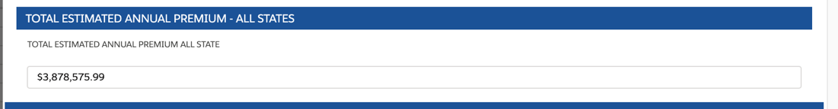

CONTACT INFORMATION
The Contact Information section will list all client contacts where Type of Accting Record, Claims Info, or Inspection is selected.
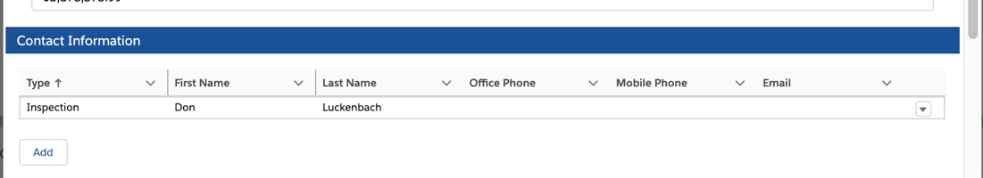
This section allows the following actions:
- Add - Add a new client contact to the ACORD Contact Information Section
- Edit – change the Type or any additional data entered on the client contact record
Note: If you change the type to ‘Client Contact’ the record will not display on this page or be included on the ACORD Form. You will be able to see the client contact on the Opportunity’s Client Contact Tab
- Delete – will delete the client contact record

OFFICERS/OWNERS
The Officers section will list all client contacts where you indicated as Included. This should contain all owners of the company.
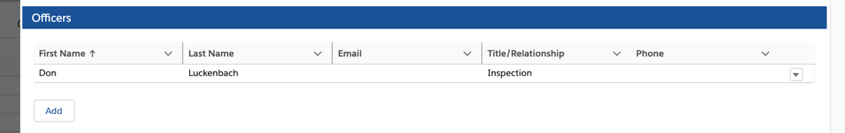
This section allows the following actions:
- Add – Add officer to ACORD Form
- Edit – Remove contact from Officers section or change any additional data entered on the client contact record
Note: If you deselect ‘Included’ the record will not display in this section or be included on the ACORD Included/Excluded section. You will be able to see the client contact on the Opportunity’s Client Contact Tab
- Delete – will delete the client contact record

STATE RATING
The Comp Codes entered in the Client Employee Info are displayed. You can take the following actions in this section.
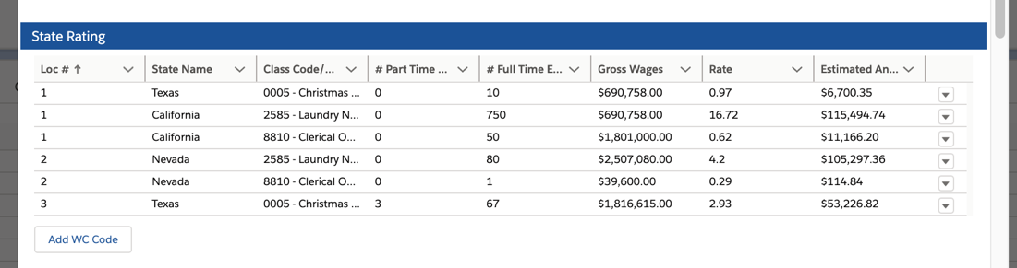
- Add Additional State/Location Comp Codes
- Edit Client Sate/Location Comp Code Entries
- Delete Client State/Location Comp Code Entries

NATURE OF BUSINESS/DESCRIPTION OF OPERATIONS
Enter the client’s nature of business and/or description of operations for the ACORD form requirements.
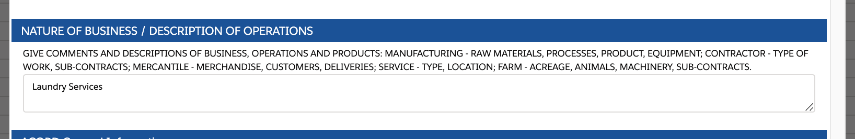

ACORD GENERAL INFORMATION
Questions default to No. Change value to yes for applicable questions.
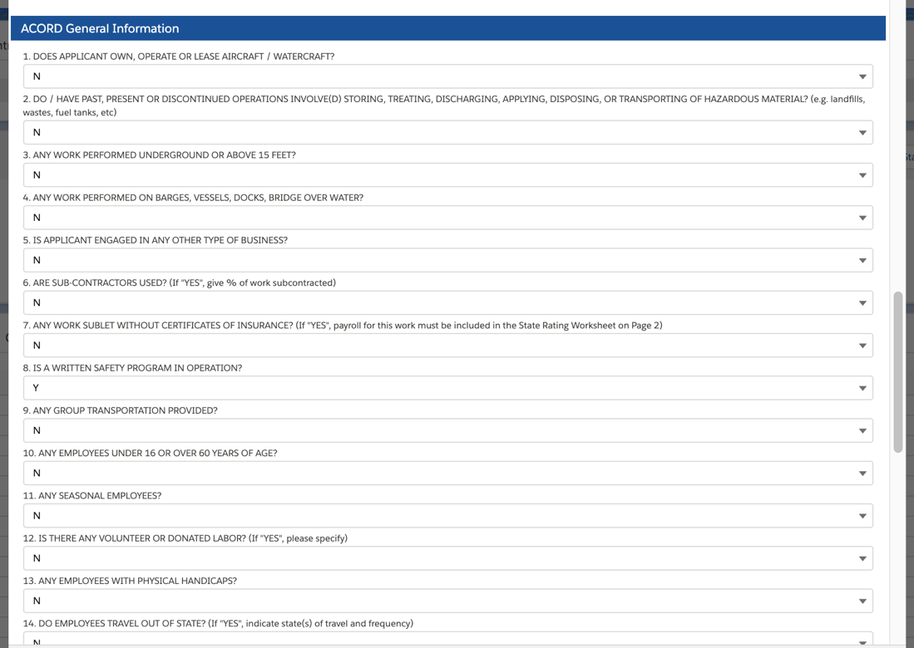

Notes
Add Notes to submit to the Sales Office and Underwriting regarding the ACORD form.
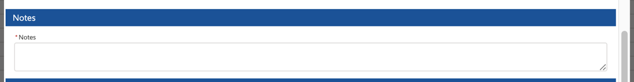

Upload File
Upload supporting documentation as needed. -
