Trion Sales Process Stages 2
Opportunity Stage 2
Sales Office Stage 2
Proposal Stage 2
Underwriting Stage 3
Submitting an Opportunity for Approval 4
Approval Request: Sales Review 4
Approval Request: Quote Pending UW Approval 5
Re-submitting Opportunity for Approval when Additional Requirements Requested 5
Review Additional Requirements Notes 6
Upload Additional Requirements Requested 7
Create New Approval Request to Review Additional Requirements Submitted 8
Closing an Opportunity 9
Closed Loss 9
Close Won 9
Sales Review 10
Request Additional Info for Review 10
Sales Qualified: Approved Approval Request 10
Sales Review Approved: PEO w/o Comp or ASO 10
Sales Review Approved: PEO 10
Quote Pending UW Final Review Approved 11
Sales Disqualified: Decline Approval Request 11
Underwriting Review 12
Request Additional Info 12
Underwriting Qualified: Approve Approval Request 12
Underwriting Disqualified: Decline Approval Request 12
Proposal Stage Client Presentation 13
Requesting a Revision of a Proposal 13
Requesting Contract 13

Trion Sales Process Stages

Opportunity Stage
The Opportunity Stage consists of the Sales Pipeline Stages. Opportunities flow through the stages defined below when an actions/decision are made by the Sales Agent, Sales Manager or Underwriting.
- Prospecting – Potential Opportunity identified by Sales Agent. Information gathering phase.
- Qualification – Information gathered and submitted to Sales Office for qualification.
- Additional Info Required – Sales Office and/or Underwriting requiring additional information for qualification.
- Client Value Proposition – Qualified by the Sales Office and the Client Presentation Deck has been generated and submitted to the Sales Agent to provide to the Broker and/or client. Underwriting Qualification not required for this stage.
- Negotiation – Sales Agent requested a revision to the proposal presented on behalf of the Client/Broker. Underwriting Qualification not required for this stage.
- Client Accepted – Client Accepted Quote
- Contract – Client accepted proposal and the Sales Office responds to Sales Agent request for Contract by generating and submitting a Contract to Sales Agent. Underwriting Qualification required for this stage.
- Closed Loss – Client Declines proposal.
- Closed Won – Contract Signed
- Disqualified – Sales Office or Underwriting disqualifies

Sales Office Stage
The Sales Office Stage displays the current status of processing an approval requested by the Sales Agent to Qualify an Opportunity to continue through Trion’s Sales Process.
- Additional Info Requested – Sales Office responds to an approval request requesting additional information.
- Qualified – Sales Office approves approval request and allows for Quoting or Underwriting Review
- Disqualified – Sales Office declines approval request and disqualifies. Does not move on to the next step of the Sales Process.

Proposal Stage
The Proposal Stage displays the current status of the quoting process.
- Not Started – Sales Office has not qualified the Opportunity.
- Quoting
  - PEO Quote Type and Approval Request for Quote Pending UW Approval – moves to this stage when Approval Request is Approved by Sales Office
  - PEO Quote Type– moves to this stage when Underwriting Approval Request submitted by Sales Managed is Approved by Underwriting
  - PEO w/o Comp – Moves to this stage when Sales Agent Approval Request approved by Sales Office
- Client Presentation Deck – Proposal stage auto updated to Client Presentation Deck when Sales Manager generates the Client Presentation Deck. Opportunity is auto updated to Client Value Proposition and Sales Opportunity Owner is notified. Version number and date. stored in Salesforce. Underwriting approval not required for this step.
- Revision – Auto updates when a Sales Agent submits an approval request for a Revised Proposal. Opportunity stage: Negotiation
Underwriting approval not required for this step.
- Proposal Accepted – Auto updates when Sales Agent submits an approval request for a contract. Proposal Accepted Date stored in Salesforce.
- Contract – Requires Underwriting Approval. Auto updates when Contract is generated. Contract generated date stored in Salesforce.

Underwriting Stage
The Underwriting Stage displays the current status of processing an approval requested by the Sales Office to Qualify an Opportunity to continue through Trion’s Sales Process.

- Additional Info Requested - Underwriting responds to an approval request requiring additional information.
- Qualified - Underwriting approves approval request.
- Submitted to Carrier
- Disqualified - Underwriting declines approval request and disqualifies. Opportunity Disqualified.

Submitting an Opportunity for Approval
Sales Agents may submit an Approval Request for qualification to the Sales Office when the Opportunity is in the Prospecting or Additional Info Required Stage.

The stage is auto updated to Additional Info Required when the Sales Office or Underwriting responds to an Sales Agent’s approval request submission by requesting additional information. Opportunity Owners will receive an email notification when additional info is requested. Opportunity Owners can also review all opportunities in the “Additional Info Required” Stage by creating a list view of opportunities they own in the Stage “Additional Info Requested”.

Approval Request: Sales Review
- Click on the Approval Tab
- Select Sales Review from the Approval Request Drop Down
- Optionally, add a note to the Comments text box
- Click Submit
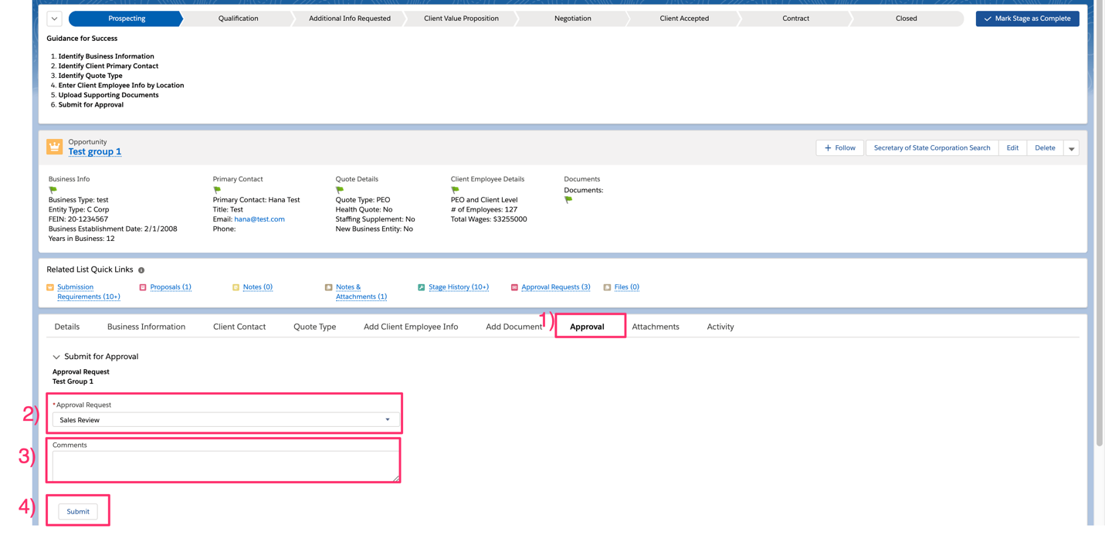
Automated Actions from Submitting an Approval:
- Opportunity Stage: Updates to Qualification
- Sales Office Stage: Updates to Pending
- Approval Record created
- Email notification sent to Sales Office
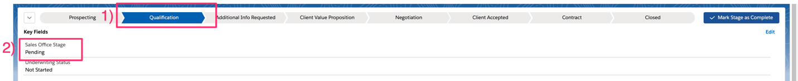
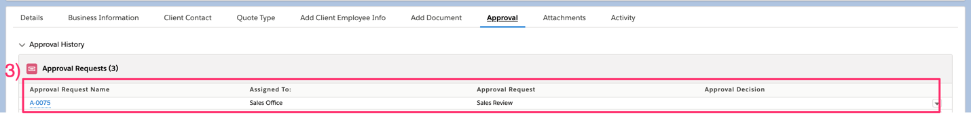

Approval Request: Quote Pending UW Approval
Option only available when Quote Type is PEO
- Click on the Approval Tab
- Select Quote Pending Final Underwriting Review from the Approval Request Drop Down
- Optionally, add a note to the Comments text box
- Click Submit

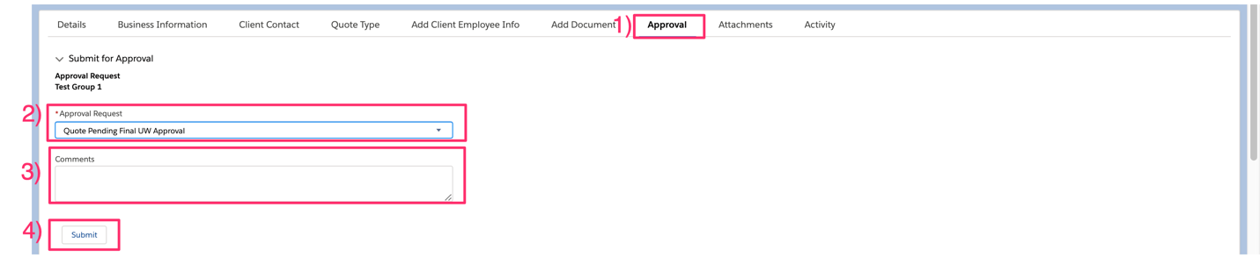

Automated Actions from Submitting an Approval:
- Opportunity Stage: Updates to Qualification
- Sales Office Stage: Updates to Pending Review
- Approval Record created
- Email notification sent to Sales Office



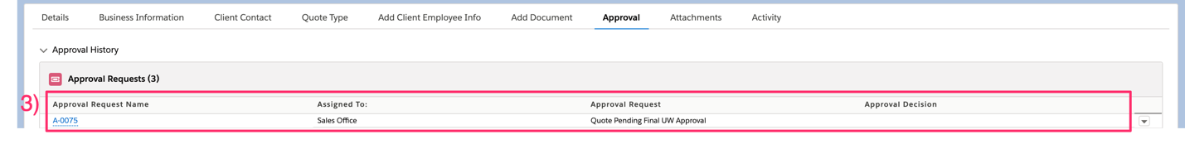

Re-submitting Opportunity for Approval when Additional Requirements Requested
- Opportunity Owner Receives an Email Notification
- Click on Link to Go to the Opportunity

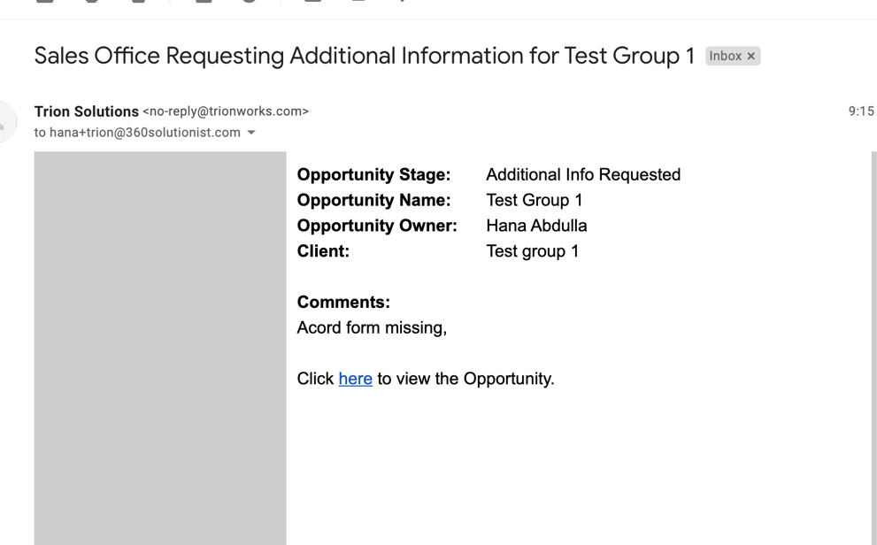

Review Additional Requirements Notes
- Opportunity Stage: Updated to Additional Requirements Requested
- If Requested by Sales Office:
  - Sales Office Stage: Additional Info Required
- If Requested by Underwriting:
  - Sales Office Stage: Qualified
  - Underwriting Stage: Additional Info Requested
- Review the Additional Requirement Note
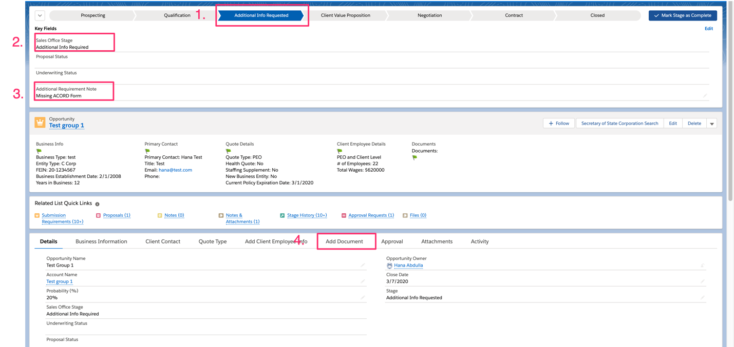

Upload Additional Requirements Requested
- Go to the Add Document Tab
- Select a document from the list or Select Other
- Click Upload Document
- Optionally, Check the Add Note checkbox
- Add a Note for the Sales Office/Underwriting regarding the document. If you choose to upload multiple requirements against a single requirement, add a note to allow Sales and Underwriting to quickly and easily find the documents submitted.
- Click Upload Files
- Select a File
- Click Done
- Click Finish

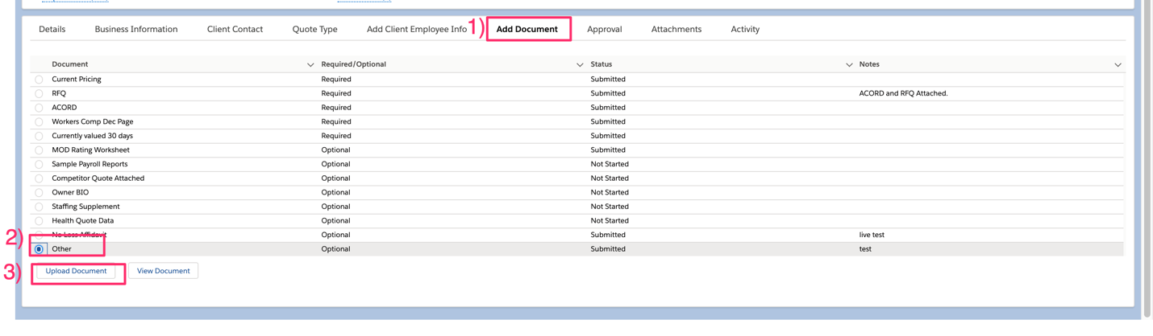
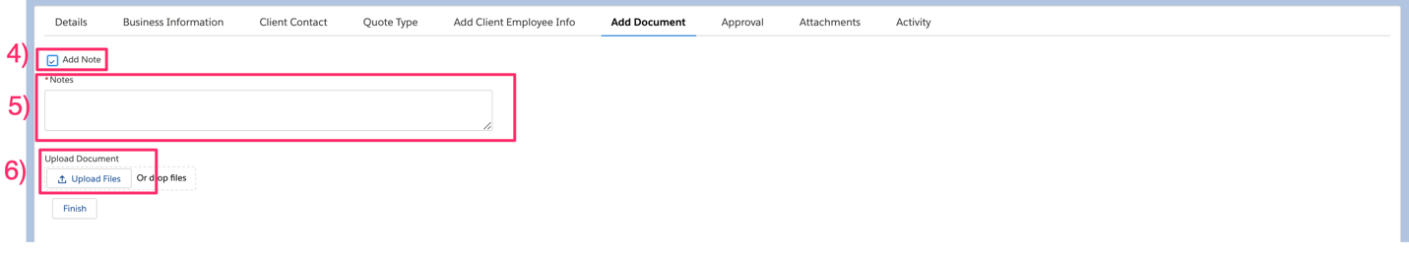
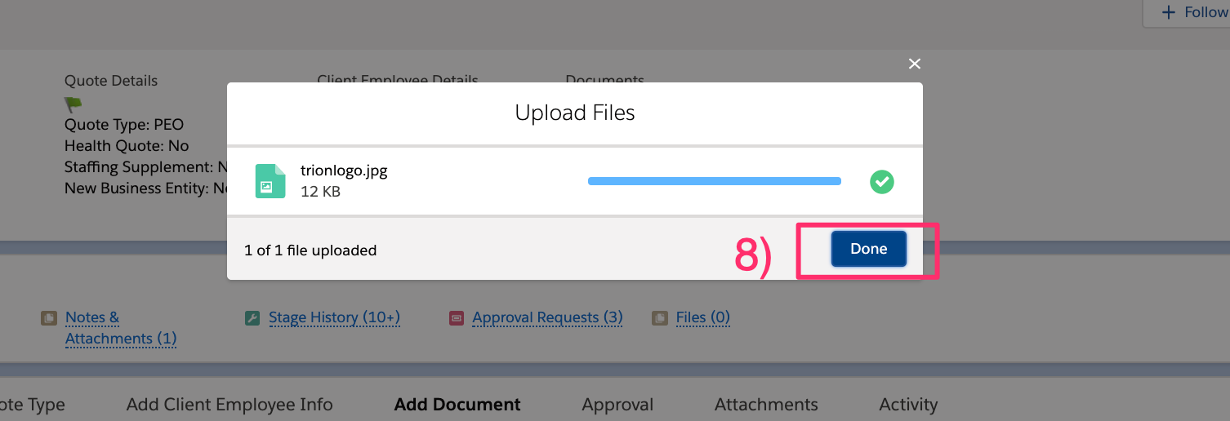

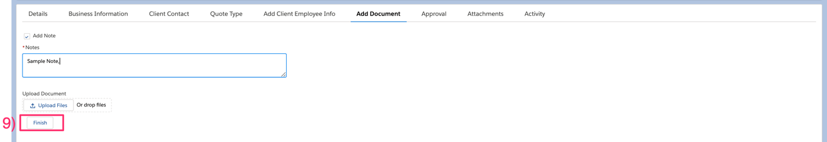
Note: Clicking Done saves the document in Salesforce. The Finish button is to identify that you have completed uploading documents for the requirement marks the requirement as submitted and saves your note.

Create New Approval Request to Review Additional Requirements Submitted
- Click on the Approval Tab
- Optionally, Add a note in the Comments text box
- Click Submit
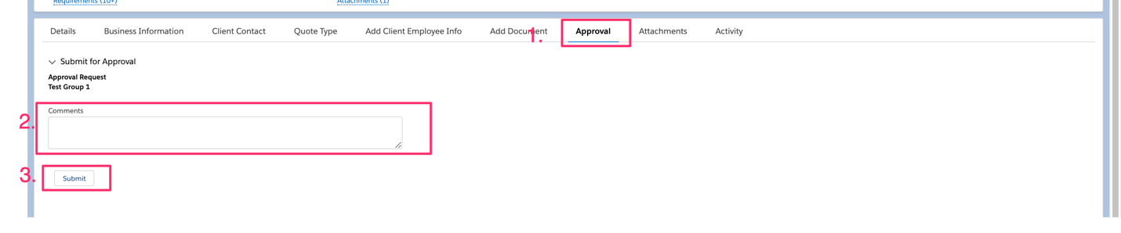

Automated Actions from Submitting an Approval:
- Opportunity Stage: Updates to Qualification
- Approval Record created
- Email notification sent to Sales Office

Closing an Opportunity

Closed Loss
- Go to the Close Loss tab on the Opportunity Path
- Click on the Close Loss Reason field and select a value from the dropdown list
- Optional, update the Close Date field to the current date
- Click Save

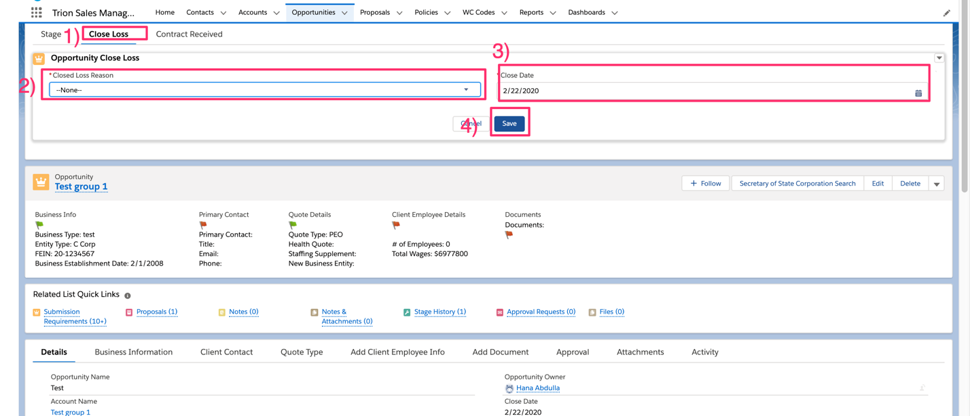

Opportunity stage auto updates to Close Loss

Close Won
- Go to the Signed Contract Received tab on the Opportunity Path
- Enter the date the signed contract was received in the Signed Contract Received date field
- Click Save
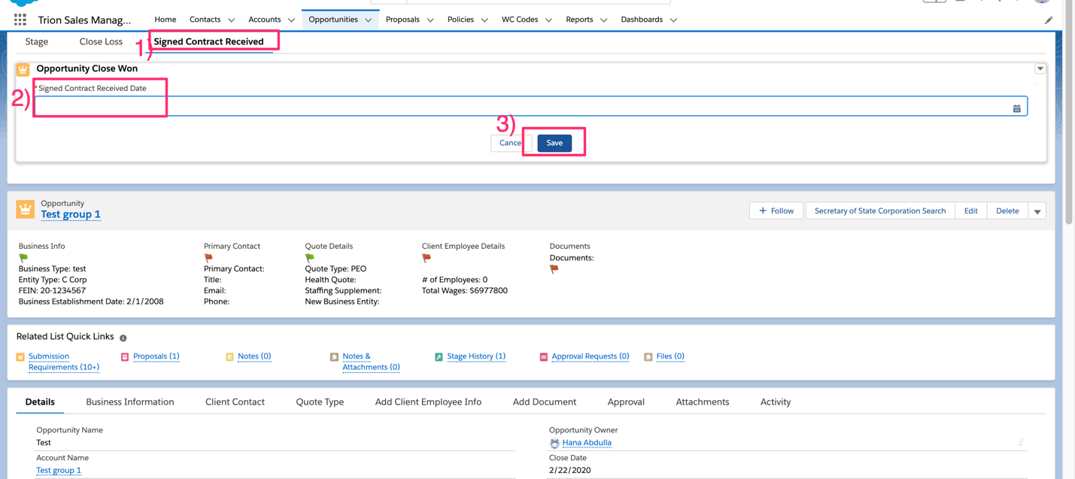

Opportunity stage auto updates to Close Won

Sales Review
Opportunities in the Qualification Stage are reviewed by Sales.

Request Additional Info for Review
- Go to the Approval Request
- Select “Request Additional Info” from the Decision menu
- Optional: Add a note in the Comments text box for the Opportunity Owner
- Click Submit
- Sales Office Stage updates to Additional Info Requested
  - Opportunity Stage: Additional Info Requested
Opportunity Owner Receives Email Notification to review

Sales Qualified: Approved Approval Request
- Go to the Approval Request Record
- Select Approve from the Decision drop down
- Optionally, Add a note in the Comments text box.
- Click Submit
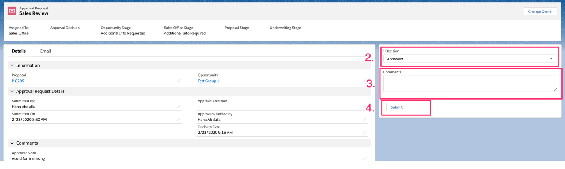

Sales Review Approved: PEO w/o Comp or ASO
- Sales Agent Approval Request Approved
  - Opportunity Stage: Remains as Qualification
  - Sales Office Stage: Updates to Qualified
  - Proposal Stage: Updates to Quoting

Sales Review Approved: PEO
- Underwriting Receives Email Notification
- Sales Agent Approval Request Approved
- Underwriting Review Request created and assigned to Underwriting
  - Opportunity Stage: Remains as Qualification
  - Sales Office Stage: Updates to Qualified
  - Proposal Stage: Not Started
  - Underwriting Stage: Updates to Pending Review

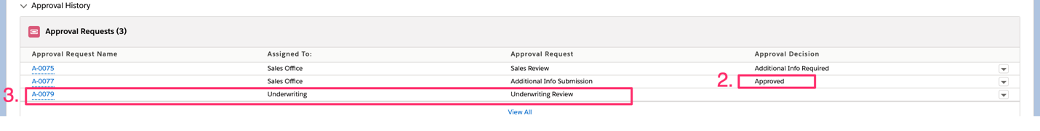

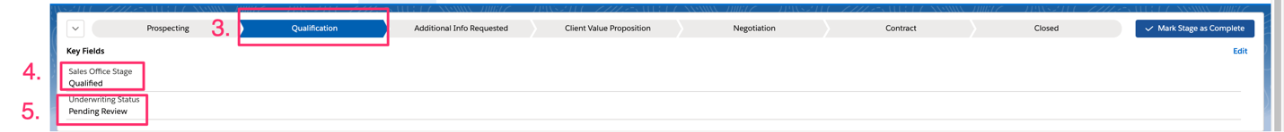

Quote Pending UW Final Review Approved
- Underwriting Receives Email Notification
- Sales Agent Approval Request Approved
- Underwriting Review Request created and assigned to Underwriting
  - Opportunity Stage: Remains as Qualification
  - Sales Office Stage: Updates to Qualified
  - Proposal Stage: Updates to Quoting
  - Underwriting Stage: Updates to Pending Review

Sales Disqualified: Decline Approval Request
- Sales Agent Approval Request Denied
- Opportunity Stage: Updates to Disqualified
- Sales Office Stage: Updates to Disqualified
- Sales Agent Receives Email Notification

Underwriting Review

Request Additional Info
- Go to the Approval Request
- Select “Request Additional Info” from the Decision menu
- Optional: Add a note in the Comments text box for the Opportunity Owner
- Click Submit
- Underwriting Stage updates to Additional Info Requested
  - Sales Office Stage: Qualified
  - If Quote Pending UW Final Approval Requested – No Change to Proposal Status
  - Opportunity Stage: Additional Info Requested

Opportunity Owner and Sales Office Receives Email Notification to review

Underwriting Qualified: Approve Approval Request
- Sales Office Receives Email Notification
- Sales Manager Approval Request Approved
- Underwriting Stage: Qualified
  - Opportunity Stage: Remains at Qualification unless a request for Quote Pending UW Approval has been submitted and approved.
  - Sales Office Stage: Qualified
  - Proposal Stage: If Quote Pending UW Final Approval has not been requested, stage updated to Quoting. Otherwise, remains in the current stage if a quote has started.

Underwriting Disqualified: Decline Approval Request
- Sales Manager Approval Request Denied
- Underwriting Stage: updates to Disqualified
- Opportunity Stage: Updates to Disqualified
  - Sales Office Stage: Remains in Qualified
- Sales Agent and Sales Manager Receives Email Notification

Proposal Stage Client Presentation
- Opportunity Stage Updated to Client Value Proposition
- Sales Office emails Sales Agent the Proposal
- Sales Agent Send the Proposal to the Broker/Client

Requesting a Revision of a Proposal
- Go to the Approval Tab
- Click the Request Proposal Revision button
- Optionally, add a comment in the comments text box
- Click Submit

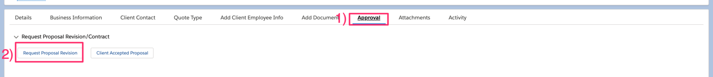

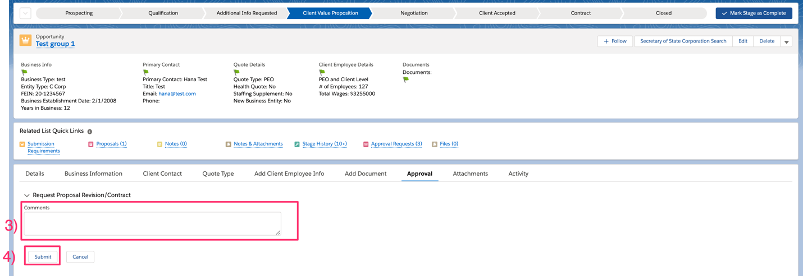

Automated Actions:
- Opportunity Stage: Updates to Negotiation
- Proposal Stage: Updates to Revision
- Approval Request record created
- Sales Office Receives Email Notification
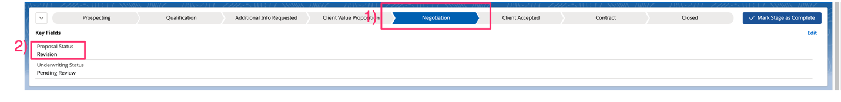

Requesting Contract
- Go to the Approval Tab
- Click the Client Accepted Proposal button
- Optionally, add a comment in the comments text box
- Click Submit
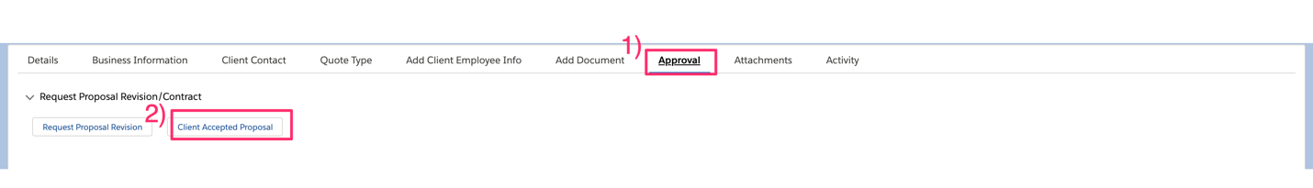


Automated Actions:
- Opportunity Stage: Updates to Client Accepted
- Proposal Stage: Updates to Proposal Accepted
- Approval Request record created
- Sales Office Receives Email Notification

