Viewing Underwriting List Views 2
Home Page Approval Request List View 2
Proposal List View 2
Submitted Documents 3
Viewing Documents 3
Viewing a Uploaded ACORD form 3
Viewing a Trion ACORD Form 4
Generating a PDF of the Trion ACORD Form 4
Underwriting Tab 6
Approval Request Detail 6
Approval Requests Tab 6
Carrier Rating 7
Underwriting Rating 7
Rating a Proposal 7
Underwriting Evaluation 9
P& L 9
Underwriting Summary 10

Viewing Underwriting List Views

Home Page Approval Request List View

- Go to the Home Tab
- Go to the My Items to Approve Section
- Expand the Pending Underwriting Review Section
- Click More to view the entire list
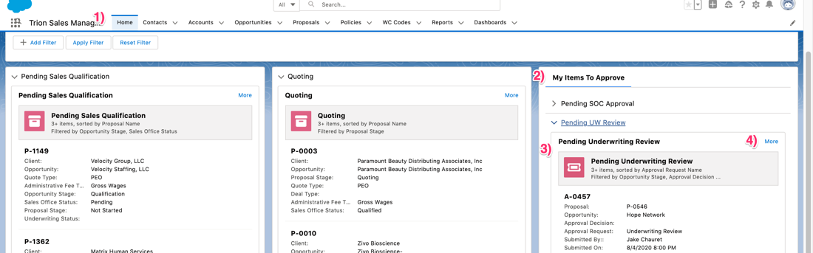

Proposal List View

- Go to the Proposal Tab
- Select the Pending UW List View from the List View menu
- Click on the Proposal Name to view the record
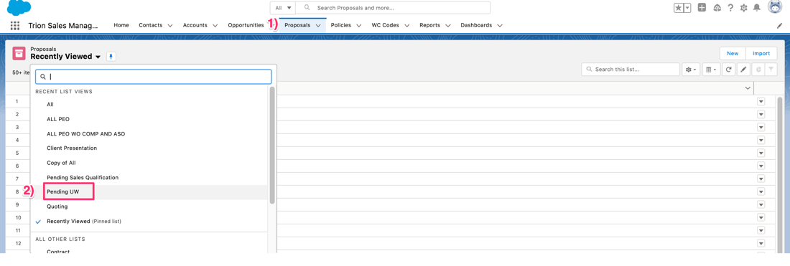

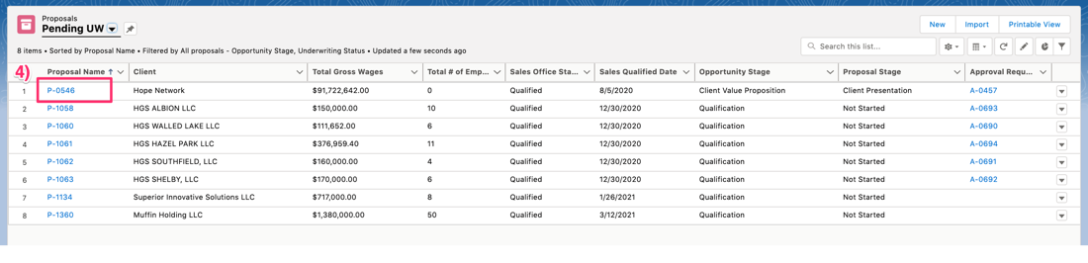

Submitted Documents

Viewing Documents
- Click on the Submitted Documents tab
- Click the view action next to a submission document record
- If more than one document has been uploaded, an arrow will appear. Click on the right facing arrow to view the next document.
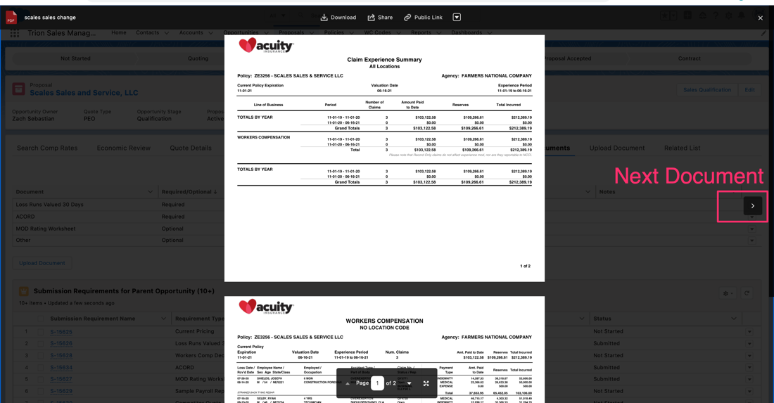
- To view the previous document, click on the left facing arrow.
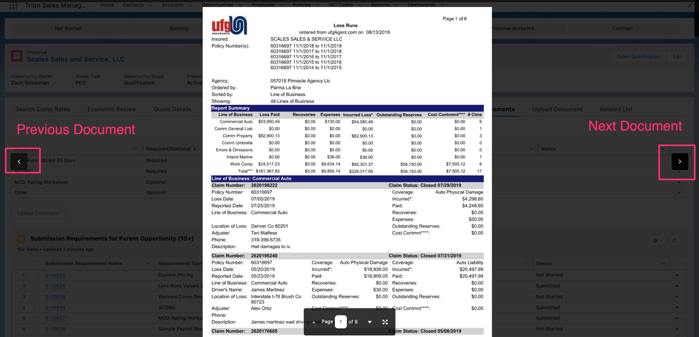

Viewing a Uploaded ACORD form
- Go to the Submitted Documents Tab
- Click the View action for the ACORD submission requirement record
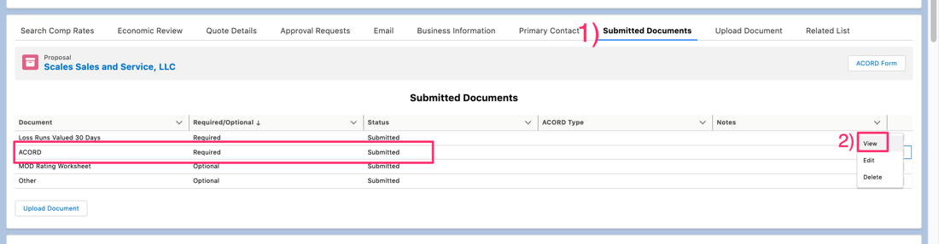

Viewing a Trion ACORD Form
- Go to the Submitted Documents Tab
- Click the Edit action for the ACORD submission requirement record
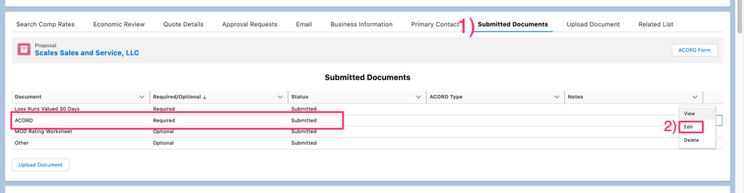

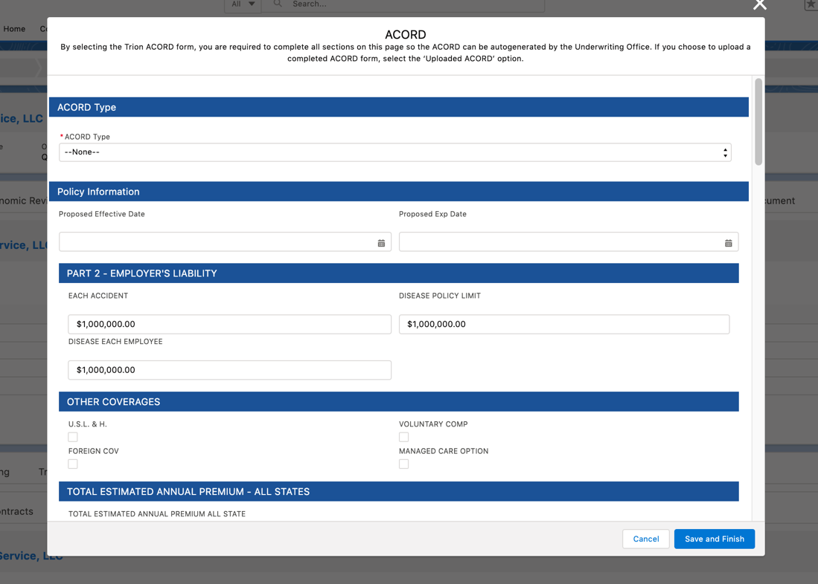

Generating a PDF of the Trion ACORD Form

- Got to the Submitted Documents Tab
- Click the ACORD Form Button
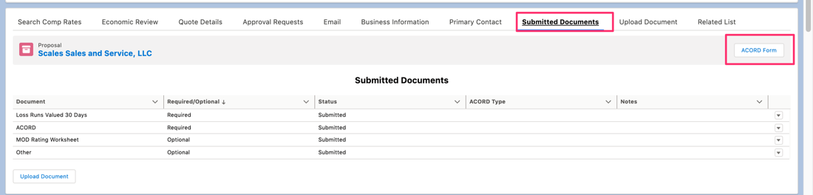
- Go to the Trion Documents Tab to view the generated ACORD pdf
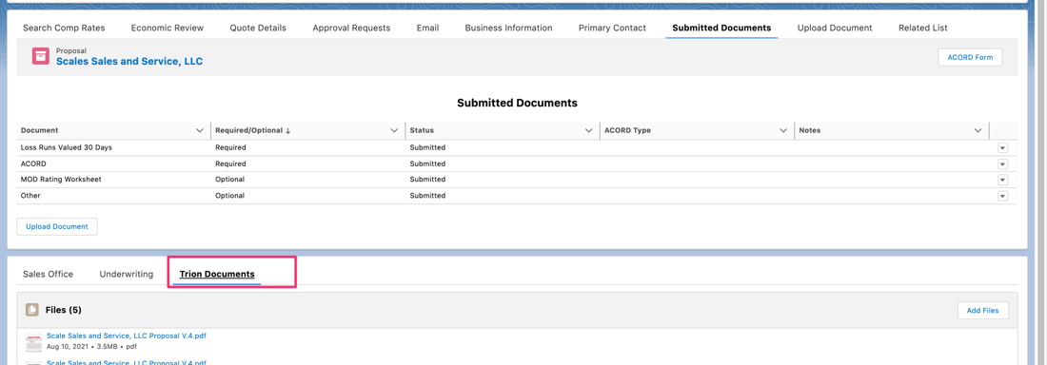

Underwriting Tab

Approval Request Detail
Approval Request Detail section only displays when an approval request that’s been submitted to Underwriting is open. Upon entering a decision, the approval request is closed out.

- Submitted by – the name of the Sales Office team member that Approved the Sales Review Approval Request
- Submitted Date – the date the Sales Office team member approved the Sales Review Approval Request
- Submitter Note – Notes from the Sales Office team member approver
- Approval Request – Underwriting Review Request
- Approval Decision – Select an option after evaluation
- Decline Reason – required when denied is selected in the Approval Decision dropdown field
- Approver Note – notes to the Sales Office and Opportunity Owner. Required if Approval request is denied
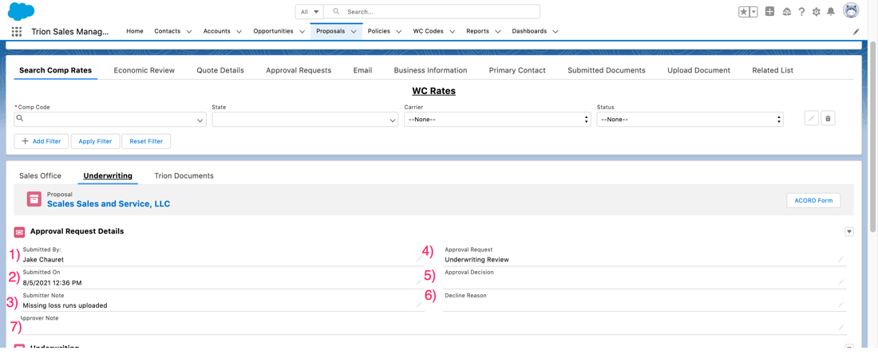

Approval Requests Tab
The Approval Requests Tab displays all approval requests submitted to the Sales Office and Underwriting.
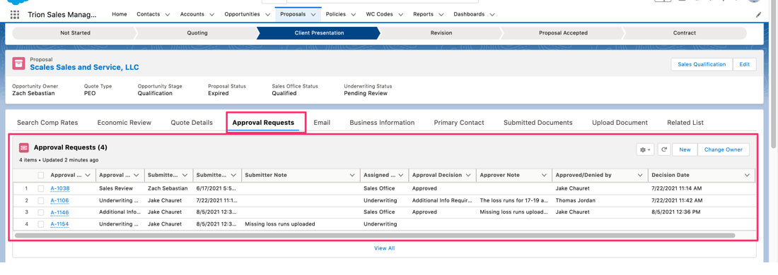

Carrier Rating
The Carrier Rating section requires the Policy Year and comp rates added to populate.

- Total # of Employees – Total client employees
- Total Gross Wages – Total Gross Wages for all client employees
- Policy Year – The master policy used to determine the submit rate
- Policy Submit Rate – Displays the selected policy year submit rate
- Trion Manual Premium – Manual premium plus state surcharge/assessment fees
- Total Carrier Cost – Manual Premium * Policy Submit Rate plus state assessment fees

Underwriting Rating
The section displays the client’s current premium, modified premium and underwriting recommended premium.

- Exp Mod – Client’s current exp mod. Estimated current modified premium only displays if the Exp Mod is entered.
- Proposed Effective Date
- Current Premium – total premium calculated from the current pricing. Only displays if the sales agent enters the client’s current rate when adding comp codes.
- Estimated Current Modified Premium – Displays if the client’s Exp Mod and current rate is available.
- Underwriting Premium – Premium calculated the UW mod entered.

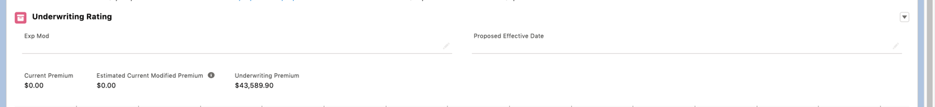

Rating a Proposal
- Go to the Client’s Workers’ Compensation Codes table
- Optional, click the Add WC Code button to add comp codes missing
- Click the Select Carrier button to select a carrier policy carrier rate

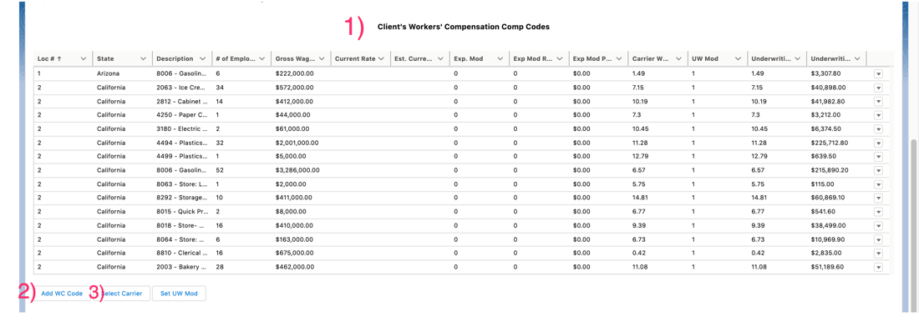
- Select a Policy Year – the Policy year dropdown will only display active policies. Select the policy that represents the recommended carrier.
- Select the master policy for to rate comp codes in master states
- Select the states to rate the comp codes using the selected master policy
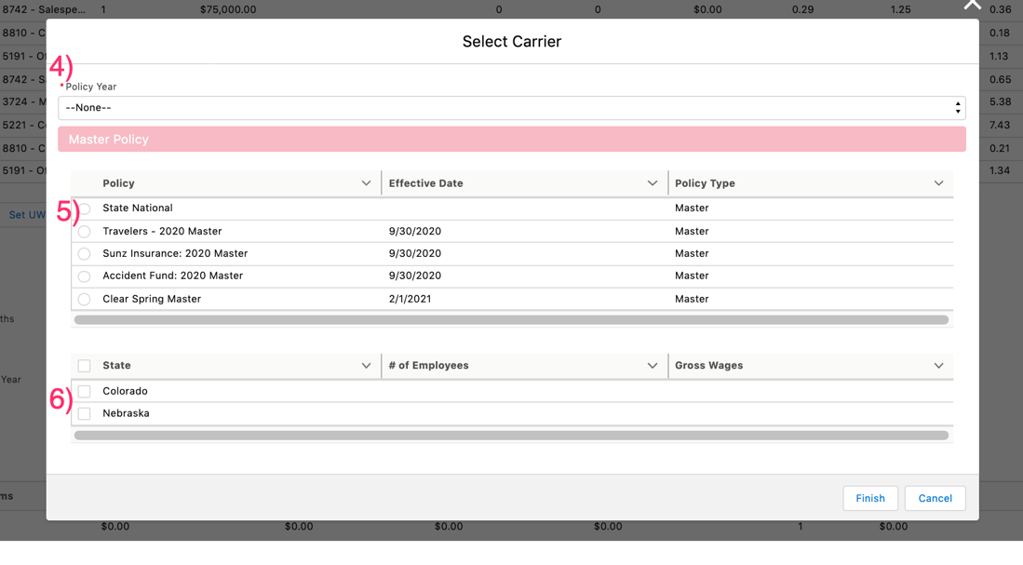
- Select the MCP policy for each MCP state.
- Click Finish
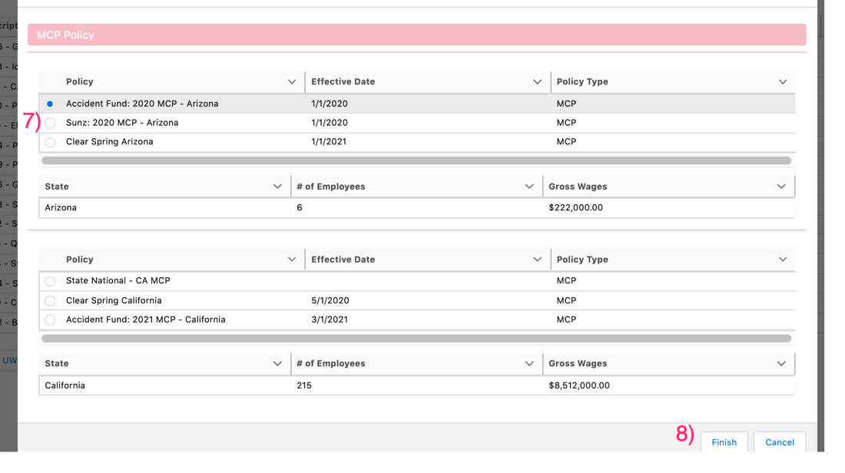
- Click the Set UW Mod button
- Enter the Mod
- Select the rows you’d like to apply the mod to
- Click Save
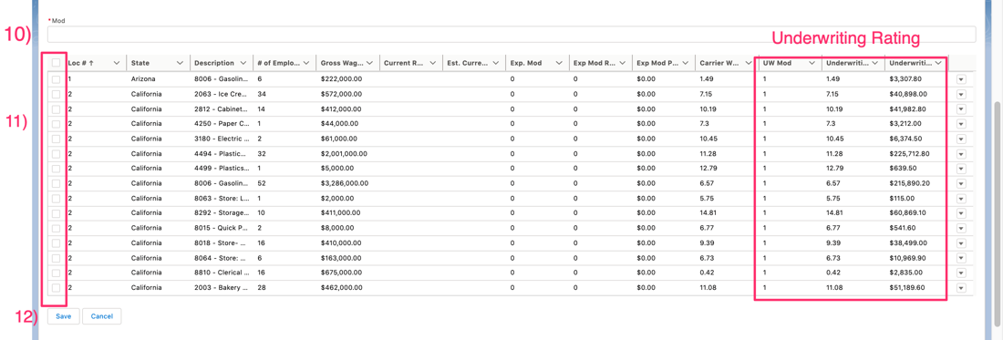

Underwriting Evaluation

P& L
- Click Add
- Select the Year
- Enter the Policy Start Date
- Enter the Policy End Date
- Enter the # of Claims
- Enter the Total Reserves
- Enter the Total Paid
- Enter any Excluded losses
- If excluded losses are entered, enter the reasoning for the excluded losses in the UW excluded losses comments field.
- Enter the LDF. Use the Trion LDF spreadsheet to identify the LDF.
- Enter the Valued Date
- Enter the Carrier
- Click Save
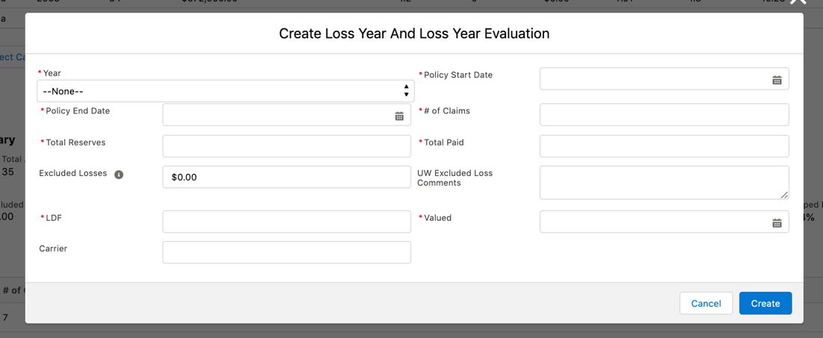

- To add additional evaluations to a previously entered loss year, expand the loss year and click add.
- To edit a loss evaluation, click the record edit action.
- To delete a loss year evaluation entry, click the delete button.
- To delete the complete loss year record and all evaluations for the loss year, click the loss year record delete action.
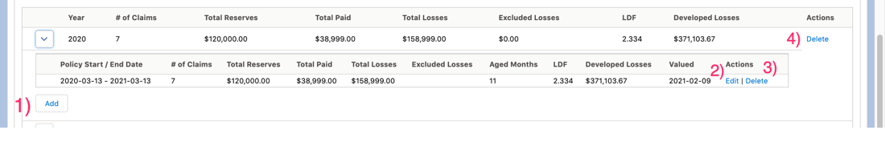

Underwriting Summary

Summarizes the P&L Evaluation Records
- Total # of Claims – aggregates the total # of claims amongst all loss year evaluation records.
- Total Aged Months – Calculates the total aged months for all loss year evaluations added. Aged months for each evaluation is calculated by calculating the number of months from the policy start date to the valued date.
- Average Aged Years – Calculates the average aged years from the total aged months.
- Excluded Losses – Calculates the sum of all losses excluded by Underwriting
- UW Selected Losses – Calculates by subtracting the excluded losses from the total losses.
- Total Losses – Calculates the sum of total reserves and total paid.
- Average Losses Per Year – Calculates the average annual Total Losses
- Incurred Loss Ratio – Average Losses per year divided by the underwriting premium
- Total Developed Losses – Total Losses multiplied by the LDF
- Average Developed Losses Per Year
- Developed Loss Ratio – Average Developed Losses divided by the Underwriting Premium

