TripSkip Color Specification
Prepared: 2025-10-22

1) Quick placement guide
• Background: Navy 900 (#0F192C) full app background.
• Surfaces: Navy 800 (#13213A) for cards/nav; add 1px border Border (#9EB3C7) @ 40–50% opacity.
• Primary actions/links: Royal Blue 600 (#2899BC) → hover Royal Blue 500 (#329FC1).
• Secondary/Accent: Orange 500 (#E78B34) → hover Orange 600 (#D05831).
• Text: White (#FFFFFF) body; Sky 300 (#90BFCB) for secondary text.
• Destructive: Red 500 (#C8102E).
• Optional micro‑accent: Yellow 500 (#FFC72C) for tiny badges/highlights only.

2) Design tokens (CSS variables)
:root {
--bg: #0F192C;
--surface: #13213A;
--text: #FFFFFF;
--text-subtle: #90BFCB;
--primary: #2899BC;
--primary-hover: #329FC1;
--accent: #E78B34;
--accent-hover: #D05831;
--danger: #C8102E;
--border: #9EB3C7;
--yellow-500: #FFC72C;
}

3) Palette (Hex / RGB / Usage)
Name | Hex | RGB | Primary Usage
Navy 900 (App Background) | #0F192C | (15, 25, 44) | Page background, full-bleed sections
Navy 800 (Surface) | #13213A | (19, 33, 58) | Cards, nav bars, modals
Royal/Logo Blue 600 (Primary) | #2899BC | (40, 153, 188) | Primary CTAs, links
Royal/Logo Blue 500 (Hover) | #329FC1 | (50, 159, 193) | CTA hover/active, link hover
Sky 300 (Light UI) | #90BFCB | (144, 191, 203) | Secondary text on dark, chips, subtle icons
Orange 500 (Accent) | #E78B34 | (231, 139, 52) | Secondary CTA, highlights, badges
Orange 600 (Accent Hover) | #D05831 | (208, 88, 49) | Accent hover/active
Red 500 (Destructive) | #C8102E | (200, 16, 46) | Errors, destructive actions
White (Foreground) | #FFFFFF | (255, 255, 255) | Body text on dark, icons
Border (Lines on Dark) | #9EB3C7 | (158, 179, 199) | Dividers, subtle borders
Yellow 500 (Optional Micro‑accent) | #FFC72C | (255, 199, 44) | Badges/micro highlights only

4) Visual previews
Palette swatches and a mini UI mock are embedded below for reference.
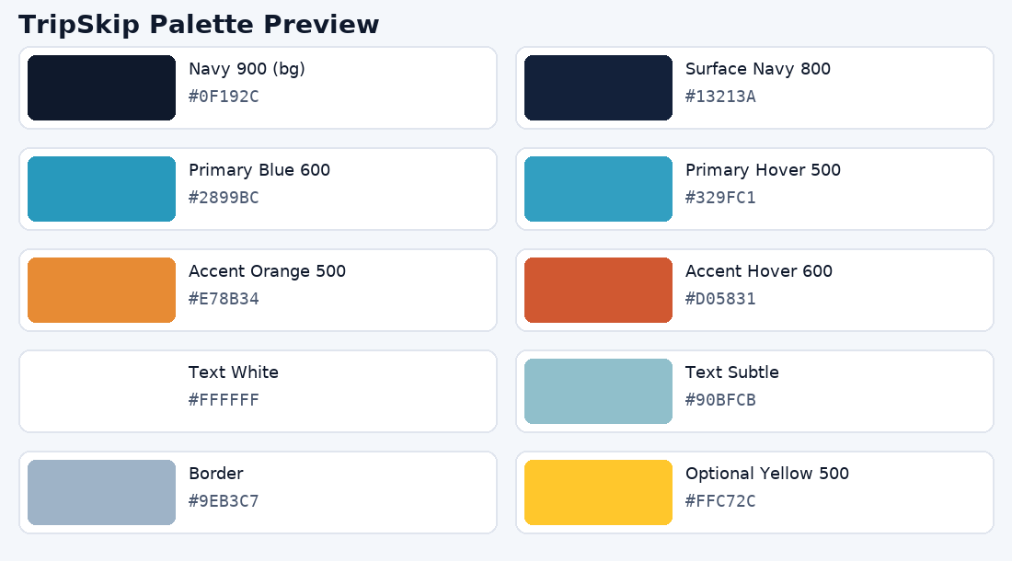
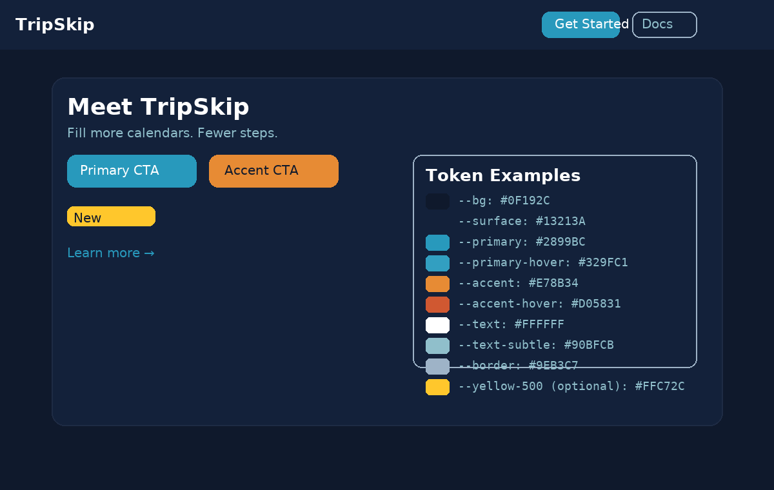
Note: Maintain AA contrast on dark backgrounds. Prefer underline for links; avoid using yellow for body text.

