Defect Title:-

After the money transfer from your Yes bank, the available balance is wrongly shown in the given message from Yes bank in your message box.

Description:

(A)Expected Result:-

Suppose you have initial balance of Rs 10000 in your Yes bank account and you want to send Rs 2000 to anyone. Then after sending money it should show that the available balance is Rs 8000 because when we transfer Rs 2000

Then Rs10000 minus Rs 2000 is Rs 8000 which is shown on Available balance in message of yes bank.

(B)Actual Result:-

You have Rs 10000 and after transfer Rs2000 from your account, it is showing that your available balance is Rs 5000 which is Rs 3000 less that the expected result.

(C)Step to replicate defect:-

(\*)Launch the Browser.

(\*)Open the Url"www.yesbank.com"

(\*)Then click on login and write your customer id, account no and password in fields of login credentials.

(\*) After login got to the My space and then click on the Fund Transfer.

(\*)After click on Fund transfer ,a pop up show which contain various fields as show in figure-1.

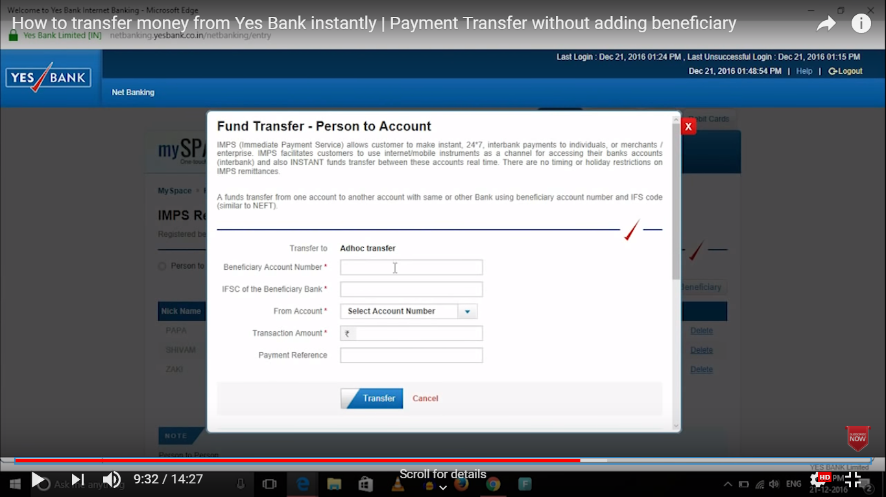

Figure 1

(\*)Then fill the above fields information which contain receiver account no,ifsc code of that branch, sender account no, transfer amount (in this case which is Rs 2000).Then click on transfer button

(\*)After click on transfer button an otp will be generated on your mobile .Then type that otp in the given field.

(\*)Then after click on submit button ,the new message will come on your mobile which tell that your available balance .Check your available balance.