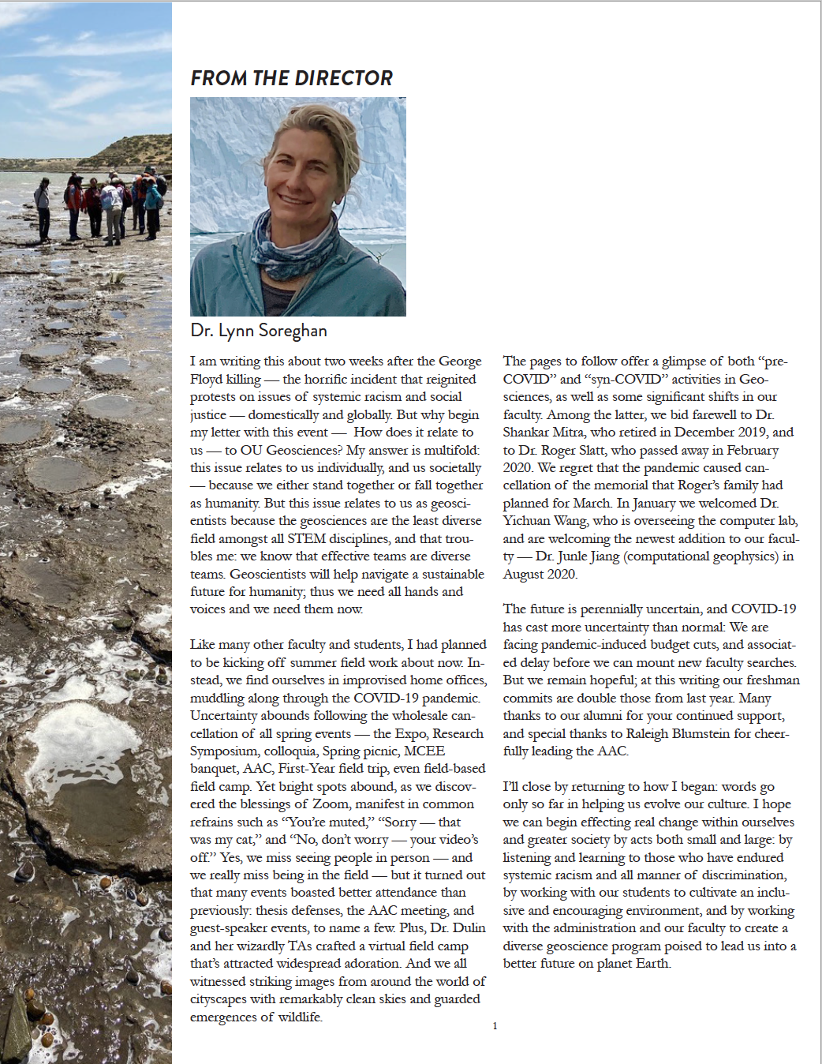

From: The Earth Scientist (OU School of Geosciences alumni magazine), v. 43, Summer 2020