Written in Python

Two files: main.py & utlis.py

Functions:

splitRGB(img)

AppliedFilter(R,G,B)

CmpDiffrence(img_orignal,img_f)

median(img1,img2)

Results:

Part1:

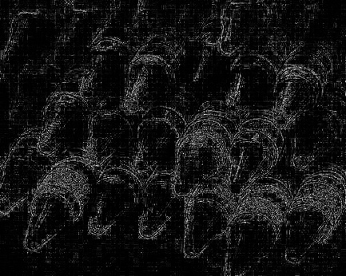

Part1_img_orignal Part1_img_filtered Part1_difference

Part2:

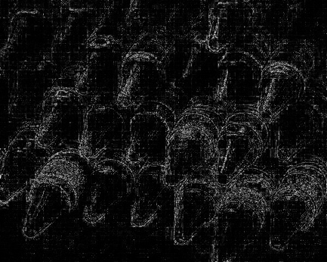

Part2_img_orignal Part2_demosaiced_img Part2_difference

Compared between the Part1_difference and Part2_difference pictures, we can see Part2_difference did improve a lot.

 

Part1_difference Part2_difference