Data_used: Single original data

Step:11400

Lr: 0.01

Loss_min:0.010669

Test_acc:0.5375

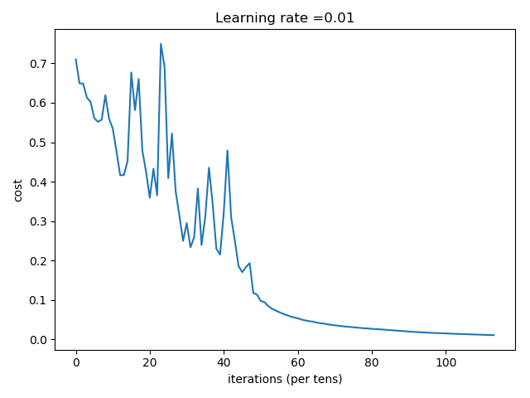

Record:

Number of training examples: 85

Number of testing examples: 80

Each image is of size: (64, 64, 3)

train_x_orig shape: (85, 64, 64, 3)

train_y shape: (85,)

test_x_orig shape: 80

test_y shape: (80,)

Cost after iteration 0: 0.710219

Cost after iteration 100: 0.649395

Cost after iteration 200: 0.648588

Cost after iteration 300: 0.613154

Cost after iteration 400: 0.602358

Cost after iteration 500: 0.560737

Cost after iteration 600: 0.551811

Cost after iteration 700: 0.557082

Cost after iteration 800: 0.618816

Cost after iteration 900: 0.559524

Cost after iteration 1000: 0.534710

Cost after iteration 1100: 0.477013

Cost after iteration 1200: 0.416159

Cost after iteration 1300: 0.416750

Cost after iteration 1400: 0.452288

Cost after iteration 1500: 0.677004

Cost after iteration 1600: 0.581352

Cost after iteration 1700: 0.660169

Cost after iteration 1800: 0.478546

Cost after iteration 1900: 0.424824

Cost after iteration 2000: 0.358931

Cost after iteration 2100: 0.432746

Cost after iteration 2200: 0.365238

Cost after iteration 2300: 0.749461

Cost after iteration 2400: 0.691064

Cost after iteration 2500: 0.408803

Cost after iteration 2600: 0.521832

Cost after iteration 2700: 0.375396

Cost after iteration 2800: 0.314528

Cost after iteration 2900: 0.249789

Cost after iteration 3000: 0.294664

Cost after iteration 3100: 0.233431

Cost after iteration 3200: 0.259143

Cost after iteration 3300: 0.382712

Cost after iteration 3400: 0.239234

Cost after iteration 3500: 0.310544

Cost after iteration 3600: 0.435324

Cost after iteration 3700: 0.344117

Cost after iteration 3800: 0.229797

Cost after iteration 3900: 0.214957

Cost after iteration 4000: 0.320676

Cost after iteration 4100: 0.478976

Cost after iteration 4200: 0.309294

Cost after iteration 4300: 0.250521

Cost after iteration 4400: 0.185805

Cost after iteration 4500: 0.170308

Cost after iteration 4600: 0.183173

Cost after iteration 4700: 0.193228

Cost after iteration 4800: 0.117308

Cost after iteration 4900: 0.113337

Cost after iteration 5000: 0.097259

Cost after iteration 5100: 0.094525

Cost after iteration 5200: 0.084413

Cost after iteration 5300: 0.077932

Cost after iteration 5400: 0.073203

Cost after iteration 5500: 0.068858

Cost after iteration 5600: 0.064904

Cost after iteration 5700: 0.061452

Cost after iteration 5800: 0.058067

Cost after iteration 5900: 0.055442

Cost after iteration 6000: 0.053440

Cost after iteration 6100: 0.050207

Cost after iteration 6200: 0.048048

Cost after iteration 6300: 0.046113

Cost after iteration 6400: 0.045086

Cost after iteration 6500: 0.042637

Cost after iteration 6600: 0.040989

Cost after iteration 6700: 0.039916

Cost after iteration 6800: 0.038079

Cost after iteration 6900: 0.036873

Cost after iteration 7000: 0.035559

Cost after iteration 7100: 0.034496

Cost after iteration 7200: 0.033327

Cost after iteration 7300: 0.032320

Cost after iteration 7400: 0.031522

Cost after iteration 7500: 0.030707

Cost after iteration 7600: 0.029668

Cost after iteration 7700: 0.028888

Cost after iteration 7800: 0.028061

Cost after iteration 7900: 0.027471

Cost after iteration 8000: 0.026603

Cost after iteration 8100: 0.025974

Cost after iteration 8200: 0.025497

Cost after iteration 8300: 0.024762

Cost after iteration 8400: 0.024108

Cost after iteration 8500: 0.023312

Cost after iteration 8600: 0.022609

Cost after iteration 8700: 0.021884

Cost after iteration 8800: 0.021212

Cost after iteration 8900: 0.020544

Cost after iteration 9000: 0.019805

Cost after iteration 9100: 0.019159

Cost after iteration 9200: 0.018634

Cost after iteration 9300: 0.018006

Cost after iteration 9400: 0.017514

Cost after iteration 9500: 0.017013

Cost after iteration 9600: 0.016576

Cost after iteration 9700: 0.016066

Cost after iteration 9800: 0.015785

Cost after iteration 9900: 0.015429

Cost after iteration 10000: 0.015029

Cost after iteration 10100: 0.014581

Cost after iteration 10200: 0.014108

Cost after iteration 10300: 0.013793

Cost after iteration 10400: 0.013421

Cost after iteration 10500: 0.013135

Cost after iteration 10600: 0.012829

Cost after iteration 10700: 0.012487

Cost after iteration 10800: 0.012163

Cost after iteration 10900: 0.011907

Cost after iteration 11000: 0.011593

Cost after iteration 11100: 0.011260

Cost after iteration 11200: 0.010967

Cost after iteration 11300: 0.010669

[[0.99559619 0.99994288 0.9842039 0.99136918 0.99907149 0.88463875

0.99140403 0.99912162 0.61189582 0.99722354 0.99920379 0.68340039

0.99951248 0.99980274 0.75589063 0.99800806 0.99950537 0.86924405

0.9854844 0.99853517 0.93685972 0.99779271 0.99971795 0.94930543

0.99801788 0.99950095 0.94831771 0.99366658 0.99963287 0.97723971

0.99831153 0.99977549 0.97087424 0.99924451 0.99981847 0.9318212

0.99934429 0.99965087 0.95813426 0.99874745 0.99990187 0.98170454

0.99848092 0.99964026 0.96542723 0.99692353 0.99918099 0.93396522

0.99381018 0.99904623 0.98015855 0.99628377 0.99920157 0.96258493

0.99659737 0.99973911 0.97106935 0.99830231 0.99992386 0.98717066

0.99816869 0.99979957 0.98834269 0.99854358 0.99978566 0.99442502

0.99902284 0.99985629 0.9934277 0.99719786 0.99981567 0.99180138

0.99522922 0.99975583 0.98970175 0.99484724 0.99972777 0.97709367

0.99761608 0.99993438]]

predictions: [[1. 1. 1. 1. 1. 1. 1. 1. 1. 1. 1. 1. 1. 1. 1. 1. 1. 1. 1. 1. 1. 1. 1. 1.

1. 1. 1. 1. 1. 1. 1. 1. 1. 1. 1. 1. 1. 1. 1. 1. 1. 1. 1. 1. 1. 1. 1. 1.

1. 1. 1. 1. 1. 1. 1. 1. 1. 1. 1. 1. 1. 1. 1. 1. 1. 1. 1. 1. 1. 1. 1. 1.

1. 1. 1. 1. 1. 1. 1. 1.]]

true labels: [0 0 0 1 1 1 1 1 1 0 0 0 0 0 1 1 1 0 1 0 0 1 1 0 0 1 0 1 0 0 0 1 1 0 0 1 1

0 0 1 0 1 1 0 0 0 1 0 1 0 0 1 1 0 1 0 0 0 1 0 1 1 1 1 1 1 1 1 0 1 1 1 1 1

0 0 1 0 1 1]

Accuracy: 0.5375