Use only Gaussian data

Data_used: Gaussianl data

Lr:0.01

Step : 600

Loss_min: 0.68

Acc: 0.62

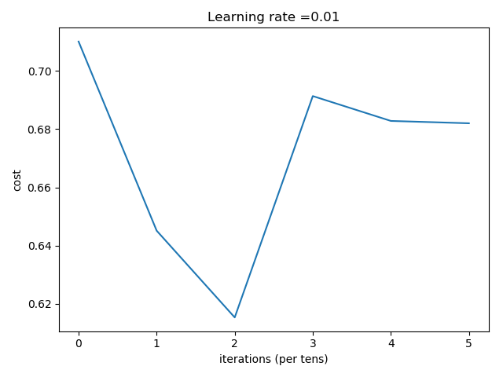

Step=700

Number of training examples: 85

Number of testing examples: 80

Each image is of size: (64, 64, 3)

train_x_orig shape: (85, 64, 64, 3)

train_y shape: (85,)

test_x_orig shape: 80

test_y shape: (80,)

Cost after iteration 0: 0.710118

Cost after iteration 100: 0.645130

Cost after iteration 200: 0.615315

Cost after iteration 300: 0.691380

Cost after iteration 400: 0.682839

Cost after iteration 500: 0.682031

Cost after iteration 600: 0.617708

[[0.50033471 0.50033471 0.49437169 0.50033471 0.50033471 0.49437169

0.50033471 0.50033471 0.49437169 0.50033471 0.50033471 0.49437169

0.50033471 0.50033471 0.49437169 0.50033471 0.50033471 0.49437169

0.50033471 0.50033471 0.49437169 0.50033471 0.50033471 0.49437169

0.50033471 0.50033471 0.49437169 0.50033471 0.50033471 0.49437169

0.50033471 0.50033471 0.49437169 0.50033471 0.50033471 0.49437169

0.50033471 0.50033471 0.49437169 0.50033471 0.50033471 0.49437169

0.50033471 0.50033471 0.49437169 0.50033471 0.50033471 0.49535262

0.50033471 0.50033471 0.49437169 0.50033471 0.50033471 0.49437169

0.50033471 0.50033471 0.49437169 0.50033471 0.50009646 0.49437169

0.50033471 0.50033471 0.49437169 0.50033471 0.50033471 0.49519439

0.50033471 0.50033471 0.49643477 0.50033471 0.50033471 0.49557379

0.50033471 0.50033471 0.49468252 0.50033471 0.50033471 0.49559814

0.50033471 0.50033471]]

predictions: [[1. 1. 0. 1. 1. 0. 1. 1. 0. 1. 1. 0. 1. 1. 0. 1. 1. 0. 1. 1. 0. 1. 1. 0.

1. 1. 0. 1. 1. 0. 1. 1. 0. 1. 1. 0. 1. 1. 0. 1. 1. 0. 1. 1. 0. 1. 1. 0.

1. 1. 0. 1. 1. 0. 1. 1. 0. 1. 1. 0. 1. 1. 0. 1. 1. 0. 1. 1. 0. 1. 1. 0.

1. 1. 0. 1. 1. 0. 1. 1.]]

true labels: [0 0 0 1 1 1 1 1 1 0 0 0 0 0 1 1 1 0 1 0 0 1 1 0 0 1 0 1 0 0 0 1 1 0 0 1 1

0 0 1 0 1 1 0 0 0 1 0 1 0 0 1 1 0 1 0 0 0 1 0 1 1 1 1 1 1 1 1 0 1 1 1 1 1

0 0 1 0 1 1]

Accuracy: 0.6375

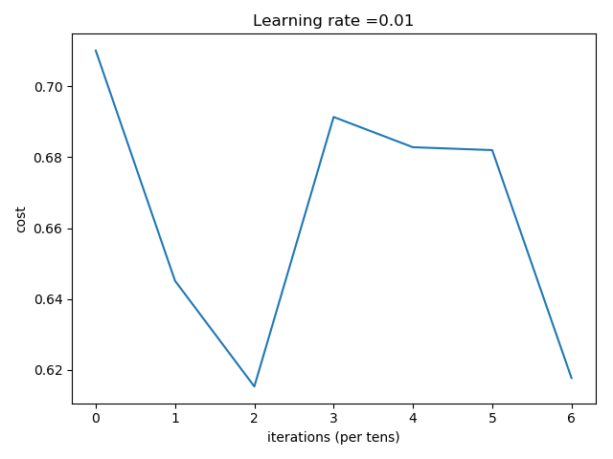

Data_used: Gaussianl data

Lr:0.01

Step : 2000

Loss_min: 0.68

Acc: 0.5375

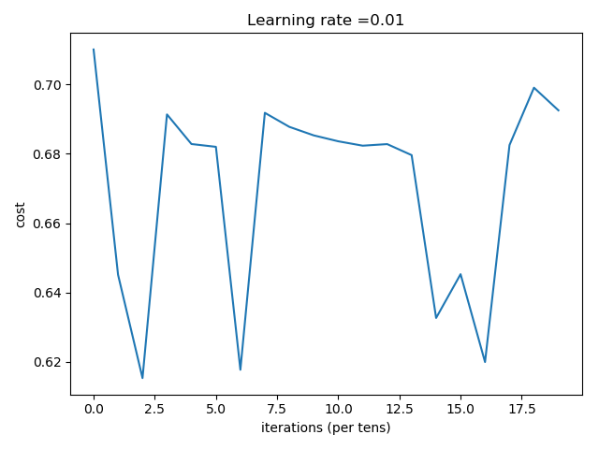

1. 1. 0. 1. 1. 0. 1. 1. 0. 1. 1. 0. 1. 1. 0. 1. 1. 0. 1. 1. 0. 1. 1. 0.

0 0 0 1 1 1 1 1 1 0 0 0 0 0 1 1 1 0 1 0 0 1 1 0

1. 1. 0. 1. 1. 0. 1. 1. 0. 1. 1. 0. 1. 1. 0. 1. 1. 0. 1. 1. 0. 1. 1. 0.

0 1 0 1 0 0 0 1 1 0 0 1 1 0 0 1 0 1 1 0 0 0 1 0

1. 1. 0. 1. 1. 0. 1. 1. 0. 1. 1. 0. 1. 1. 0. 1. 1. 0. 1. 1. 0. 1. 1. 0.

1 0 0 1 1 0 1 0 0 0 1 0 1 1 1 1 1 1 1 1 0 1 1 1

1. 1. 0. 1. 1. 0. 1. 1.

1 1 0 0 1 0 1 1