Data_used: Original data

Lr:0.01

Step : 1900

Loss_min: 0.478546

Acc: 0.6735

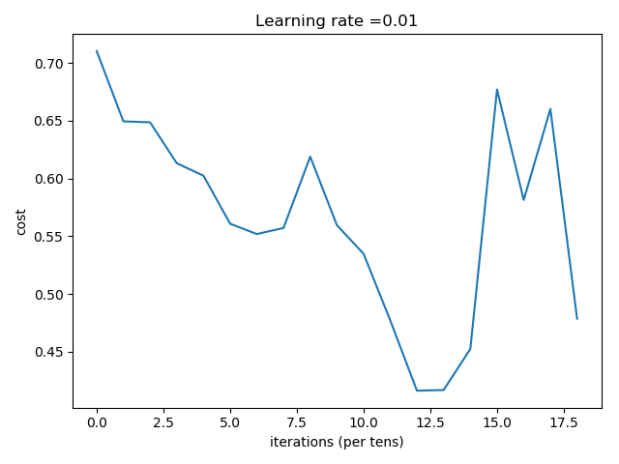

Number of training examples: 85

Number of testing examples: 80

Each image is of size: (64, 64, 3)

train_x_orig shape: (85, 64, 64, 3)

train_y shape: (85,)

test_x_orig shape: 80

test_y shape: (80,)

Cost after iteration 0: 0.710219

Cost after iteration 100: 0.649395

Cost after iteration 200: 0.648588

Cost after iteration 300: 0.613154

Cost after iteration 400: 0.602358

Cost after iteration 500: 0.560737

Cost after iteration 600: 0.551811

Cost after iteration 700: 0.557082

Cost after iteration 800: 0.618816

Cost after iteration 900: 0.559524

Cost after iteration 1000: 0.534710

Cost after iteration 1100: 0.477013

Cost after iteration 1200: 0.416159

Cost after iteration 1300: 0.416750

Cost after iteration 1400: 0.452288

Cost after iteration 1500: 0.677004

Cost after iteration 1600: 0.581352

Cost after iteration 1700: 0.660169

Cost after iteration 1800: 0.478546

[[0.89272 0.88591292 0.34821428 0.86720725 0.8525393 0.34821428

0.86490373 0.86025498 0.34821428 0.89740968 0.87192348 0.34821428

0.92483278 0.88819386 0.34821428 0.91006388 0.87538565 0.34821428

0.87908252 0.85094809 0.34821428 0.90357405 0.88932232 0.34821428

0.90622827 0.86961634 0.34821428 0.88618493 0.85325251 0.34821428

0.89989433 0.87503455 0.34821428 0.91743177 0.88521121 0.34821428

0.92240374 0.87532976 0.34821428 0.912942 0.8848936 0.34821428

0.9085385 0.87827154 0.34821428 0.90568318 0.87933037 0.34821428

0.89587525 0.85569738 0.34821428 0.90458248 0.84731177 0.34821428

0.90595134 0.87036874 0.34821428 0.91731819 0.89027665 0.34821428

0.9093318 0.87196283 0.34821428 0.90222788 0.86675925 0.34821428

0.91187721 0.87921455 0.34821428 0.90460052 0.87951235 0.34821428

0.8988937 0.86696483 0.34821428 0.89750755 0.86934651 0.34821428

0.90567277 0.88637878]]

predictions: [[1. 1. 0. 1. 1. 0. 1. 1. 0. 1. 1. 0. 1. 1. 0. 1. 1. 0. 1. 1. 0. 1. 1. 0.

1. 1. 0. 1. 1. 0. 1. 1. 0. 1. 1. 0. 1. 1. 0. 1. 1. 0. 1. 1. 0. 1. 1. 0.

1. 1. 0. 1. 1. 0. 1. 1. 0. 1. 1. 0. 1. 1. 0. 1. 1. 0. 1. 1. 0. 1. 1. 0.

1. 1. 0. 1. 1. 0. 1. 1.]]

true labels: [0 0 0 1 1 1 1 1 1 0 0 0 0 0 1 1 1 0 1 0 0 1 1 0 0 1 0 1 0 0 0 1 1 0 0 1 1

0 0 1 0 1 1 0 0 0 1 0 1 0 0 1 1 0 1 0 0 0 1 0 1 1 1 1 1 1 1 1 0 1 1 1 1 1

0 0 1 0 1 1]

Accuracy: 0.6375

(2)

Step : 600

Acc:0.6735

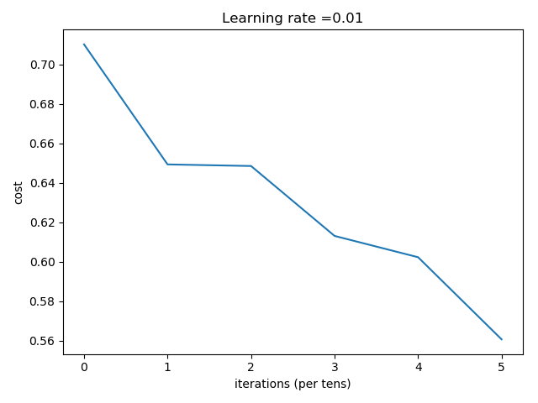

Number of training examples: 85

Number of testing examples: 80

Each image is of size: (64, 64, 3)

train_x_orig shape: (85, 64, 64, 3)

train_y shape: (85,)

test_x_orig shape: 80

test_y shape: (80,)

Cost after iteration 0: 0.710219

Cost after iteration 100: 0.649395

Cost after iteration 200: 0.648588

Cost after iteration 300: 0.613154

Cost after iteration 400: 0.602358

Cost after iteration 500: 0.560737

[[0.62831696 0.67249211 0.4493985 0.59856403 0.6504425 0.4493985

0.59870271 0.64724837 0.4493985 0.62428338 0.6489328 0.4493985

0.64608368 0.67087567 0.4493985 0.63524734 0.67601347 0.4493985

0.62481211 0.66997538 0.4493985 0.63685697 0.69172963 0.4493985

0.63955022 0.67670395 0.4493985 0.63142631 0.66615229 0.4493985

0.63445102 0.67008782 0.4493985 0.65063276 0.68144545 0.4499235

0.65488652 0.66900127 0.4493985 0.64301733 0.68106433 0.4493985

0.637622 0.6763323 0.4493985 0.64094489 0.66454041 0.4493985

0.63753173 0.66460966 0.4493985 0.63520456 0.65923681 0.4493985

0.62881192 0.67244218 0.4493985 0.64300034 0.6846354 0.4493985

0.6313407 0.67062753 0.4493985 0.61589712 0.6640662 0.4493985

0.64053217 0.67456702 0.4493985 0.64657222 0.67991736 0.4493985

0.64252827 0.69021332 0.45337025 0.63405317 0.67309032 0.4493985

0.63579705 0.68104886]]

predictions: [[1. 1. 0. 1. 1. 0. 1. 1. 0. 1. 1. 0. 1. 1. 0. 1. 1. 0. 1. 1. 0. 1. 1. 0.

1. 1. 0. 1. 1. 0. 1. 1. 0. 1. 1. 0. 1. 1. 0. 1. 1. 0. 1. 1. 0. 1. 1. 0.

1. 1. 0. 1. 1. 0. 1. 1. 0. 1. 1. 0. 1. 1. 0. 1. 1. 0. 1. 1. 0. 1. 1. 0.

1. 1. 0. 1. 1. 0. 1. 1.]]

true labels: [0 0 0 1 1 1 1 1 1 0 0 0 0 0 1 1 1 0 1 0 0 1 1 0 0 1 0 1 0 0 0 1 1 0 0 1 1

0 0 1 0 1 1 0 0 0 1 0 1 0 0 1 1 0 1 0 0 0 1 0 1 1 1 1 1 1 1 1 0 1 1 1 1 1

0 0 1 0 1 1]

Accuracy: 0.6375