**LAB 1.1 : Platform Setup & Development Enviroment**

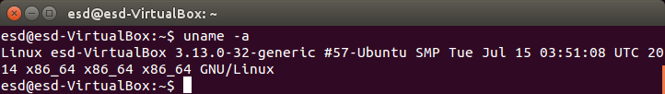

⦁ Vivado Design Suit 2013.4

- install

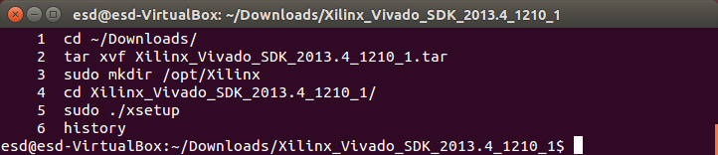

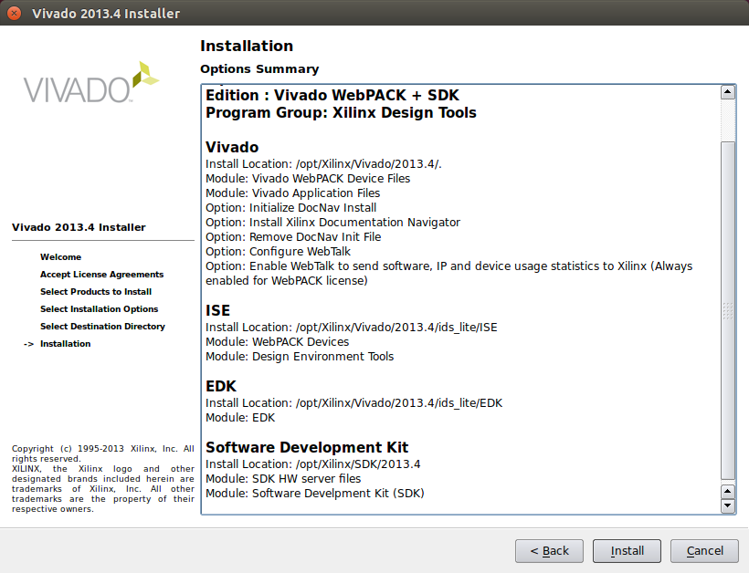

- source

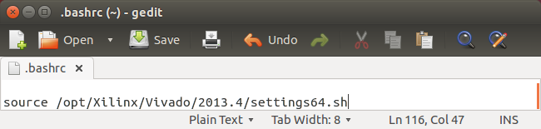

- license

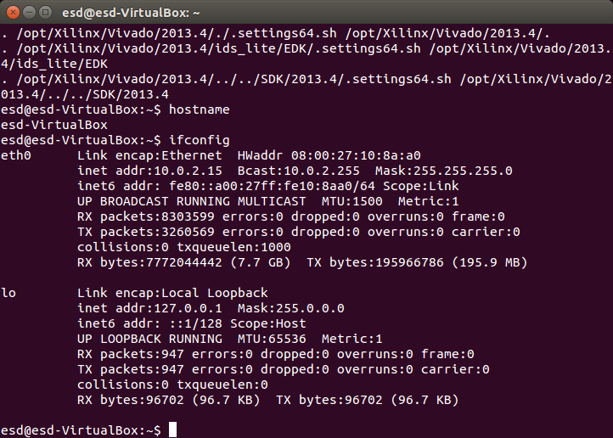

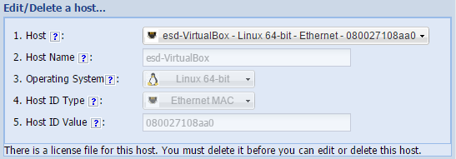

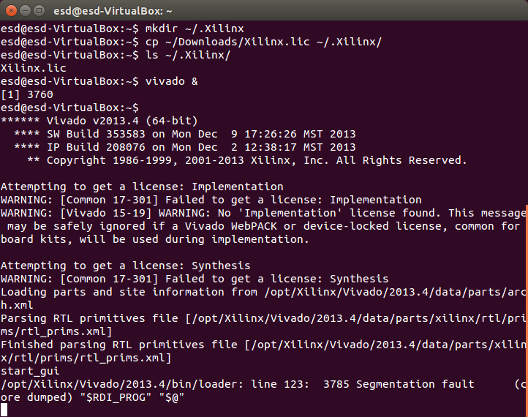

- vivado segmentation fault



- - openjdk setup

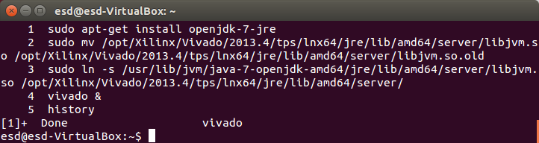

- finish

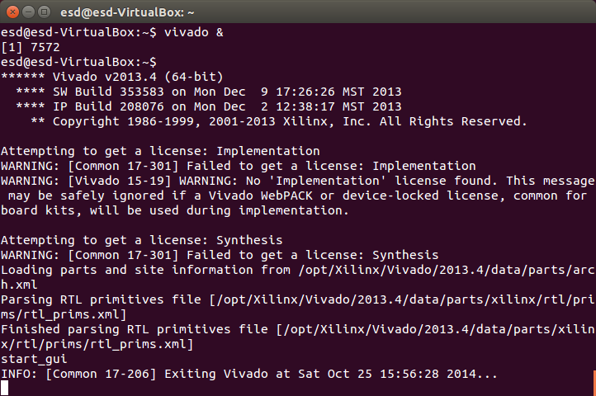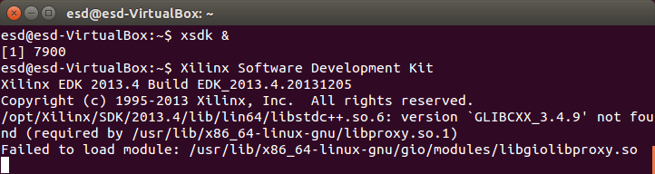

⦁ PetaLinux 2013.10

- requirment

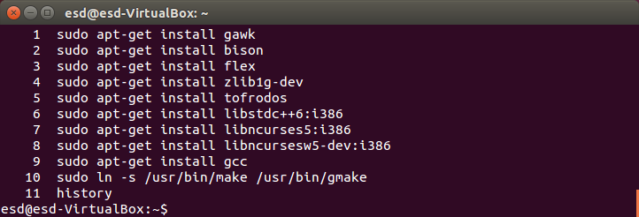

- sudo .run file failed

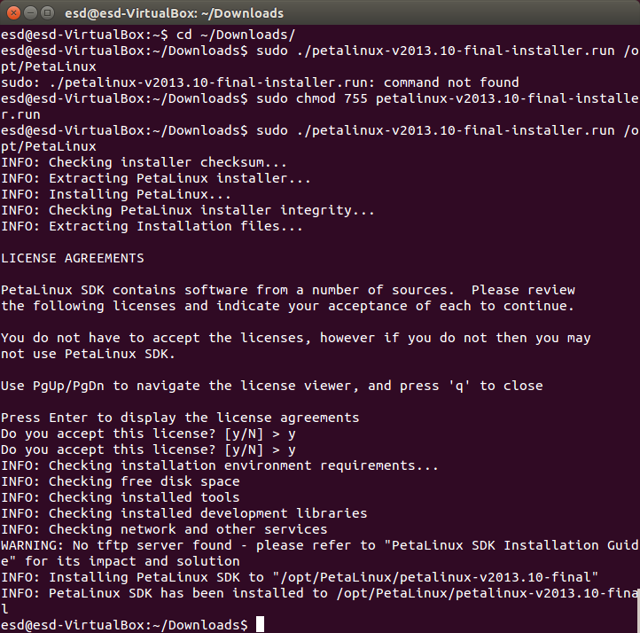

- - chmod .run file



- source

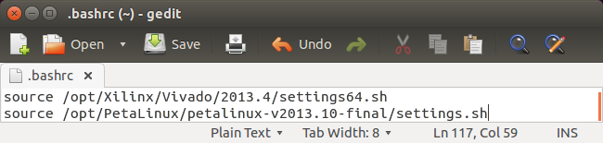

- petalinux warning : bash is petalinux recommanded shell

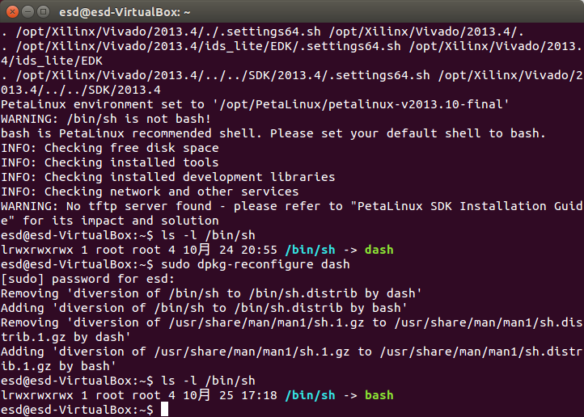

- - reconfigure shell from dash to bash



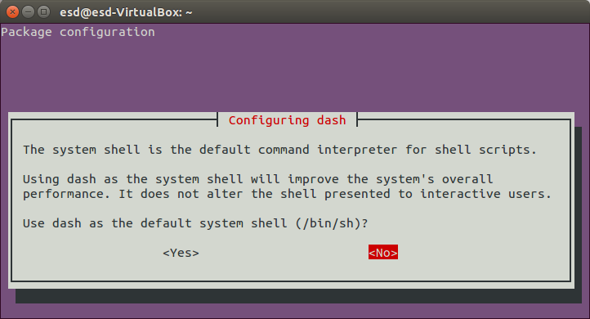

- petalinux warning : no tftp server found



- - tftp server setup

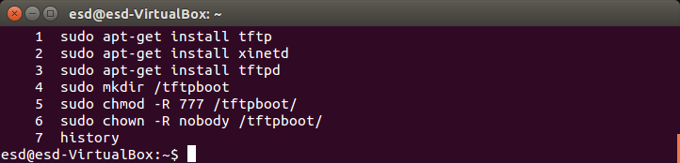

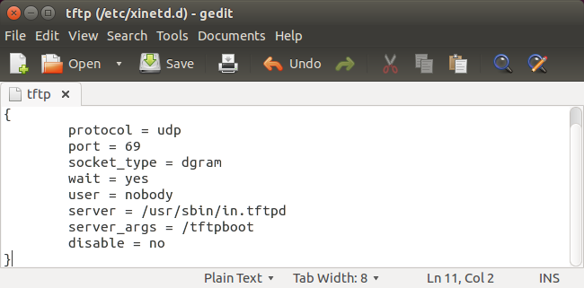

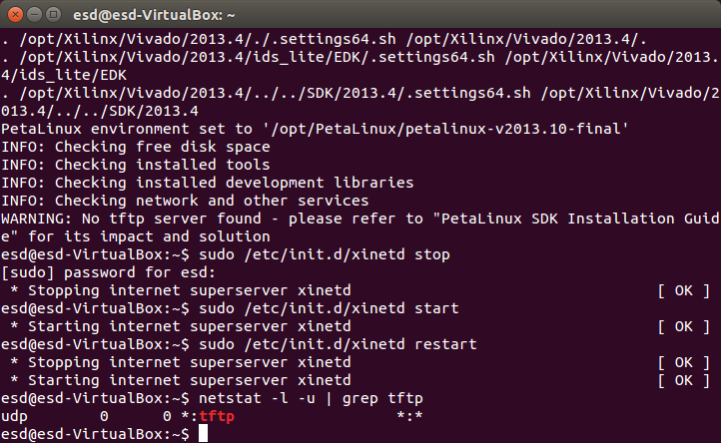

- finish

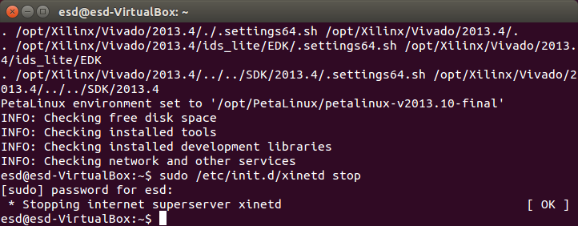

**LAB 1.2.1 : Bare-metal Design**

⦁ Vivado Project

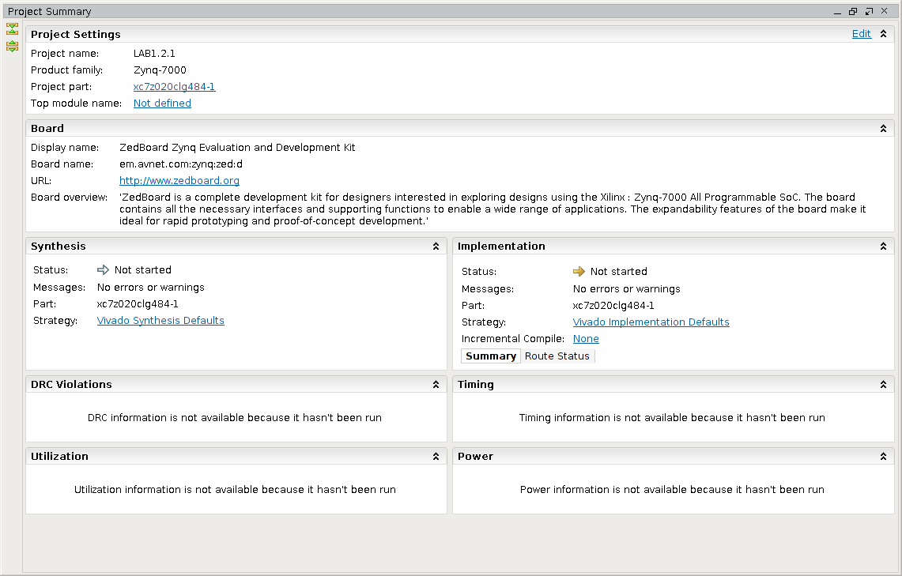

- address editor

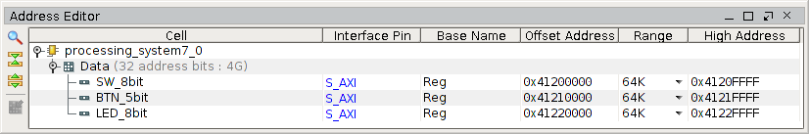

- block design

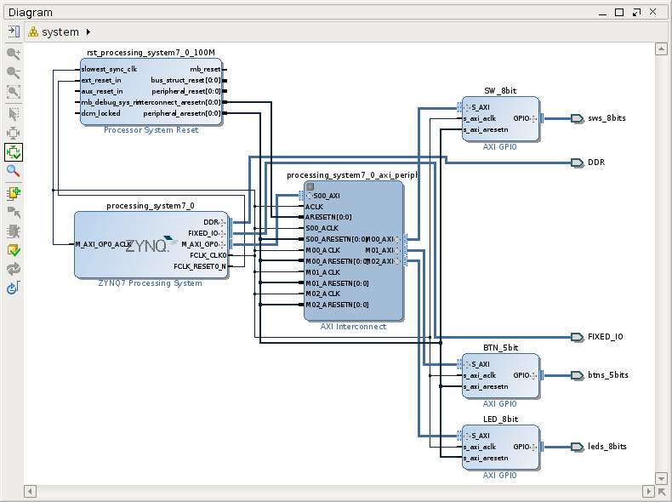

- synthesized design

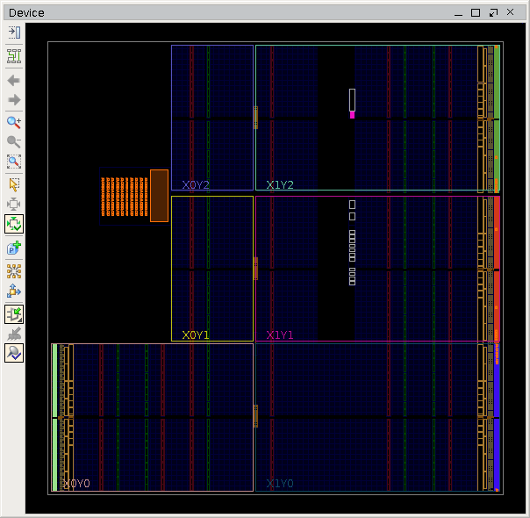

- implemeted design

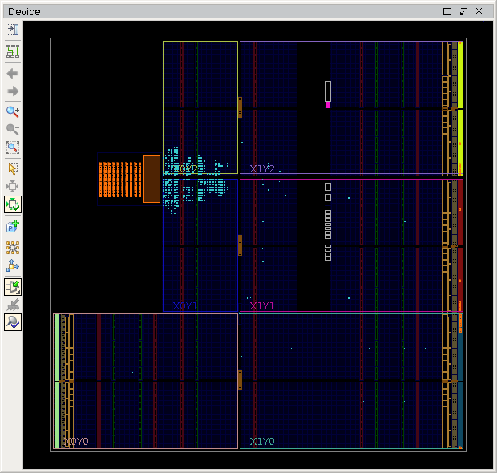

- export hardware for SDK error

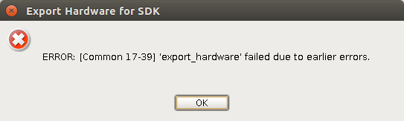

- - generate bitstream and open block design

⦁ XSDK Project

- application project

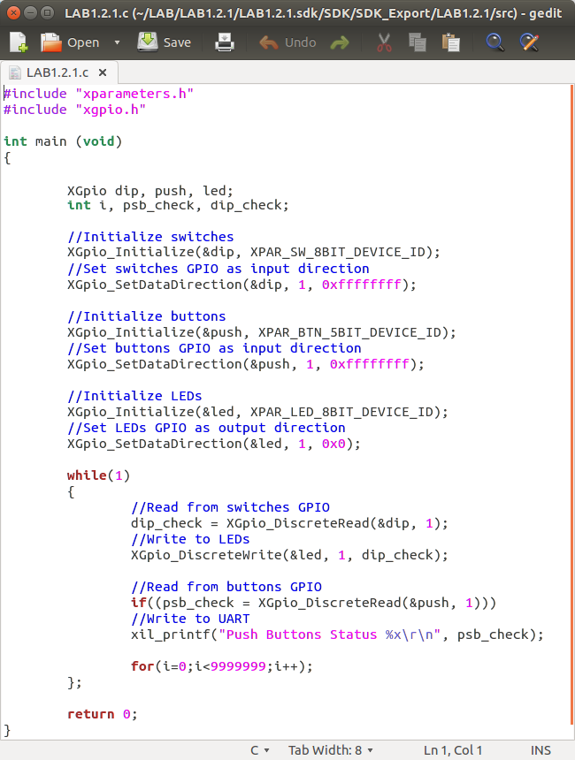

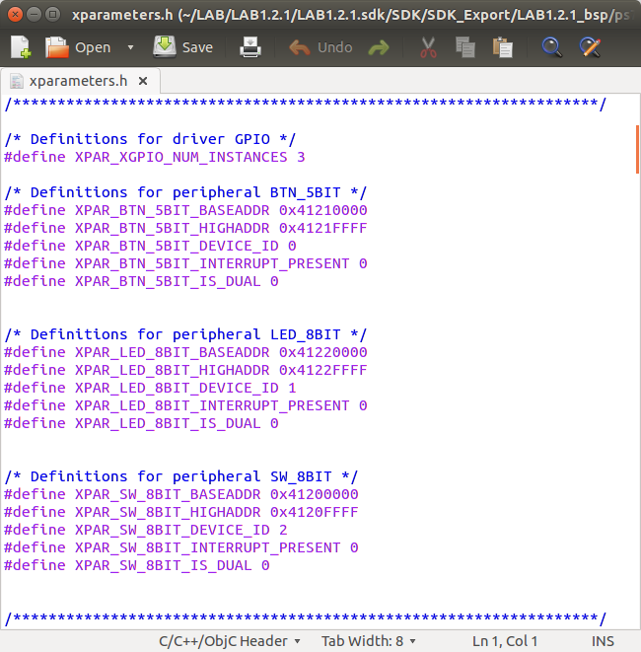

- UART driver setup

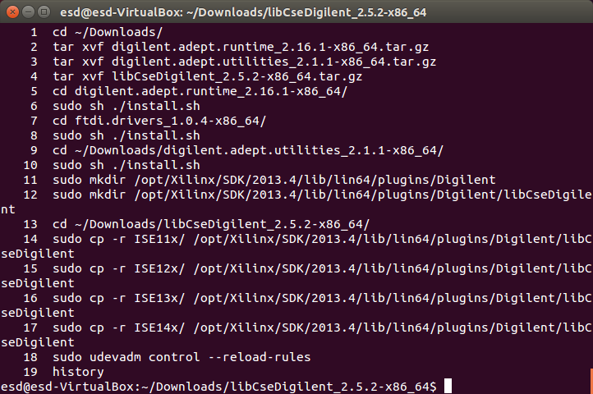

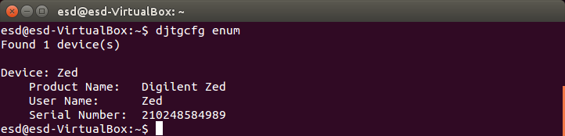

⦁ switch-led test

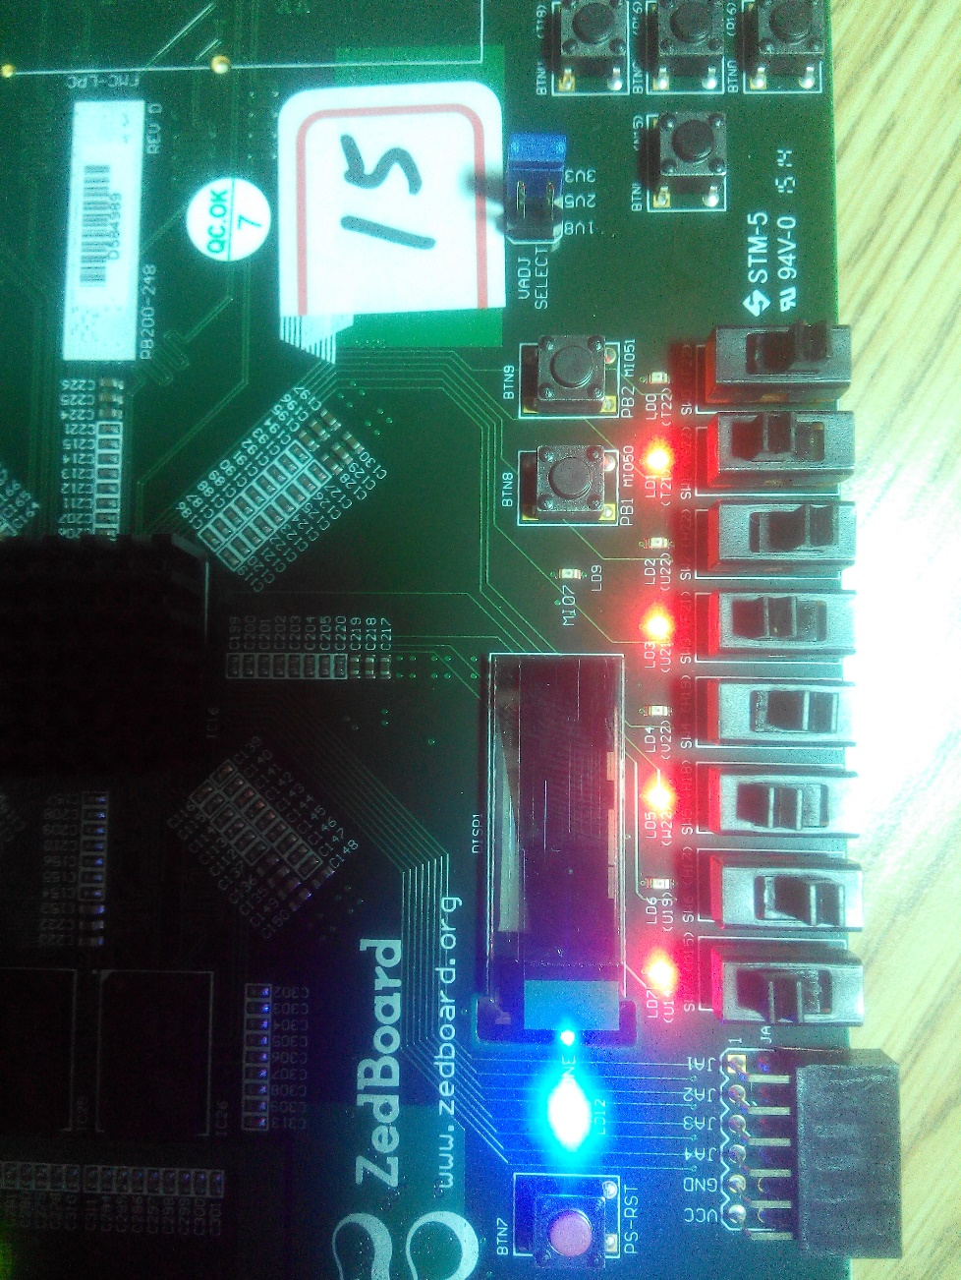

⦁ botton-uart test



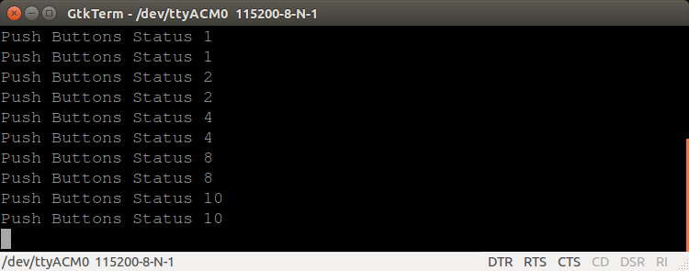

**LAB 1.2.2 : Hello World Program on Basic PetaLinux**

⦁ Vivado Project

- ZYNQ7 processing system IP

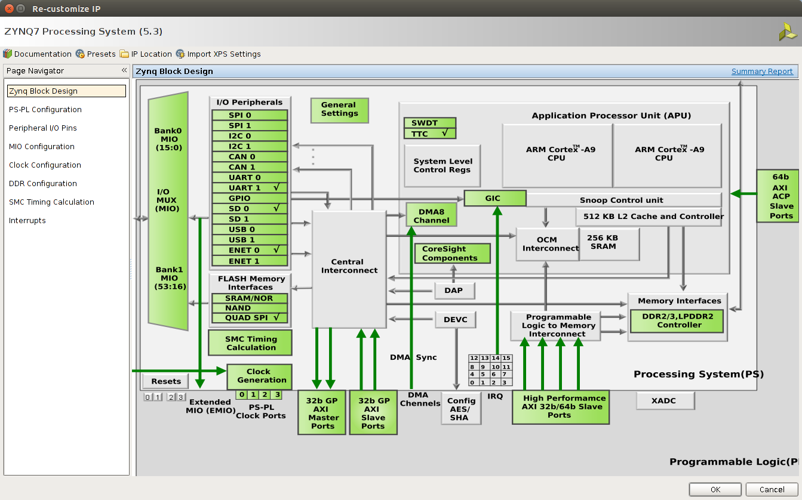

- block design

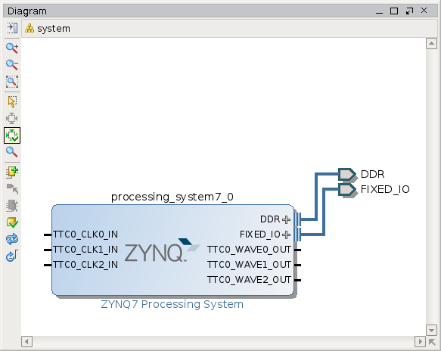

⦁ XSDK Project

- board support package

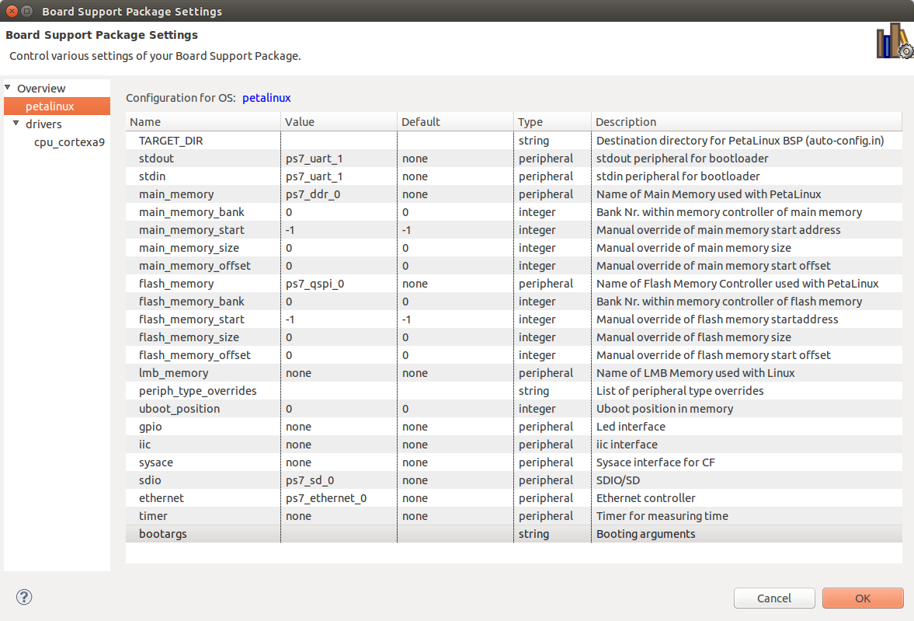

- boot image (after petalinux-build u-boot.elf)

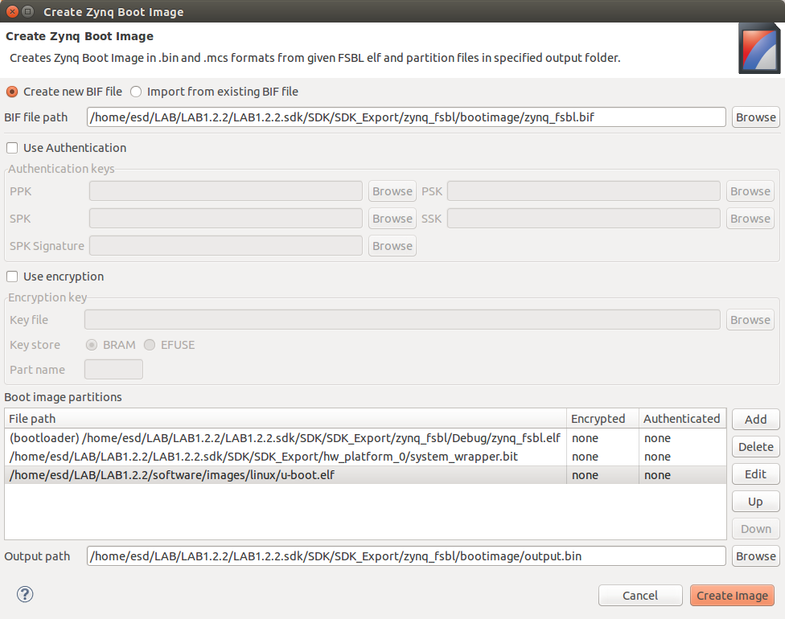

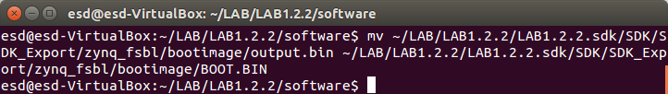

⦁ PetaLinux Project

- create project

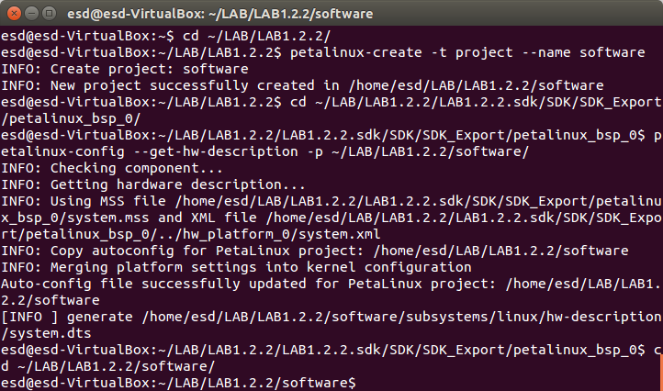

- hardware description



- configuration

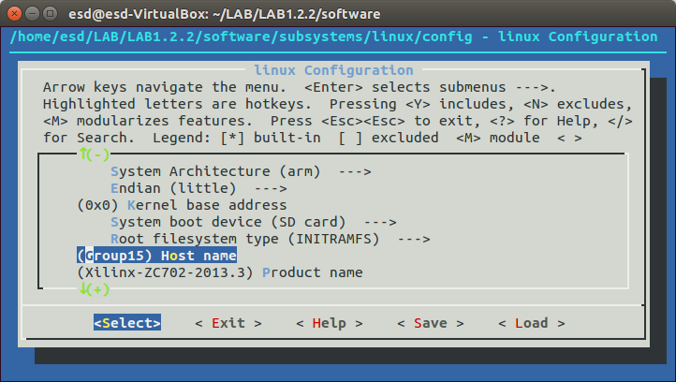

- petalinux-build error

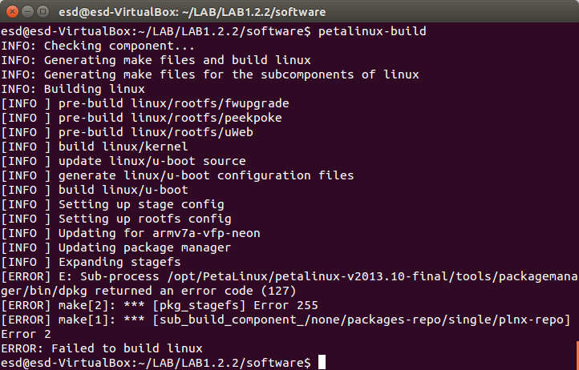

- - restore shared library libselinux.so

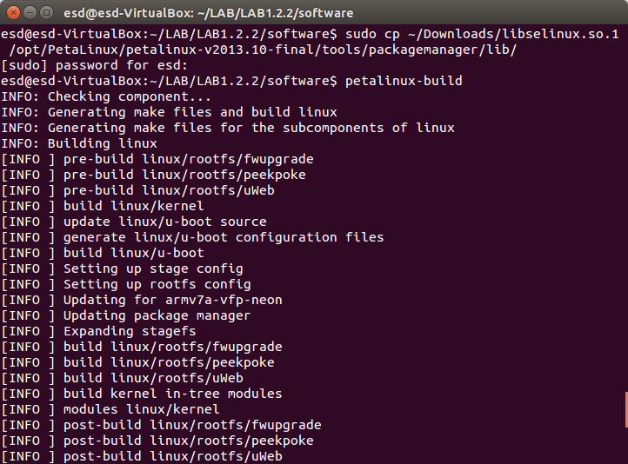

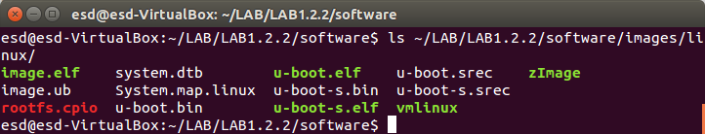

⦁ boot

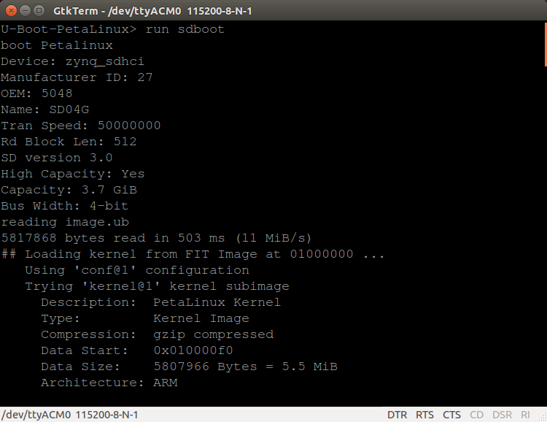

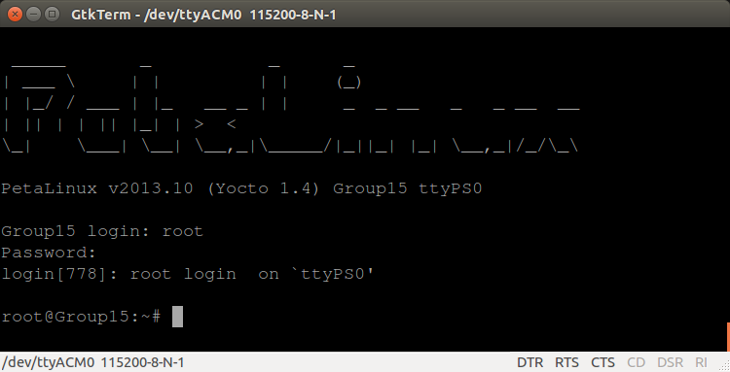

⦁ hello world program

- vm network setting

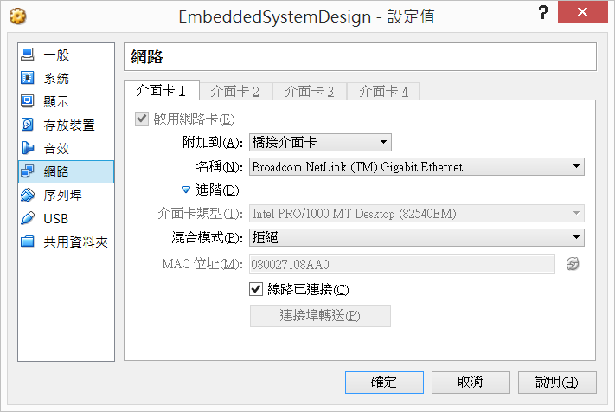

- cross compile

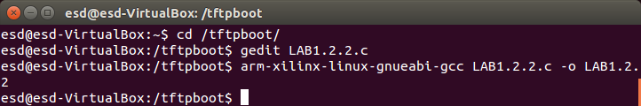

- host

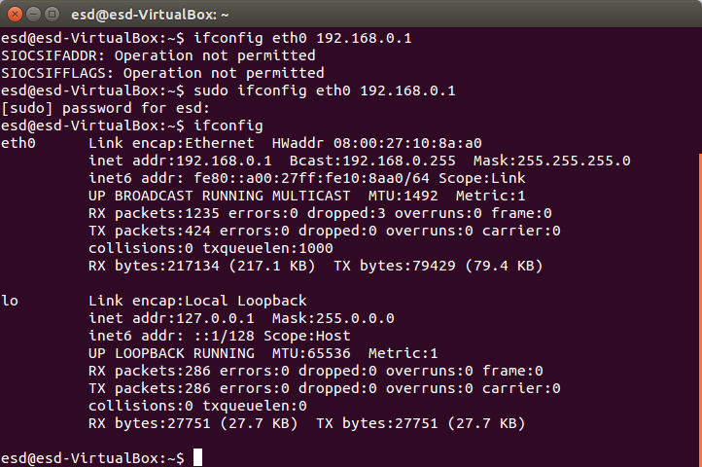

- target

