**Name:Komal Mukesh More**

**Roll No.:78**

**Assignment No.: 14**

**Assignment Title: Develop programs to learn GUI programming using Tkinter.**

**__________________________________________________________________________**

Code:

**14.1. Create simple Application Window**

from tkinter import *  
GUI = Tk()  
GUI.mainloop()

**Output:**

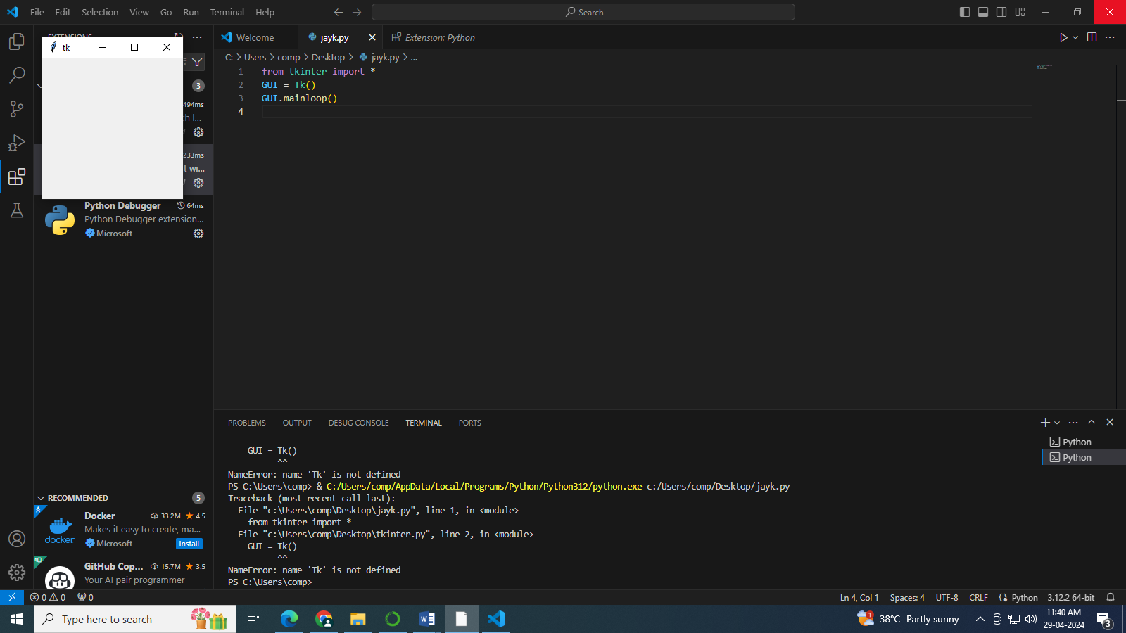

**14.2. Application Window with size**

from tkinter import *  
GUI = Tk()  
  
# If you want to provide size of the window  
GUI.geometry("500x500")  
  
GUI.mainloop()

**Output:**

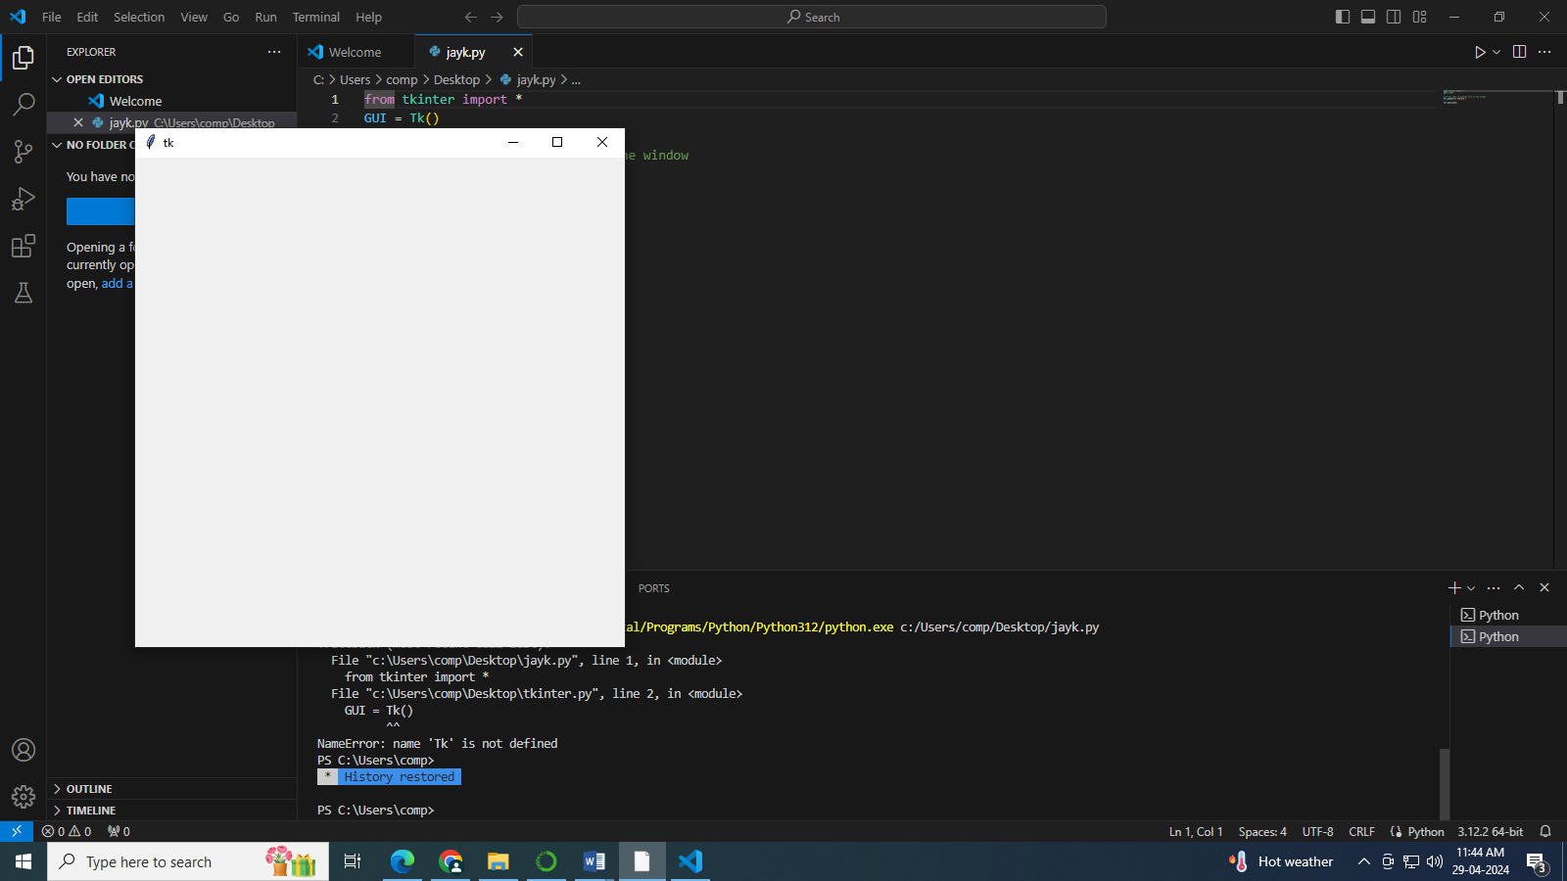

**14.3. Application Window to get information from user**

from tkinter import *  
GUI = Tk()  
  
# If you want to provide size of the window   
GUI.geometry("500x500")  
  
# If you want to add labels  
uname = Label(GUI, text = "Username").place(x = 30, y = 50)  
password = Label(GUI, text = "Password").place(x = 30, y = 80)  
  
  
# Add Textbox  
txtbx1 = Entry(GUI, width = 20).place(x = 100, y = 50)  
txtbx2 = Entry(GUI, width = 20).place(x = 100, y = 80)  
  
# Add Button on window  
sbmitbtn = Button(GUI, text = "Submit").place(x = 220, y = 300)  
  
  
GUI.mainloop()

**Output:**

