Software Requirements Specification
for

Trivia Maze Game

Version 1.0 unpproved

Prepared by Richard S., Andrew M., Ana K., Kevin R.

CSCD350
May 15, 2014

Table of Contents
Table of Contents ii
Revision History ii
1. Introduction 1
1.1 Purpose 1
1.2 Project Scope and Product Features 1
1.3 References 1
2. Overall Description 1
2.1 Product Perspective 1
2.2 User Classes and Characteristics 1
2.3 Operating Environment 2
2.4 Design and Implementation Constraints 2
2.5 User Documentation 2
2.6 Assumptions and Dependencies 2
3. System Features 2
3.1 Order Meals 2
3.2 Create, View, Modify, and Delete Meal Subscriptions 6
3.3 Register for Meal Payment Options 6
3.4 Request Meal Delivery 6
3.5 Create, View, Modify, and Delete Cafeteria Menus 6
4. External Interface Requirements 6
4.1 User Interfaces 6
4.2 Hardware Interfaces 7
4.3 Software Interfaces 7
4.4 Communications Interfaces 7
5. Other Nonfunctional Requirements 7
5.1 Performance Requirements 7
5.2 Safety Requirements 8
5.3 Security Requirements 8
5.4 Software Quality Attributes 8
Appendix A: Data Dictionary and Data Model 8
Appendix B: Analysis Models 12

Revision History
Name | Date | Reason For Changes | Version
Group | 5/15/14 | initial draft | 1.0 draft 1

Introduction

Purpose
This SRS describes the software functional and nonfunctional requirements for release 1.0 of the Trivia Maze Game (TMG). This document is intended to be used by the members of the project team that will implement and verify the correct functioning of the game. Unless otherwise noted, all requirements specified here are high priority and committed for release 1.0.

Project Scope and Product Features
TMG randomly generates a maze. The player must correctly answer trivia questions in order to progress to the exit. The player has a health status and key inventory. The player loses the game if they run out of health, deducted after each wrong answer. The player wins the game if they reach the exit point. Each maze room prompts the player with a question. TMG uses simple windows to display the maze, trivia questions, and answers.

References
????

Overall Description

Product Perspective
MTG is designed for single player use. It is expected to eventually save player progress and track past performance through a simple leader board. It uses a connection to a small database to retrieve questions and answers.

User Classes and Characteristics
Insert context diagram?

Operating Environment
OE-1: TMG shall operate on Windows OS.
OE-1: Code shall be written in Java, including the database setup via a JDBC:SQLite driver.

Design and Implementation Constraints
DC-1: TMG is designed for single player use.
DC-2: The maze is square with odd numbered dimensions, and shall be no larger than 13X13.
DC-3: The trivia database shall contain no fewer than 50 questions and no more than 100 questions.

Assumptions and Dependencies
AS-1: The player knows how to read English and is able to answer trivia questions.
AS-2: The user can run Java programs.
AS-3: The user has SQLite DB and appropriate drivers installed.

Playing the Game

2.5.1 Description and Priority

The maze is randomly generated on each attempt. Priority = 1.

The player navigates through the maze using keyboard arrow directions. Priority = 1.

The player can see their progress through the maze.

The player can see their health and key inventory.

The player reads and answers trivia questions in a simple window.

2.5.2 Stimulus/Response Sequences
Stimulus: Player requests to play the game.
Response: Maze is randomly generated and displayed.
Stimulus: Player uses keyboard arrow keys to move .
Response: Maze updates player location & prompts question.
Stimulus: Player choses wrong answer.
Reponse: Player’s health decreases.
Stimulus: Player choses correct answer.
Response: Player may gain a key & has option to move again.
2.5.3 Functional Requirements

System Features
3.1 ???

External Interface Requirements

User Interfaces
UI-1: A simple start/quit menu with active buttons is displayed to the console.
UI-2: The player’s maze and location is displayed to the console.
UI-3: The user navigates the maze using the keyboard arrow keys.
UI-4: The user sees trivia questions and selects answers in a simple window displayed to the console.

Software Interfaces
SI-1: TMG shall connect to the SQLite DB via JDBC:SQLite driver.

Other Non-functional Requirements

Performance Requirements
PE-1: TMG shall allow 1 user to play the game.
PE-2: The user may choose which direction they wish to travel within the maze confines.
PE-3: The user may use keys to open doors as a shortcut.
PE-4: TMG shall display trivia in a text box, and the user shall select answers using radio buttons.

Safety Requirements
No safety requirements have been identified.

Software Quality Attributes
Availability-1: TMG shall be available for Windows OS.

Appendix A: Key Terms
Player | Traverses the maze, answers questions
Maze | Randomly generated path surrounded by walls and blocked by doors. Begins with a start, ends with an exit.
Path | Divided into rooms, each prompting the player with a question.
Exit | The player’s destination to win the game.
Door | A path obstruction opened with a key.
Key | Opens a door. Obtained after entering a room that contains it and answering a question correctly.
Health | Player attribute that starts full, decreases with wrong answers, potentially increases with correct answers
Database | File that stores trivia questions, possible answers, and the correct answers.

Appendix B : Diagrams & Tables
Table 1: Database Table Schema
Question : String | Answer1 : String | Answer2 : String | Answer3 : String | CorrectAnswer : String
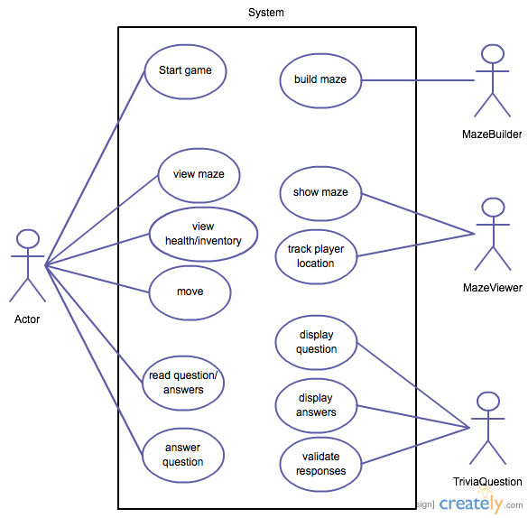
Figure 1 Use Case Diagram

