FlightBooker Web Application
ASP.NET Core MVC Flight Booking System

Project Overview
This is an educational web application developed using ASP.NET Core MVC. This mock flight booking system simulates real-world airline reservation functionality, including multi-city flight searches, layover management, and complete booking workflows.
Also look at the “code snapshots” folder to see some of the key pieces of code of this project.

Architecture & Design Patterns
Key architectural patterns and development practices:
- Model-View-Controller (MVC) Architecture: Clear separation of concerns between data models, business logic, and presentation layers
- Multi-layered Architecture: Distinct layers for frontend presentation and database interaction through Data Access Objects (DAOs)
- View Models: Careful curation and transformation of database entities to optimize data transfer between layers and ensures data security
- Dependency Injection: Efficient service registration and dependency management for loose coupling and testability

Core Features & Components

Flight Management System
The flight generation system ensures comprehensive coverage with at least one daily arrival in each of the eight supported cities. A separate DatabaseFiller project handles the task of flight schedule generation.
The code will take a random arrival time for each city and pick a random city that will be the original destination of this flight or series of flights if layovers are needed. So for example, the flight to Tokio for any given day is scheduled from a random departing city. it will then look for which flights are necessary to connect those cities in a table in the database. It will then create each flight with 3 hours in between.
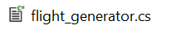

Flight Search Engine

Every combination of cities has a route ID. Flights are created with a predetermined route ID and journey ID. This tracks if a flight is part of a journey of multiple flights between 2 cities that require layovers and which flights specifically belong together for each journey. When searching a flight the system returns all flights of the desired route grouped by journeyID within the desired timeframe.

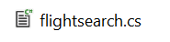

User Experience Features

Authentication & Authorization
Implements ASP.NET Core Identity for secure user authentication, enabling personalized features such as booking history and shopping cart persistence.

Shopping Cart
Authenticated users can add flights to their cart, modify selections, and initiate bookings either directly from search results or from their saved cart items.

Booking Management
The booking history feature provides comprehensive trip management:
- Status tracking (Confirmed, Cancelled, or Pending)
- Post-booking modifications including meal selection
- Cancellation functionality with time-based restrictions
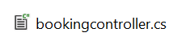

Meal Selection
Passengers can select and modify meal preferences for each flight segment within their journey.
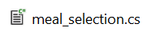

Seat Management
- Separate inventory tracking for Economy and Business class seats
- Real-time availability checking during search and booking
- Automatic seat number assignment upon booking completion
- Prevention of overbooking through database constraints

Personalized Promotions
A banner is displayed at the flight searching page that advertises a random city or when a user is logged in, the most often booked flight of that user.
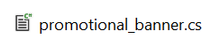

Technical Implementation Details

Database Design
The application utilizes a normalized relational database schema designed to efficiently handle complex flight routing, user management, and booking operations. The database structure supports all business requirements while maintaining data integrity through appropriate constraints and relationships.

Code Organization
Following clean code principles, the application maintains clear separation between controllers, services, and data access layers. This modular approach ensures maintainability, testability, and scalability for future enhancements.

Application Screenshots
Seaching page:
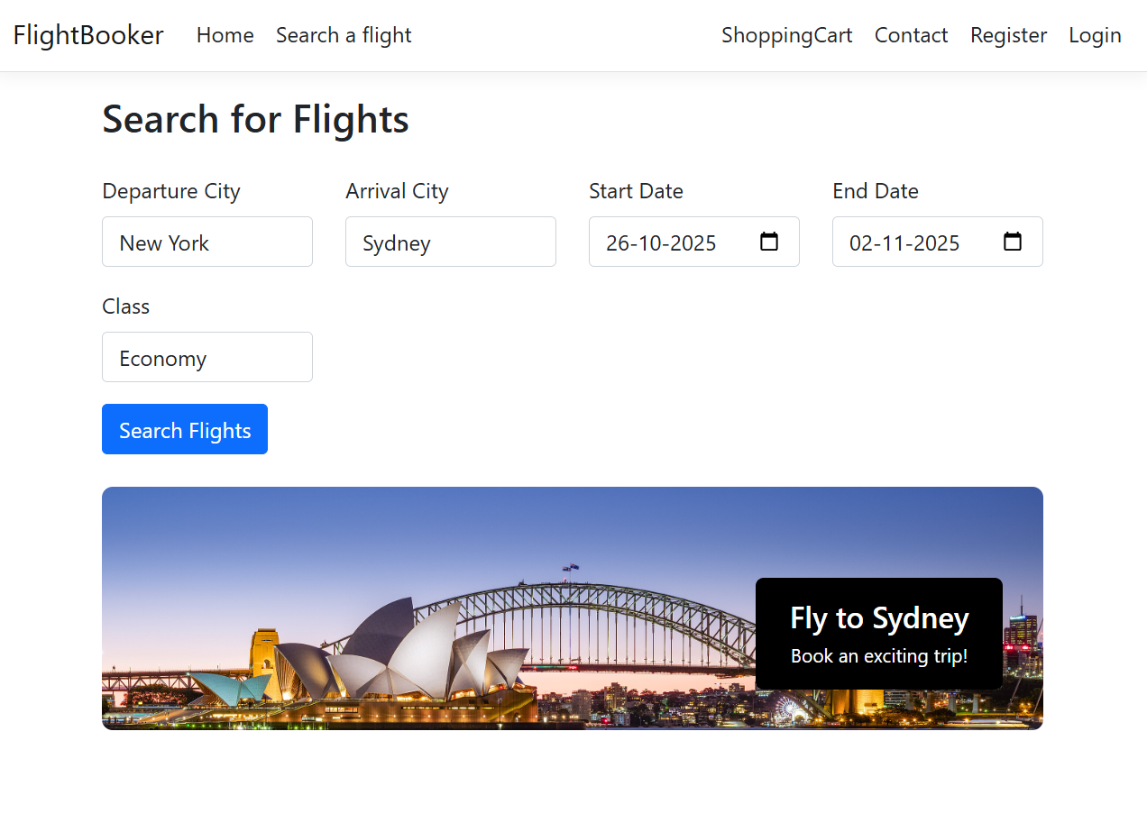

Search results page:

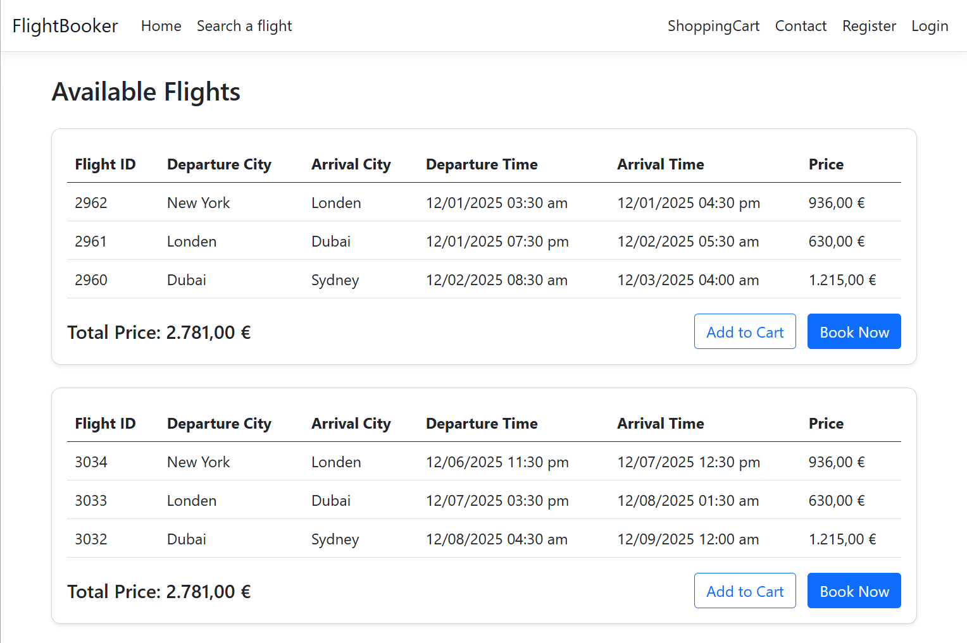

Meal selection page:
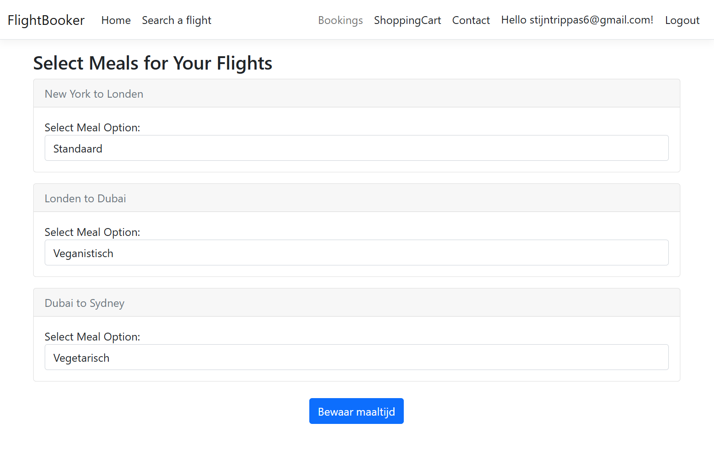
Booking history page:
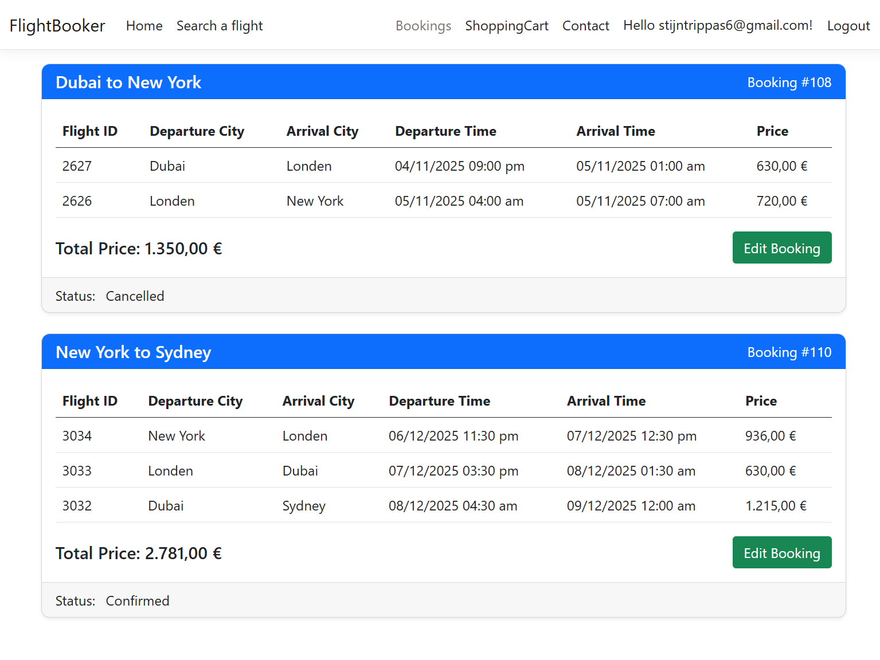
Database diagram:
