2024 SANS Holiday Hack Challenge post writeup

Author: Tripper Harrison
Challenge #1: Holiday Hack Orientation
Difficulty: 1/5 (easiest)
Description: Talk to Jingle Ringford on Christmas Island and get your bearings at Geese Islands

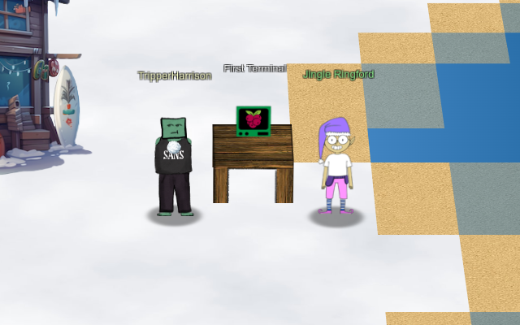

Conversations
Jingle Ringford (Frosty's Beach)
Welcome to the Geese Islands and the 2023 SANS Holiday Hack Challenge!
I'm Jingle Ringford, one of Santa's many elves.
...
Just kidding! It's actually the 2024 SANS Holiday Hack Challenge!
And although we're on Frosty's Beach on Christmas Island, we'll soon be on our way back to the North Pole.
I thought it best to wait here for people that heard we're on the Geese Islands but may not know we're leaving.
I haven't seen Santa since we started packing up, but he always asks me to give a quick orientation to newcomers, so I'm continuing the tradition.
Before you head out any further onto the island, you need to accomplish two simple tasks.
But first, here's a parting gift. I packed this snowball made of the magical, never-melting snow of Christmas Island. A little souvenir to take with you when we leave for the North Pole.
Click on the snowball on your avatar. That's where you will see your Objectives, Hints, resource links, and Conversations for the Holiday Hack Challenge.
Now, click on the Cranberry Pi Terminal and follow the on-screen instructions.

First Terminal

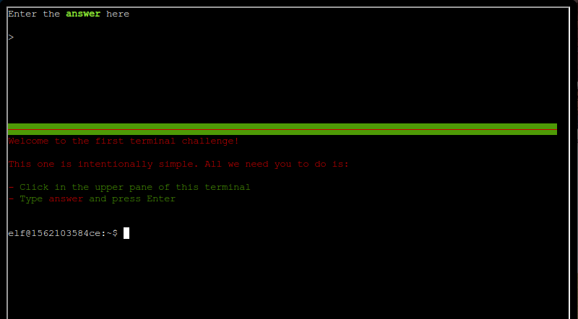

Welcome to the first terminal challenge!

This one is intentionally simple. All we need you to do is:

- Click in the upper pane of this terminal
- Type answer and press Enter

Solution
As prompted, typing the word, "answer" in the upper pane of the terminal and pressing "Enter" completes this challenge. The terminal window closes.

Continue the conversation with Jingle Ringford:
You're a natural! Something new this year you may not know is that all challenges have an easy and hard mode. There's also story mode, if you want to skip the challenges and watch how our holiday season's adventure unfolds!
Your snowball will reflect how you've solved the challenges with the bronze, silver, and gold trophies.
Well, that's it, now you're orientated! Feel free to get yourself settled in, establish a cohort with others, or just explore this lovely island. Just be careful where you walk as we are moving around some pretty heavy crates.
Oh, while we're preparing everything to set sail for the North Pole, I heard Poinsettia McMittens and Angel Candysalt could use some assistance. I'm sure they'll appreciate any help you can provide!
We'll let you know when the boat leaves, but for now relax, enjoy the sun, and most importantly, have FUN!

Conclusion
Elf Connect and Elf Minder 9000 challenges are assigned.

