# Ufarm Market

An eCommerce web app that provides functionality for customers to browse and purchase products, add items to the shopping cart and checkout using email and phone payment methods. It would also provide functionality for sellers to manage their inventory and orders, and for administrators to manage the overall operation of the eCommerce store.

**Source Code:** <https://github.com/TrippleA-Ashaba/node_ufarm_project>

Features:

* Authentication: Passport JS
* Database: Mongo DB
* Frontend: Pug, CSS, JavaScript, Bootstrap
* Form Validations
* Flash messages

## About

### Server

Node.js and Express.js is used to create the server-side code of the application. Express.js provides a framework for building web applications on top of Node.js, and allows for easy creation of routes and handling of HTTP requests.

### Database

MongoDB is used to store data related to products, customers, orders, and other eCommerce-related information. MongoDB being a NoSQL database meant it stored data in JSON-like documents instead of tables, making it flexible and easy to work with.

### Authentication

Passport.js is used for user authentication and authorization. Passport.js is a middleware that can be easily integrated into Express.js applications, and provides a variety of authentication strategies (such as local, Google, Facebook, etc.) to choose from.

### Front-end

The front-end of the web app would be built using Pug, CSS, and JavaScript. The Pug templating language was used because of it’s ease in passing variables from the server.

## Login Page

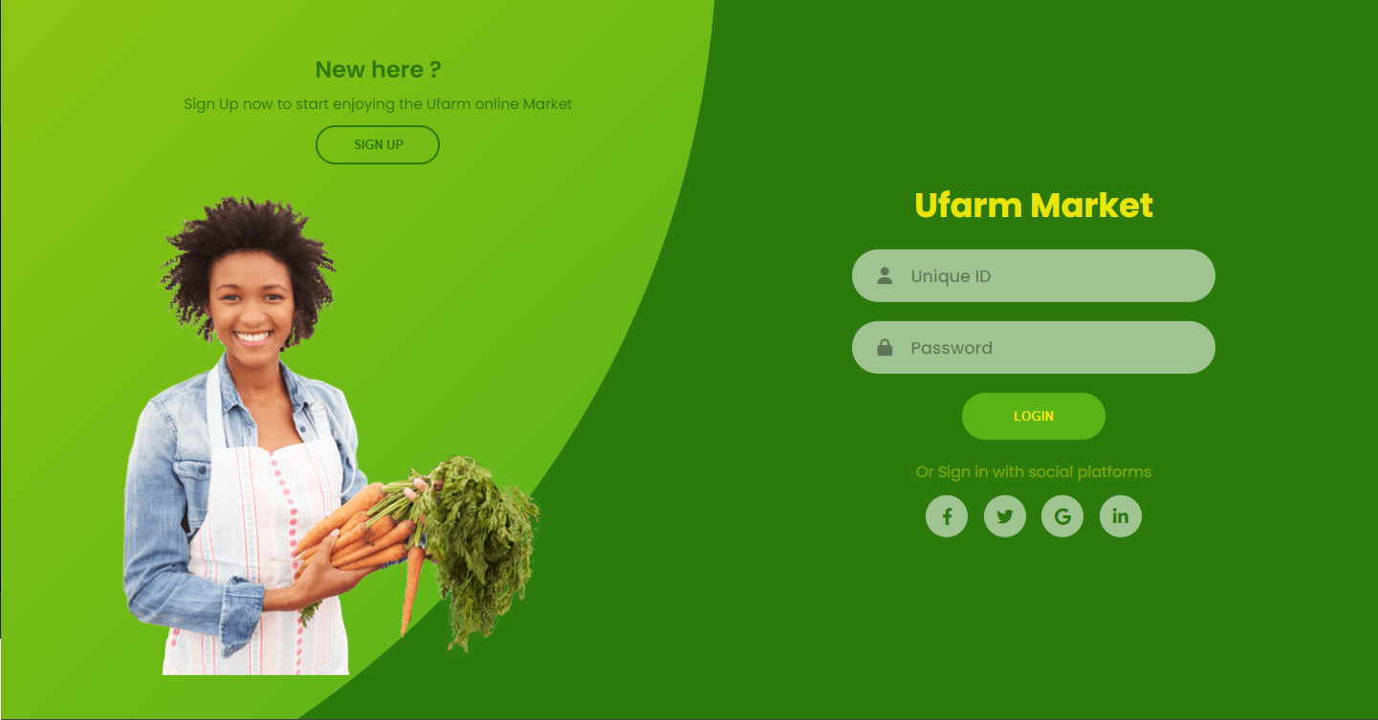

## Sign Up Page

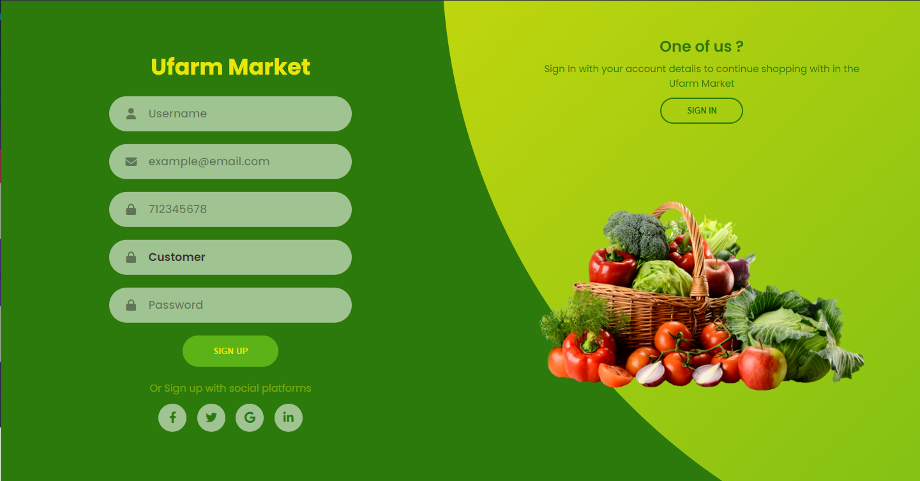

## Sellers/Farmers/ Admins Registration

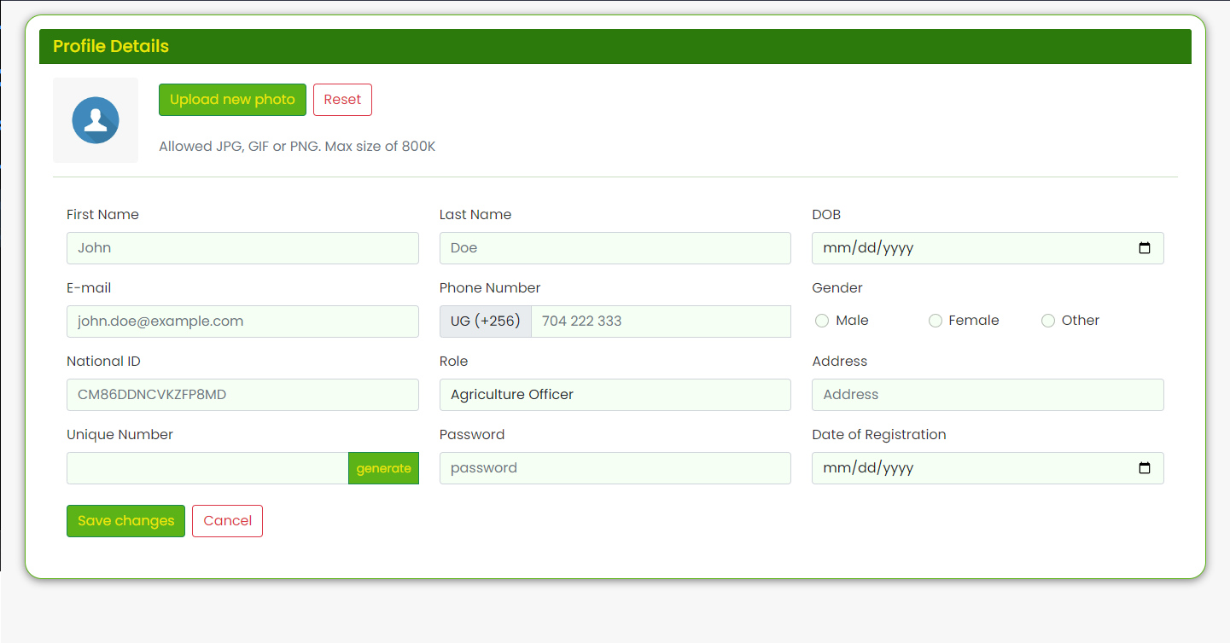

## Form Validation

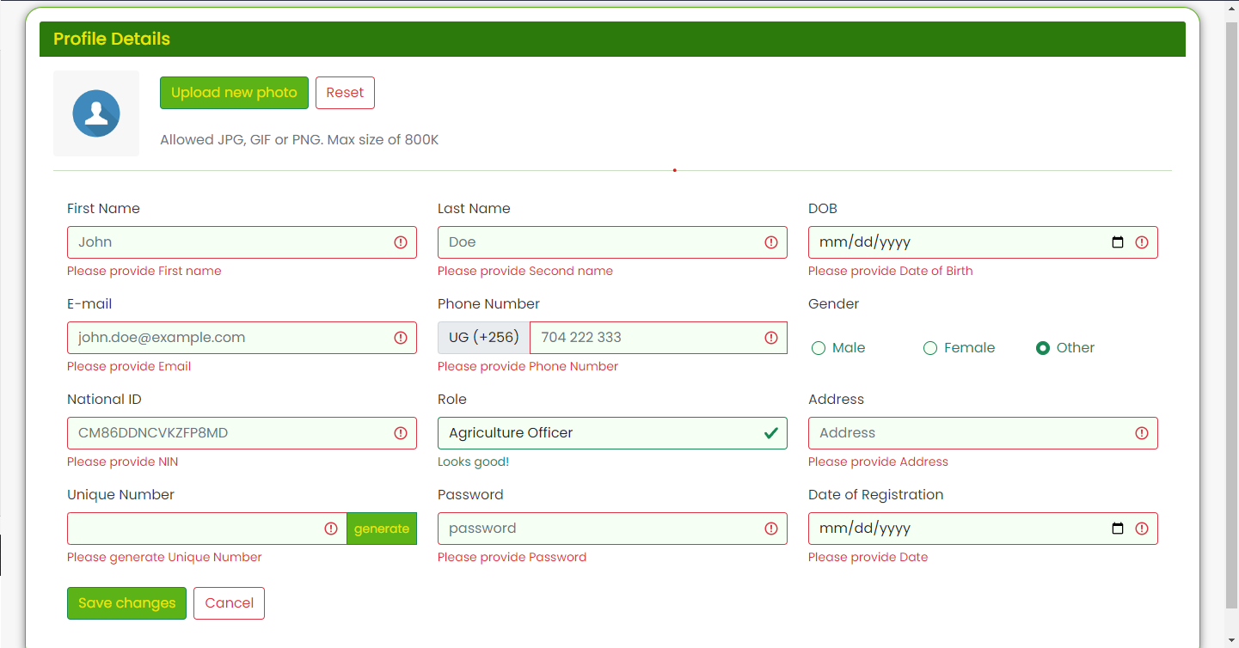

## Flash Messages

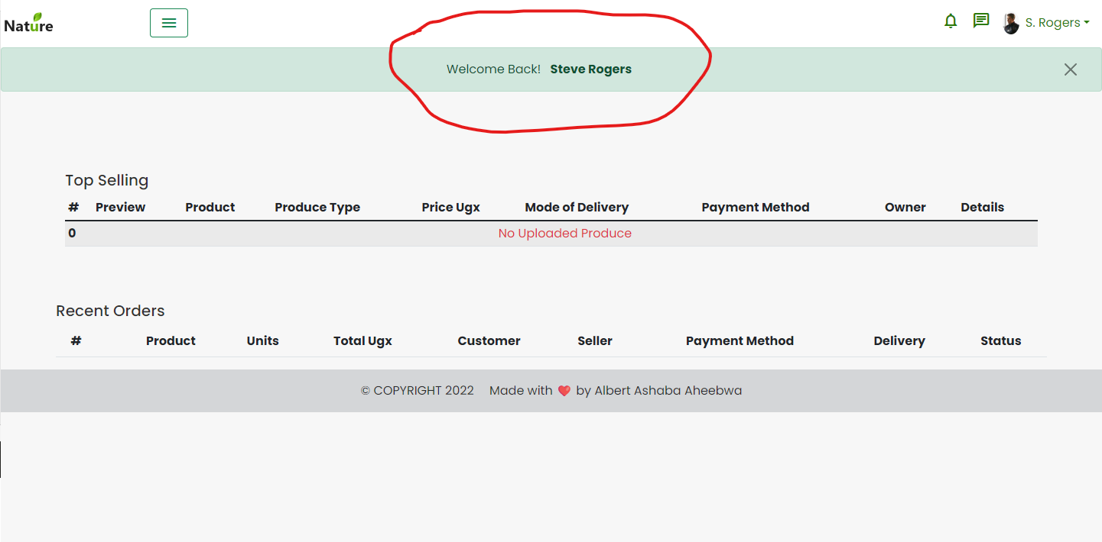

## Produce Update

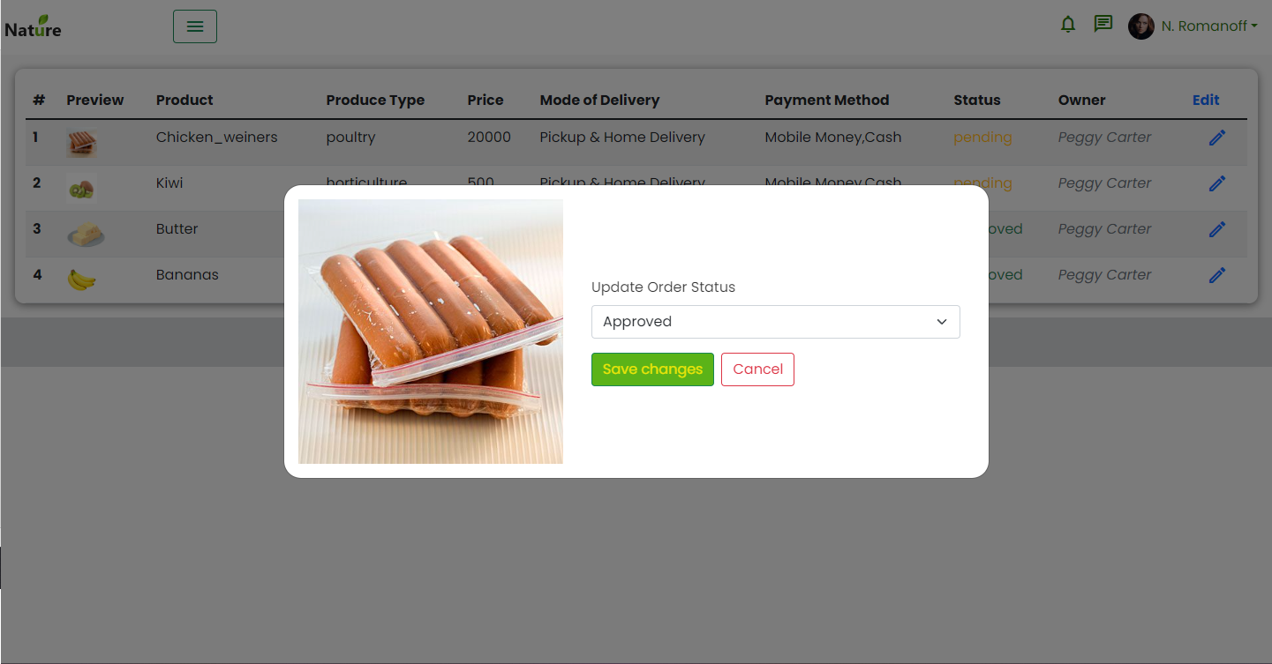

## Dashboard

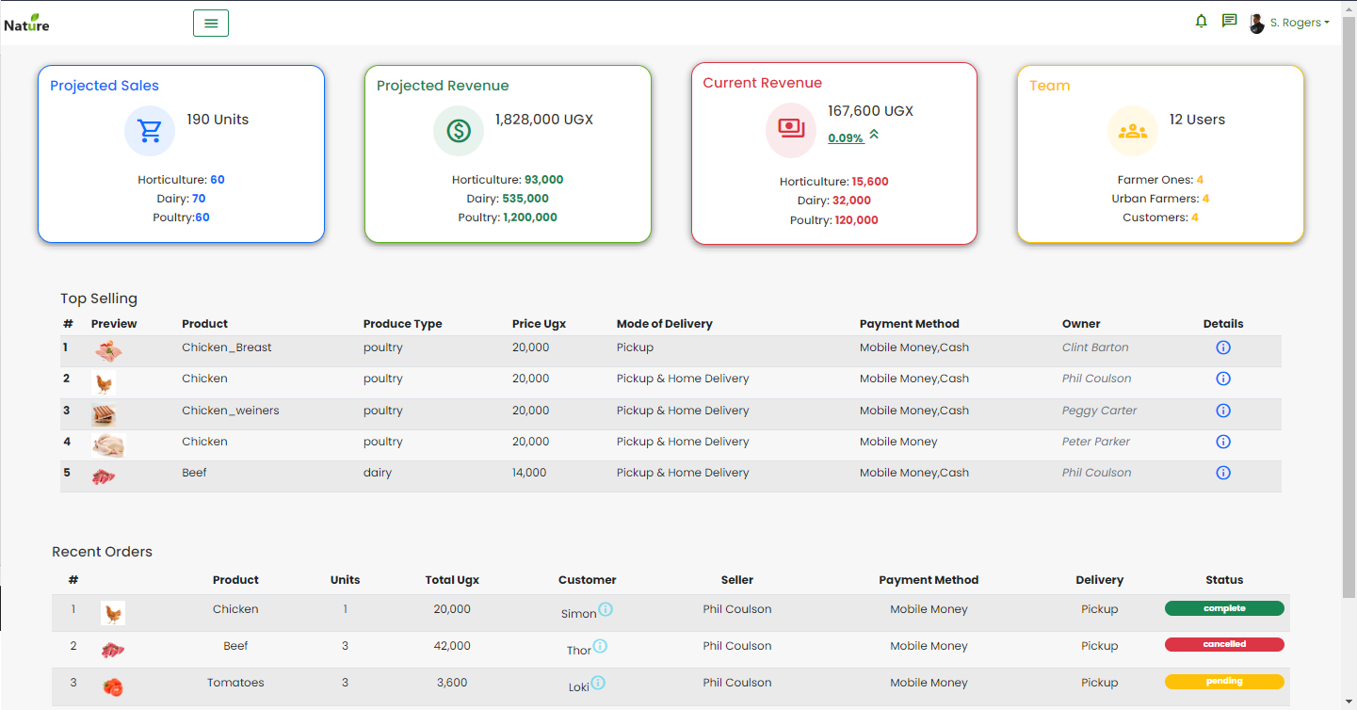

## Landing Page

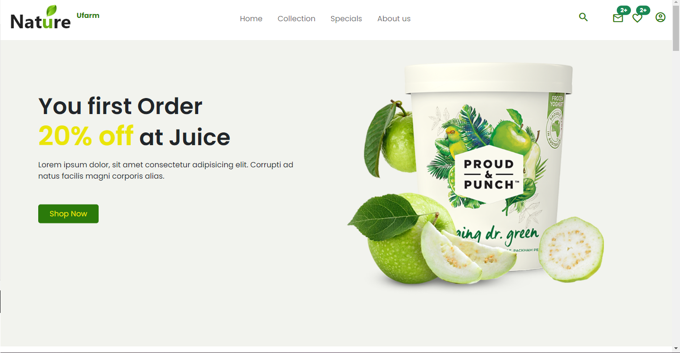

## Active Filter

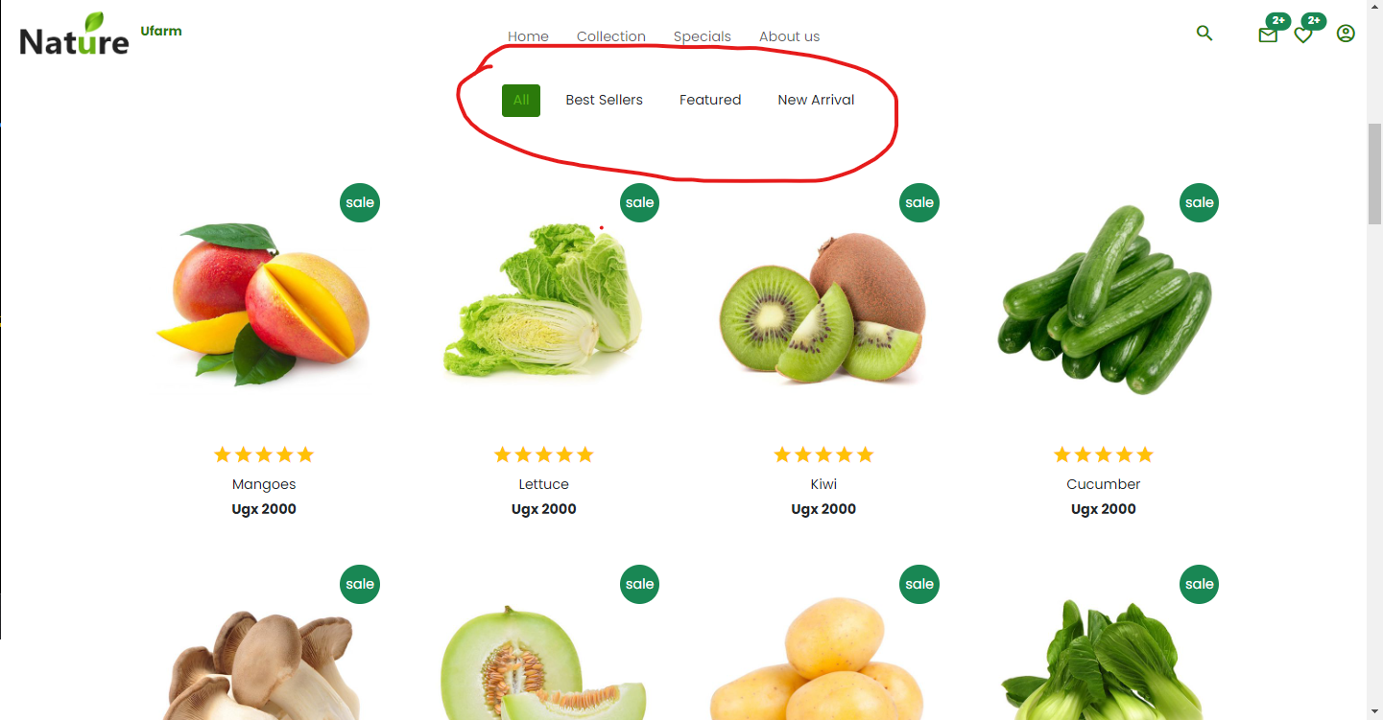

## Product Dashboard

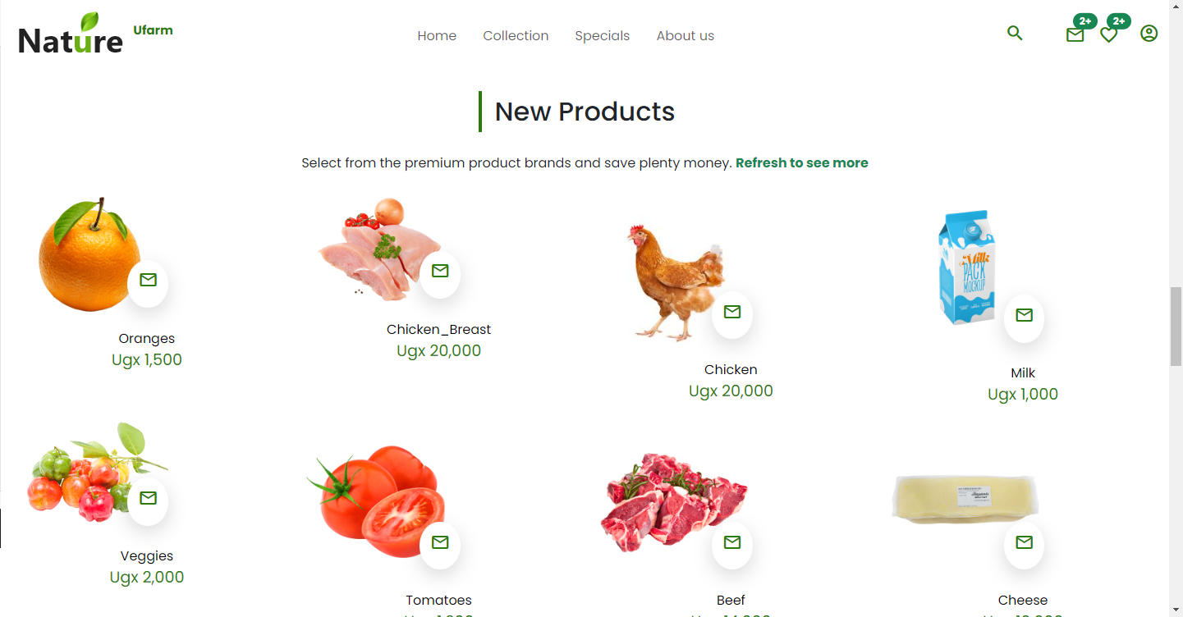

## Countdown Timer

