TFIDF + Gradient Boosting:

Tr. Acc. = 82.77

Cross Val. Score = 73.24

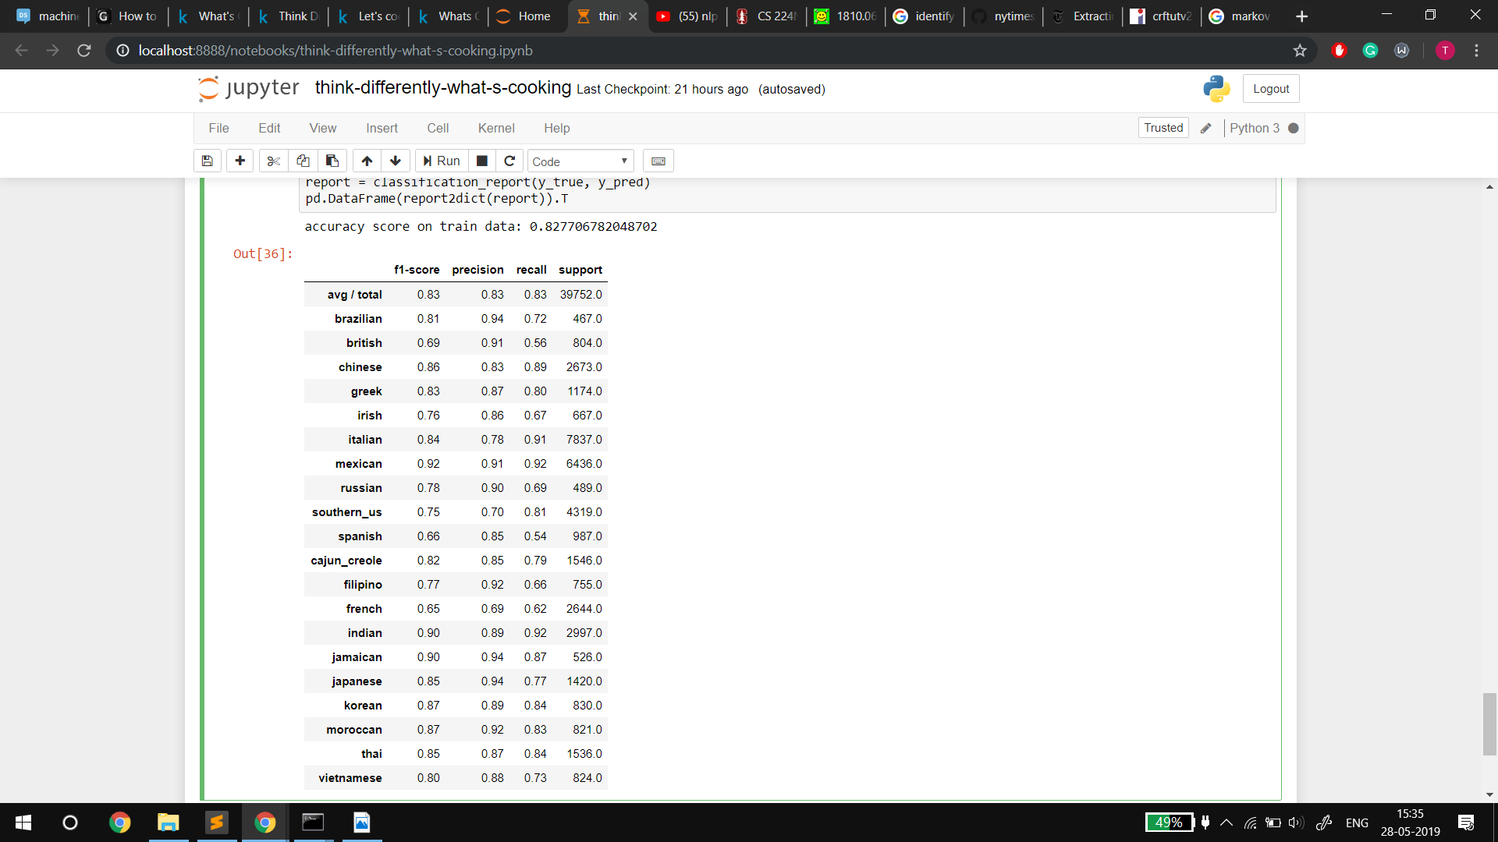

TFIDF + OneVSAll (multiclass classification)

Tr. Acc. = 99.96

Cross Val. Score = 81.20

