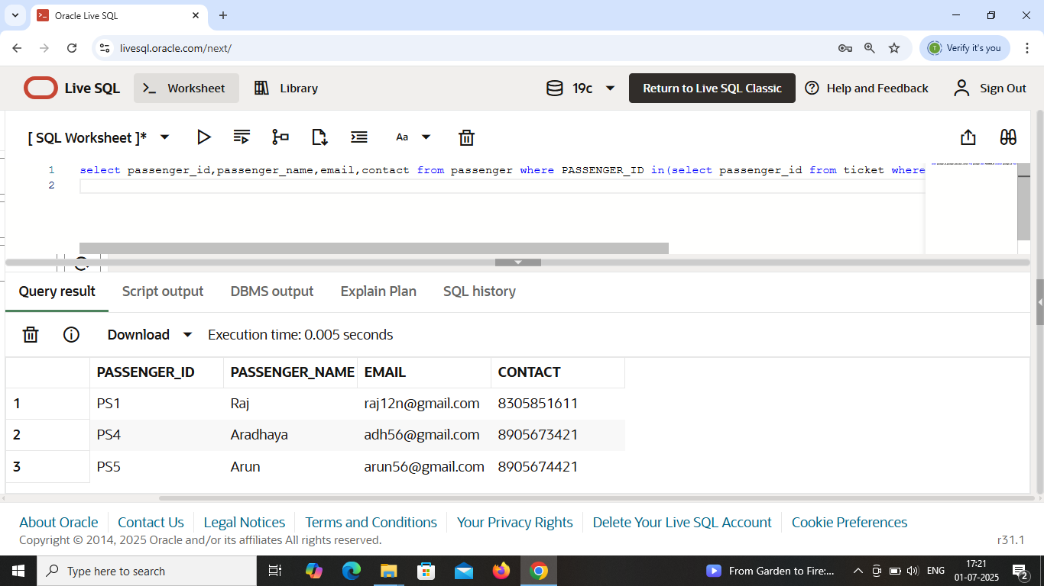

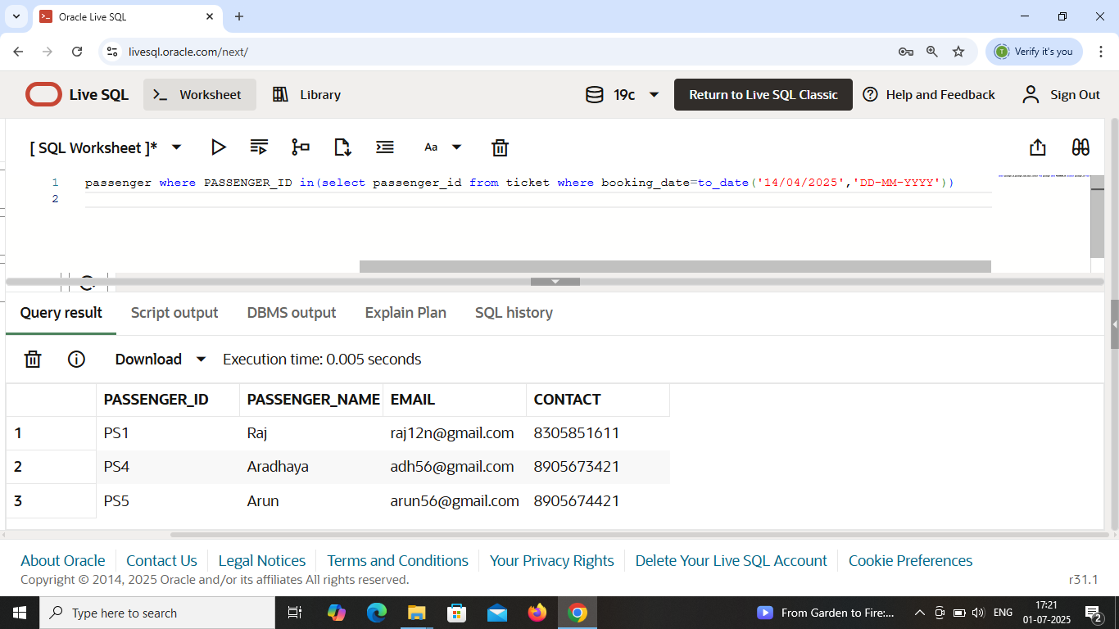

Display passenger details who has booking date on ’14-04-2025’ .

Use : Subquery using ‘in’ operator with ‘where’ clause .

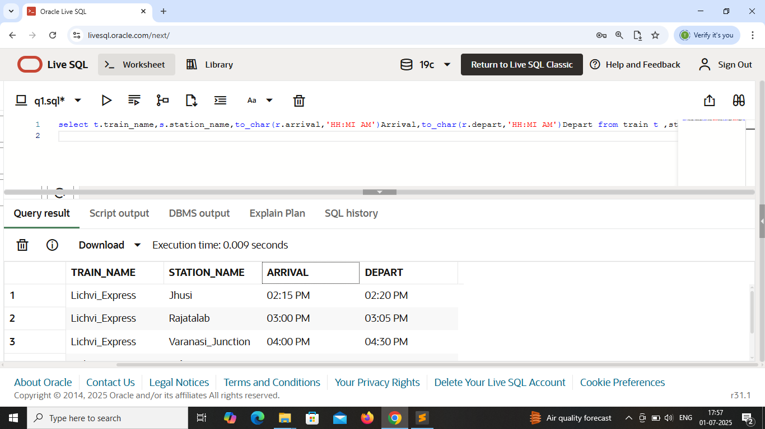

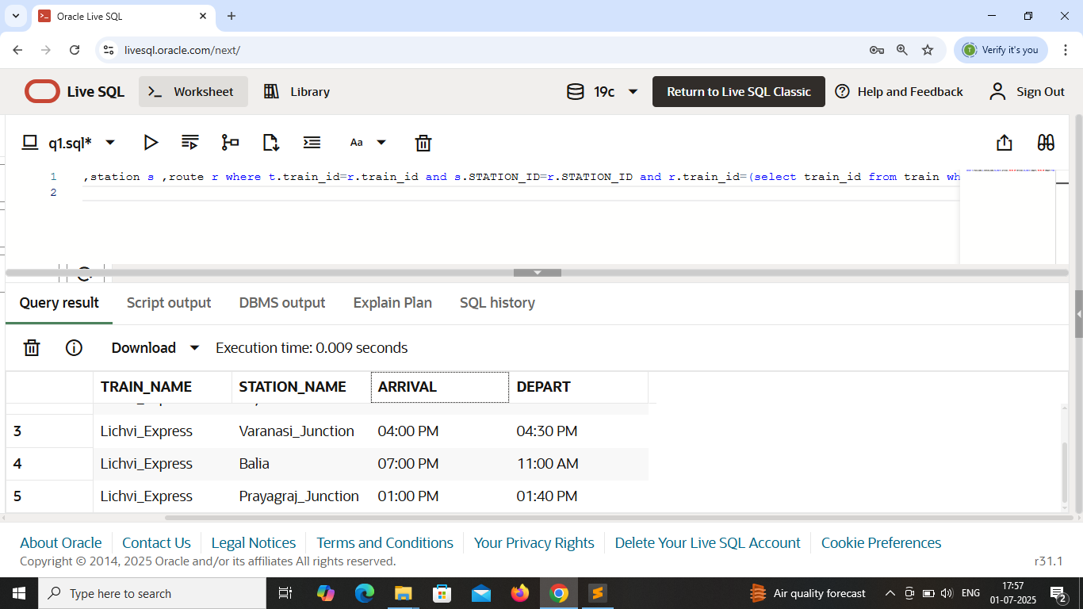

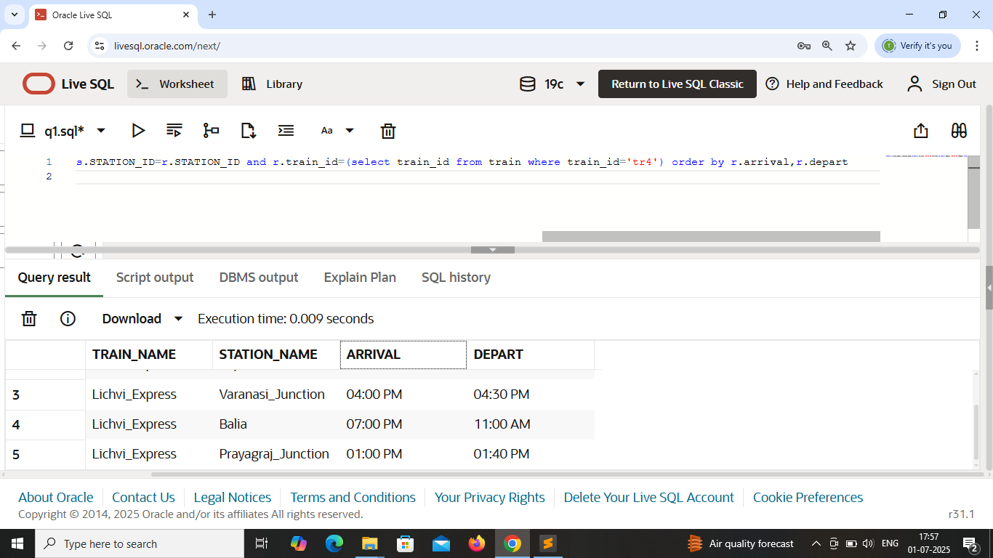

Train_id=’tr4’ arrives on which station . Display train_name , arrival ,depart ,station_name .

Use : subquery using ‘=’ operator with ‘where’ clause .

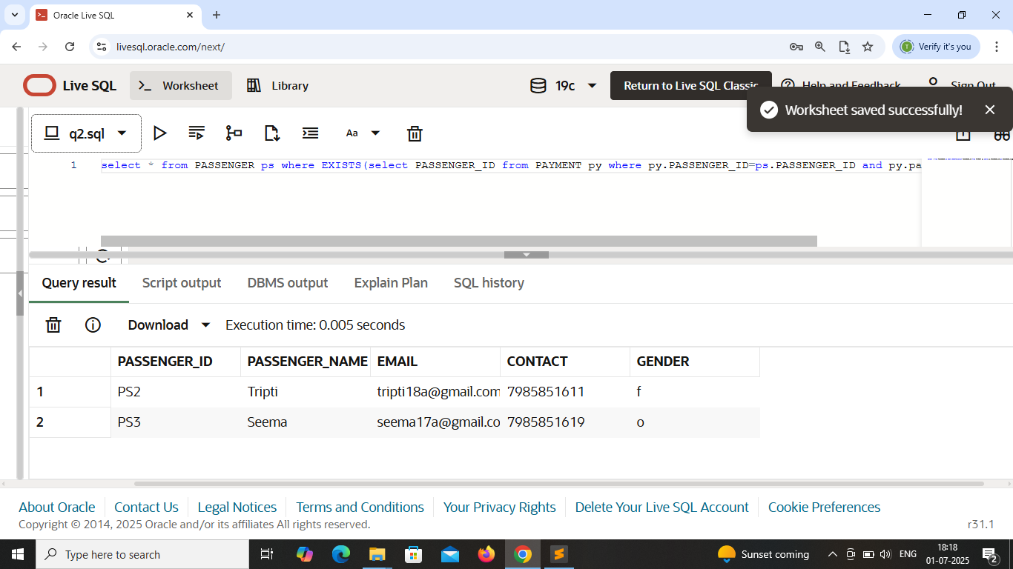

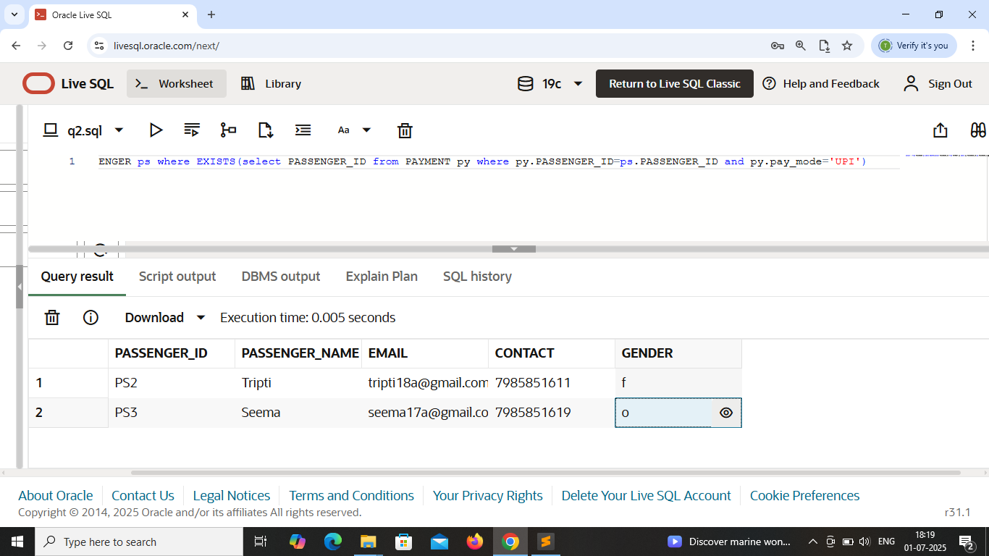

That Passenger details who uses pay_mode=’UPI’.

Use : ‘Exists’ operator .

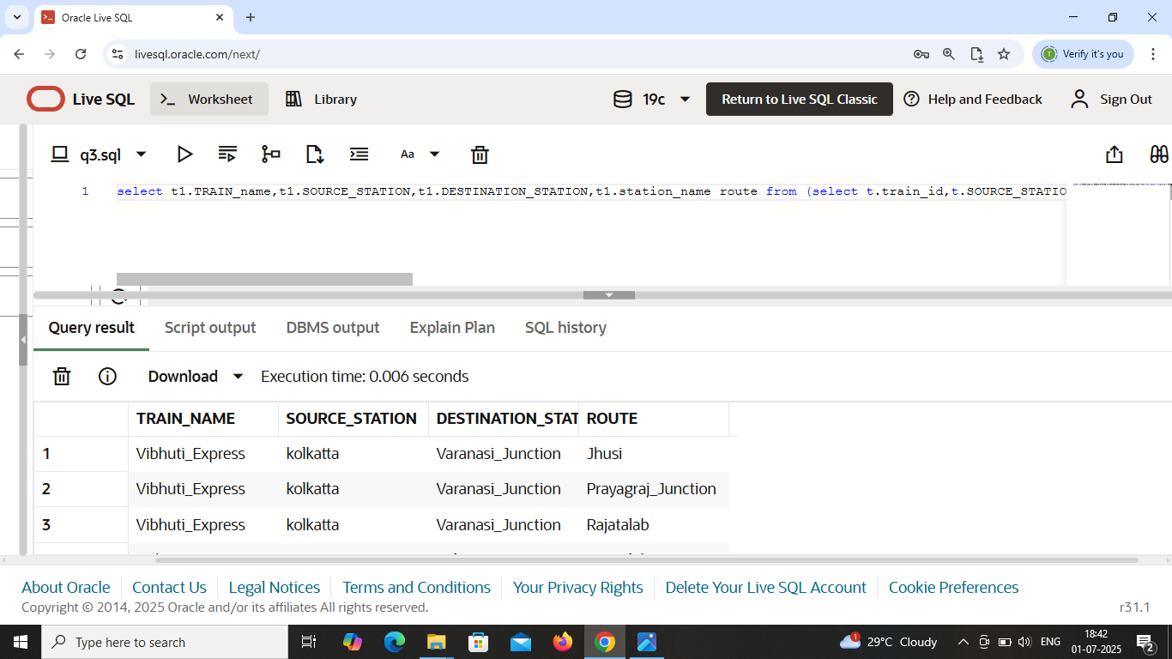

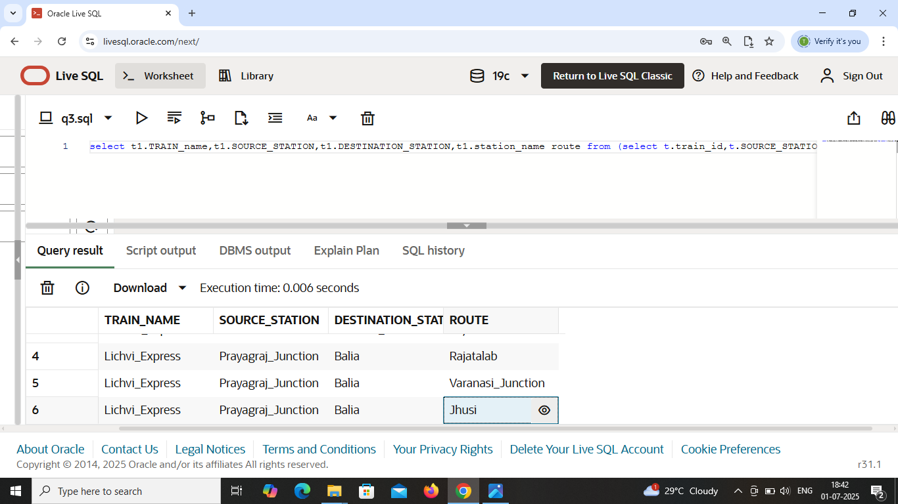

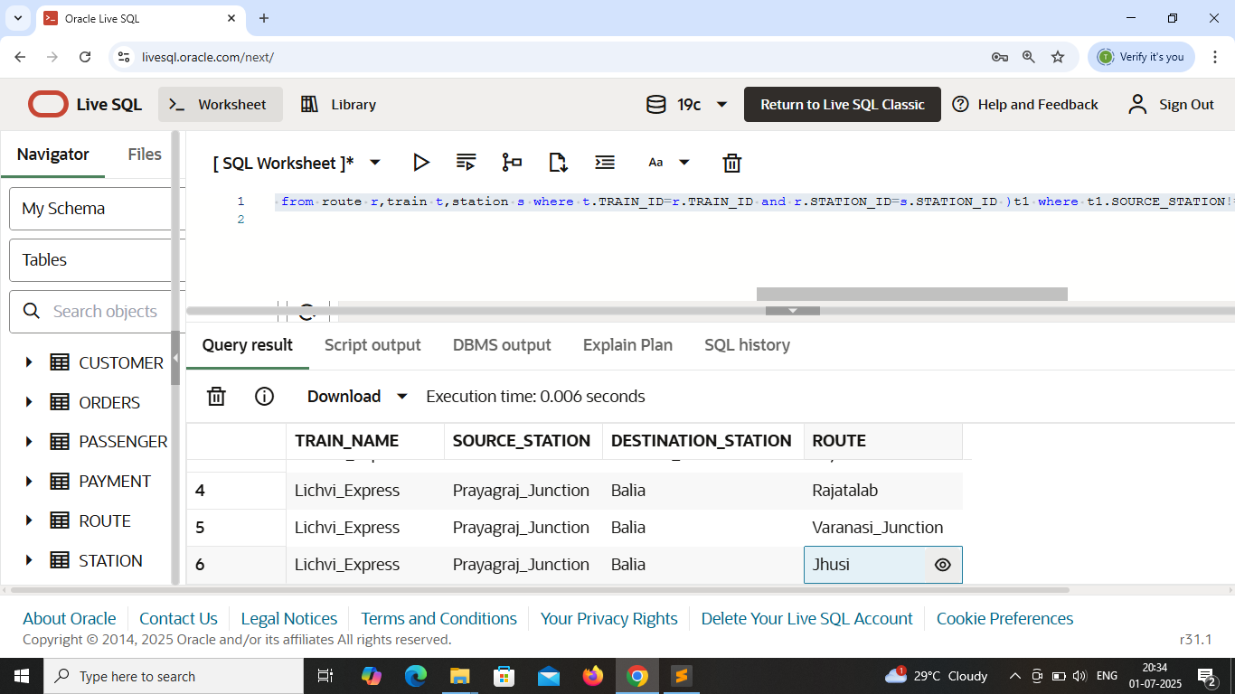

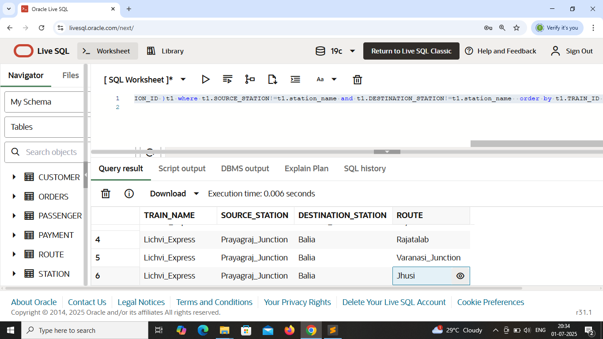

List of Train_name with their source, destination & route in which it pass through .

Use : subquery in ‘from’ clause .

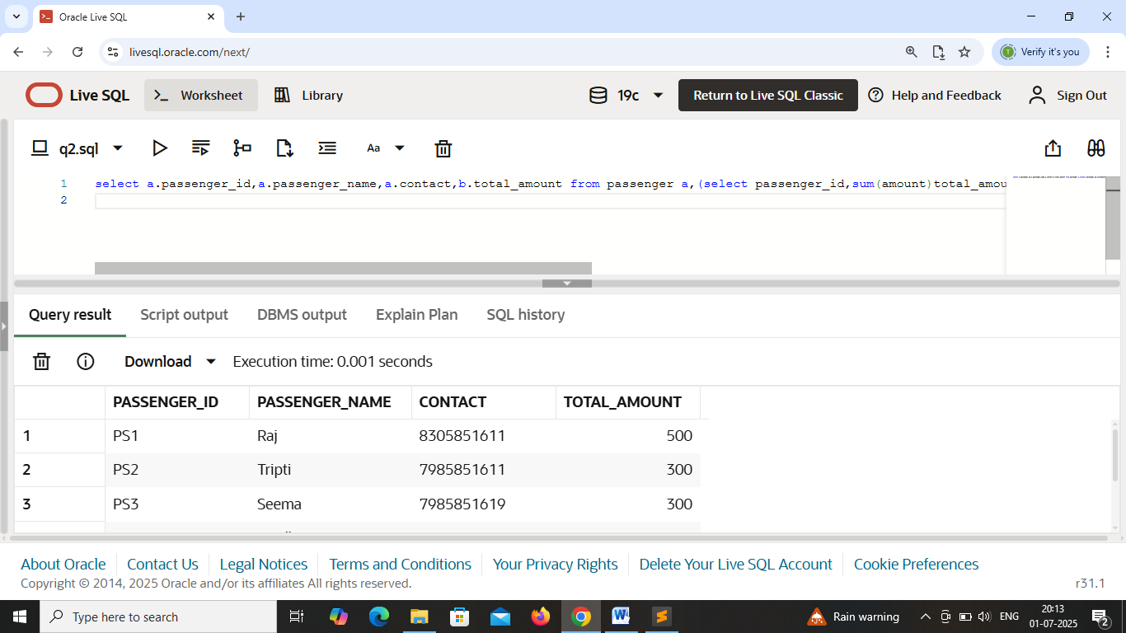

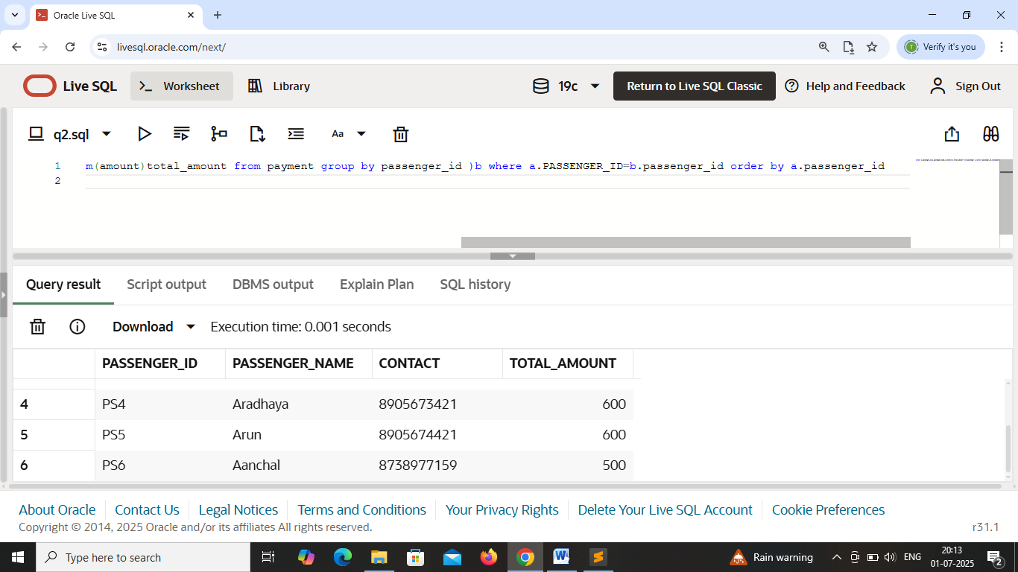

List of passenger_details with their total_amount that is paid for booking the train .

Use : Subquery in ‘from’ clause .