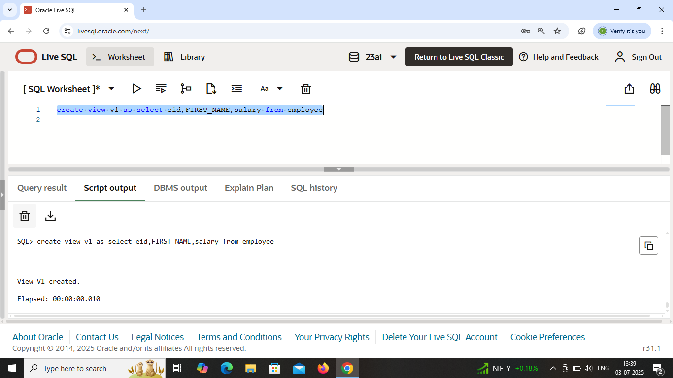

View ‘v1’ is created by using single table .

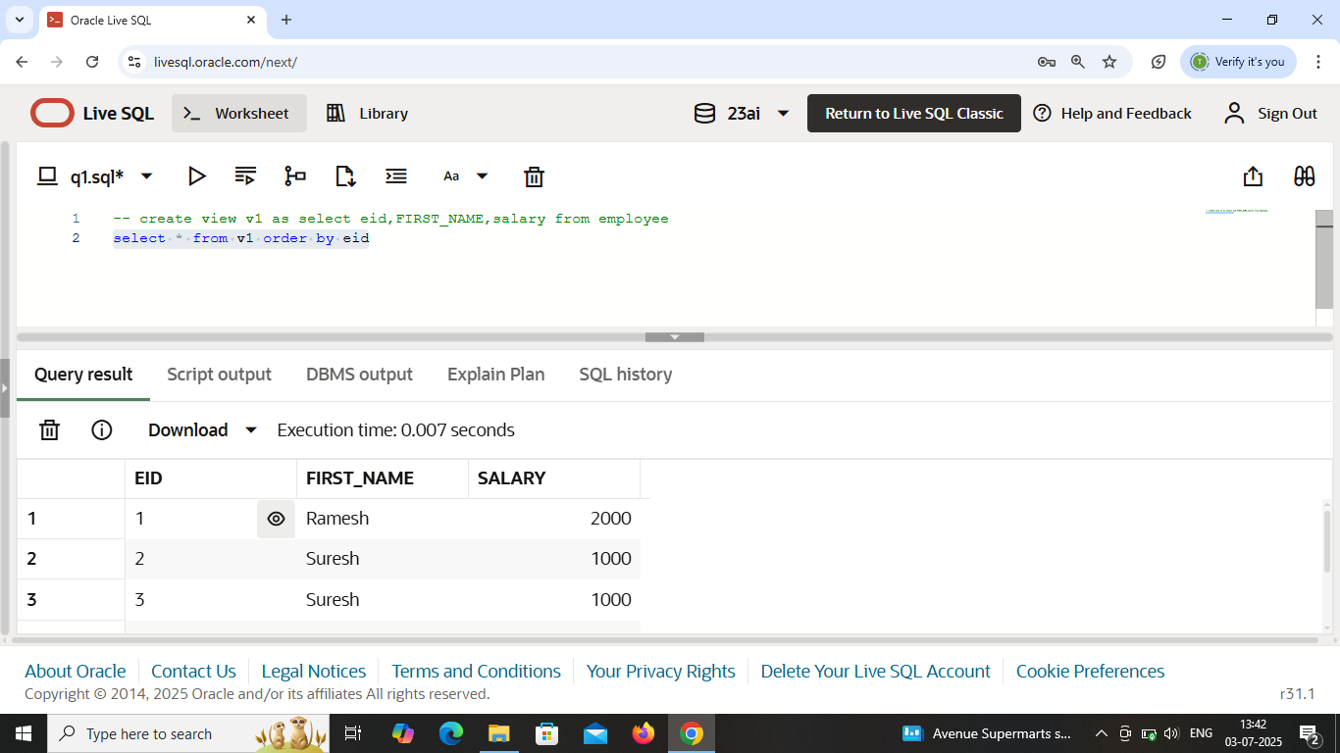

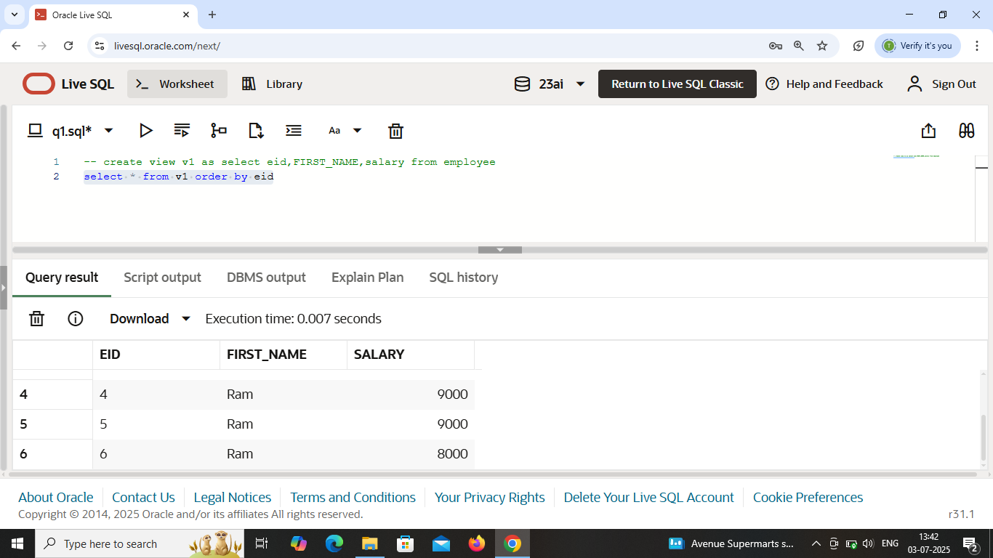

Accessing data from view .

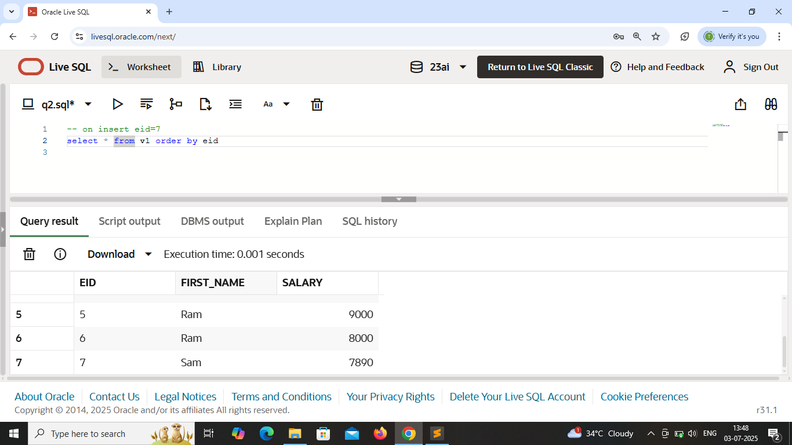

On inserting data in view , eid=7 .

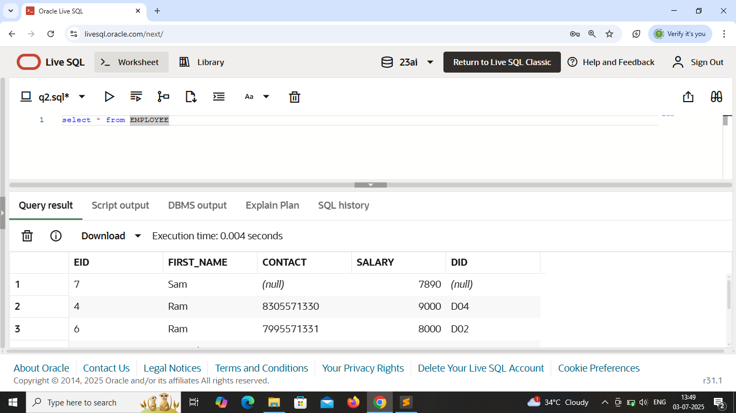

It will also insert on employee table, eid=7 .

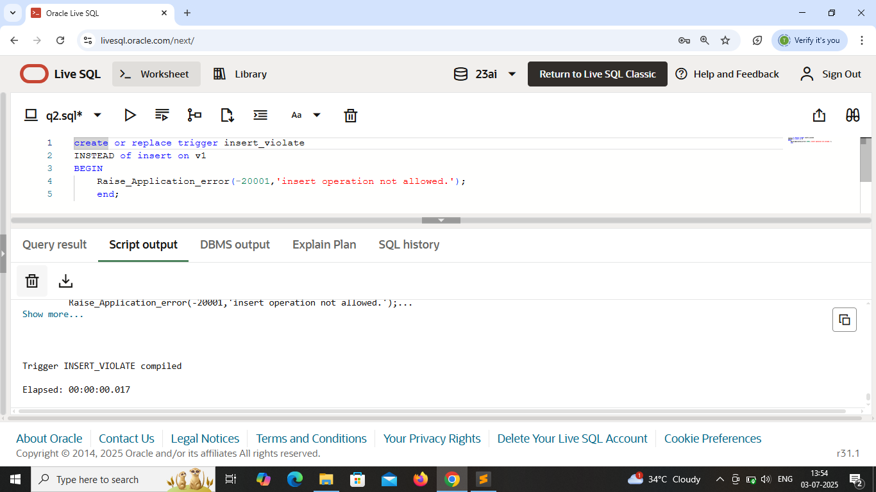

To disable insertion operation on view , trigger is created .

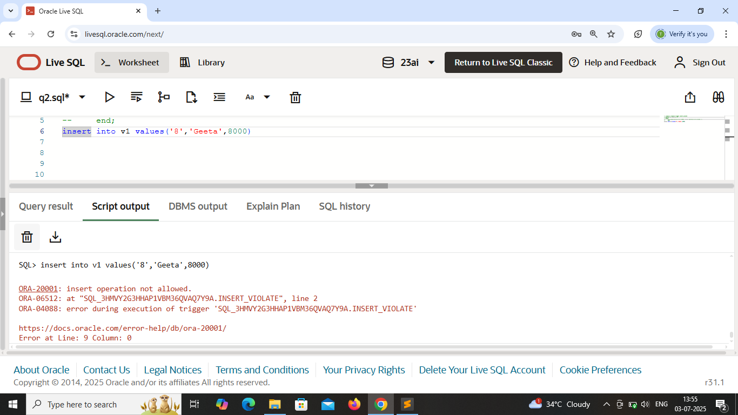

By this way , insertion operation is disabled and make a view “Read-only”.

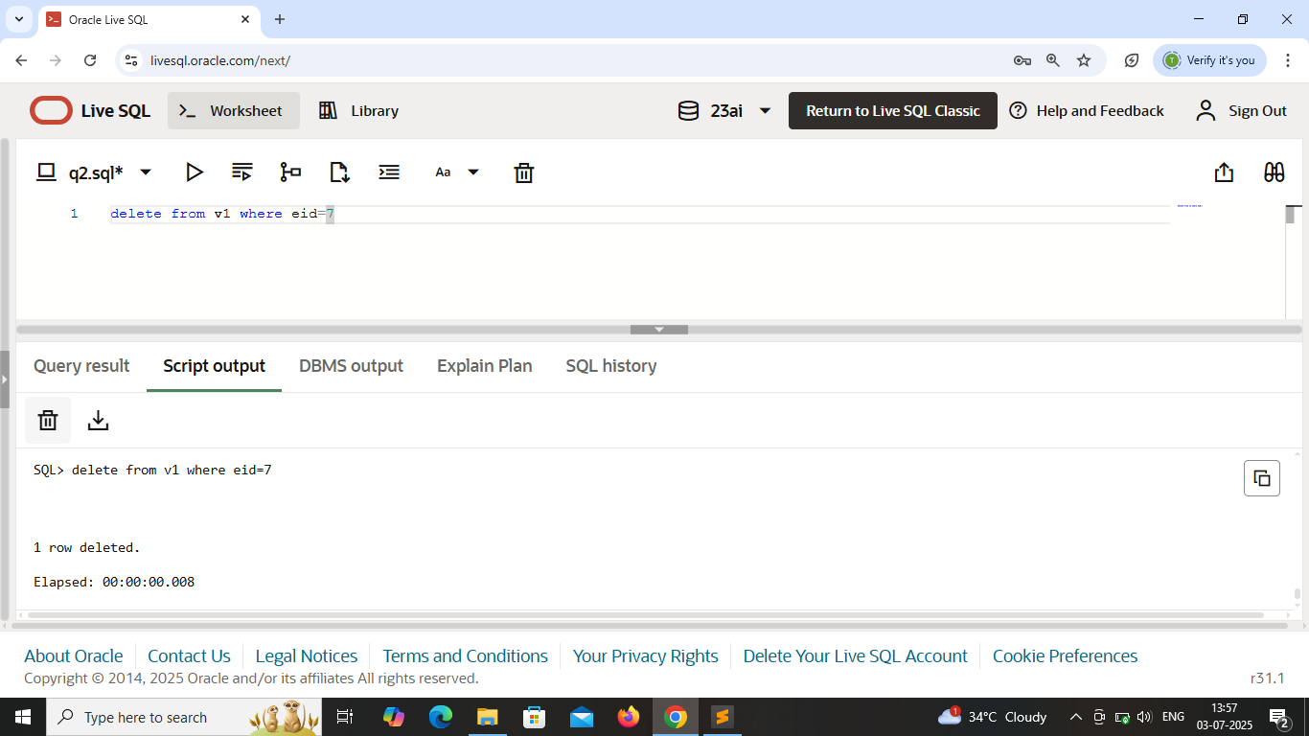

On deleting data from view , eid=7 .

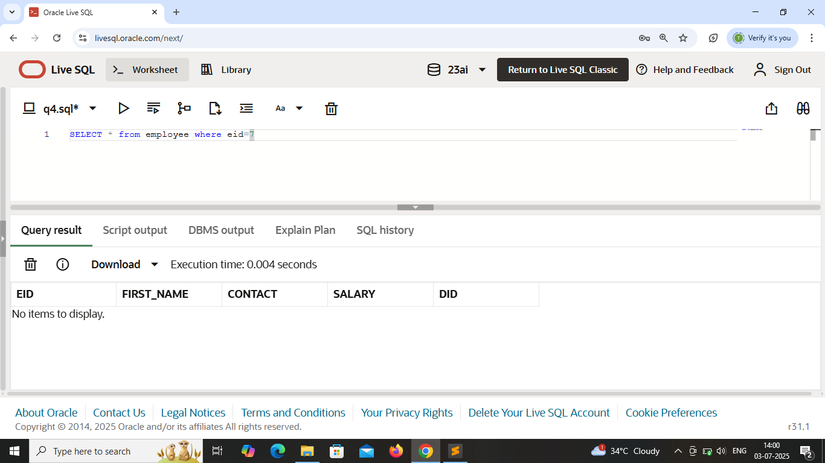

It will also deleted from employee table .

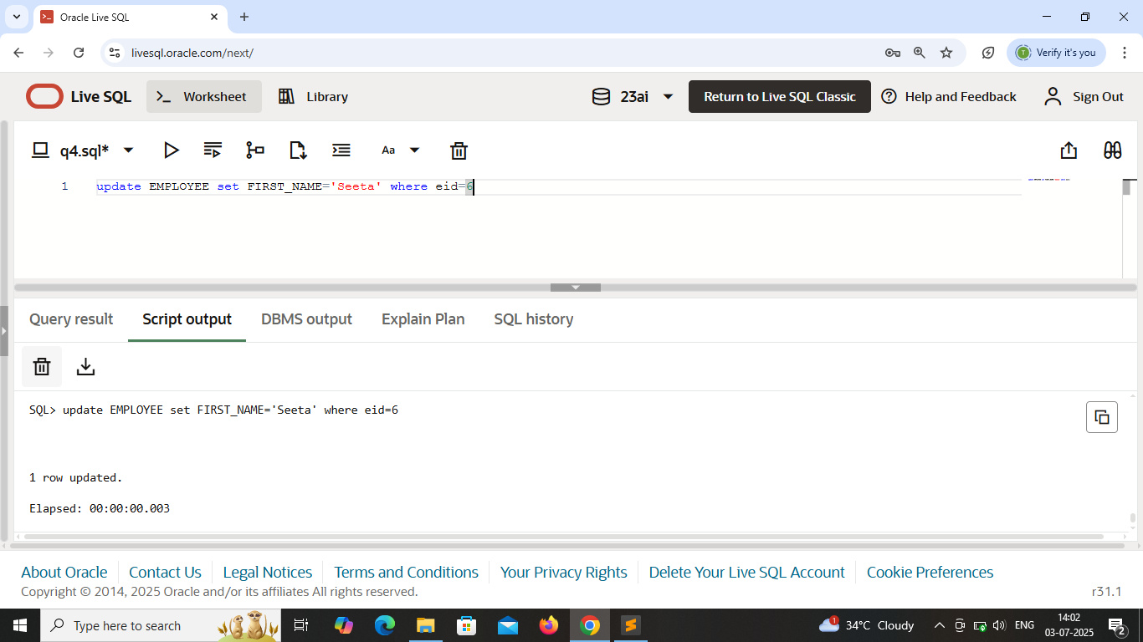

On updating the data in view , change first_name for eid=6 .

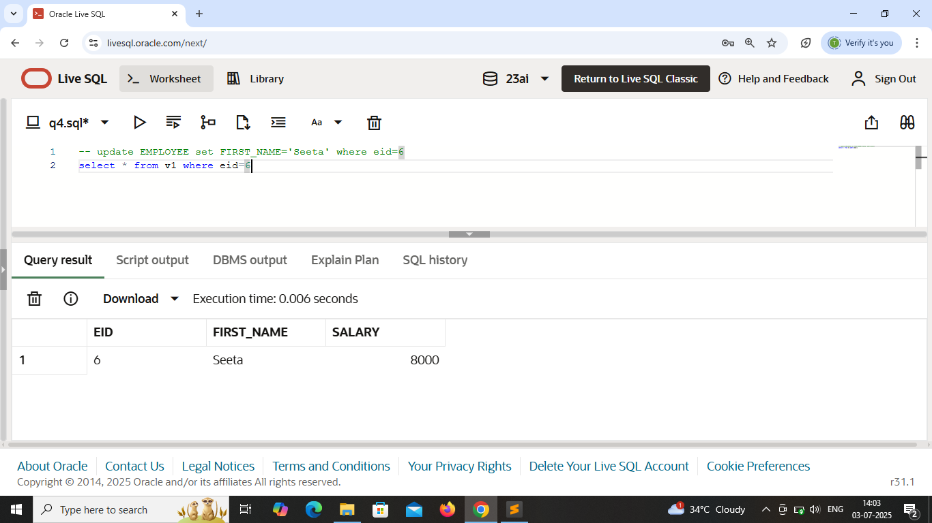

It will also updated on employee table .

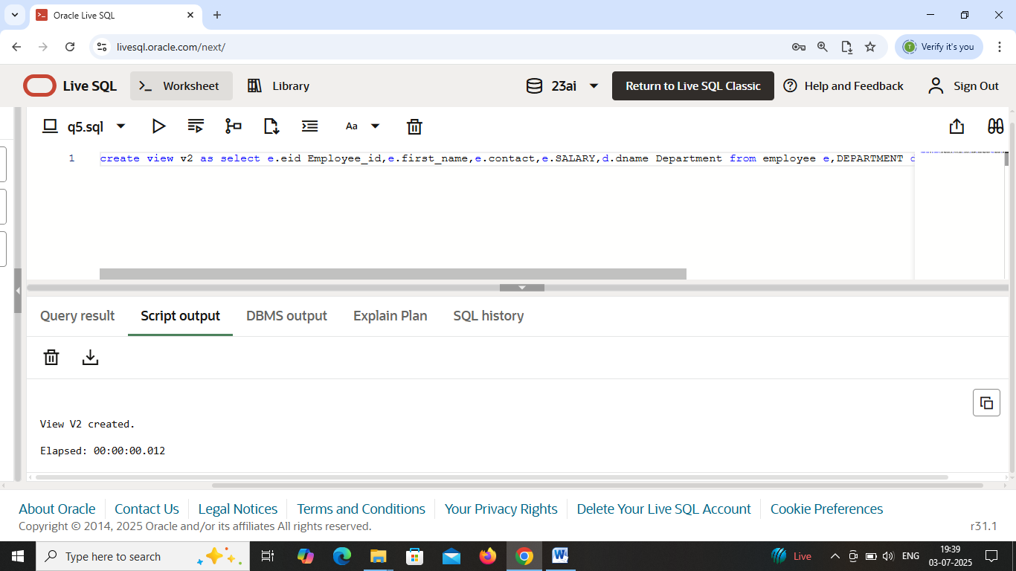

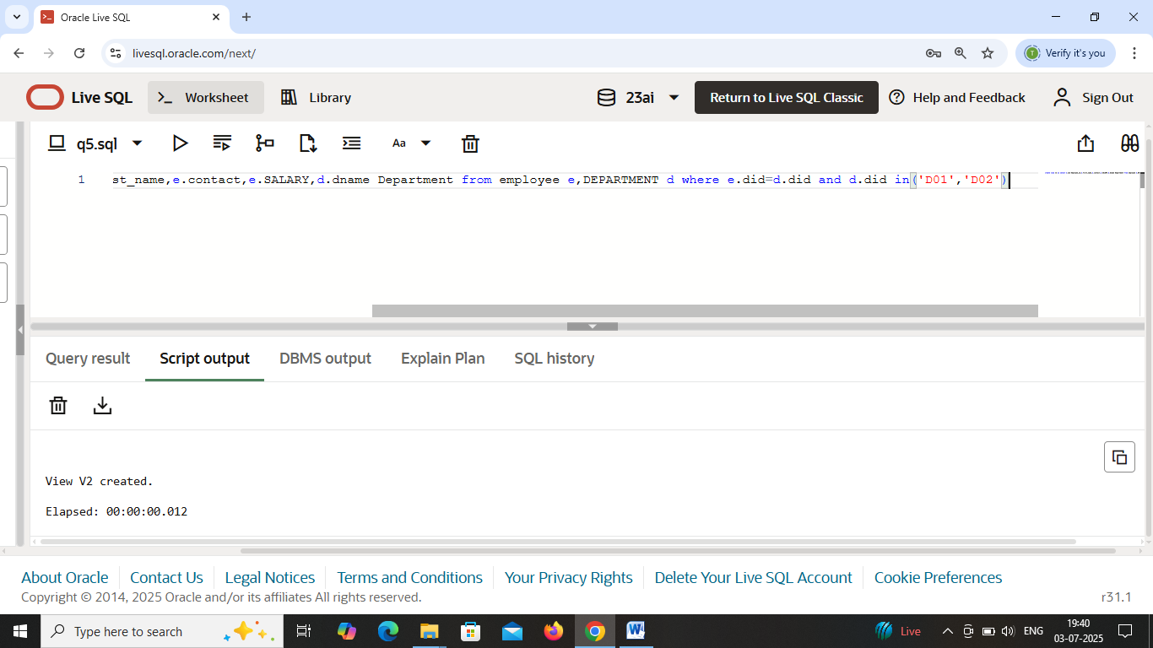

View ‘v2’ is created by using more than one tables. Tables:(employee,department).

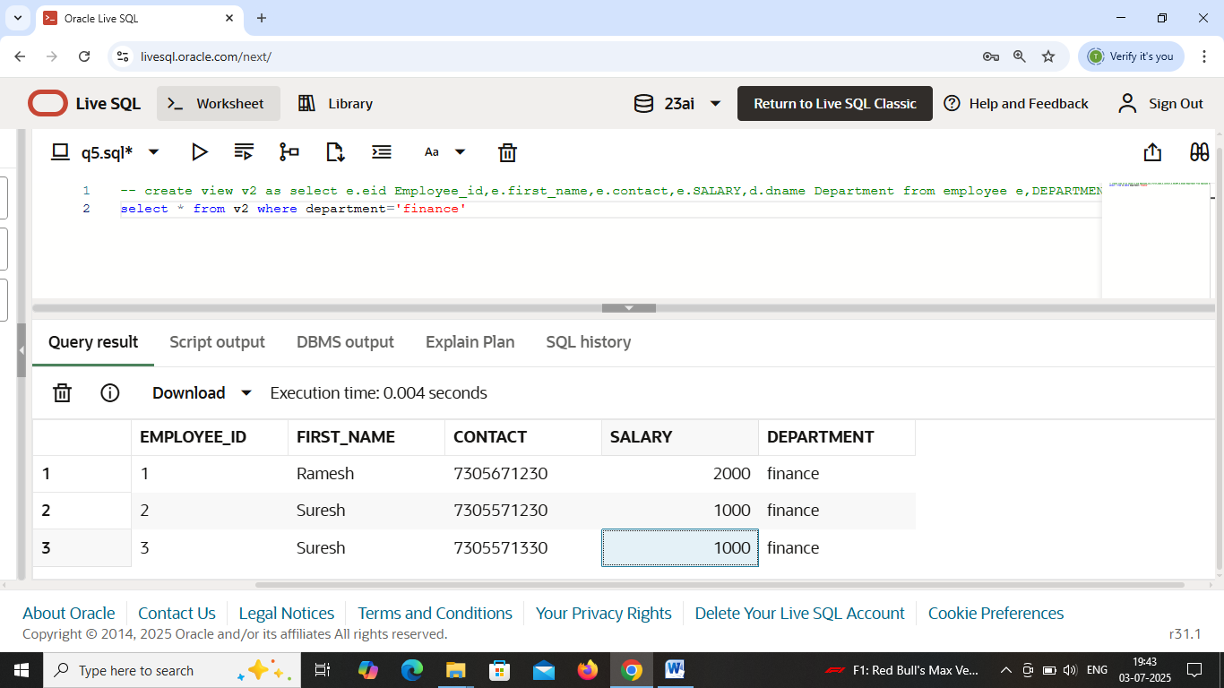

Display employee details whose department is ’finance’ .

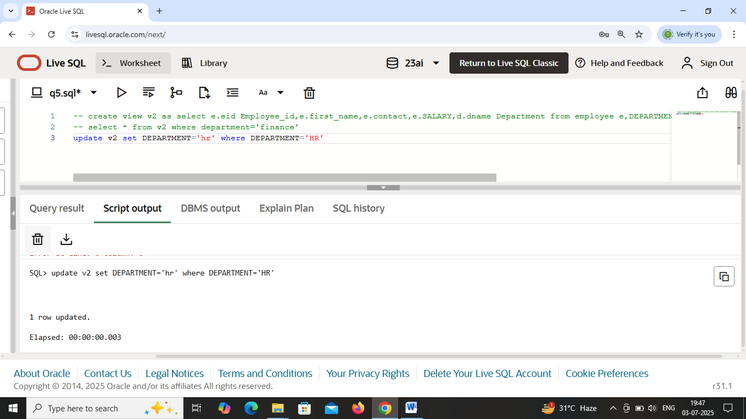

On updating the view ‘v2’ where department=’HR’.

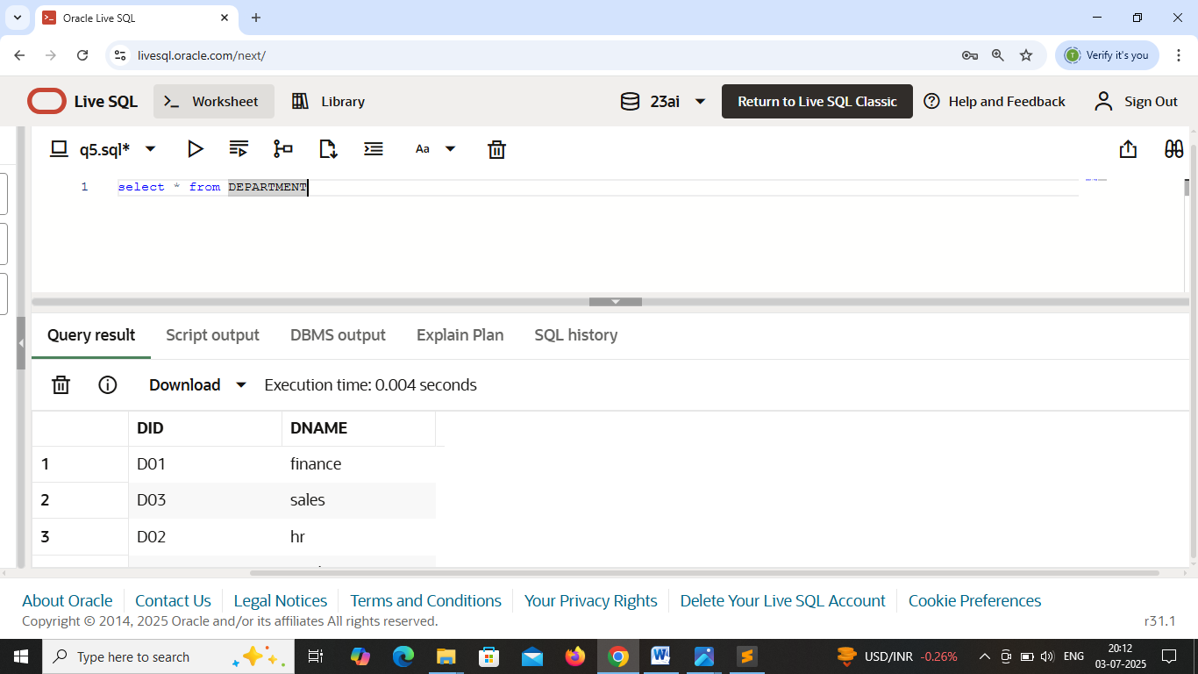

It will also updated on ‘department’ table where department=’HR’.

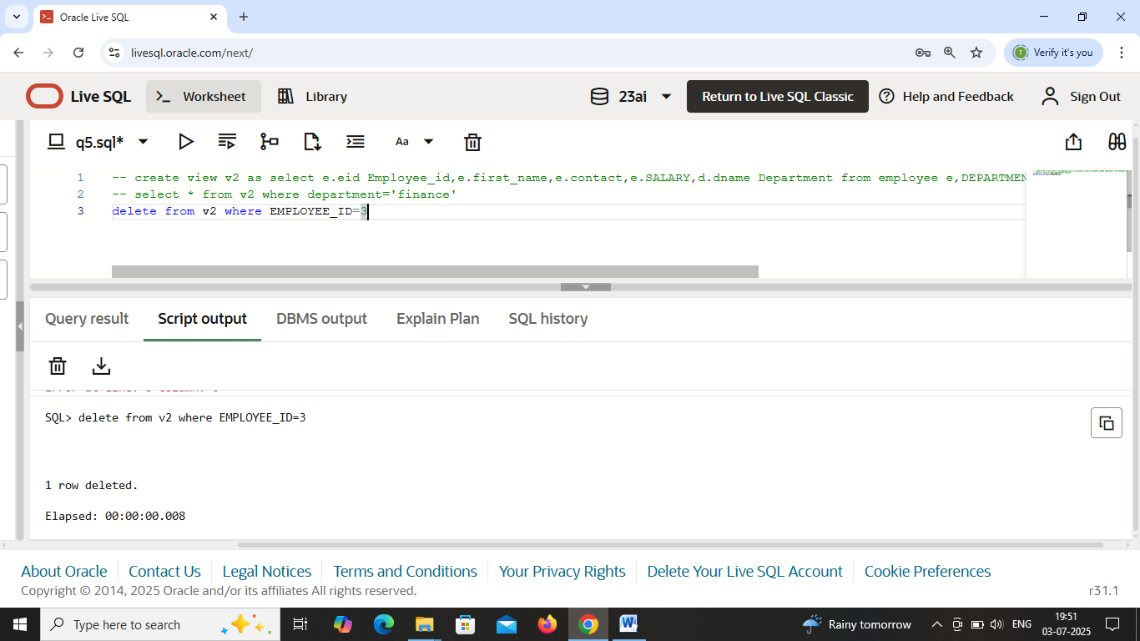

On deleting the data from ‘v2’ , where employee_id=’3’.

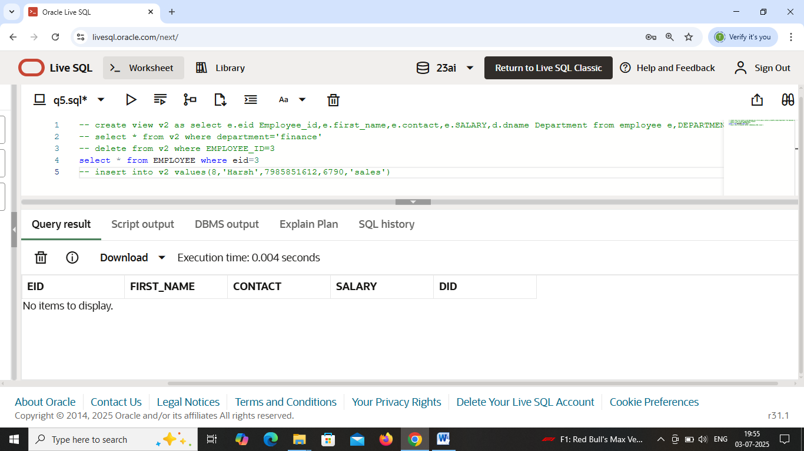

It will also deleted from ‘employee’ table where eid=’3’.

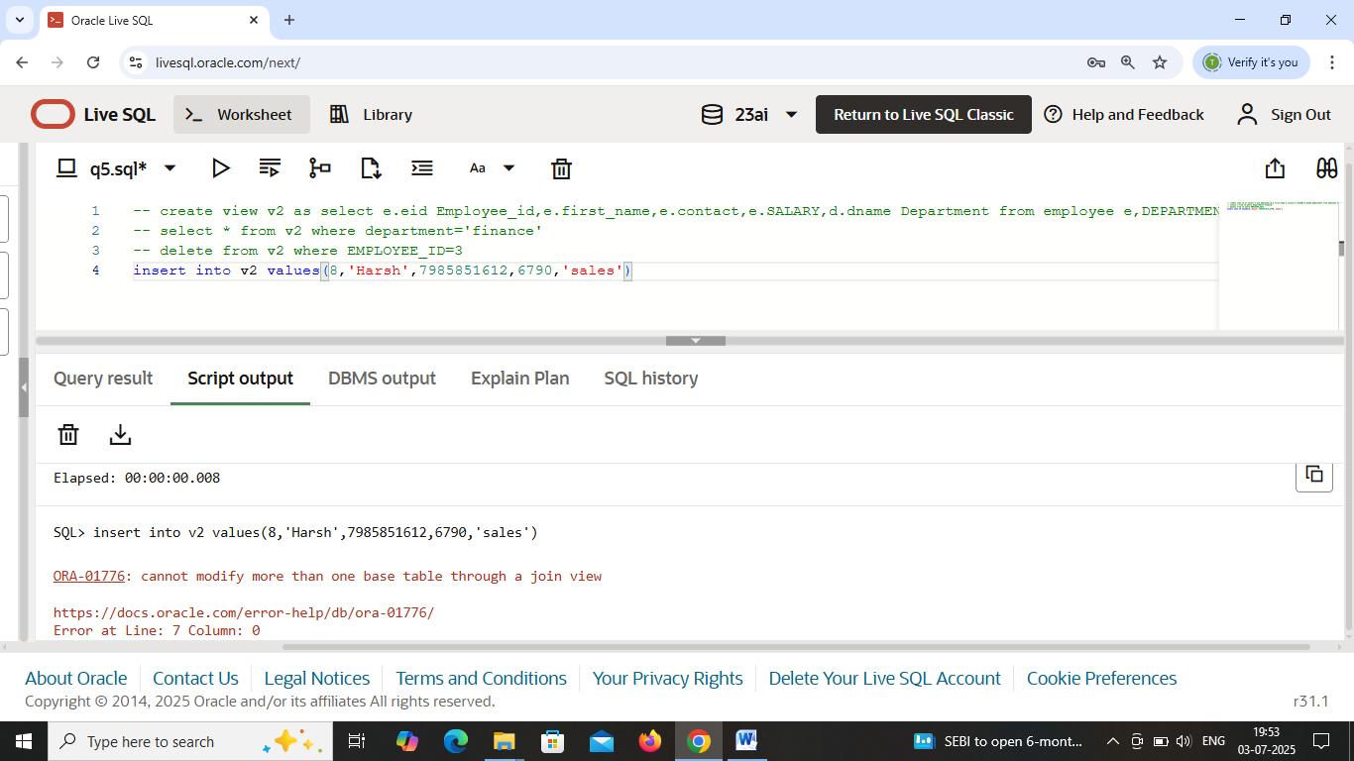

Insertion operation is disabled in this case because in this view , data is taken from more than one tables(i.e., employee,department) which is linked with each other.

**To make view Read-Only**

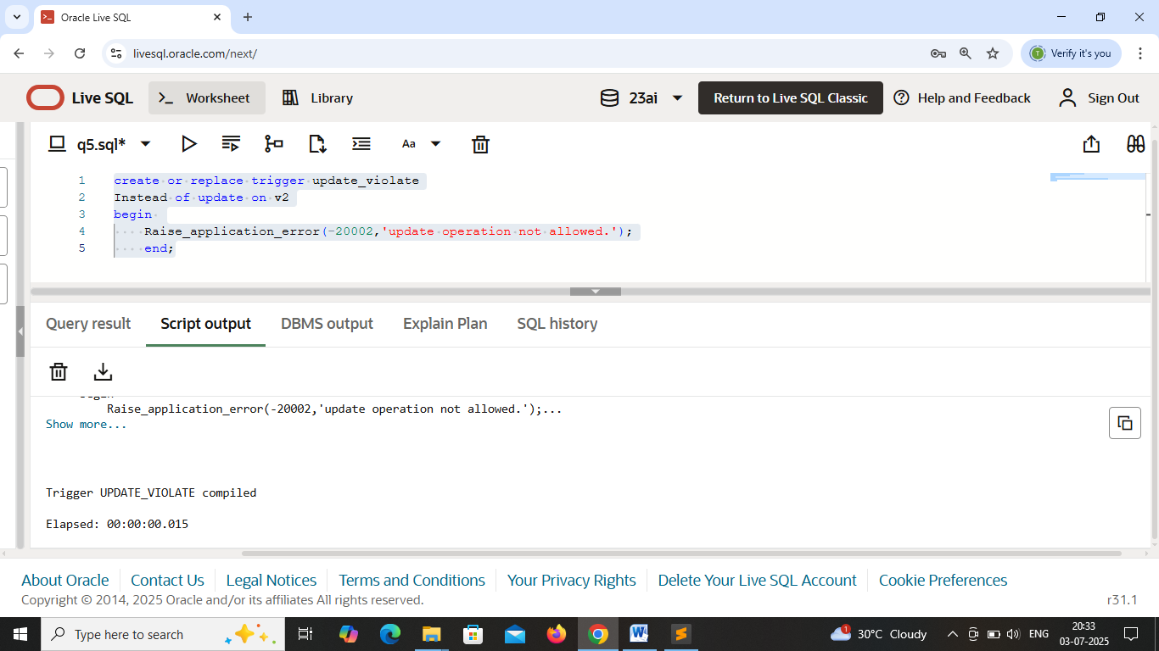

Trigger is created for disable update operation in view ‘v2’ .

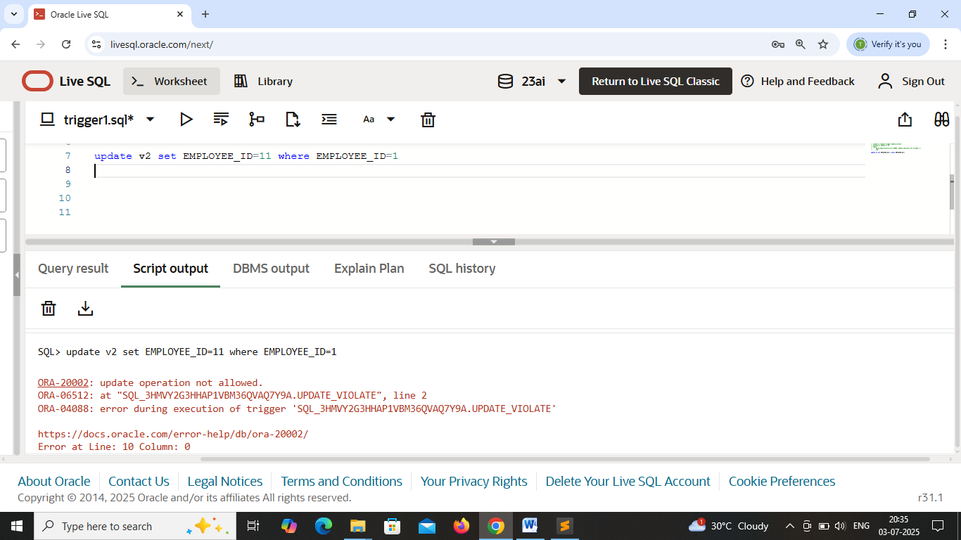

By this way, update operation is disabled .

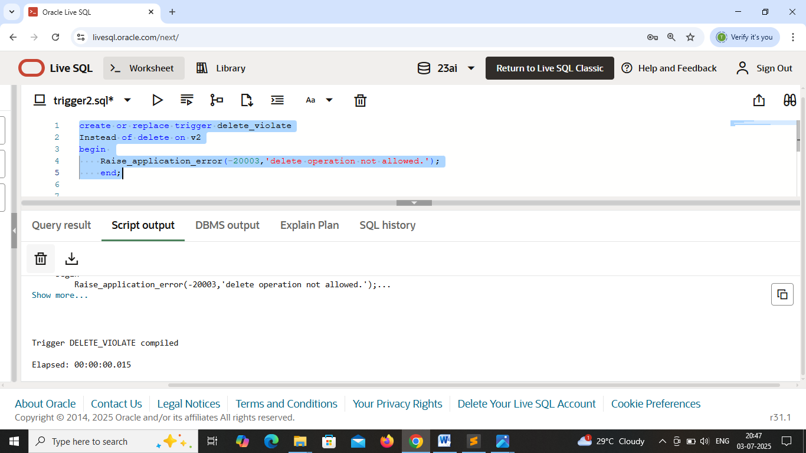

Trigger is created to disable delete operation in view ‘v2’.