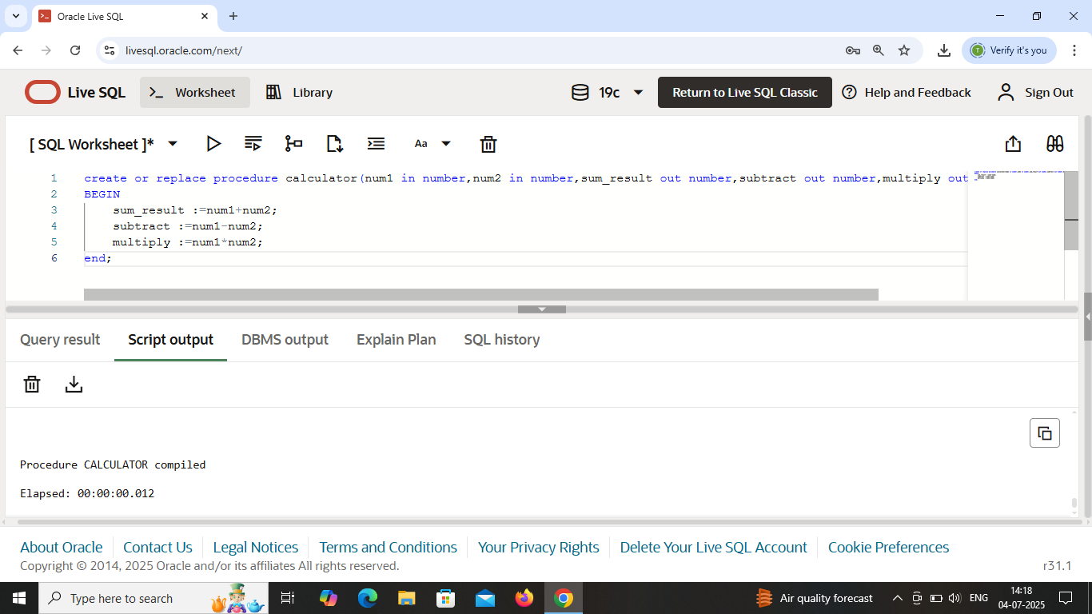

Procedure ‘calculator’ is created .

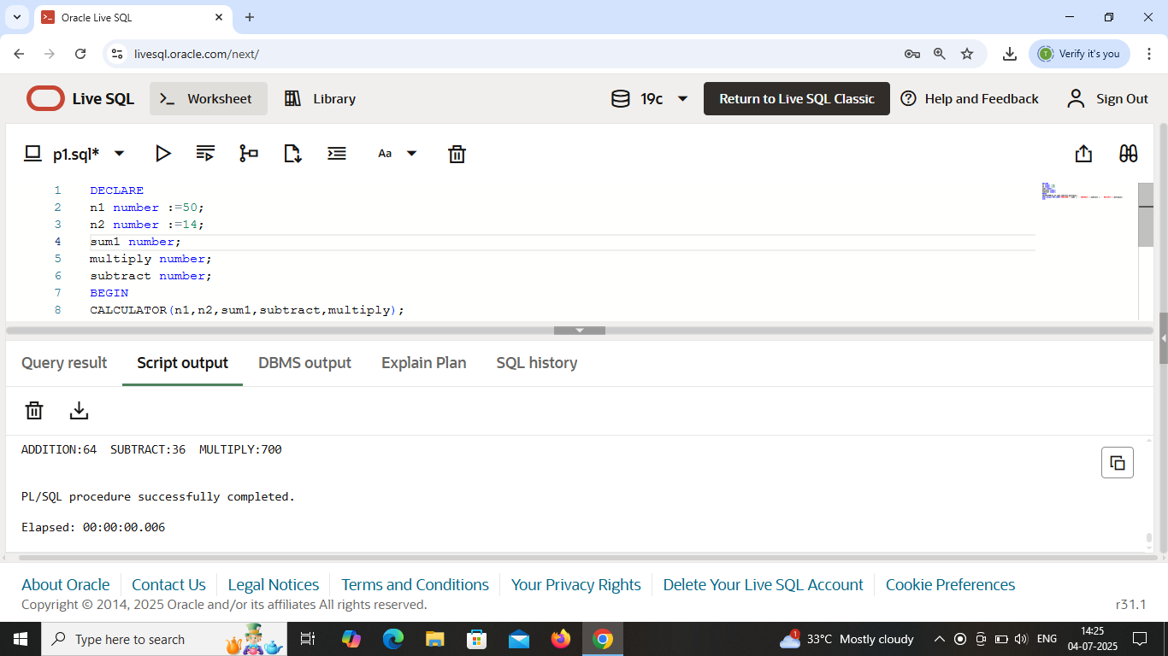

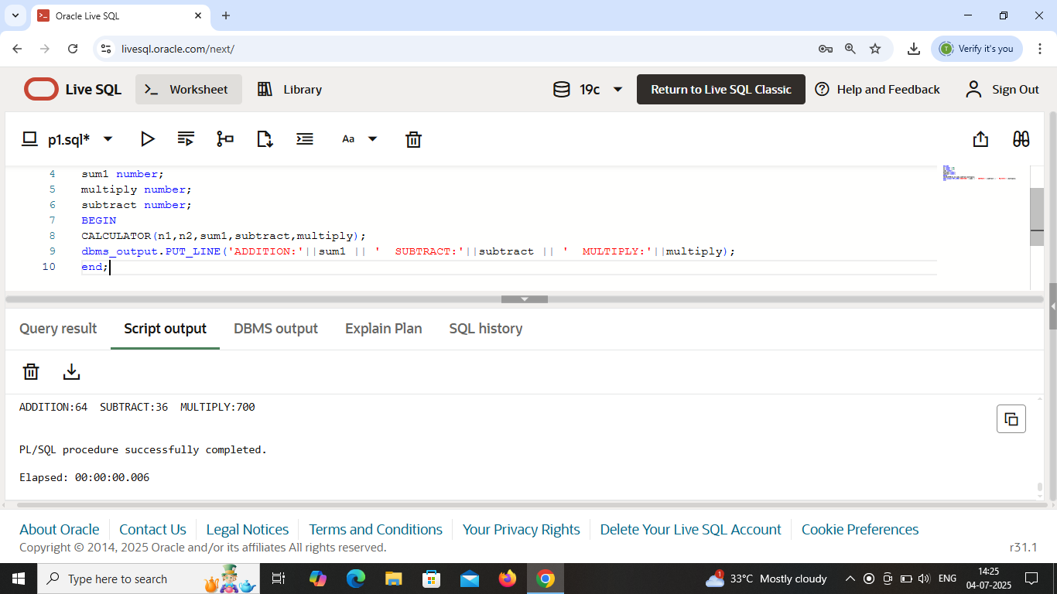

Values are initialized in ‘calculator’ procedure and called it.

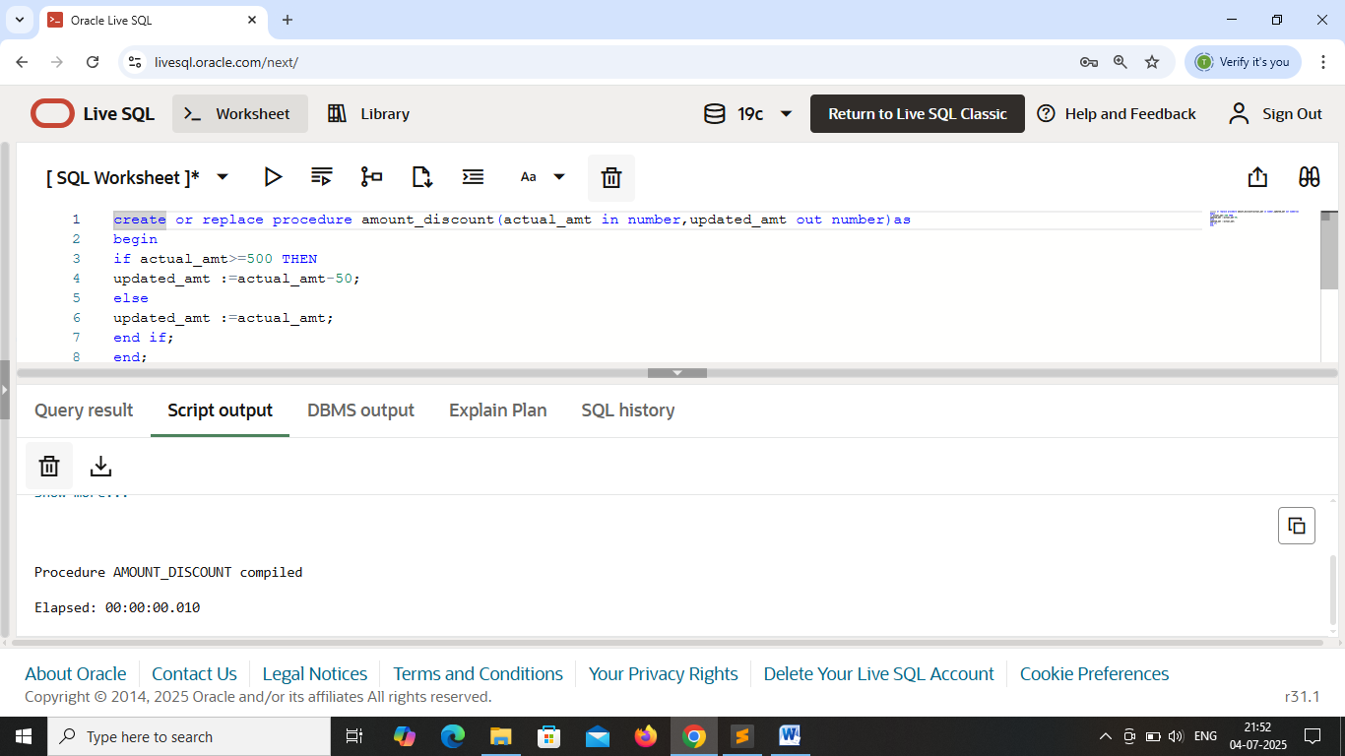

Here procedure ‘amount_discount’ is created . In this procedure , deduct Rs. 50 from amount whose passenger’s amount is greater than or equal to Rs.500 .

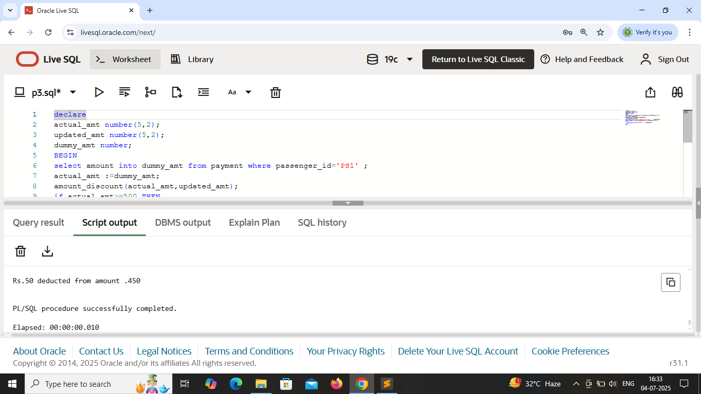

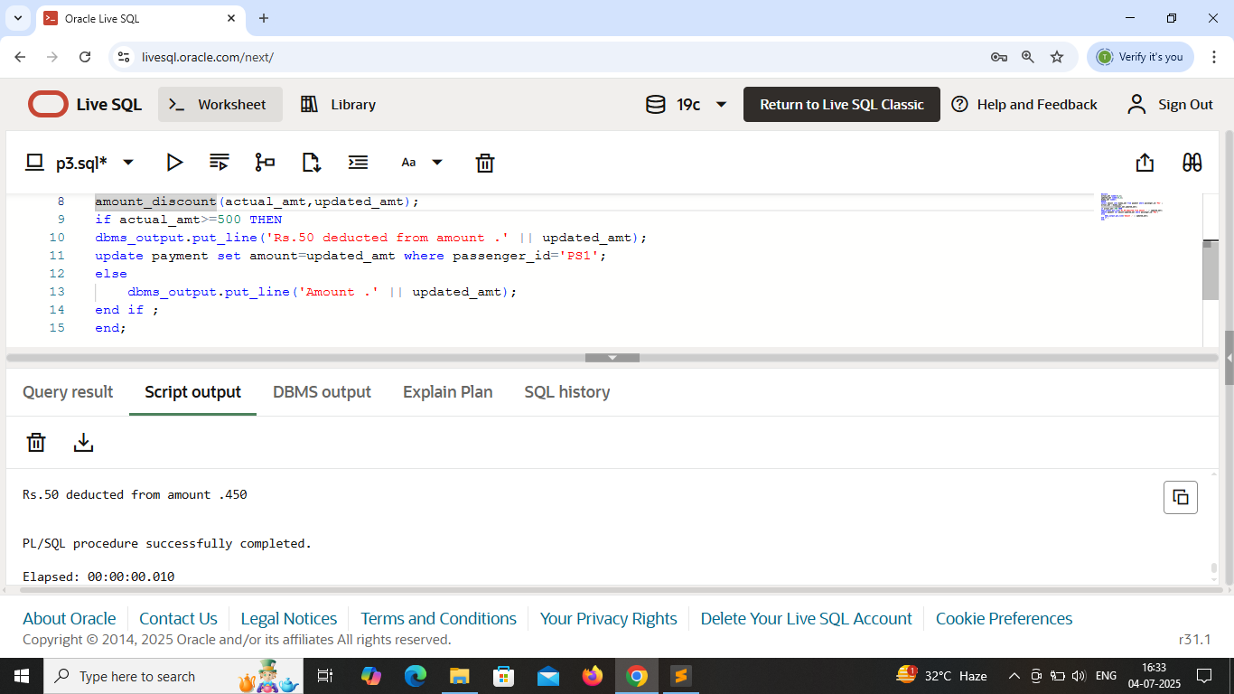

Output of Procedure ‘amount_discount’ . Passenger=’PS1’ is entered and their amount=500 that’s why deducted Rs.50 from amount .

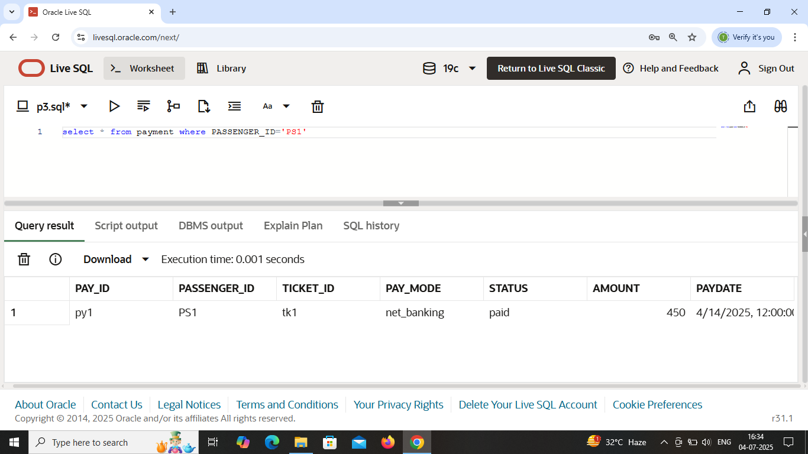

Updated in ‘payment’ table .

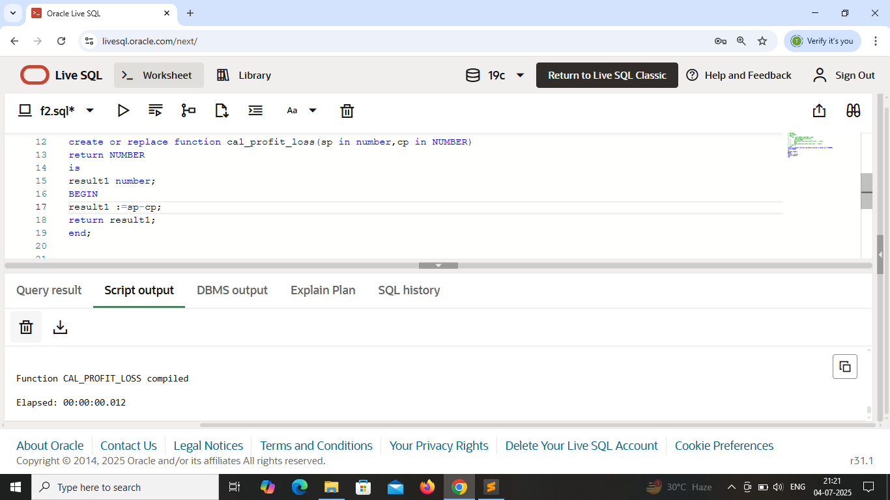

Function ‘cal_profit_loss’ is created . This function calculate profit and loss according to the value of selling price(sp) and cost price(cp) .

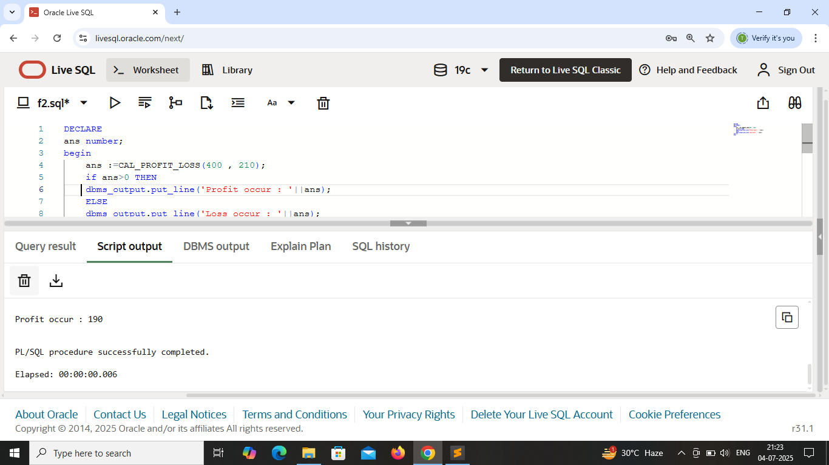 values are initialized in function and called it .In this , sp=400 ; cp=200 so profit occured .

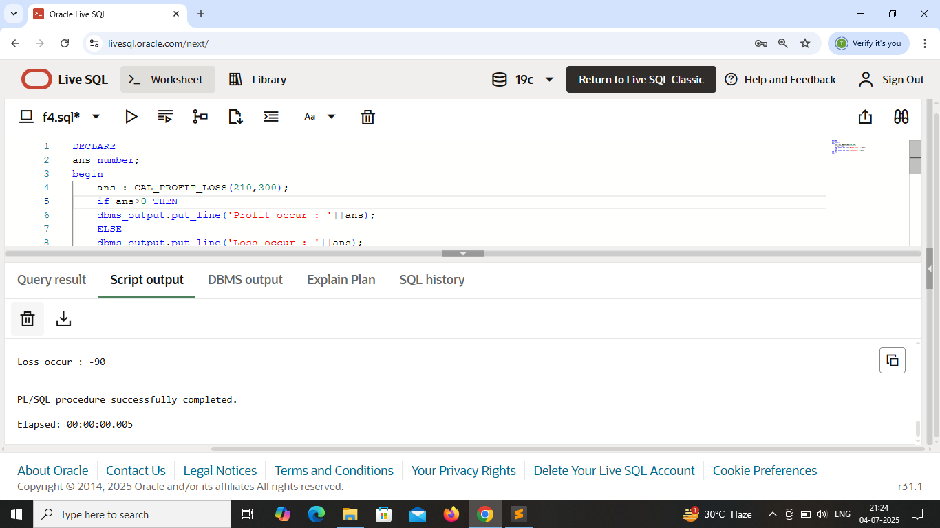 values are initialized in function and called it .In this , sp=210 ; cp=300 so loss occured .