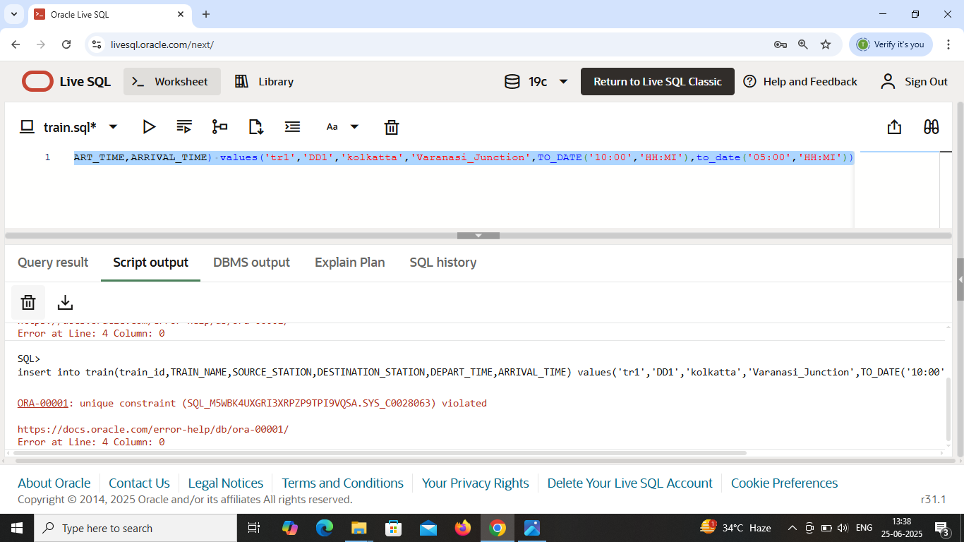

It doesn’t allowed duplicate entry because train_id holds **Primary key** . That’s why it’s not insert ‘tr1’ as ‘tr1’ already inserted .

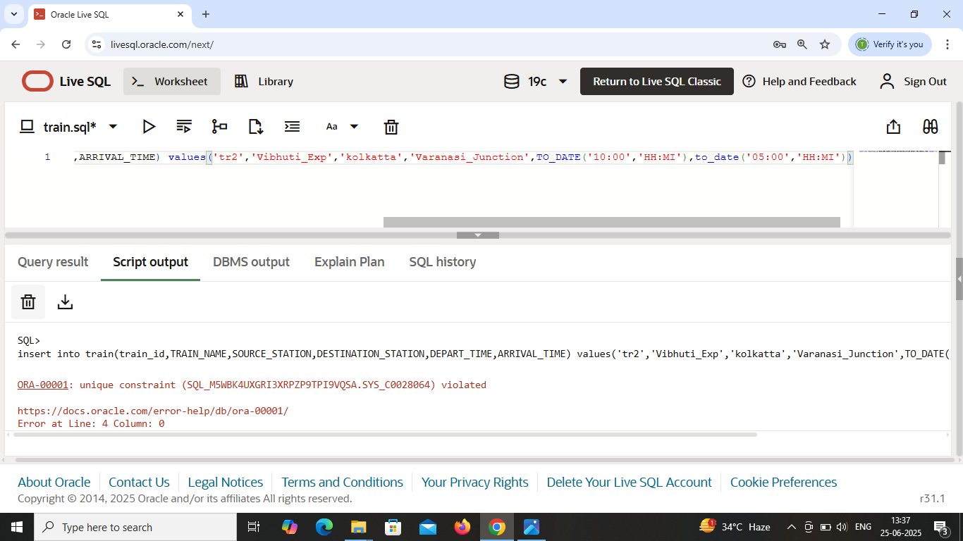

It doesn’t allowed duplicate entry as train_name holds **unique key** constraint . As ‘Vibhuti_Exp’ already inserted in train_name .

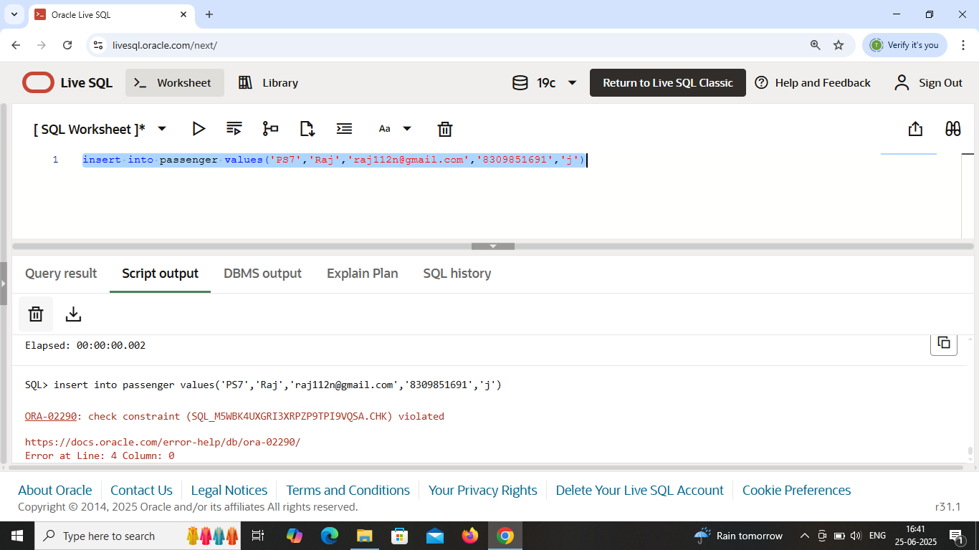

In passenger table , gender attribute holds **“check constraint” .** As this attribute only allow values (i.e., ‘f’,’m’,’o’).

Here, f : female ; m : male ; o : others .

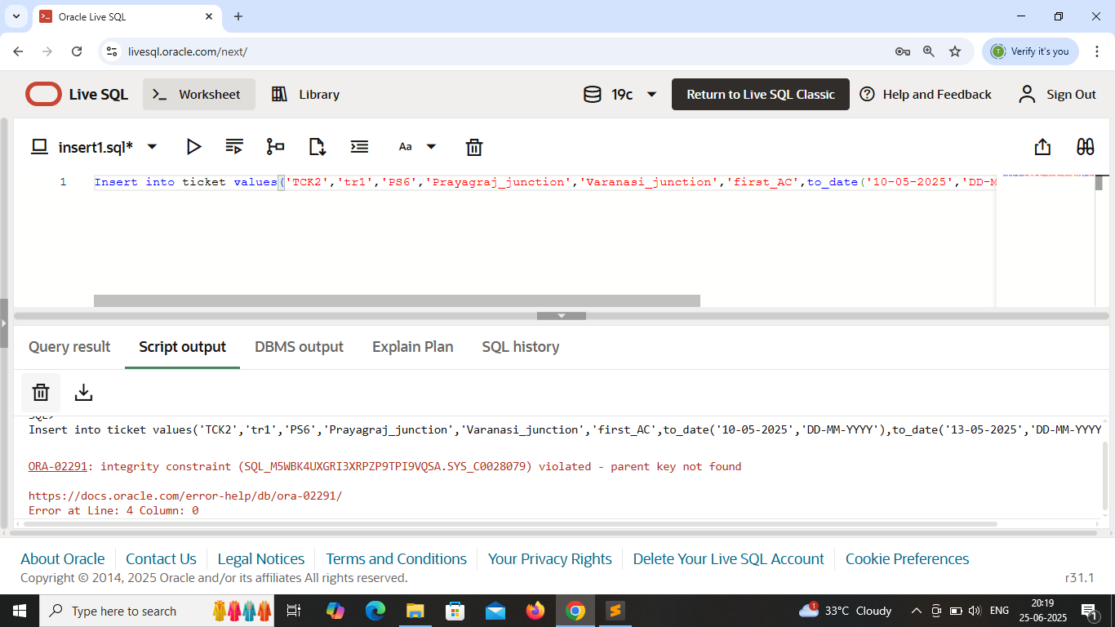

In ticket table , passenger_id is given as **foreign key** and ‘PS6’ is not inserted in passenger_id of Passenger table .