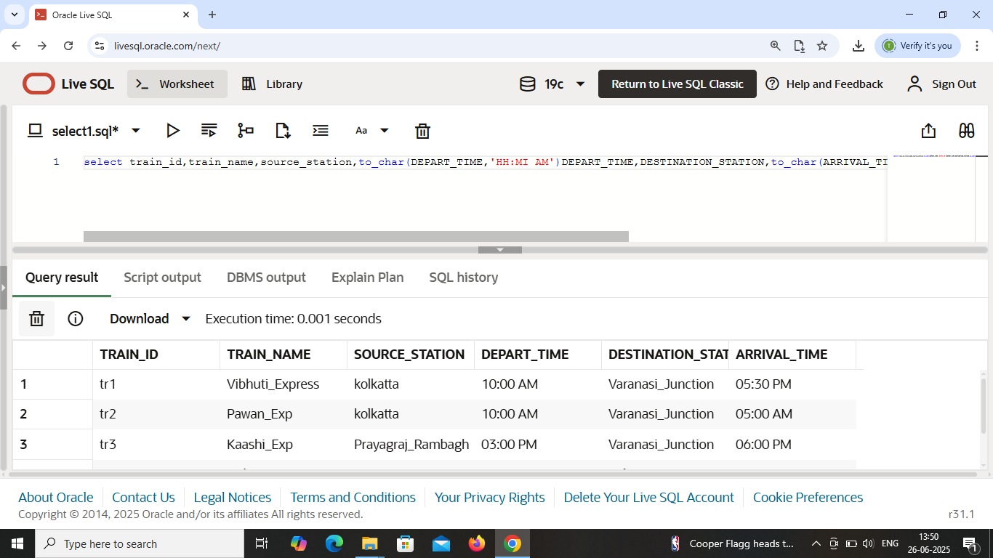

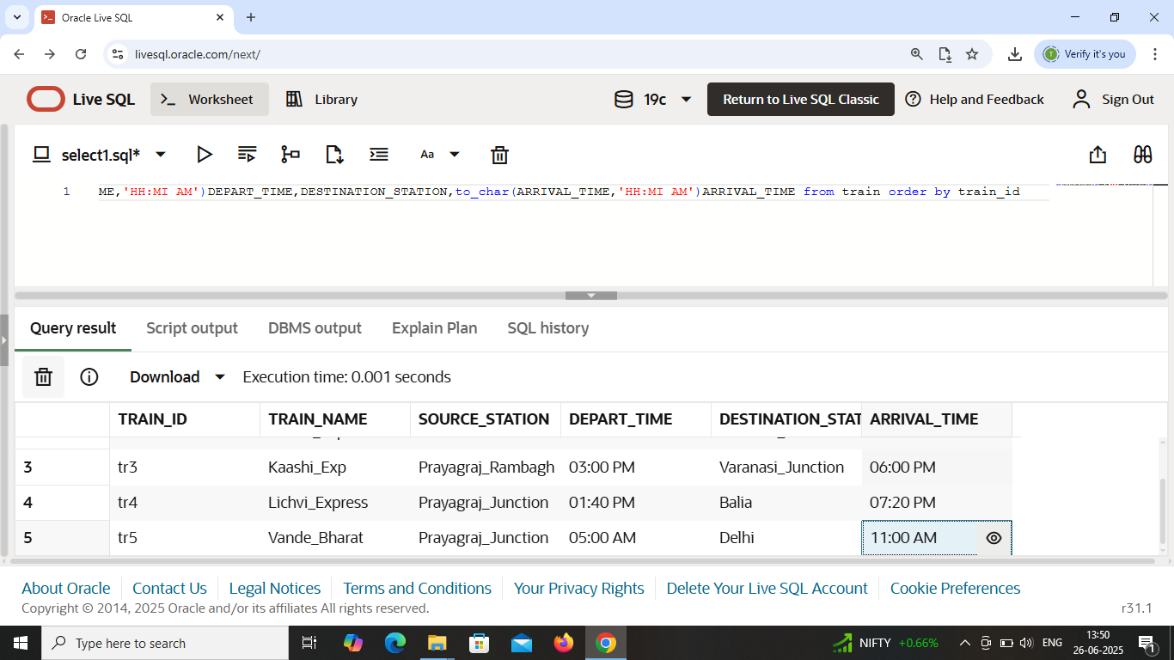

Fetching data from **train** table .

List of train details with their source & destination .

Use : Select , order by .

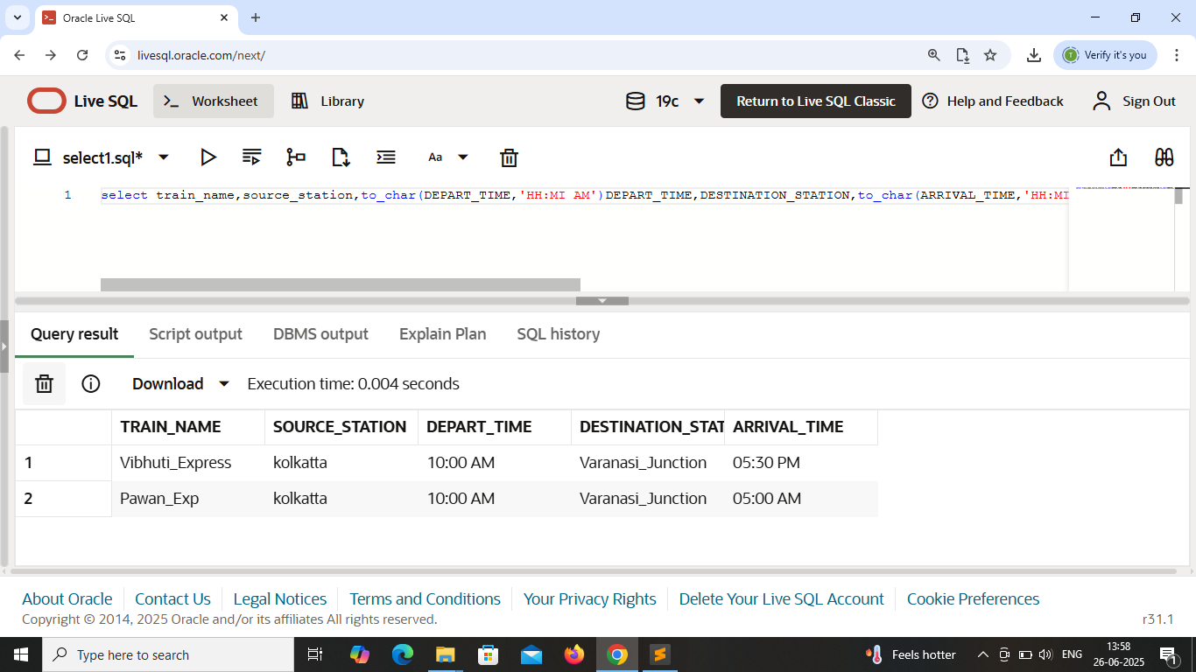

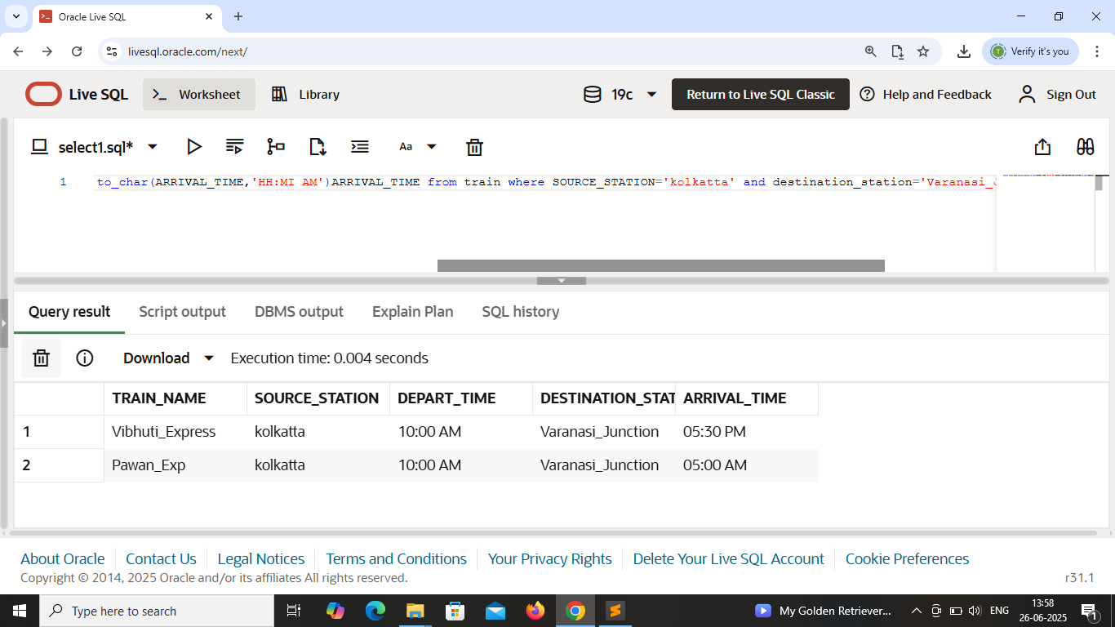

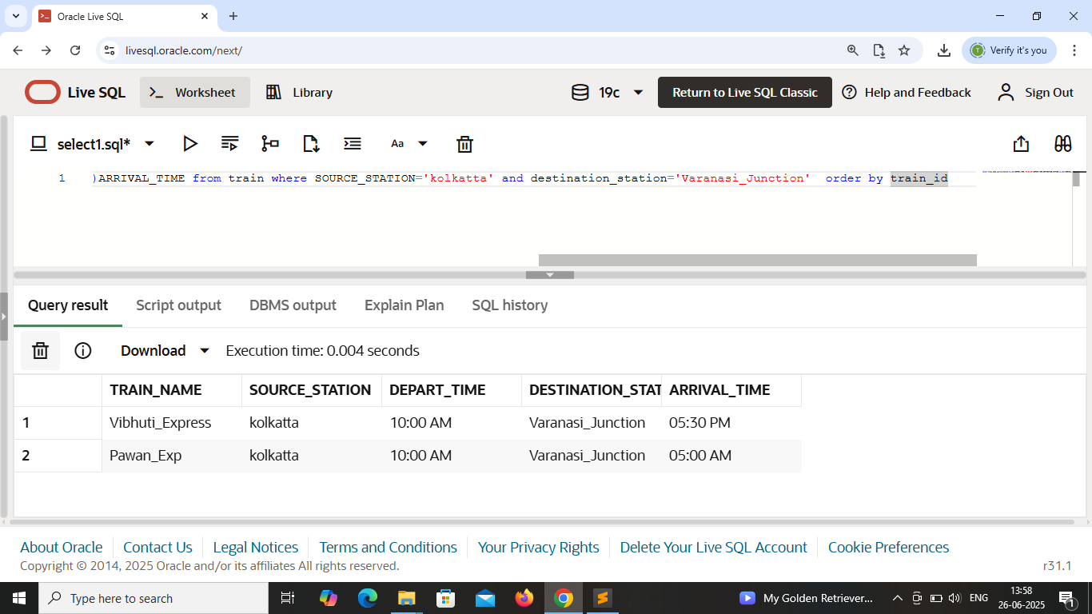

This output shows **train** details from source_station=**’Kolkatta’** to destination_station=**’Varanasi_junction’**.

Use : select , where , and , order by .

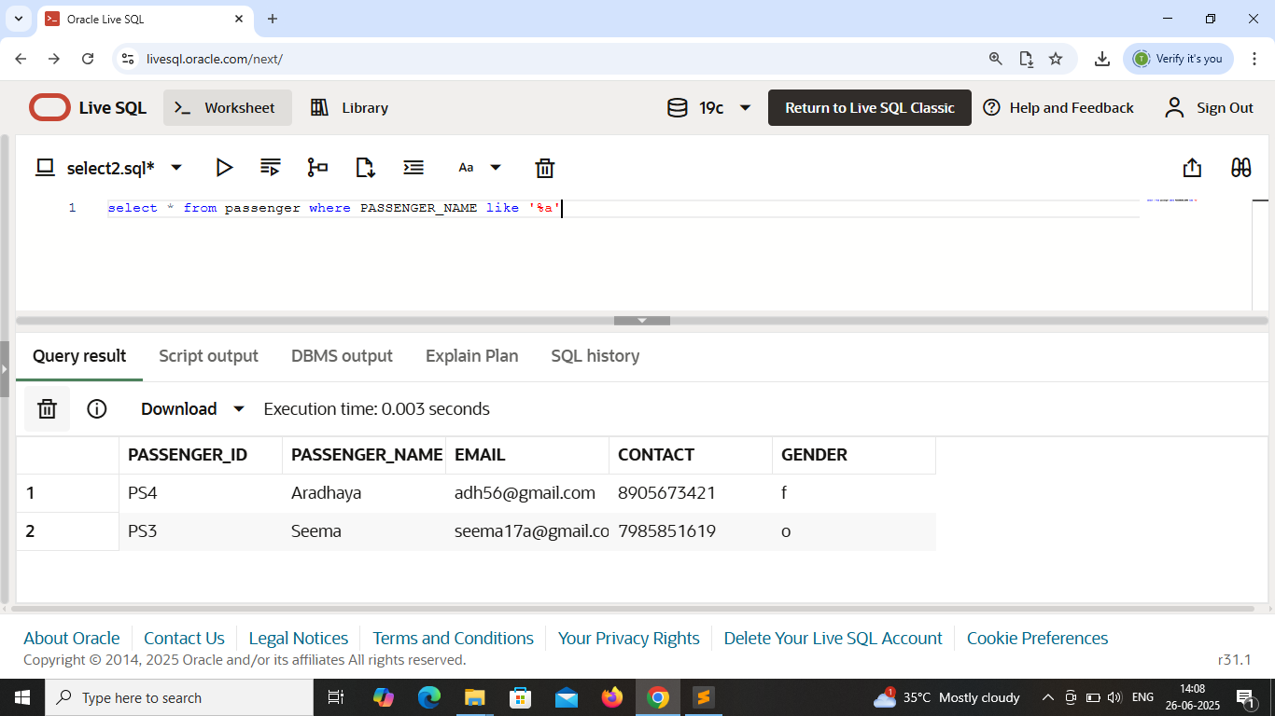 Passenger_name end with ‘a’ .

Use : select * with like operator .

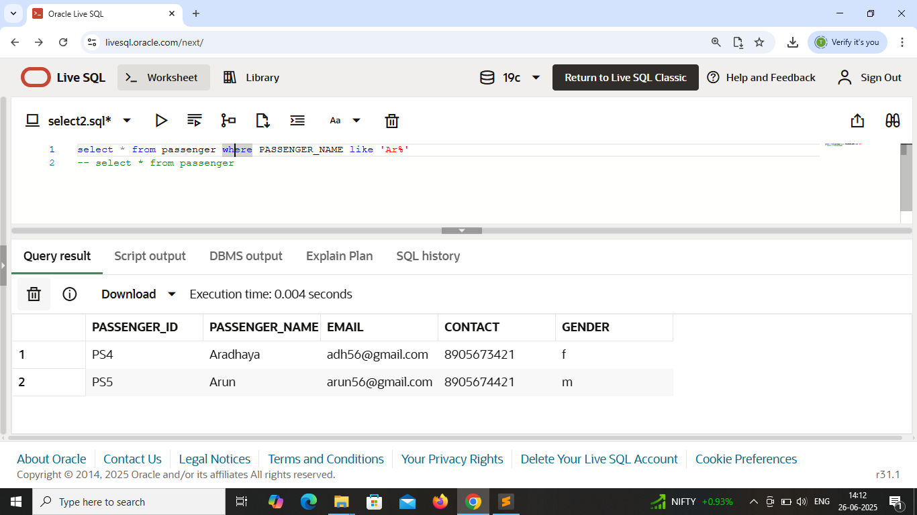

Passenger_name starts with ‘Ar’ .

Use : like operator .

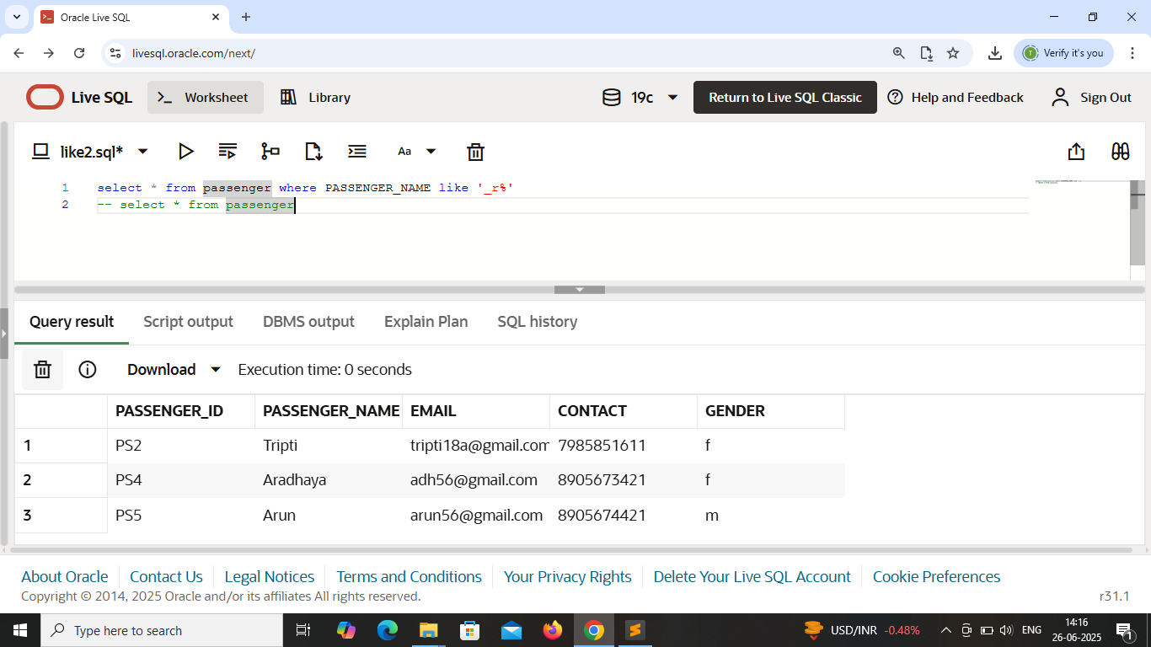

Passenger_name containing **first letter anything but second letter must be ‘r’** .

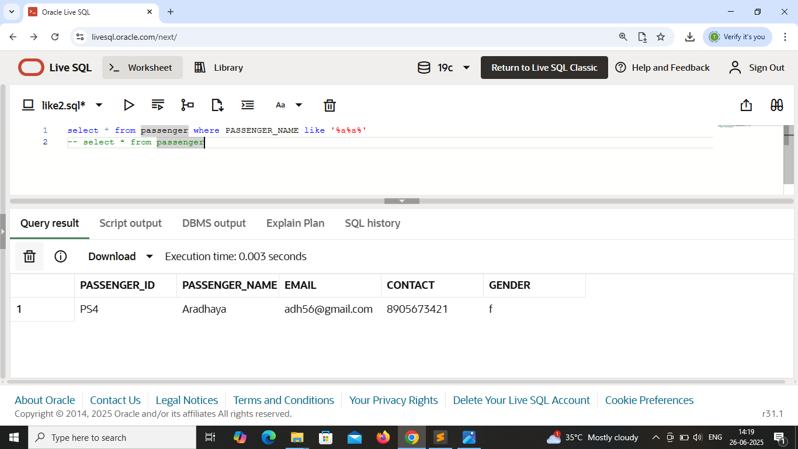 Passenger_name containing atleast ‘2 a’ .

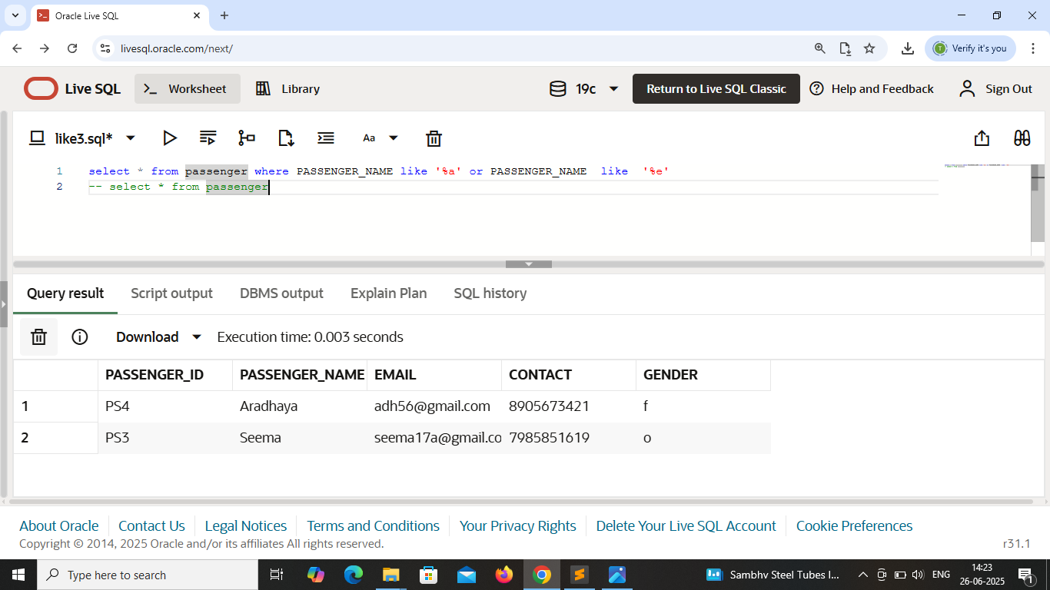 Passenger_name ends with ‘a’ or ‘e’ .

Use : like , or .

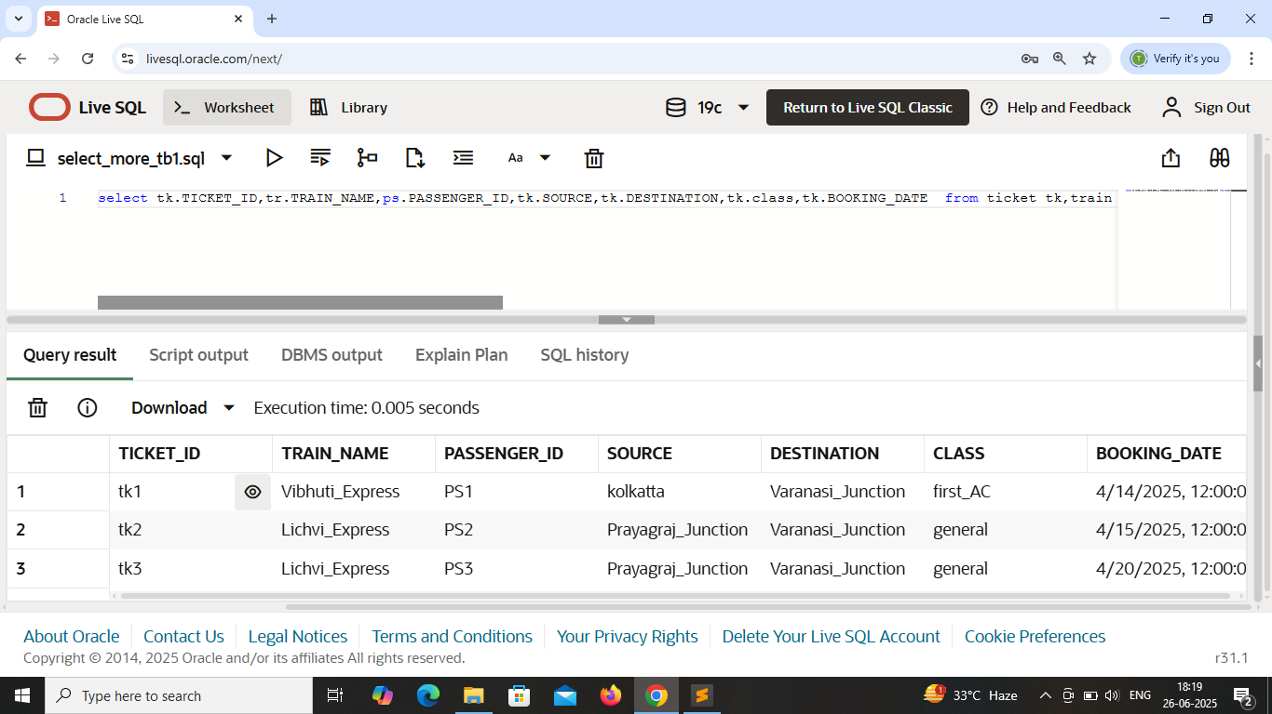

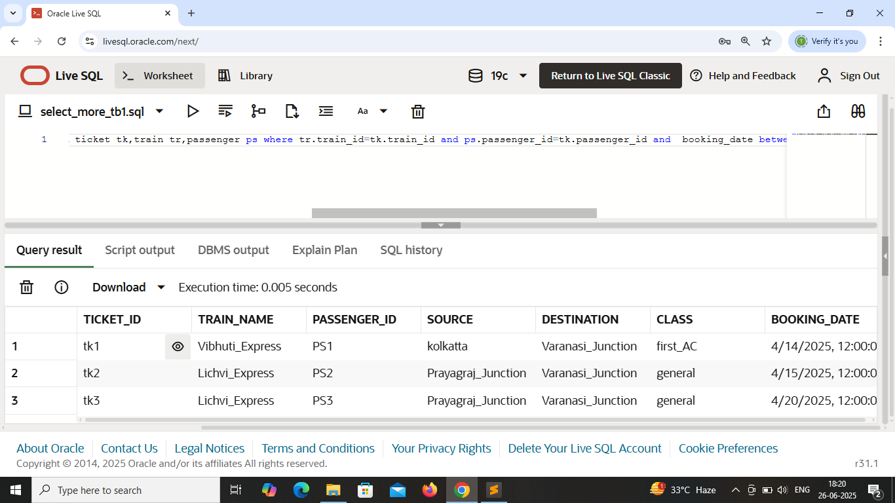

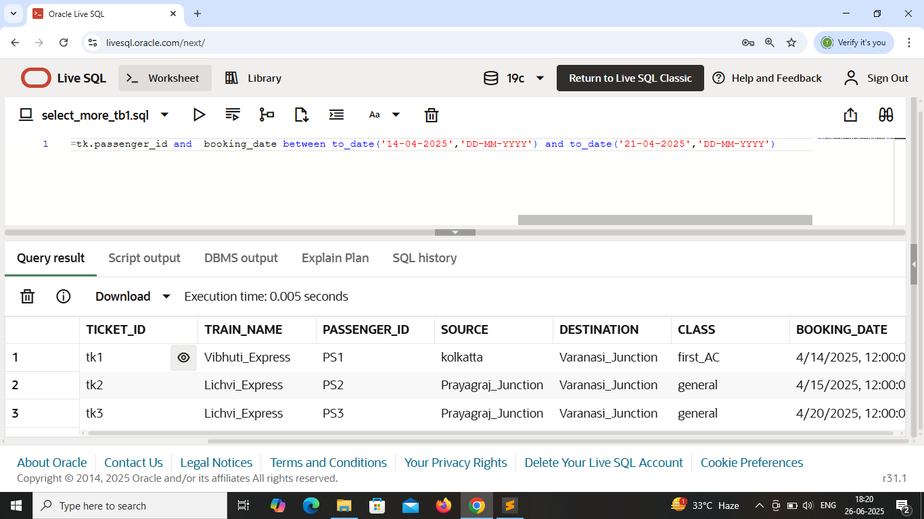

Fetching data from more than one tables .

Tables : Ticket , Train and Passenger .

Use select , where , and , between .

This output displays booking_date of passenger with their ticket and train details between 14/04/2025 to 21/04/2025 .

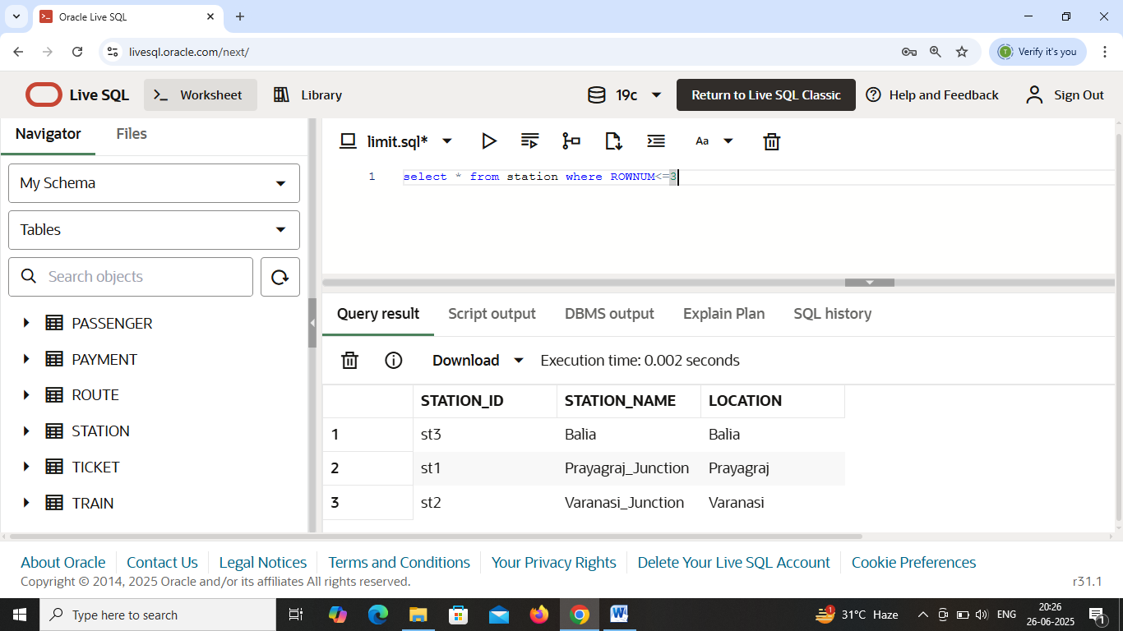

Limit : This keyword is not used in oracle database .

**Rownum** equivalent to **limit** .

This output displays **first 3 rows** of **station** table .