**Module-6 Jenkins**

**Assignment-1:**

Github repo -- <https://github.com/Tripti-TD/jenkins-assignments.git>

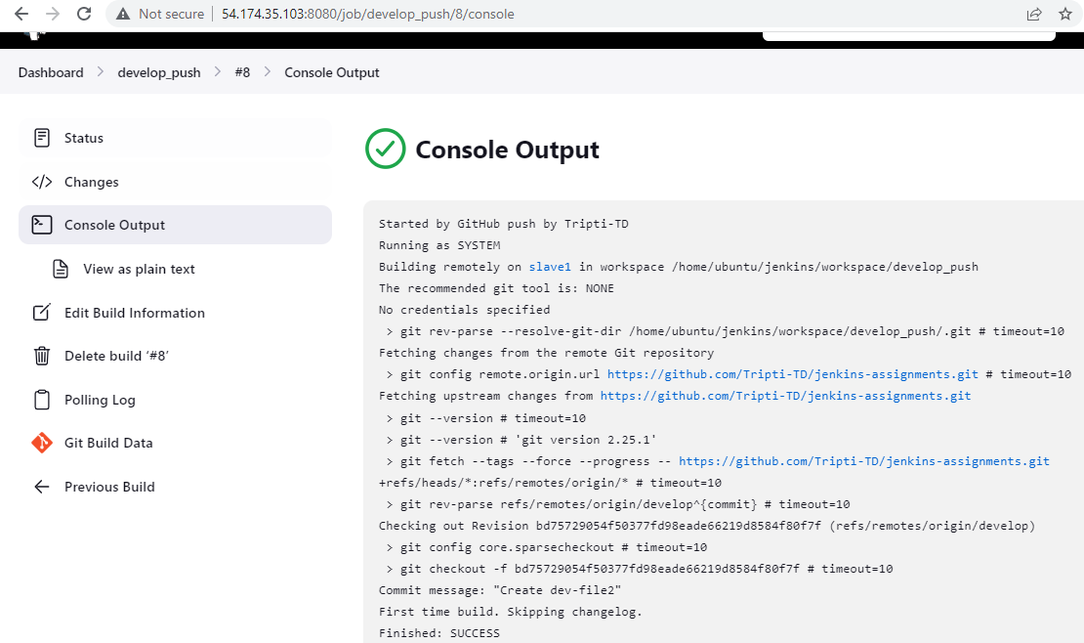

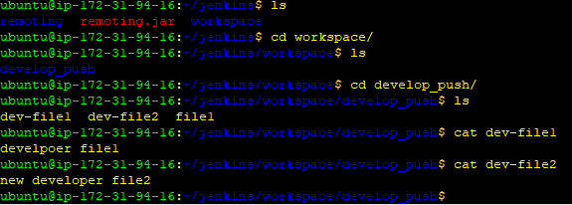

**Assignment-2:**

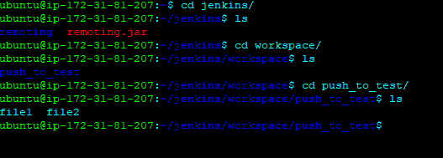

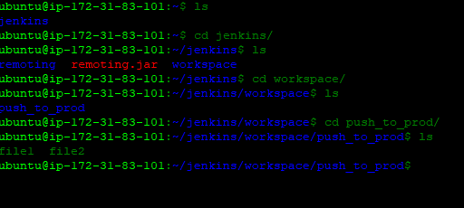

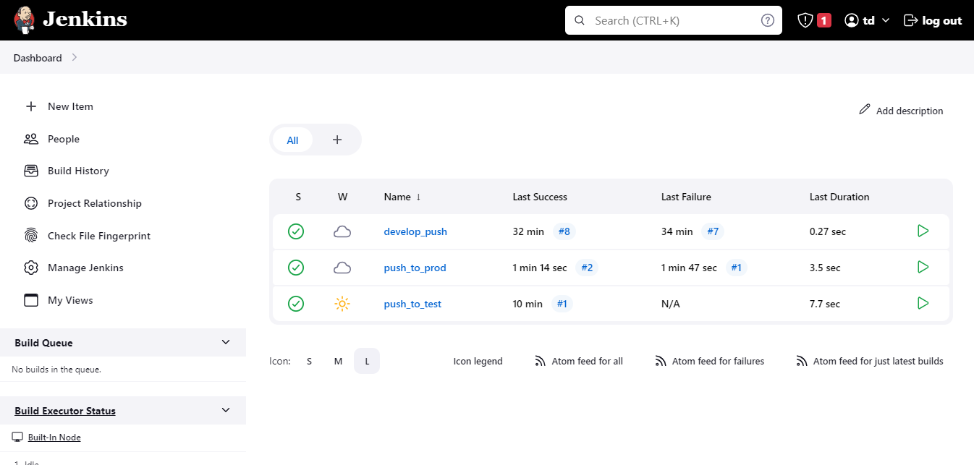

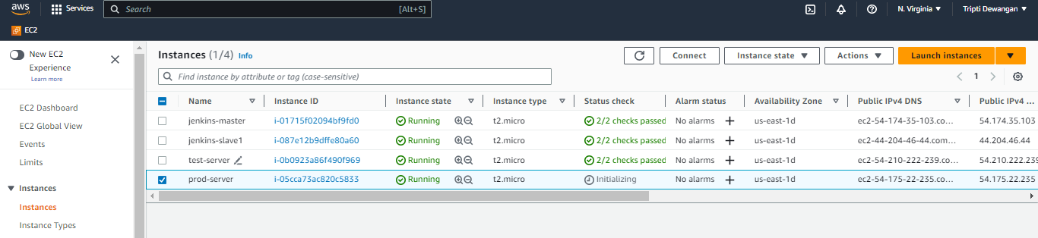

**Assignment-3:**

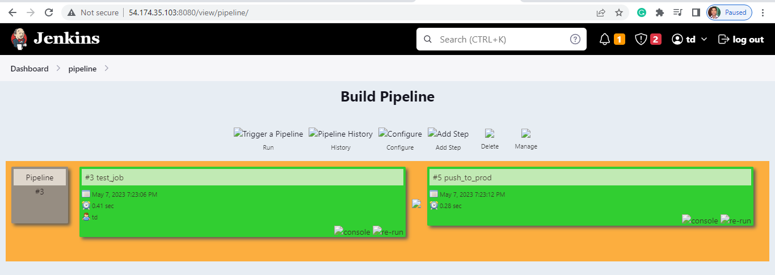

**Submitted by:**

***Tripti Dewangan***