Part A. Visualization
- Recreate Hans Rosling’s Visualization (with Graphics and Text Integration)
- An animated Hans Rosling-style visualization was created in Tableau, open the Tableau file to view the interactive chart with hover details.
- Additional columns were added to the dataset to enable interactive filters and customized tooltips in Tableau for better visualization and analysis.
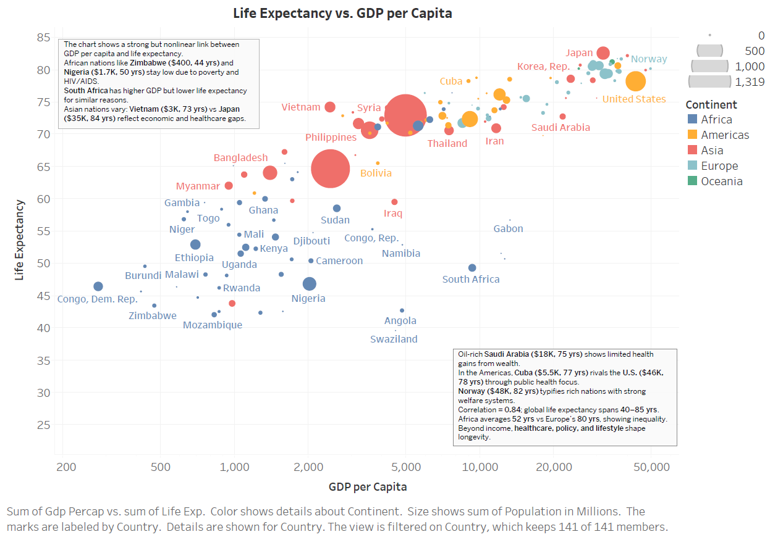
Key Differences & Influencing Events
- Strong GDP - Health Link:
Overall, life expectancy rises with income but gains slow after middle income showing diminishing health returns from wealth.
- Africa:
Many African countries (e.g., Zimbabwe, Mozambique, Nigeria) remain in the low-GDP, low-life-expectancy zone due to poverty, disease (especially HIV/AIDS), and limited healthcare investment.
- Asia:
Asian nations show wide variation, Japan and Korea achieved long lifespans through postwar industrialization and universal healthcare, while Vietnam, Bangladesh, and Philippines reflect rapid but uneven development.
- Americas:
Latin American countries like Cuba and Chile improved life expectancy through public health and education despite modest GDP, while United States remains high-GDP but not top-ranked in longevity due to healthcare inequality and lifestyle diseases.
- Oil-Rich Outliers:
Countries such as Saudi Arabia show wealth without proportional health gains, high GDP from oil, but only moderate life expectancy, highlighting uneven social development.
- Europe:
Wealthy European nations (e.g., Norway, Switzerland) combine high income and high longevity through strong welfare systems and healthcare access.

- Connected Scatterplot (with Graphics and Text Integration)
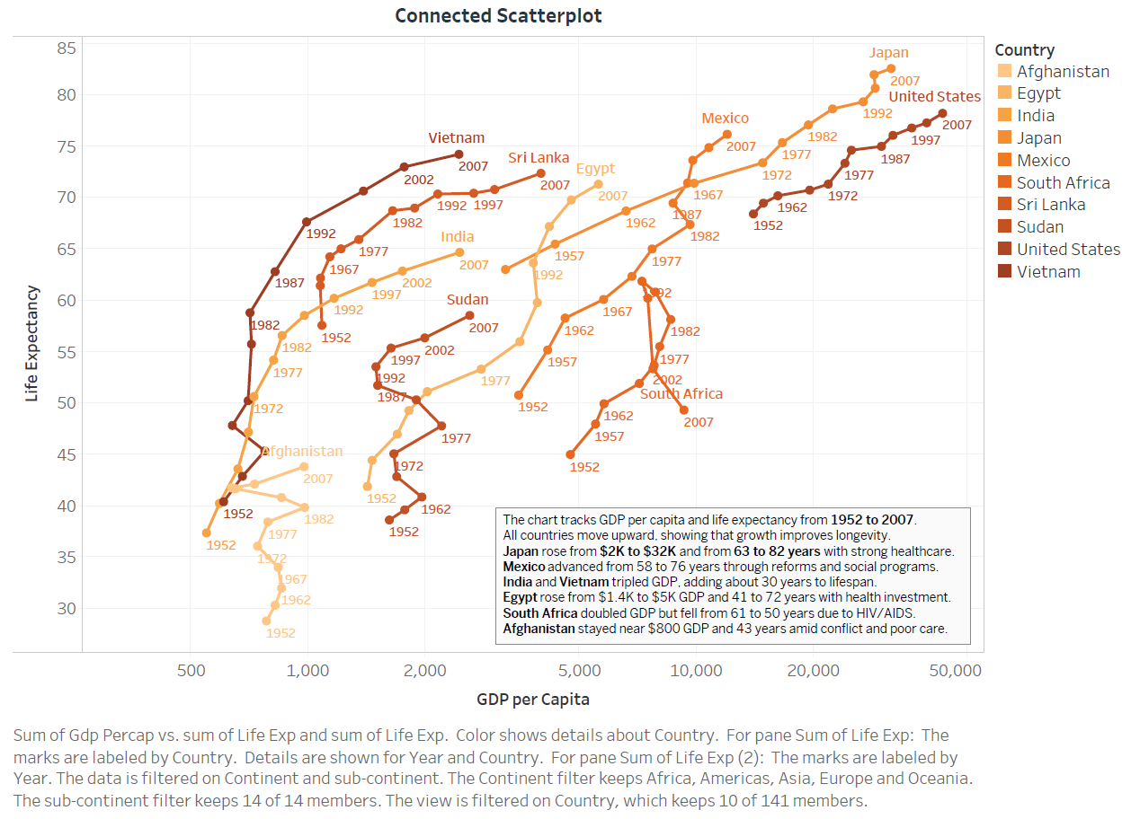
Key Differences & Influencing Events
- Overall Pattern:
All countries move upward and rightward over time (1952–2007), showing that rising GDP generally improves life expectancy.
- Japan:
Rapid post-World War II industrialization and investment in healthcare lifted Japan from poverty to one of the world’s healthiest, wealthiest nations.
- India & Vietnam:
Both nations tripled GDP and gained almost 30 years in life expectancy through economic liberalization and health reforms after the 1980s.
- Mexico & Egypt:
Achieved steady economic and social progress through education and healthcare expansion; moderate but consistent improvements.
- South Africa:
A unique case - economic growth did not translate to longer lives due to the HIV/AIDS epidemic in the 1990s–2000s.
- Afghanistan:
Minimal change, persistent conflict and poverty kept both income and life expectancy low.

Part B. Analytics
- Feature Set Construction
Steps to Create the Wide-Format Dataset
- I used Python (pandas library) to perform this task.
- Imported the Gapminder dataset using pd.read_csv() from the file gapminder_after1952.csv, which contains columns such as country, continent, year, gdpPercap (GDP per Capita), and lifeExp (Life Expectancy).
- Applied the pivot() function to reshape the dataset from long format (one row per country-year) to wide format, using: index = ["country", "continent"], columns = "year", and values = ["gdpPercap", "lifeExp"].
- Flattened the resulting MultiIndex column names to create readable labels like gdpPercap_1952, lifeExp_2007, etc. Used reset_index() to make country and continent regular columns.
- Finally, exported the transformed dataset as gapminder_wide_format.csv for subsequent analysis and visualization.
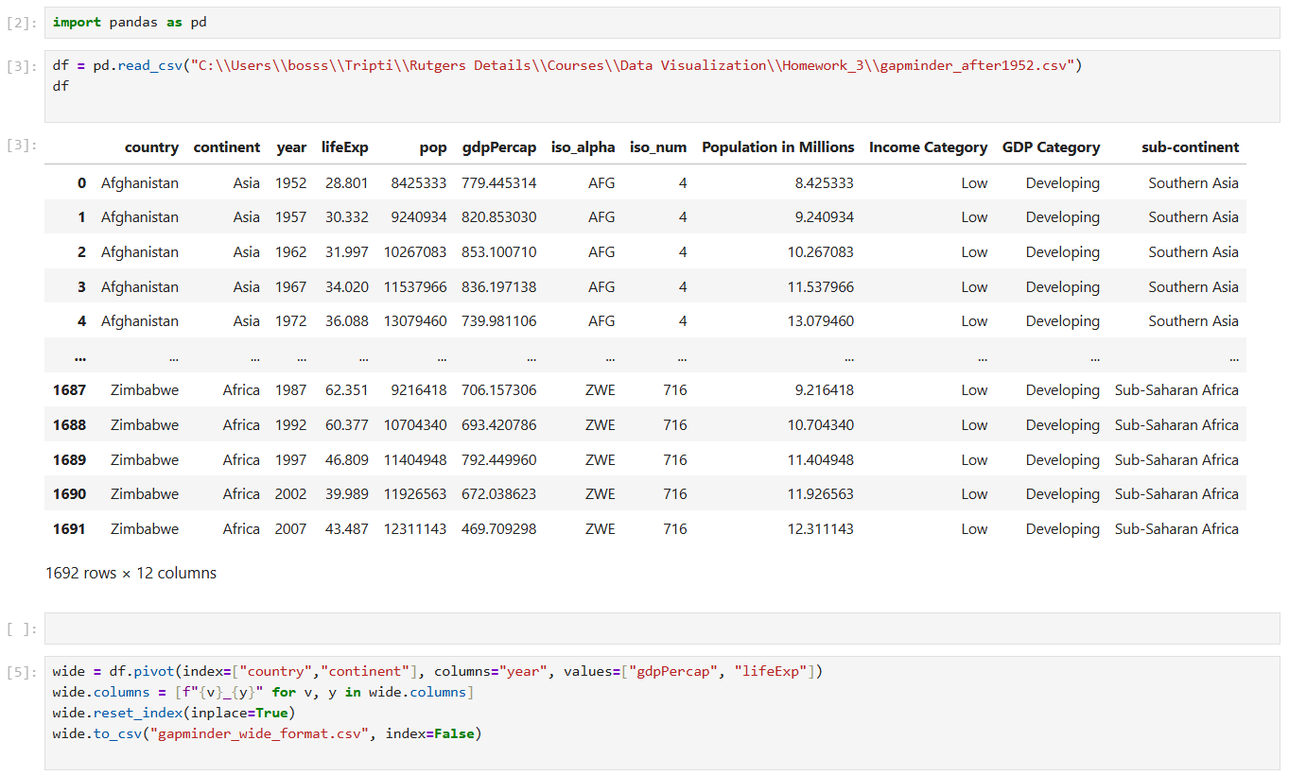
- 2-D Projection (MDS)
I used Orange to perform the Multidimensional Scaling (MDS) task.
- Imported the wide-format Gapminder dataset into Orange.
- Applied the MDS widget to project all countries into a two-dimensional space, where distances represent similarities based on GDP per Capita and Life Expectancy patterns.
- Exported the resulting 2-D coordinates as a CSV file.
- Imported this file into Tableau and created an interactive scatterplot.
- The visualization shows how countries cluster together based on economic and health similarities, countries close to each other have similar development patterns, while distant ones differ significantly.
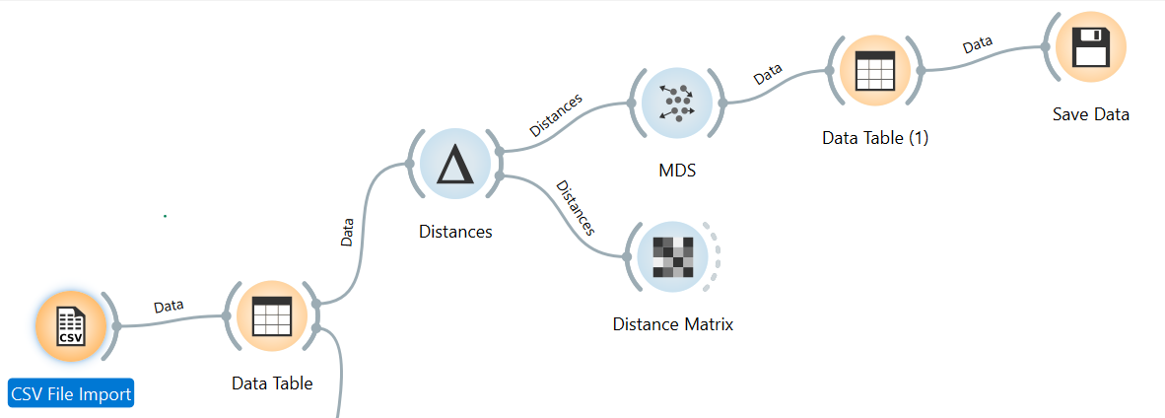

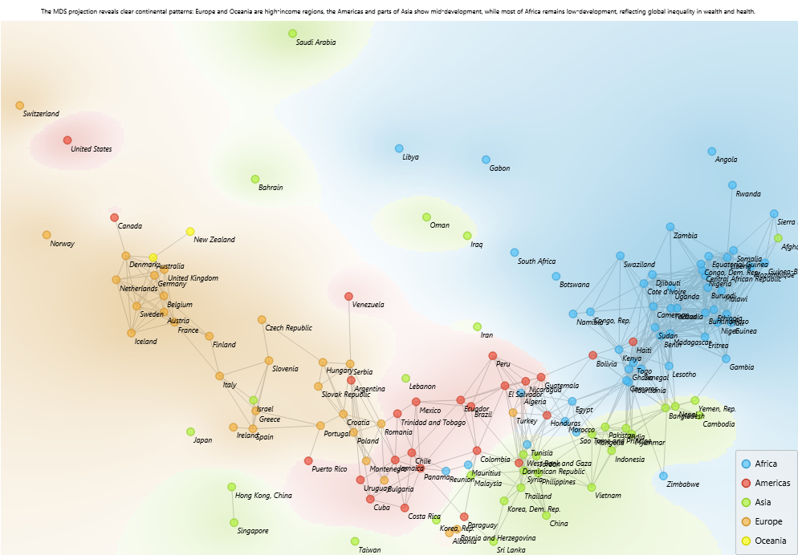
- Exported the resulting 2-D coordinates to Tableau to visualize.
- Created an interactive scatterplot showing how countries relate to one another based on their similarities.
- Used python code to add the flags in Shapes.
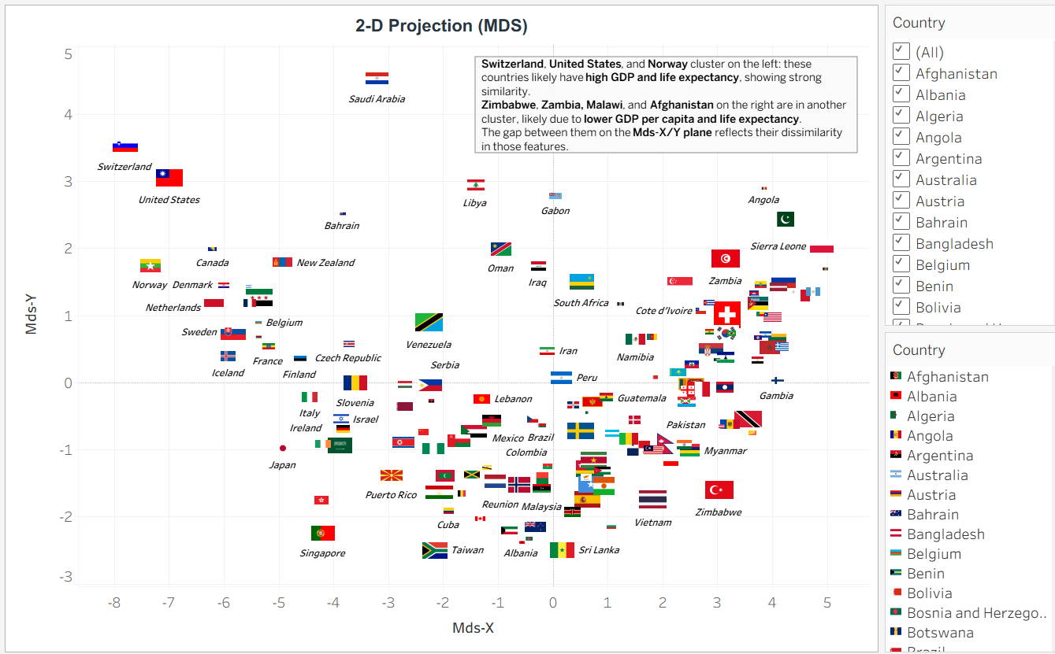
- Cross-Continental Similarities
  - United States – Switzerland – Norway:
Cluster together with high development levels.
GDP per capita ranges from $30000–$34000, and life expectancy from 79–82 years.
Their closeness reflects strong economies, advanced healthcare, and early industrialization.
  - Japan – Italy:
Appear near each other, despite being on different continents.
GDP per capita increased from $2000–$3000 (1952) to $30000 (2007), with life expectancy rising from 63–82 years.
Both experienced rapid post-war industrial growth and improved living standards.
  - Mexico – Turkey:
Represent mid-income countries with steady progress.
GDP per capita grew from $2000 to $10000, and life expectancy from 58 to 75 years.
Their similar upward trends explain their proximity in the MDS map.
  - South Africa – Guatemala:
Cluster together due to stagnation and inequality.
South Africa’s GDP rose from $3000 to $6000, but life expectancy declined to 50 years (HIV/AIDS impact).
Guatemala’s GDP grew from $2000 to $5000, with life expectancy improving to 70 years.
  - Vietnam – India – Egypt:
Show comparable upward development paths.
GDP per capita increased from about $1500 to $5000, and life expectancy from 40 to 72 years.
Reflect similar progress through industrial reforms and health improvements.
Summary:
The MDS map captures these cross-continental similarities by placing countries with parallel economic and health progress near each other, while the connected scatterplot visually confirms their comparable trajectories over time.
- Outliers
- Saudi Arabia:
Positioned high on the MDS-Y axis with GDP around $25000–$27000 and life expectancy near 74 years. The rapid oil-based economic rise increased wealth faster than health outcomes.
- United States:
High GDP around $32000, but slightly lower life expectancy (79 years) compared to other rich nations due to lifestyle and healthcare disparities.
- Singapore and Hong Kong:
High-performing Asian economies with GDP up to $30000 and life expectancy above 80 years. Their export-led growth and dense urban systems make them distinct from regional peers.
- Zimbabwe and Zambia:
Low GDP below $2000 and life expectancy around 40–50 years. Economic instability and disease burden explain their distant position on the MDS map.
- Afghanistan:
With a very low GDP of around $800 and a life expectancy of about 43 years, the country is significantly affected by ongoing conflict and poor access to healthcare.
Summary:
The connected scatterplot supports these patterns: Saudi Arabia shows strong GDP gains but slow health improvement, the United States plateaus at high GDP, and countries like Zimbabwe and Afghanistan progress minimally. Their unusual economic and health paths make them clear outliers in the MDS projection.
- Clustering
- The process starts with CSV Import, Data Table, and K-Means, where the dataset is clustered based on GDP per capita and Life Expectancy to group countries with similar development patterns.
- Next, Select Columns, Group By, and Data Table summarize each cluster by calculating mean values for key features.
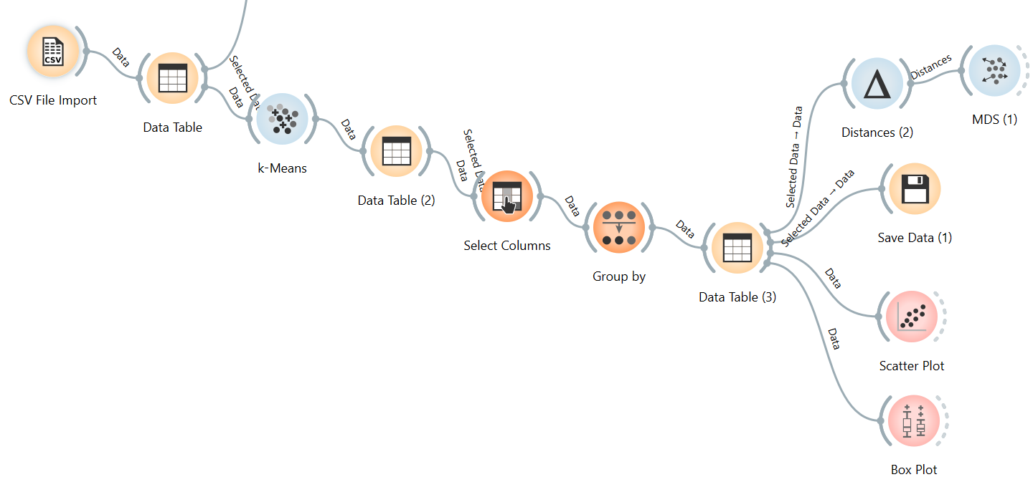
- Cluster Visualization
- The Distances, MDS, and Scatter Plot steps visualize how countries relate based on overall similarity. The MDS plot reduces multiple variables into two dimensions, showing how similar or different countries are as a whole. In contrast, the Scatter Plot directly compares two specific variables, such as GDP per capita and Life Expectancy, showing their actual relationship rather than overall similarity.
- Finally, the Box Plot displays the distribution of features such as Life Expectancy, revealing global variation with an average of about 51.46 years in 1957. In short, box plot is showing centroid.
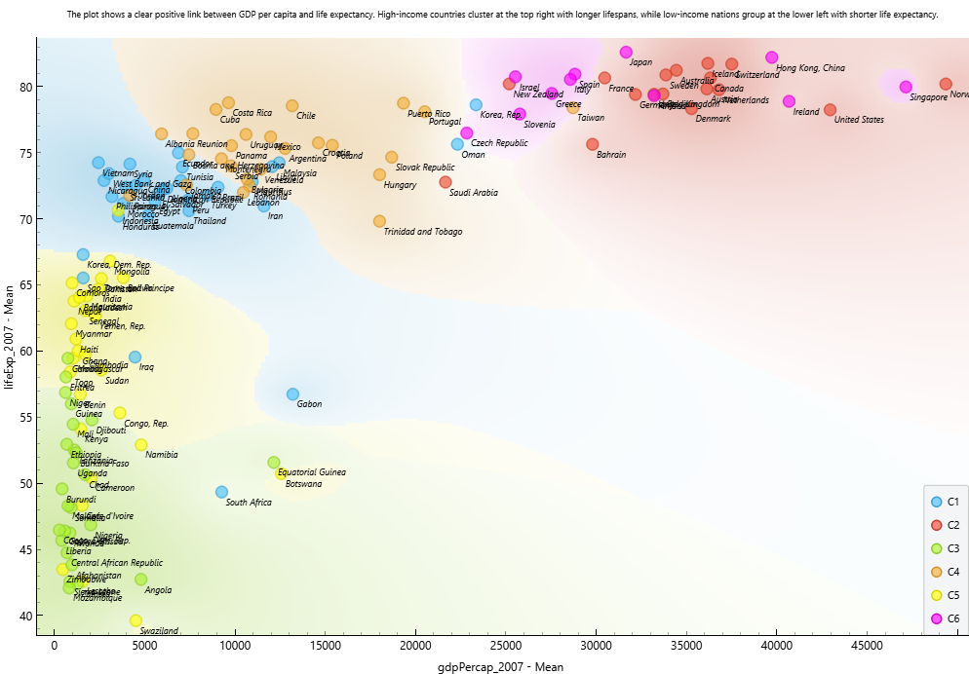
Clustered Relationship between GDP and Life Expectancy (2007)
The plot shows a strong positive relationship between GDP per capita and life expectancy across clusters.
- C1 & C3 (Blue/Green): Low-income countries with GDP below $10000 and life expectancy under 65 years, mainly in Africa.
- C4 (Orange): Middle-income nations like Mexico, Brazil, and Malaysia with GDP between $10000–$25000 and life expectancy around 70–75 years.
- C2 & C6 (Red/Pink): High-income economies such as the US, Japan, and Switzerland, with GDP above $25000 and life expectancy over 80 years.
Overall, higher GDP corresponds to longer life expectancy, with clear separation between low-, middle-, and high-income country clusters.

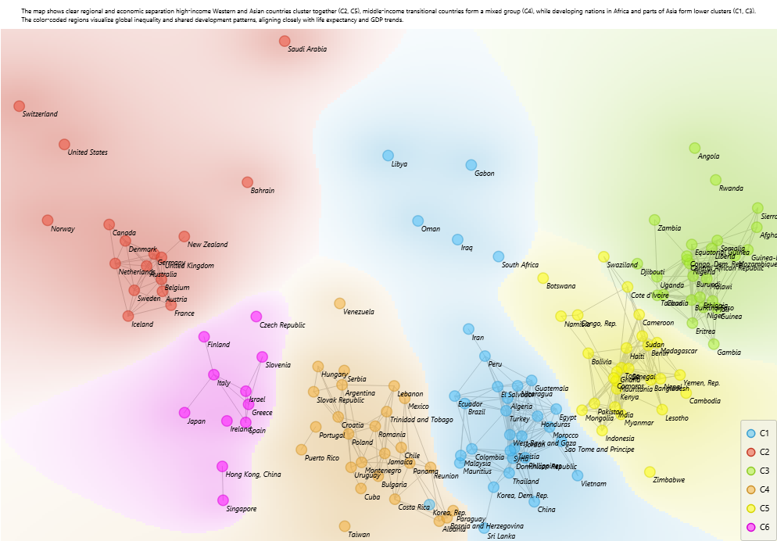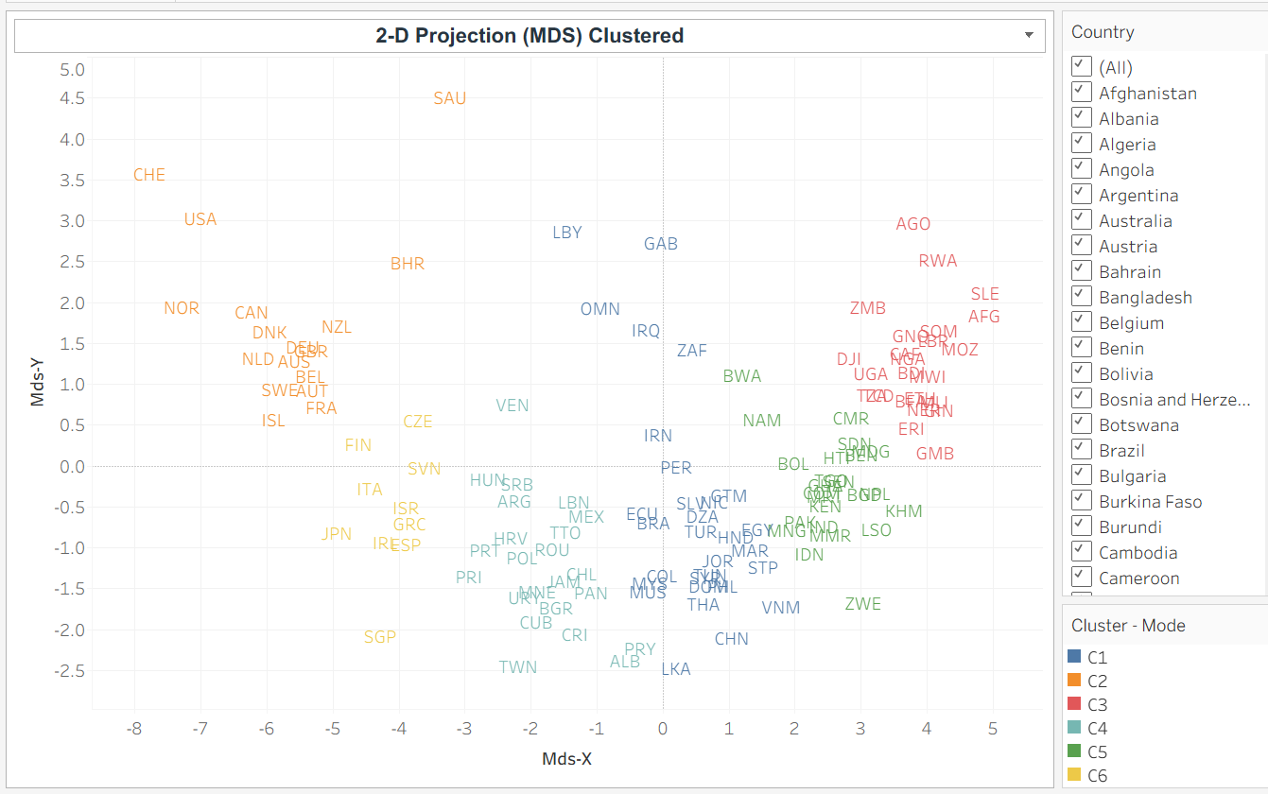
MDS Projection (In Orange & Tableau)
• High-income cluster (C2, C5):
Includes countries like the United States, Switzerland, and Japan, representing highly developed economies with long life expectancy and strong social systems.
• Upper-middle-income cluster (C4):
Countries such as Mexico, Brazil, and Turkey show steady economic growth and improving health outcomes, reflecting emerging stability.
• Emerging economies cluster (C1):
Nations like Peru, Egypt, and Indonesia are in a transitional stage, progressing toward higher income and better living standards.
• Developing cluster (C3):
African and South Asian countries such as Zambia, Kenya, and Bangladesh face limited healthcare and slower economic advancement.
• Low-income cluster (C6):
Countries like Zimbabwe, Malawi, and Mozambique struggle with poverty and lower life expectancy due to poor access to health and resources.
• Oil-rich outliers:
Nations like Saudi Arabia and Bahrain exhibit strong economic wealth but moderate health outcomes, reflecting uneven development.
Cluster & Continent Centroids (In Tableau)
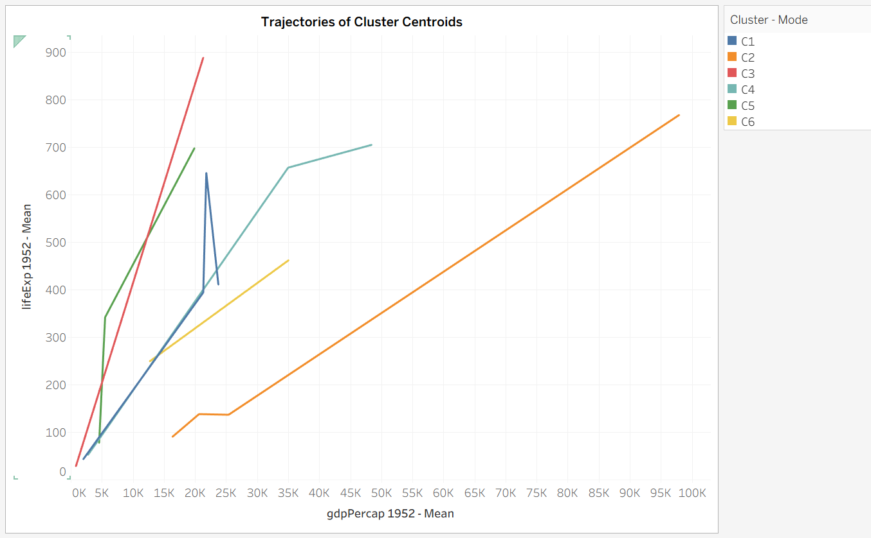
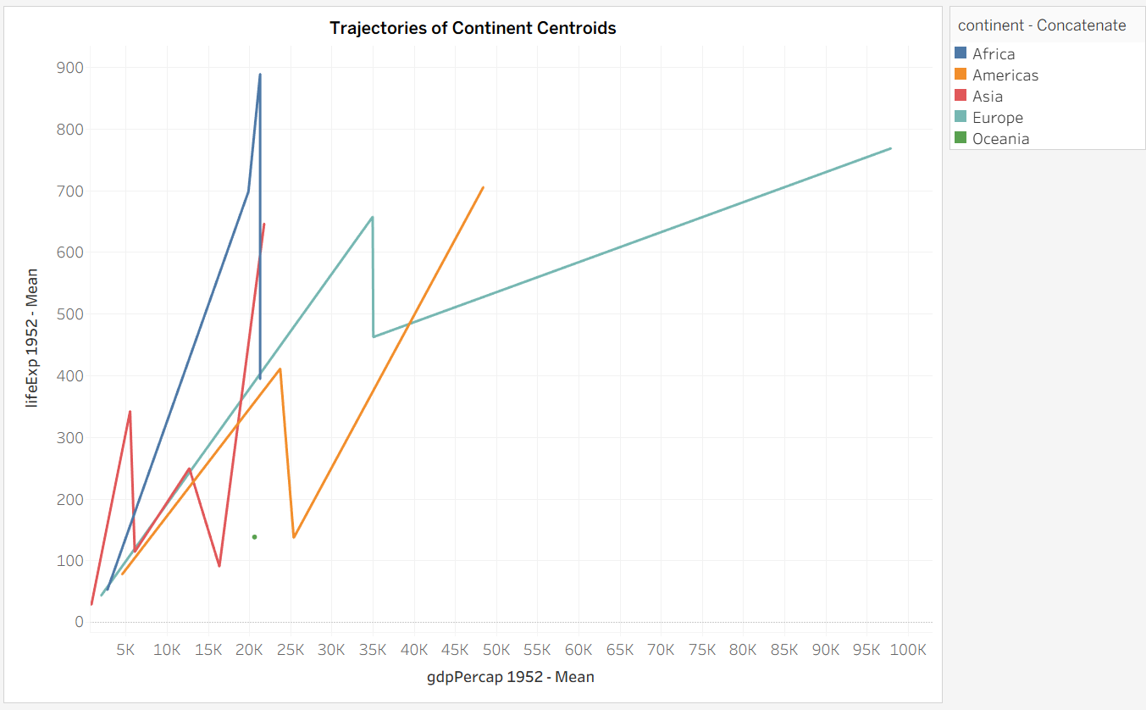
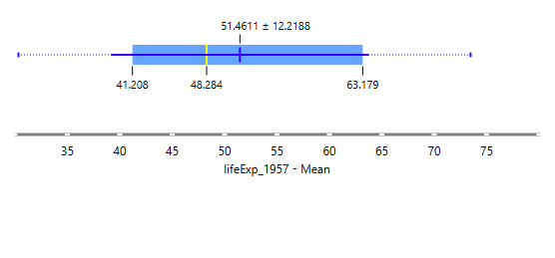
Box plot (In Orange)
The box plot shows the distribution of life expectancy in 1957 across all countries. The mean life expectancy was about 51.46 years, with a standard deviation of + and - 12.22, indicating considerable variation among nations. Most countries had life expectancy values between 41.21 and 63.18 years, as shown by the box’s interquartile range. The yellow line marks the mean, while the black line represents the median, highlighting that several developing countries had much lower life expectancy than the global average during that period.

----------------

