HCLTech Career Shaper Programme
III Year Industry Project | Academic Year 2025-26
RAG-Based Document Q&A System
Project No. 72 | Domain: LLM / Python | Advanced
Project Report
Field | Details
Learner name | [FILL IN]
Roll number | [FILL IN]
College / campus | [FILL IN]
Mentor | [FILL IN]
Submission date | [FILL IN]
Format | Individual project (1 learner), 4 weeks

Retrieval-Augmented Generation for question answering over public-domain documents (Indian Constitution, government schemes, technical manuals) using LangChain, ChromaDB and an OpenAI / open-source LLM, with source display, abstention and legal/medical safeguards.

Abstract
This report describes the design, implementation and evaluation of a Retrieval-Augmented Generation (RAG) system that answers questions over a corpus of 50 public documents: 20 on the Constitution of India, 15 on government schemes and Acts, and 15 technical manuals from US federal agencies. The system splits documents into sentence-aware chunks, retrieves the most similar chunks, and returns an answer together with the exact source chunks, a retrieval-confidence score and, when appropriate, a legal or medical disclaimer. If the best chunk is not similar enough, it abstains instead of guessing. The code supports a ChromaDB vector store through LangChain with local or OpenAI embeddings, an OpenAI or Ollama chat model, and a fully offline TF-IDF + extractive baseline that needs no API key.
On 150 hand-written gold questions the offline baseline retrieves the correct document first 96.7% of the time (hit@3 99.3%, MRR 0.980), returns an answer containing the gold span in 80.0% of cases, and refuses 76.7% of 30 out-of-scope questions while wrongly refusing 6.7% of in-scope ones. A 5,000-row monitoring dataset was cleaned, profiled in an EDA notebook with six visualisations, and documented in a data dictionary. Honest scope note: the dense-embedding and LLM configurations are implemented but were not executed in the development environment (no network access), so no measured results are claimed for them; Section 7.6 lists the commands to produce them.

Contents
- 1 Introduction and problem statement
- 2 Objectives and scope
- 3 Background and related work
- 4 Data: corpus, Q&A pairs and monitoring dataset
- 5 Exploratory data analysis
- 6 System design and implementation
- 7 Evaluation and results
- 8 Testing
- 9 Ethical considerations and compliance
- 10 Deployment
- 11 Challenges and resolutions
- 12 Limitations and future work
- 13 Conclusion
- References
- Appendices A-D

1. Introduction and problem statement
Who - students, analysts and citizens who must find specific facts in long public documents. What - looking up a figure, an article number or a procedure in a 300-page PDF is slow, and generic chatbots answer fluently but can invent details (hallucination). When/where - whenever someone needs a quick, checkable answer, for example the benefit amount of a welfare scheme or the minimum password length in a security standard. Why it matters - a wrong figure or a wrong article can mislead decisions, and in legal or health-related contexts it can cause harm. How - a RAG system grounds every answer in retrieved passages, shows those passages to the user, and abstains when the evidence is weak.
The problem is concrete. In the corpus built for this project a fact such as "MGNREGA guaranteed 100 days of work" became out of date on 1 July 2026, when the Viksit Bharat G RAM G Act replaced it with a 125-day guarantee. A system that answers from memory would silently repeat the old figure; a RAG system that cites its source, carries an "as of" date and lets the owner update the documents can be corrected in minutes.

2. Objectives and scope
- Build a working prototype (Streamlit) that answers questions over PDF/Word/TXT/Markdown documents using LangChain and ChromaDB, with an OpenAI or open-source (Ollama) LLM option.
- Create a corpus of 50 public-domain/open-licensed documents and 1,000 Q&A pairs, plus a cleaned 5,000-row monitoring dataset with a complete data dictionary.
- Measure retrieval quality, answer correctness, abstention behaviour and latency on held-out questions, and report failures honestly.
- Implement the ethical requirements of the brief: always display the source chunk beside the answer; do not give legal or medical advice without expert review.
- Package the project so that it can be pushed to GitHub and deployed (Streamlit Community Cloud) with a documented fallback that needs no API key.
Out of scope: fine-tuning models, multi-lingual retrieval, OCR of scanned PDFs, user authentication, and certified legal or medical advice.

3. Background and related work
Retrieval-Augmented Generation combines a non-parametric memory (a document index) with a generative model, so the model can condition its answer on retrieved evidence rather than only on its training data [1]. Retrieval can be sparse, such as TF-IDF weighting [2], or dense, where a neural encoder maps queries and passages to vectors and similarity search finds the nearest ones [3]. Sentence encoders such as the MiniLM models distributed with Sentence-Transformers make dense retrieval cheap enough to run on a CPU [4]. Language models can still produce fluent but unsupported statements, which is the hallucination problem surveyed in [5], and they may under-use information placed in the middle of long contexts [6]. The NIST AI Risk Management Framework recommends documenting limitations, measuring risks and keeping humans in the loop [7], and India's Digital Personal Data Protection Act, 2023 sets duties for processing personal data [8].
These sources shaped four design decisions: (i) always return source chunks, (ii) keep the number of retrieved passages small (top-4) to limit context dilution, (iii) calibrate an abstention threshold instead of trusting the model, and (iv) retain a no-LLM extractive mode that cannot hallucinate because it only copies text.

4. Data: corpus, Q&A pairs and monitoring dataset

4.1 Document corpus (50 documents)
The corpus consists of 50 documents of about 175 words each (8,723 words in total). Because the sandbox used to build the project had no internet access, the documents are condensed, original-wording paraphrases of public material, each carrying front-matter metadata (doc_id, title, category, source, source_url, as_of). They are not verbatim copies of the originals. Time-sensitive scheme facts were verified against current web sources on 28 October 2026 before writing.
Table 1. Corpus composition
Category | Docs | Examples | Source / licence note
Constitution of India | 20 | Preamble; Fundamental Rights; Directive Principles; President; Parliament; Supreme Court; Emergency; Article 368 and basic structure; Panchayati Raj | Government of India (Legislative Department); reuse permitted with attribution
Government schemes and Acts | 15 | PM-KISAN; Ayushman Bharat PM-JAY; MGNREGA/VB-G RAM G; PMJDY; PMAY; Jal Jeevan Mission; RTI Act; NFSA; RTE Act | Government of India ministries and PIB (GODL-India)
Technical manuals | 15 | NIST CSF 2.0; NIST SP 800-63B; SP 800-61; SP 800-88; AI RMF; SP 800-53; NASA SE Handbook; FEMA; Army FM 3-25.26; OSHA LOTO and HazCom; USDA temperatures | US federal works (public domain)

4.2 Q&A pairs (1,000)
The Q&A set has 1,000 pairs: 150 hand-written gold pairs (three per document, covering the five query types factual, procedural, comparative, analytical and summarization) and 850 synthetic cloze pairs generated automatically by masking a number, article reference, named entity or rare technical term in a source sentence (20 pairs per document in total). Every answer is an exact span of its document, which a unit test verifies. A further 30 out-of-scope questions (for example "What is the capital of France?") test abstention. The synthetic pairs quote nearly verbatim text and the document title, so they are a sanity check rather than a benchmark; headline results use only the gold pairs.

4.3 Monitoring dataset (dataset.csv)
The brief supplies dataset.csv with seven columns (doc_id, doc_type, chunk_id, word_count, retrieval_score, query_type, answer_quality_score) and 500 rows. It was extended to 5,000 rows with the same columns and value ranges (retrieval 0.5-1.0, quality 0.6-1.0, 50-499 words). The first 500 rows are untouched. About 3% of the new rows are injected faults of three kinds: retrieval failure (retrieval below 0.5), hallucination suspect (retrieval at least 0.85 but quality below 0.55) and truncated chunk (fewer than 50 words). The data are synthetic, so the scores do not measure a real system. The brief's timestamp rule does not apply because dataset.csv has no timestamp column.
Cleaning and pre-processing (scripts/prepare_dataset.py): whitespace and case normalisation; type validation; null and duplicate checks (none found); range checks; harmonising doc_type so that each document has exactly one format (3,702 of 5,000 values changed, because the raw data listed up to five different formats for the same document); rule-based anomaly flags (3.14% of rows, 157 rows, which exactly match the injected labels); and derived columns (category, anomaly_flag, anomaly_type, chunk_length_band, retrieval_band, quality_band). Anomalies are retained and flagged, not deleted. data_dictionary.csv describes all 14 columns.

5. Exploratory data analysis
The full analysis is in notebooks/EDA.ipynb (13 executed cells, six visualisations, statistical tests). The main findings are summarised here.
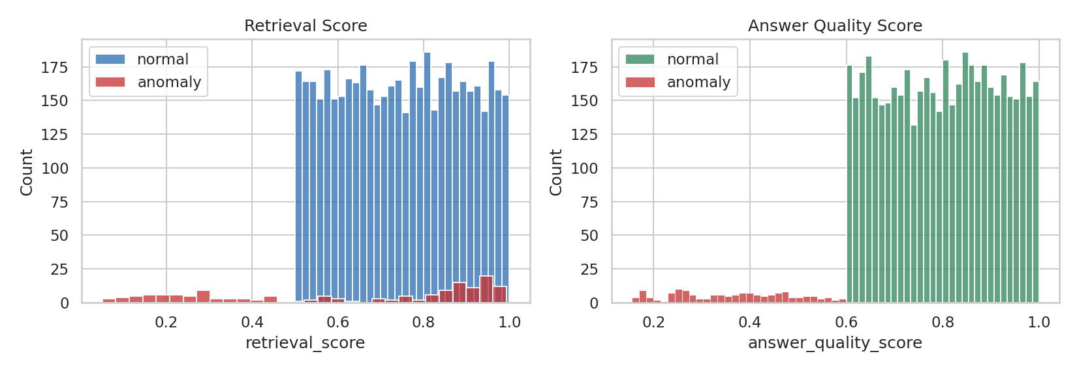
Figure 1. Distributions of retrieval score and answer-quality score; anomalies (red) lie outside the normal ranges.
Normal rows are close to uniform inside the documented ranges (retrieval mean 0.750, quality mean 0.800). Anomalous rows have a much lower mean quality (0.367) and, for retrieval failures, retrieval scores down to 0.05. Because the anomalies break the normal ranges, simple threshold rules detect them exactly.
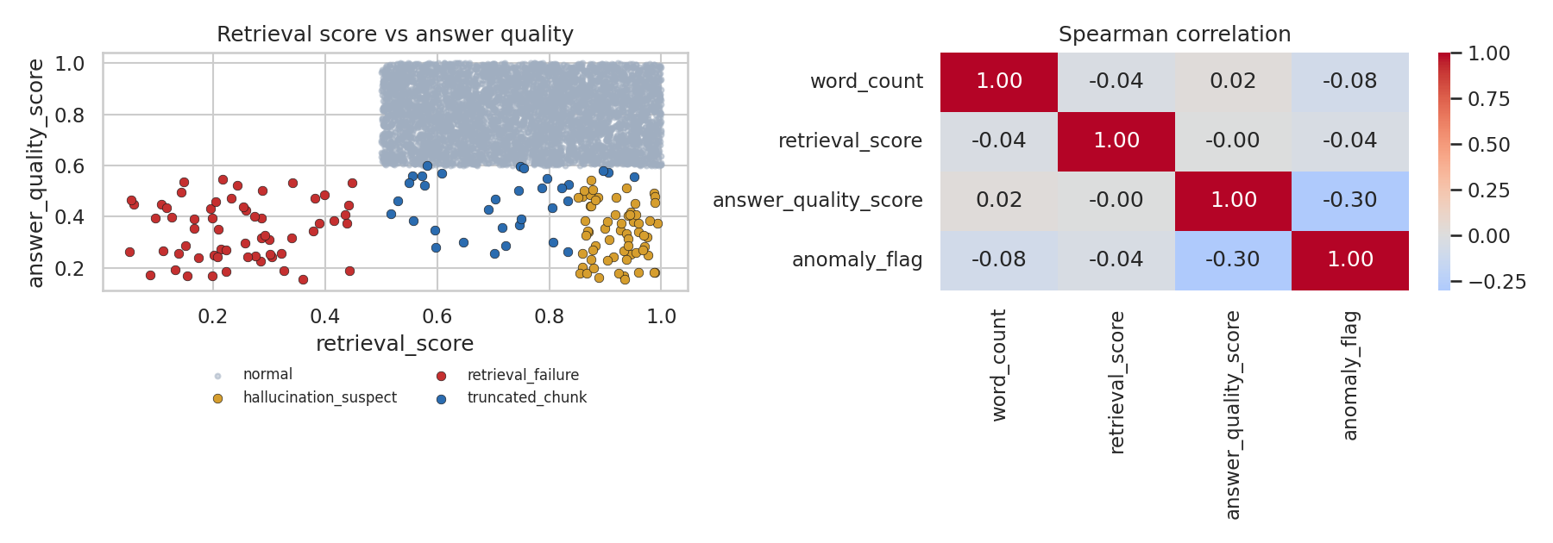
Figure 2. Left: retrieval score versus answer quality with anomaly types highlighted. Right: Spearman correlations.
Among normal rows retrieval score and answer quality are uncorrelated (Spearman rho = -0.016, p = 0.26). This is a property of the synthetic generator and must not be read as a property of real RAG systems, where better retrieval normally improves answers. Hallucination suspects form a distinct cluster at high retrieval and low quality, the pattern a monitoring dashboard would alert on.
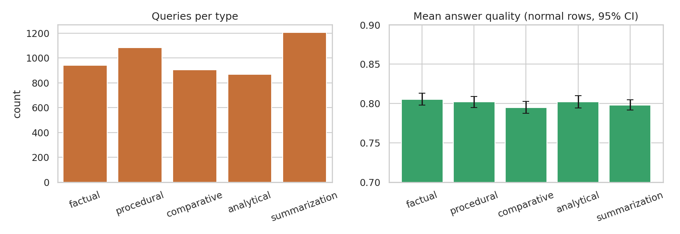
Figure 3. Query-type frequencies and mean answer quality by query type (normal rows, 95% CI).
Quality does not differ significantly between query types (Kruskal-Wallis H = 4.44, p = 0.350); chunk length does not differ by document type (p = 0.886); and the anomaly rate does not depend on the document category (chi-square p = 0.814). These null results are expected for generated data and document that no group is accidentally privileged.
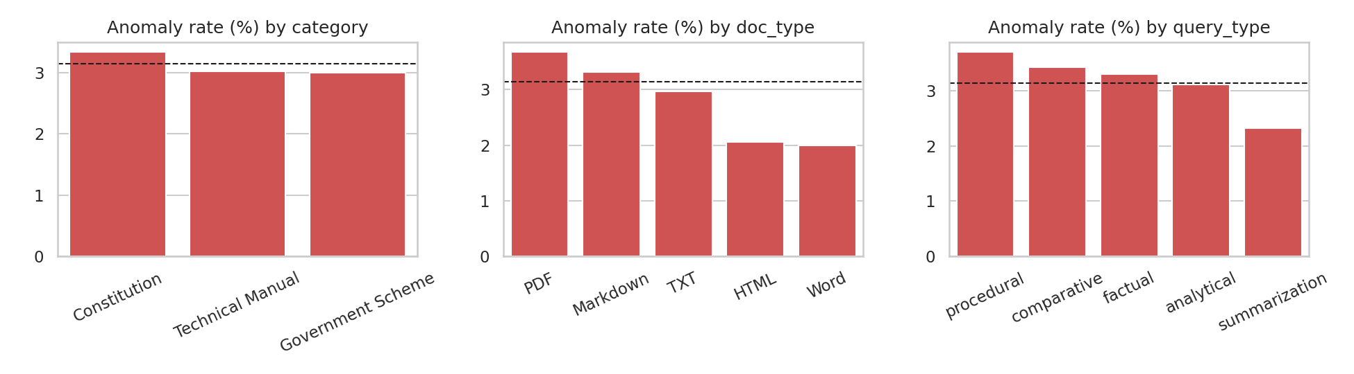
Figure 4. Anomaly rate (%) by category, document type and query type; dashed line is the overall rate.
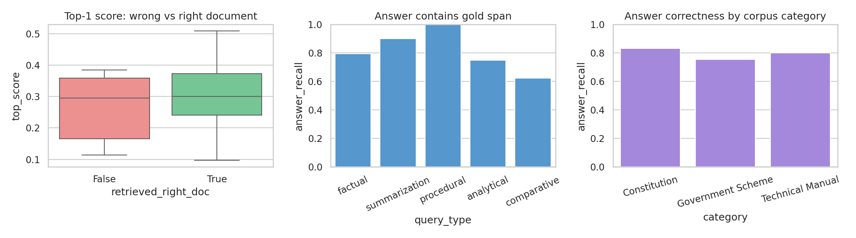
Figure 5. Measurements from the real pipeline (not synthetic): top-1 score by retrieval correctness, and answer correctness by query type and category.
Section 8 of the notebook switches from synthetic to real data. The top-1 retrieval score separates in-scope questions (median 0.30) from out-of-scope questions (median 0.09), which is what makes score-based abstention possible. Only five gold questions retrieved a wrong document first, too few to say whether the score also predicts retrieval errors.

6. System design and implementation

6.1 Architecture
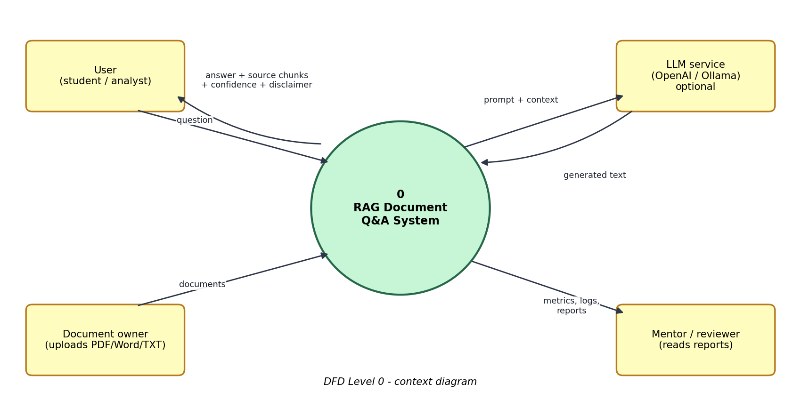
Figure 6. Data Flow Diagram, Level 0 (context diagram).
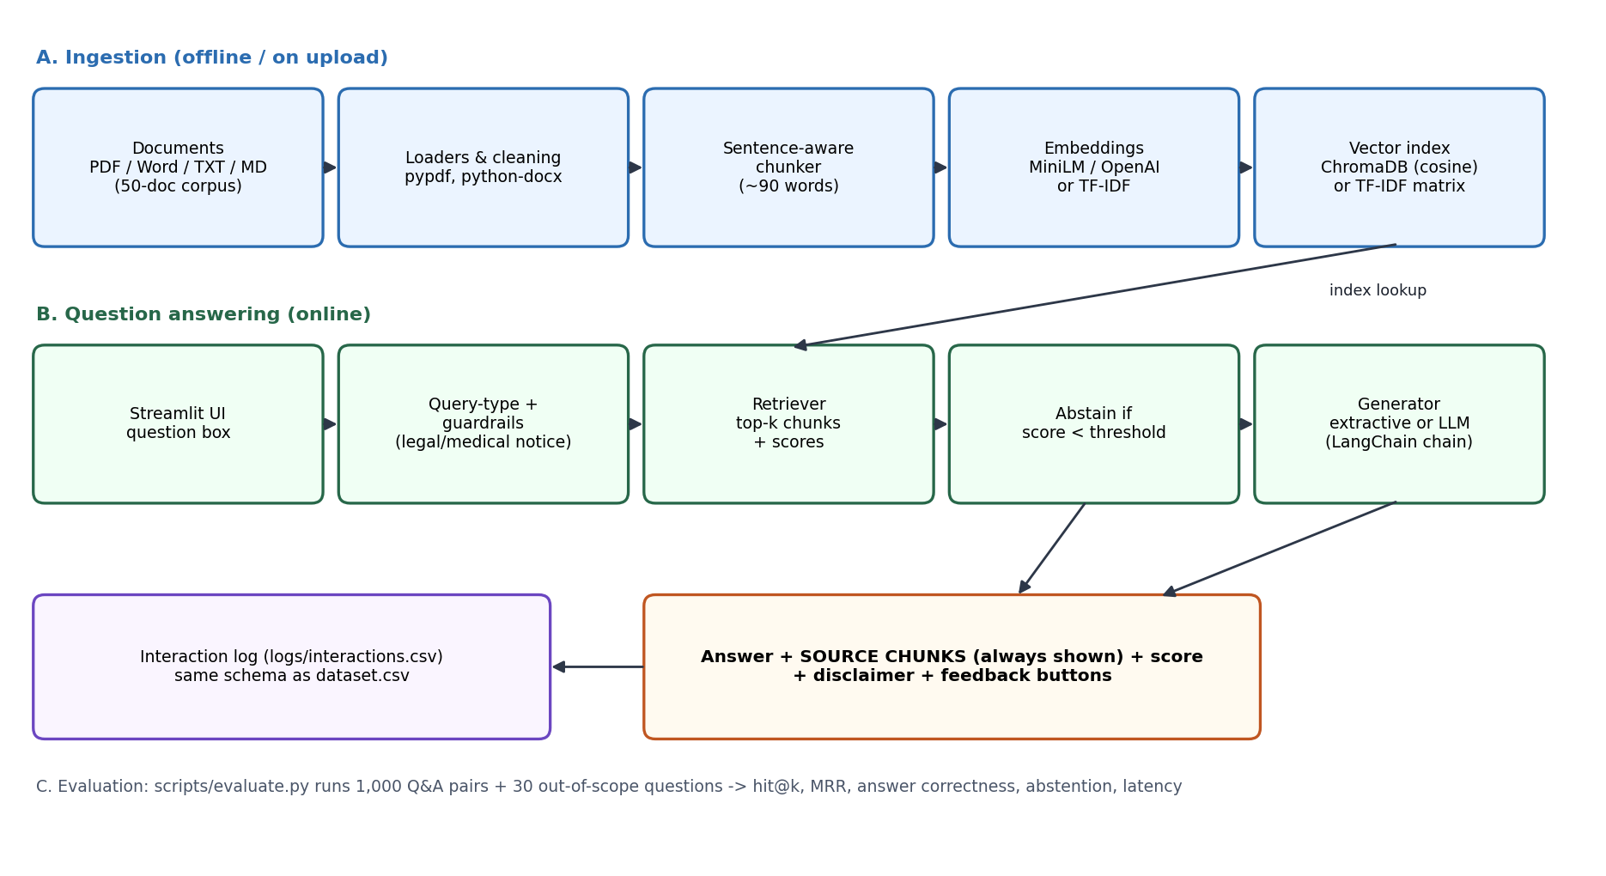
Figure 7. System block diagram: ingestion, question answering and evaluation paths.
Ingestion loads documents (Markdown with metadata, plus PDF through pypdf and Word through python-docx for uploads), cleans whitespace, and splits text into sentence-aware chunks of about 90 words with one sentence of overlap, producing 155 chunks for the 50-document corpus. The retriever returns the top-k chunks with a similarity score in [0, 1]. The pipeline classifies the query type, checks for legal/medical advice triggers, abstains if the best score is below the threshold, and otherwise generates the answer. The user interface always shows the source chunks next to the answer.

6.2 Components
Table 2. Code modules
Module | Responsibility
ragqa/ingest.py | Loaders (md, pdf, docx, txt), sentence splitter, chunker with overlap; Chunk and Doc data classes
ragqa/retrieval.py | TfidfRetriever (word + character n-gram blend, offline); ChromaRetriever (LangChain Chroma, cosine); local ONNX MiniLM or OpenAI embeddings; SQLite shim for Streamlit Cloud
ragqa/generation.py | ExtractiveAnswerer (IDF-weighted sentence selection, cannot hallucinate); LLMAnswerer (LangChain prompt | chat model | parser for OpenAI or Ollama)
ragqa/guardrails.py | Abstention rule; legal and medical advice detectors with notices
ragqa/pipeline.py | RAGPipeline.ask(): retrieve, guard, generate, fall back to extractive if the LLM is unavailable, return Answer with sources
ragqa/evaluation.py | Hit@k, MRR, support and answer recall, false-abstain rate, threshold calibration
ragqa/telemetry.py | Interaction log in the dataset.csv schema plus question, answer and feedback
app.py | Streamlit UI: settings, uploads, chat, source panel, feedback, corpus browser, evaluation tab
scripts/ | build_corpus, make_qa, prepare_dataset, evaluate, build_notebook, make_diagrams, build_documents

6.3 Key design decisions
- Three retrieval backends behind one interface (tfidf, chroma-onnx, chroma-openai) so the project runs anywhere and the dense options can be compared on identical questions.
- Sentence-aware chunking keeps facts intact; a fixed-size character splitter would cut sentences such as "Rs 6,000 per year in three equal instalments" in half.
- Prompt contract for the LLM: answer only from numbered context, cite passages like [1], and reply exactly "I don't know based on the provided documents." when the context is insufficient; temperature 0.
- Graceful degradation: if an API key is missing or a package is not installed, the app explains why and continues with TF-IDF + extractive instead of crashing.
- Extractive default: the safe default only copies text from retrieved chunks, so it cannot fabricate a figure; LLM generation is opt-in.
- Word + character TF-IDF blend: the character n-grams tolerate hyphenation and plurals ("PM-KISAN"); this was added after a failure analysis (Section 11).

6.4 User interface
The Ask tab shows the answer, the top retrieval score, query type, latency and generator. A bordered panel lists every source chunk with title, doc_id, chunk_id, category, format and score, expanded by default so the evidence is never hidden. Legal or medical notices appear as an info box. Thumbs-up and thumbs-down buttons log feedback. The Corpus tab lists the 50 documents; the Evaluation tab shows the measured metrics and figures. The sidebar lets the user choose the backend and generator, chunk size, top-k and abstention threshold, and upload their own PDF, Word, TXT or Markdown files.

7. Evaluation and results

7.1 Method
All metrics come from scripts/evaluate.py, which runs the pipeline on the 1,000 Q&A pairs and 30 out-of-scope questions and writes eval_results_tfidf.json. Doc hit@k: the gold document appears among the top-k chunks. MRR@5: mean reciprocal rank of the gold document. Answer correct: at least 80% of the content tokens of the gold span appear in the returned answer (abstentions count as incorrect). Abstention: share of out-of-scope questions whose top score is below the threshold, and share of in-scope questions wrongly refused. Configuration: offline TF-IDF retriever, extractive answerer, 155 chunks of about 90 words, top-4, abstention threshold 0.15.

7.2 Retrieval and answer quality
Table 3. Results of the offline TF-IDF + extractive baseline
Question set | n | Doc hit@1 | Doc hit@3 | MRR@5 | Support hit@3 | Answer correct | False abstain
Gold (hand-written) | 150 | 96.7% | 99.3% | 0.980 | 99.3% | 80.0% | 6.7%
Synthetic cloze | 850 | 100.0% | 100.0% | 1.000 | 98.7% | 98.5% | 0.0%

On the gold set the right document is ranked first for 96.7% of questions and within the top three for 99.3%. The synthetic set scores 100.0% hit@1 and 98.5% answer-correct because its questions copy the wording of the source sentence and include the document title; it confirms that the plumbing works but says little about real difficulty. The gold figures are the ones to quote. The corpus has only 50 documents, so retrieval is an easier problem than on a large enterprise collection and the numbers will not transfer unchanged.

7.3 Abstention (out-of-scope questions)
Table 4. Abstention behaviour
Metric | Value
Median top-1 score, in-scope gold questions | 0.300
Median top-1 score, out-of-scope questions | 0.088
Out-of-scope questions correctly refused (threshold 0.15, n = 30) | 76.7%
In-scope questions wrongly refused (n = 150) | 6.7%
Threshold maximising balanced accuracy | 0.19

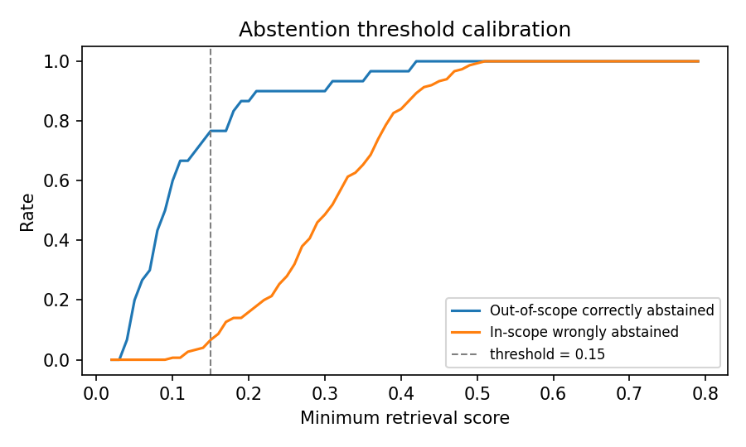
Figure 8. Trade-off between refusing out-of-scope questions and wrongly refusing in-scope ones as the threshold changes.
The default threshold of 0.15 deliberately favours answering over refusing (balanced accuracy is highest at 0.19). Because the extractive mode only copies text, a wrong-but-answered question costs less than it would with free generation. With an LLM the threshold should be raised. Near-domain questions that are not in the corpus (for example "What is Article 370?") are the hardest to refuse because they share vocabulary with the documents. Of the seven out-of-scope questions that were answered, four were near-domain (Article 370, the Atal Pension premium, the Sukanya Samriddhi rate, 2019 Lok Sabha seats) and three shared an incidental word with a document ("Prime Minister", "population").

7.4 Breakdown by corpus category and query type
Table 5. Gold-set results by group
Group (gold set) | n | Doc hit@1 | Doc hit@3 | Answer correct
Constitution | 60 | 95.0% | 100.0% | 83.3%
Government Scheme | 45 | 95.6% | 97.8% | 75.6%
Technical Manual | 45 | 100.0% | 100.0% | 80.0%
analytical (query type) | 16 | 87.5% | 93.8% | 75.0%
comparative (query type) | 8 | 100.0% | 100.0% | 62.5%
factual (query type) | 107 | 97.2% | 100.0% | 79.4%
procedural (query type) | 9 | 100.0% | 100.0% | 100.0%
summarization (query type) | 10 | 100.0% | 100.0% | 90.0%

Technical manuals are retrieved best, probably because their vocabulary is distinctive. Comparative questions have the lowest answer correctness (62.5%, n = 8) because a sentence-level extractor cannot combine two facts; generative or multi-sentence answers are needed. Groups with n below 20 should be read with caution.

7.5 Chunk-size sensitivity and latency
Table 6. Sensitivity of the gold-set results to chunk size (reported, not used to choose the default)
Chunk size (words) | Chunks | Doc hit@1 | Doc hit@3 | Answer correct
60 | 249 | 95.3% | 99.3% | 81.3%
90 | 155 | 96.7% | 99.3% | 80.0%
120 | 102 | 98.0% | 99.3% | 79.3%
200 | 51 | 97.3% | 99.3% | 75.3%

The default of 90 words was fixed in advance; the sweep shows the results are stable, with larger chunks slightly improving document ranking and smaller chunks slightly improving sentence-level answers. Mean end-to-end latency of retrieval plus extractive answering is about 2.5 ms per question on a CPU (95th percentile 3.0 ms); an LLM call would add network and generation time that was not measured.

7.6 Dense retrieval and LLM generation (not yet measured)
The ChromaDB, MiniLM, OpenAI and Ollama code paths are implemented but could not be executed or evaluated in the development environment, which had no network access and no LangChain or ChromaDB installation. Their results must be produced on a networked machine; the evaluation script writes the same files for each configuration so they can be compared directly:
Table 7. Evaluation plan for the remaining configurations
Configuration | Command | Doc hit@1 | Answer correct | Status
TF-IDF + extractive (baseline) | python -m scripts.evaluate --sweep | 96.7% | 80.0% | Measured
Chroma + MiniLM + extractive | python -m scripts.evaluate --backend chroma-onnx | - | - | To be run by learner
Chroma + OpenAI embeddings + OpenAI LLM | python -m scripts.evaluate --backend chroma-openai --llm openai | - | - | To be run by learner

Before relying on the dense configurations, re-calibrate the abstention threshold (the script reports the optimum) because cosine scores from neural embeddings have a different scale than TF-IDF scores; the app's default of 0.30 for them is only a starting point.

7.7 Failure analysis
Of the 150 gold questions, 30 did not produce an answer containing the gold span. They fall into three groups (five questions retrieved a wrong document first; one of them was refused and counted under false abstention, and one still returned a span-bearing answer):
Table 8. Failure analysis on the gold set (counts add to 30)
Failure type | Count | Example | Cause
False abstention | 10 | "What does Article 24 prohibit?" (top score 0.148) | Short questions with few distinctive words score just below the 0.15 threshold
Right document, wrong sentence | 17 | "How many days of work does VB-G RAM G guarantee?" returned the 15-day work-on-demand sentence instead of the 125-day guarantee | Lexical overlap rewards a different sentence containing "days" and "work"; no semantic understanding
Wrong document ranked first | 3 | "Which article protects life and personal liberty?" retrieved the Emergency document | Article 21 is discussed in several documents; lexical retrieval cannot tell which is the main one

Most errors are in answer selection rather than retrieval, which is the expected strength of an LLM generator reading the retrieved passages. This is the main reason to run the LLM configuration, provided its answers are checked against the displayed source chunks.

8. Testing
Fourteen automated tests (tests/) pass. They check that the corpus has 50 documents in the 20/15/15 split; that the Q&A file has 1,000 unique pairs covering all 50 documents and that every answer is an exact span of its document; that dataset.csv has the required schema, valid ranges, an anomaly rate between 2% and 5% and one format per document; that the first 500 rows are unchanged; that the data dictionary has no placeholder text; chunking covers all text and respects the size limit; every answer, even an abstention, ships source chunks; a known question is answered from the right document; an out-of-scope question abstains; gold hit@3 stays at or above 95%; the legal/medical detectors fire and stay quiet on neutral questions; and the query-type classifier labels five sample questions correctly. A continuous-integration workflow (.github/workflows/ci.yml) runs the tests and the evaluation on every push.
The Streamlit app was executed end to end against a stub of the Streamlit API to catch logic and name errors (question, answer rendering, feedback and re-run), and compiled cleanly. It has not been run in a real browser session, so the visual layout and the Chroma/LLM paths still need a manual smoke test (Section 10).

9. Ethical considerations and compliance
Table 9. Ethical risks and mitigations
Risk or duty | How the project addresses it
Hallucination (brief: always display the source chunk) | Every answer is accompanied by its source chunks, expanded by default, with document, chunk id and score. Abstention when evidence is weak. Extractive mode cannot fabricate. LLM prompt forbids unsupported figures.
Legal or medical advice (brief: not without expert review) | Regex triggers add a notice for personal-advice questions; the app banner states the limitation; scheme and Constitution texts are informational summaries, and the PM-JAY and food-safety documents carry 'not medical advice' wording.
Out-of-date information | Each document has an as_of date. MGNREGA's replacement on 1 July 2026 shows how quickly facts change; users are told to verify against the official portal.
Licence and provenance | Only public government material is used (Government of India publications; US federal works in the public domain). Texts are paraphrases with the source and URL recorded in corpus_manifest.csv. The code is MIT-licensed; the licence note excludes the underlying publications.
Synthetic data | The monitoring dataset and the 850 cloze questions are synthetic and labelled as such everywhere; no conclusions about real users are drawn from them.
Personal data (DPDP Act 2023) | No personal data is in the corpus or datasets. Typed questions are logged only to a local, git-ignored CSV; users are advised not to type personal data. Uploaded files are processed in memory. If an OpenAI option is chosen, text is sent to that provider, which the user must accept.
Bias and coverage | The corpus covers 50 documents and mostly English formal text; results do not generalise to other languages or domains.
Transparency | AI assistance in producing the code and documents is disclosed in Appendix A and in the Ethical Compliance Declaration.

10. Deployment
The repository is ready for Streamlit Community Cloud. After pushing to GitHub, create a new app on share.streamlit.io, select the repository and branch, set the main file to app.py and choose Python 3.11 in the advanced settings. Add OPENAI_API_KEY under Secrets only if OpenAI options are wanted. requirements.txt installs the full stack; if the build fails on chromadb, copy requirements-lite.txt over requirements.txt and the app runs in offline TF-IDF mode with identical features except dense retrieval. The README gives the Git commands and a post-deploy smoke-test checklist: ask an example question, confirm the source chunks appear, ask an out-of-scope question and confirm abstention, upload a small PDF, and switch backends.
Operational notes: the ChromaDB index and interaction log are written to the container's local disk, which Streamlit Cloud resets on restart, so nothing is persisted; free-tier memory is limited, which is why the default embedding option avoids PyTorch; and API keys must never be committed (.streamlit/secrets.toml is git-ignored).

11. Challenges and resolutions
Table 10. Challenges and how they were resolved
Challenge | Resolution
Facts in the corpus can go stale: from memory, MGNREGA would still have been described with a 100-day guarantee. | Checked volatile schemes and the NIST password standard against current sources; rewrote the MGNREGA document to cover its 2026 replacement; added as_of metadata and a user warning.
The raw dataset gave the same document up to five different formats and had no timestamp or label columns. | Harmonised doc_type per document, kept the original in doc_type_original, derived anomaly flags by rule and checked them against the label file; documented that the timestamp rule is not applicable.
Lexical retrieval matched "money" in a question about PM-KISAN to a document titled "Money Bills". | Blended word and character n-gram TF-IDF (gold hit@1 rose from 92.7% to 96.7%) and down-weighted title words when choosing answer sentences. This change was made after seeing the gold-set failures, so the gold results are slightly optimistic.
Synthetic cloze questions gave near-perfect scores that hid real difficulty. | Reported gold and synthetic results separately and based all headline claims on the 150 hand-written questions.
No network access or LangChain/ChromaDB in the build environment. | Used lazy imports and a pure scikit-learn baseline so that the whole pipeline is testable offline; clearly marked the dense and LLM paths as untested.
ChromaDB needs a newer SQLite than Streamlit Community Cloud provides. | Added a pysqlite3-binary shim and a lite requirements fallback.

12. Limitations and future work
- Untested paths: dense retrieval, OpenAI/Ollama generation and the live Streamlit UI were not run here (Sections 7.6 and 8).
- Small corpus: 50 documents, about 175 words each; a real enterprise collection has far more near-duplicates and longer documents, so retrieval will be harder.
- Paraphrased text: the corpus is condensed and may omit nuances; it must not be treated as an authoritative copy of the law or standards.
- Metric proxy: answer correctness is token overlap with a gold span, not a human judgement; it under-credits correct paraphrases and over-credits long answers that happen to contain the span.
- Optimistic tuning: the TF-IDF blend and sentence-selection heuristics were adjusted after inspecting gold-set errors.
- Future work: hybrid dense + sparse retrieval with reciprocal-rank fusion; a cross-encoder re-ranker; an LLM-as-judge and RAGAS-style faithfulness scoring; OCR for scanned PDFs; multilingual (Hindi) support; scheduled corpus refresh with change alerts; and persistent storage with user authentication.

13. Conclusion
The project delivers a complete, documented RAG prototype with a defensible evaluation: a safe offline baseline that finds the right document first for 96.7% of 150 gold questions, returns the correct fact in 80.0% of cases, refuses most out-of-scope questions, and always shows its evidence. The failure analysis shows where an LLM generator is expected to help, and the code is arranged so that the dense and LLM configurations can be measured with a single command each. The work follows the brief's ethical requirement that source chunks accompany every answer and that the system is not a substitute for legal or medical advice.

References
- Lewis, P., Perez, E., Piktus, A., et al. (2020). Retrieval-Augmented Generation for Knowledge-Intensive NLP Tasks. Advances in Neural Information Processing Systems 33. arXiv:2005.11401.
- Salton, G. and Buckley, C. (1988). Term-weighting approaches in automatic text retrieval. Information Processing & Management, 24(5), 513-523.
- Karpukhin, V., Oguz, B., Min, S., et al. (2020). Dense Passage Retrieval for Open-Domain Question Answering. Proceedings of EMNLP 2020. arXiv:2004.04906.
- Reimers, N. and Gurevych, I. (2019). Sentence-BERT: Sentence Embeddings using Siamese BERT-Networks. Proceedings of EMNLP-IJCNLP 2019. arXiv:1908.10084.
- Ji, Z., Lee, N., Frieske, R., et al. (2023). Survey of Hallucination in Natural Language Generation. ACM Computing Surveys, 55(12).
- Liu, N. F., Lin, K., Hewitt, J., et al. (2024). Lost in the Middle: How Language Models Use Long Contexts. Transactions of the ACL, 12.
- National Institute of Standards and Technology (2023). Artificial Intelligence Risk Management Framework (AI RMF 1.0), NIST AI 100-1.
- Government of India (2023). The Digital Personal Data Protection Act, 2023. https://www.meity.gov.in
- LangChain documentation, https://python.langchain.com ; Chroma documentation, https://docs.trychroma.com ; Streamlit documentation, https://docs.streamlit.io
- Corpus sources: Constitution of India (https://legislative.gov.in); ministry portals such as https://pmkisan.gov.in, https://pmjay.gov.in, https://rti.gov.in; NIST (https://csrc.nist.gov); OSHA (https://www.osha.gov); FEMA (https://www.ready.gov); USDA (https://www.foodsafety.gov).
- HCLTech Career Shaper Programme Guidelines (provided by Programme Coordinator); mentor-validated references to be added: [FILL IN]

Appendix A. AI-tool disclosure
AI assistance disclosure: the source code, corpus text, evaluation scripts, notebook and the first drafts of these documents were produced with the assistance of Claude (Anthropic's AI assistant) in response to the learner's instructions. Scheme facts that change over time were checked against current web sources on 28 October 2026 (for example the replacement of MGNREGA by VB-G RAM G on 1 July 2026 and NIST SP 800-63B Revision 4). The learner is responsible for reviewing, running and understanding all submitted material before submission.

Appendix B. Repository structure
app.py (Streamlit UI) | ragqa/ (package) | scripts/ (build, evaluate, clean, documents) | tests/ | data/ (corpus, QA, dataset, manifest) | notebooks/EDA.ipynb | reports/ (documents, evaluation outputs, figures) | docs/ (diagrams, demo script) | requirements*.txt | .github/workflows/ci.yml | .streamlit/ | README.md.

Appendix C. Reproducing the results
pip install -r requirements-dev.txt
python -m scripts.build_corpus && python -m scripts.make_qa
python -m scripts.prepare_dataset
python -m scripts.evaluate --sweep
python -m scripts.build_notebook
python -m pytest -q
streamlit run app.py

Appendix D. Deliverables checklist
Table 11. Mapping of deliverables to files
Deliverable (from the brief) | Where
Completed project (working prototype) | app.py + ragqa/ (run: streamlit run app.py)
Project report, minimum 8 pages | reports/Project_Report.docx (this document)
EDA notebook with 3+ visualisations | notebooks/EDA.ipynb (6 visualisations, executed)
dataset.csv, cleaned and pre-processed | data/dataset.csv (+ data/dataset_raw.csv)
data_dictionary.csv, all columns described | data_dictionary.csv
Demo video (1-2 minutes) or live demo | docs/demo_script.md (script and shot list; the video itself must be recorded by the learner)
Signed Ethical Compliance Declaration | reports/Ethical_Compliance_Declaration.docx (to be reviewed, ticked and signed by the learner)
Project synopsis (template) | reports/Project_Synopsis.docx (name, roll number, mentor and date to be filled in)

