Project Synopsis
HCLTech Career Shaper Programme | III Year Industry Project | 2025-26

Field | Details (Learner to complete)
Project Title | RAG-Based Document Q&A System
Project No. | 72
Domain | LLM / Python
Difficulty | Advanced
Duration | 4 Weeks
Format | Individual Project
Learner Name | [FILL IN]
Roll Number | [FILL IN]
College / Campus | [FILL IN]
Mentor Name | [FILL IN]
Submission Date | [FILL IN]

1. Problem Statement
Students and analysts who must find specific facts in long public documents such as the Constitution of India, welfare-scheme rules and technical standards currently scan PDFs by keyword, while generic chatbots answer fluently but may invent details. A wrong figure or article can mislead decisions, and in legal or health-related contexts it can cause harm. This project builds a RAG question-answering system that answers only from a 50-document public corpus (and user-uploaded files), shows the source chunk beside every answer, and refuses to answer when the evidence is weak.

2. Proposed Solution & Approach
I built a Streamlit application and a Python package (ragqa) that splits documents into sentence-aware chunks, retrieves the most similar chunks and returns an answer with its source chunks, a confidence score and legal/medical notices. Retrieval uses ChromaDB through LangChain with local MiniLM or OpenAI embeddings, or an offline TF-IDF fallback; answers come from an OpenAI/Ollama LangChain chain or an extractive baseline that cannot hallucinate. An abstention threshold, a 1,000-pair Q&A set and an evaluation script measure and control quality.

3. System Architecture
Figures below: (a) Data Flow Diagram Level 0, (b) system block diagram.
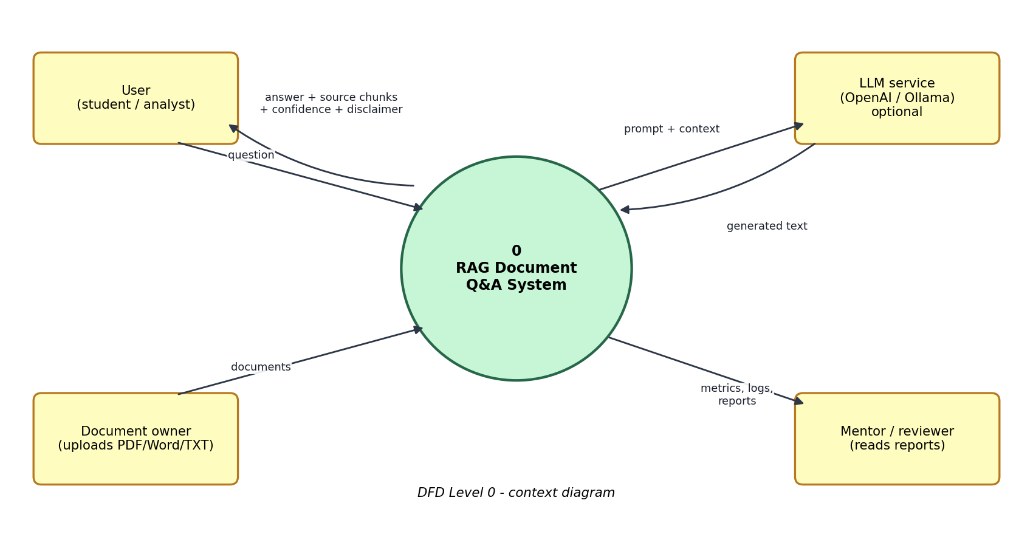
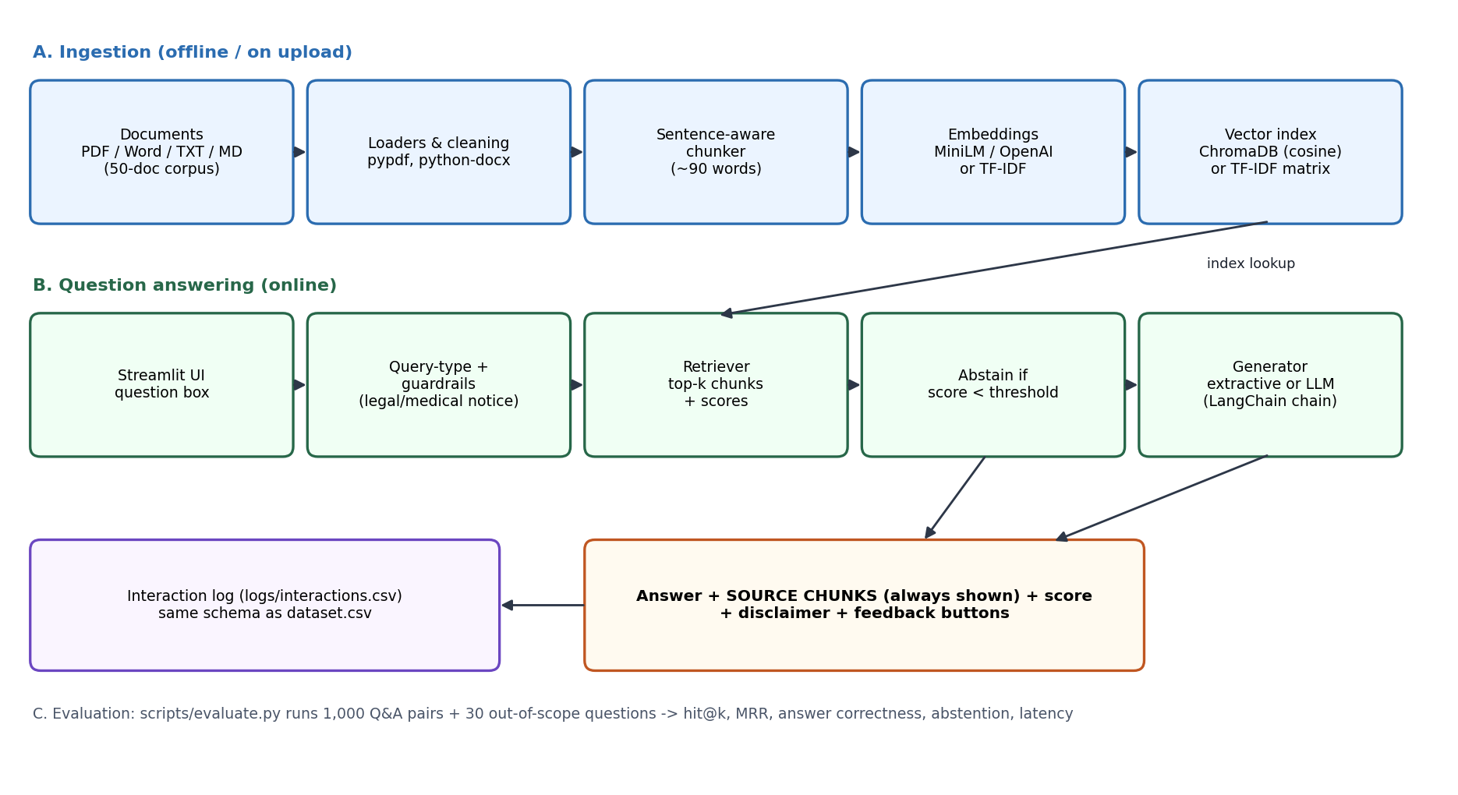

4. Technology Stack
Frontend / UI: Streamlit (chat, source-chunk panel, feedback, corpus browser)
Backend / Logic: Python 3.11, ragqa package, pypdf, python-docx
Database: ChromaDB vector store (cosine) or in-memory TF-IDF index; CSV interaction log
AI/ML Framework: LangChain, ChromaDB, all-MiniLM-L6-v2 (ONNX) or OpenAI embeddings, OpenAI chat model or Ollama, scikit-learn
Visualisation: matplotlib, seaborn, scipy (EDA notebook); Streamlit metrics
Hardware: standard laptop/CPU; no GPU required

5. Dataset Used
Dataset file name: dataset.csv (provided in project folder; extended and cleaned)
Number of rows: 5,000 (500 provided + 4,500 generated, same schema)
Number of columns: 14 (7 original + 7 derived)
Key columns: doc_id, doc_type, retrieval_score, query_type, answer_quality_score (also chunk_id, word_count)
Any additional data collected: 50-document public corpus (8,723 words), 1,000 Q&A pairs (150 hand-written + 850 synthetic), 30 out-of-scope questions, 1,000-row Q&A log in the brief's corpus schema

6. Key Results & Metrics
Metric 1: Retrieval - correct document ranked first (Hit@1) / in top 3 (Hit@3) on 150 gold questions - 96.7% / 99.3% (MRR 0.980)
Metric 2: Response time (retrieval + extractive answer, CPU) - mean 2.5 ms, p95 3.0 ms (LLM latency not measured)
Metric 3: Answer contains the gold span - 80.0%; out-of-scope questions refused - 76.7% (in-scope wrongly refused 6.7%)
Business value achieved: a cited, checkable answer in about a second instead of manual scanning, with built-in refusal and disclaimers. Measured on the offline baseline over a small curated corpus; dense-embedding and LLM results are still to be run (see report Section 7.6).

7. Challenges Faced & How Resolved
Challenge 1: Time-sensitive facts (MGNREGA was replaced by VB-G RAM G on 1 July 2026) → Resolution: verified against current sources, rewrote the document, added as_of dates and a verify-with-official-source warning.
Challenge 2: Lexical retrieval confused "money" with a document on Money Bills → Resolution: blended word and character n-gram TF-IDF (hit@1 92.7% → 96.7%) and down-weighted title words in answer selection.
Challenge 3: Synthetic questions leaked answers (near-100% scores) → Resolution: reported them separately and used only the 150 hand-written questions for headline results.
Challenge 4: No network in the build environment → Resolution: lazy imports and an offline baseline so the pipeline is testable; dense/LLM paths clearly marked as not yet measured.

8. References
1. Lewis, P. et al. (2020). Retrieval-Augmented Generation for Knowledge-Intensive NLP Tasks. NeurIPS 33. arXiv:2005.11401.
2. Karpukhin, V. et al. (2020). Dense Passage Retrieval for Open-Domain Question Answering. EMNLP 2020. arXiv:2004.04906.
3. Ji, Z. et al. (2023). Survey of Hallucination in Natural Language Generation. ACM Computing Surveys 55(12).
4. NIST (2023). AI Risk Management Framework 1.0 (NIST AI 100-1).
5. LangChain (https://python.langchain.com) and Chroma (https://docs.trychroma.com) documentation.

9. Ethical Compliance Declaration
I confirm that:
☐ All dataset usage complies with the source licence.
☐ No personally identifiable information (PII) is stored without consent.
☐ AI tools used for code/writing are disclosed in the Appendix.
☐ This project complies with the DPDP Act 2023 where applicable.
Learner Signature: _________________________ Date: ________________

Submit this file as 'Project_Synopsis_[YourName]_[RollNo].docx' | HCLTech Career Shaper Programme 2025-26

Appendix - AI-tool disclosure
AI assistance disclosure: the source code, corpus text, evaluation scripts, notebook and the first drafts of these documents were produced with the assistance of Claude (Anthropic's AI assistant) in response to the learner's instructions. Scheme facts that change over time were checked against current web sources on 28 October 2026 (for example the replacement of MGNREGA by VB-G RAM G on 1 July 2026 and NIST SP 800-63B Revision 4). The learner is responsible for reviewing, running and understanding all submitted material before submission.

