HTML & CSS

<https://vimeo.com/265509280>

For basics of html/css go through this video, It have things to explain basic layouts and design pattern

Password to watch video is : java@123

Read the tutorial for the following topics from <http://www.w3schools.com> before proceeding with the assignments

1. HTML
   1. Elements, attributes, headings.
   2. Paragraphs, Fonts, Styles, Link
   3. Images, Tables, Lists, Forms
   4. Layouts
   5. Doctypes
   6. CSS
   7. Head, Meta, Scripts

1. CSS
   1. CSS BASIC (Syntax, ID, Class)
   2. CSS Styling (Backgrounds, Texts, Fonts, Links, Lists, Tables )
   3. CSS BOX MODEL (Border, outline, Margin, Padding)
   4. CSS ADVANCED (Grouping, Nesting, Dimension, Positioning, Floating, Align, navigation bar, image gallery, image sprites , pseudo class – hover, active etc)

**Assignment 1**

Topics that are covered by this assignment:

1. Div structure – How to visualize the div elements in a design.
2. Background and its different uses
3. Margin – logic behind centering a given div.
4. Padding
5. Float – Positioning of elements using float left and float right
6. Concept of Clearing Float using clear: both
7. Inline Style and External Stylesheet difference.
8. Use of ID and Classes for CSS implementation.

Please refer to the folder named assignment 1 sent to you as zip along with this assignment document.

You need to create a structure similar to assignment1.png using a div based structure. You should follow proper html methodology as you have studied when covering the basic HTML and basic CSS. The dimensions and other details are provided in the PNG file for your reference.

**Working with layouts**

There are 3 files attached Layout1, Layout2, Layout3. All 3 layouts need to be implemented using div based designs. For placeholder images used in the layout use website <http://placehold.it/>

Read these and then implement responsive layouts for above.

Before going to Assignment2 and ahead, discuss with your PM. If it's needed.

**Assignment 2 – INTERSECTING BOXES**

Topics that are covered by this assignment:

1. CSS property – position, difference between absolute, relative and static position of element
2. EFFECT of having an absolute position element inside a relatively position element.
3. BEST PRACTISES when using POSITION.

Create a structure as shown in the diagram below.

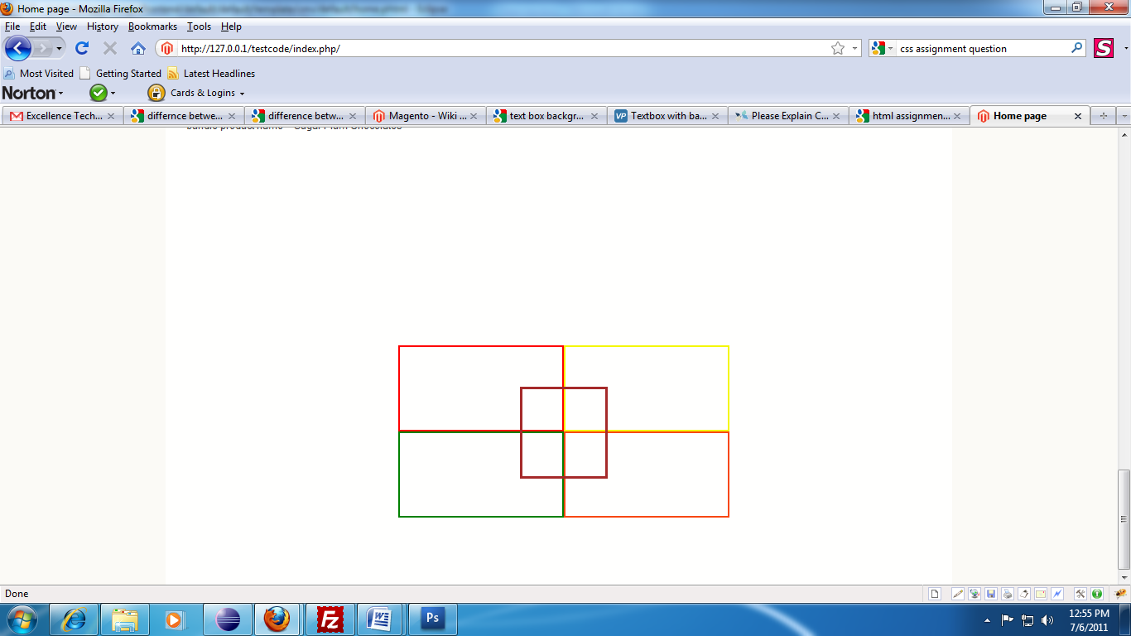

**Assignment 3 – Rounded Corners**

Topics that are covered by this assignment:

1. Background – image
2. Background – position
3. Background – repeat
4. Structure of div to be followed in a rounded corners
5. Image extraction from PSD
6. Nesting of Elements to create a dynamic height/width element.

Please refer to the folder named assignment 3 sent to you as zip along with this assignment document.

You need to create a structure similar to assignment3.psd using elements as per your judgment. The below attached image is for your reference only, do not use it for extracting images, use the images after extracting from the PSD file. First create the grey rounded background, the height of the grey rounded area should be dynamic and if required can be increased to any height as per your convenience. Next add the two buttons, do not use the entire image for the button, the buttons need to be dynamic in width, so that in case we need to add an even larger text to the button no changes in CSS or html needs to be done. Both the buttons will use the same set of images to create these buttons.



**Assignment 4 – Use of Tables**

Topics that are covered by this assignment:

1. HTML Element Table and its properties
2. Application of CSS to Tables
3. Best Practices
4. Use of Rowspan and colspan
5. Cellspacing, Cellpadding and concept of border-collapse.

Please refer to the table structure created below. You need to replicate the same table structure using tables.

| **SL No/ Date** | | **Item** | **Quantity** | **Color** | **Total Price** |
| --- | --- | --- | --- | --- | --- |
| 1 | 2011-05-05 | Item A | 15 | Blue | 1500 |
| 2 | 2011-05-05 | Item B | 25 | Red | 2500 |
| 3 | 2011-05-05 | Item C | 12 | Red | 1200 |
|  | 2011-05-06 | 22 | Red | 1500 |

**Assignment 5 – Suckerfish Menu**

Topics that are covered by this assignment:

1. Horizontal Navigation Menu using UL LI
2. Usage of pseudo class HOVER
3. NESTED SELECTION of elements for application of CSS
4. USAGE of firebug for CSS/HTML understanding.

Please refer to the horizontal menu on this url for reference for this assignment

<http://vinceinthehamptons.com/>

C:\Users\mukul\Downloads\assignment1\assignment4.png

Exact same replica of the drop down menu needs to be created as part of this assignment. Please don’t use JavaScript in this assignment, the menu needs to be created using HTML/CSS only.

**Assignment 6 – PSD to HTML Conversion**

Topics that are covered by this assignment:

1. Usage of Doctype
2. Best Practises in HTML conversion
3. Use of div based design
4. Optimized use of images
5. Optimizing page loading time

Please refer to the folder named assignment 6 sent to you as zip along with this assignment document.

You will find a PSD with the name of assignment6.psd, you need to convert this PSD file into HTML using proper CSS implementation. Proper class and id naming conventions should be followed when creating HTML elements. No inline CSS is allowed . Please make sure that all the images files are under, images folder, all css inside css folder and all js files are under js folder in this assignment. The folder structure is very important and should be strictly adhered to.