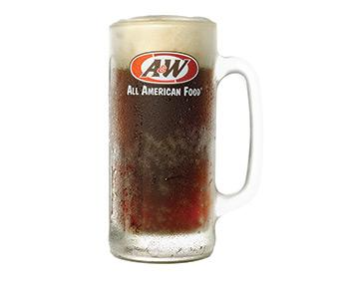

Classic. Timeless. One-of-a-kind.

**ROOT BEER**

Our signature item since the opening of our first tiny root beer stand in 1919. It’s caffeine-free, made with real cane sugar and a proprietary blend of herbs, bark, spices and berries. It’s always gone hand-in-hand with celebrations and good times. This frosty mug deserves a celebration of its own.

[**NUTRITION INFORMATION**](http://www.awrestaurants.com/menu)

**SHARE WITH YOUR FRIENDS**[**[facebook](http://www.facebook.com/sharer/sharer.php?u=http://www.awrestaurants.com/menu/item/root-beer)**](http://www.facebook.com/sharer/sharer.php?u=http://www.awrestaurants.com/menu/item/root-beer)[**[pintrest](http://pinterest.com/pin/create/button/?url=http://www.awrestaurants.com/menu/item/root-beer&media=http://www.awrestaurants.com/sites/default/files/root-beer-20oz2014_0.jpg)**](http://pinterest.com/pin/create/button/?url=http://www.awrestaurants.com/menu/item/root-beer&media=http://www.awrestaurants.com/sites/default/files/root-beer-20oz2014_0.jpg)**[twitter](https://twitter.com/intent/tweet?url=http://www.awrestaurants.com/menu/item/root-beer&text=Root%20Beer)**

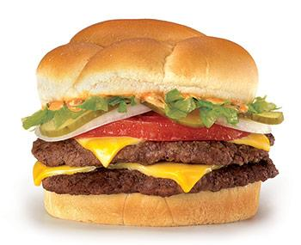

Stack up the goodness.

**PAPA BURGER®**

Two juicy 100% U.S. Beef patties, two slices of American cheese, lettuce, tomato, onion, pickles and our signature A&W Papa Sauce on a lightly butter-toasted bun. This burger is 1/3 pound of AWsome!

Try this delightful combination

French Fries

A&W Ampersand Logo

Famous Floats

[**NUTRITION INFORMATION**](http://www.awrestaurants.com/menu)

**SHARE WITH YOUR FRIENDS**[**[facebook](http://www.facebook.com/sharer/sharer.php?u=http://www.awrestaurants.com/menu/item/papa-burger%C2%AE)**](http://www.facebook.com/sharer/sharer.php?u=http://www.awrestaurants.com/menu/item/papa-burger%C2%AE)[**[pintrest](http://pinterest.com/pin/create/button/?url=http://www.awrestaurants.com/menu/item/papa-burger%C2%AE&media=http://www.awrestaurants.com/sites/default/files/papaburger2014.jpg)**](http://pinterest.com/pin/create/button/?url=http://www.awrestaurants.com/menu/item/papa-burger%C2%AE&media=http://www.awrestaurants.com/sites/default/files/papaburger2014.jpg)**[twitter](https://twitter.com/intent/tweet?url=http://www.awrestaurants.com/menu/item/papa-burger%C2%AE&text=Papa%20Burger%C2%AE)**

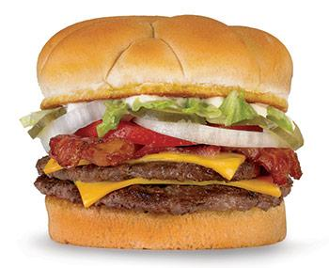

For when you want it all.

**ORIGINAL BACON DOUBLE CHEESEBURGER**

Get a full 1/3 pound of 100% U.S. Beef patties, each with their own slice of American cheese, crispy hickory-smoked bacon, lettuce, tomato, onions and pickles on a lightly butter-toasted bun.

Try this delightful combination

Onion Rings

A&W Ampersand Logo

Root Beer

[**NUTRITION INFORMATION**](http://www.awrestaurants.com/menu)

**SHARE WITH YOUR FRIENDS**[**[facebook](http://www.facebook.com/sharer/sharer.php?u=http://www.awrestaurants.com/menu/item/original-bacon-double-cheeseburger)**](http://www.facebook.com/sharer/sharer.php?u=http://www.awrestaurants.com/menu/item/original-bacon-double-cheeseburger)[**[pintrest](http://pinterest.com/pin/create/button/?url=http://www.awrestaurants.com/menu/item/original-bacon-double-cheeseburger&media=http://www.awrestaurants.com/sites/default/files/ori-bacon-double-chee.jpg)**](http://pinterest.com/pin/create/button/?url=http://www.awrestaurants.com/menu/item/original-bacon-double-cheeseburger&media=http://www.awrestaurants.com/sites/default/files/ori-bacon-double-chee.jpg)**[twitter](https://twitter.com/intent/tweet?url=http://www.awrestaurants.com/menu/item/original-bacon-double-cheeseburger&text=Original%20Bacon%20Double%20Cheeseburger)**

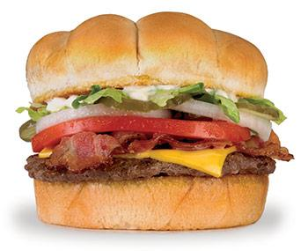

Bacon makes everything better.

**ORIGINAL BACON CHEESEBURGER**

100% U.S Beef and crispy hickory-smoked bacon—one of the world’s great duos. Add American cheese, lettuce, tomato, onions and pickles and you have an All-American Classic.

Try this delightful combination

Chili Cheese Fries

A&W Ampersand Logo

Root Beer Freeze

[**NUTRITION INFORMATION**](http://www.awrestaurants.com/menu)

**SHARE WITH YOUR FRIENDS**[**[facebook](http://www.facebook.com/sharer/sharer.php?u=http://www.awrestaurants.com/menu/item/original-bacon-cheeseburger)**](http://www.facebook.com/sharer/sharer.php?u=http://www.awrestaurants.com/menu/item/original-bacon-cheeseburger)[**[pintrest](http://pinterest.com/pin/create/button/?url=http://www.awrestaurants.com/menu/item/original-bacon-cheeseburger&media=http://www.awrestaurants.com/sites/default/files/ori-bacon-chee.jpg)**](http://pinterest.com/pin/create/button/?url=http://www.awrestaurants.com/menu/item/original-bacon-cheeseburger&media=http://www.awrestaurants.com/sites/default/files/ori-bacon-chee.jpg)**[twitter](https://twitter.com/intent/tweet?url=http://www.awrestaurants.com/menu/item/original-bacon-cheeseburger&text=Original%20Bacon%20Cheeseburger)**

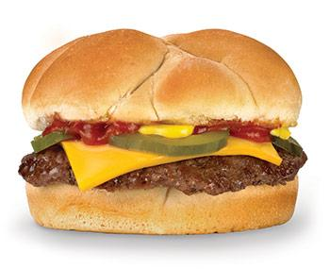

Nothing too fancy, just tasty.

**CHEESEBURGER**

A 100% U.S. Beef patty, American cheese, ketchup, mustard and pickles on a lightly butter-toasted bun.

Try this delightful combination

Box of Cheese Curds

A&W Ampersand Logo

Root Beer

[**NUTRITION INFORMATION**](http://www.awrestaurants.com/menu)

**SHARE WITH YOUR FRIENDS**[**[facebook](http://www.facebook.com/sharer/sharer.php?u=http://www.awrestaurants.com/menu/item/cheeseburger)**](http://www.facebook.com/sharer/sharer.php?u=http://www.awrestaurants.com/menu/item/cheeseburger)[**[pintrest](http://pinterest.com/pin/create/button/?url=http://www.awrestaurants.com/menu/item/cheeseburger&media=http://www.awrestaurants.com/sites/default/files/cheeseburger-2014.jpg)**](http://pinterest.com/pin/create/button/?url=http://www.awrestaurants.com/menu/item/cheeseburger&media=http://www.awrestaurants.com/sites/default/files/cheeseburger-2014.jpg)**[twitter](https://twitter.com/intent/tweet?url=http://www.awrestaurants.com/menu/item/cheeseburger&text=Cheeseburger)**

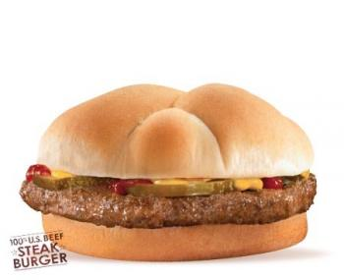

Keep it simple & delicious.

**HAMBURGER**

A 100% U.S. Beef patty dressed up with ketchup, mustard and pickles on a lightly butter-toasted bun.

Try this delightful combination

Onion Rings

A&W Ampersand Logo

Famous Floats

[**NUTRITION INFORMATION**](http://www.awrestaurants.com/menu)

**SHARE WITH YOUR FRIENDS**[**[facebook](http://www.facebook.com/sharer/sharer.php?u=http://www.awrestaurants.com/menu/item/hamburger)**](http://www.facebook.com/sharer/sharer.php?u=http://www.awrestaurants.com/menu/item/hamburger)[**[pintrest](http://pinterest.com/pin/create/button/?url=http://www.awrestaurants.com/menu/item/hamburger&media=http://www.awrestaurants.com/sites/default/files/hamburger.jpg)**](http://pinterest.com/pin/create/button/?url=http://www.awrestaurants.com/menu/item/hamburger&media=http://www.awrestaurants.com/sites/default/files/hamburger.jpg)**[twitter](https://twitter.com/intent/tweet?url=http://www.awrestaurants.com/menu/item/hamburger&text=Hamburger)**

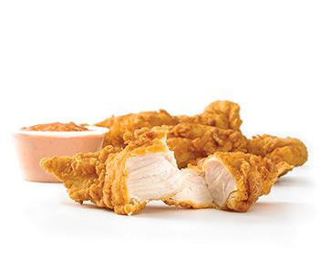

Tender Lovin'

**HAND-BREADED CHICKEN TENDERS**

Everything’s better when it’s handmade, including our 100% all white meat chicken tenders. Made right, every time and served with your choice of signature sauces.

Available at participating locations only; check local menu.

Try this delightful combination

Spicy Papa Sauce

A&W Ampersand Logo

Famous Floats

[**NUTRITION INFORMATION**](http://www.awrestaurants.com/menu)

**SHARE WITH YOUR FRIENDS**[**[facebook](http://www.facebook.com/sharer/sharer.php?u=http://www.awrestaurants.com/menu/item/hand-breaded-chicken-tenders)**](http://www.facebook.com/sharer/sharer.php?u=http://www.awrestaurants.com/menu/item/hand-breaded-chicken-tenders)[**[pintrest](http://pinterest.com/pin/create/button/?url=http://www.awrestaurants.com/menu/item/hand-breaded-chicken-tenders&media=http://www.awrestaurants.com/sites/default/files/hbc.jpg)**](http://pinterest.com/pin/create/button/?url=http://www.awrestaurants.com/menu/item/hand-breaded-chicken-tenders&media=http://www.awrestaurants.com/sites/default/files/hbc.jpg)**[twitter](https://twitter.com/intent/tweet?url=http://www.awrestaurants.com/menu/item/hand-breaded-chicken-tenders&text=Hand-Breaded%20Chicken%20Tenders)**

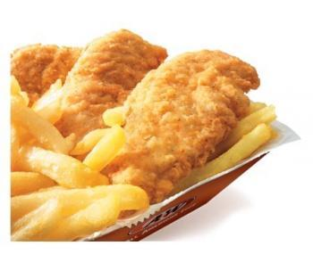

Hands-on deliciousness.

**CHICKEN STRIPS**

Lightly breaded juicy all white meat chicken made for dipping. Introduce a little spice with our chipotle dipping sauce.

Available at participating locations only; check local menu.

Try this delightful combination

Spicy Papa Sauce

A&W Ampersand Logo

Famous Floats

[**NUTRITION INFORMATION**](http://www.awrestaurants.com/menu)

**SHARE WITH YOUR FRIENDS**[**[facebook](http://www.facebook.com/sharer/sharer.php?u=http://www.awrestaurants.com/menu/item/chicken-strips)**](http://www.facebook.com/sharer/sharer.php?u=http://www.awrestaurants.com/menu/item/chicken-strips)[**[pintrest](http://pinterest.com/pin/create/button/?url=http://www.awrestaurants.com/menu/item/chicken-strips&media=http://www.awrestaurants.com/sites/default/files/chickenstrips.jpg)**](http://pinterest.com/pin/create/button/?url=http://www.awrestaurants.com/menu/item/chicken-strips&media=http://www.awrestaurants.com/sites/default/files/chickenstrips.jpg)**[twitter](https://twitter.com/intent/tweet?url=http://www.awrestaurants.com/menu/item/chicken-strips&text=Chicken%20Strips)**

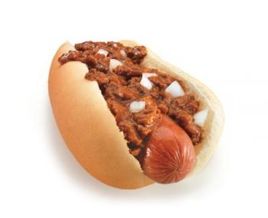

Test of time: Passed.

**CONEY DOG**

An A&W original. An all-beef hot dog topped with our signature meaty chili sauce and sweet onions.

Try this delightful combination

Onion Rings

A&W Ampersand Logo

Root Beer

[**NUTRITION INFORMATION**](http://www.awrestaurants.com/menu)

**SHARE WITH YOUR FRIENDS**[**[facebook](http://www.facebook.com/sharer/sharer.php?u=http://www.awrestaurants.com/menu/item/coney-dog)**](http://www.facebook.com/sharer/sharer.php?u=http://www.awrestaurants.com/menu/item/coney-dog)[**[pintrest](http://pinterest.com/pin/create/button/?url=http://www.awrestaurants.com/menu/item/coney-dog&media=http://www.awrestaurants.com/sites/default/files/coneydog.jpg)**](http://pinterest.com/pin/create/button/?url=http://www.awrestaurants.com/menu/item/coney-dog&media=http://www.awrestaurants.com/sites/default/files/coneydog.jpg)**[twitter](https://twitter.com/intent/tweet?url=http://www.awrestaurants.com/menu/item/coney-dog&text=Coney%20Dog)**

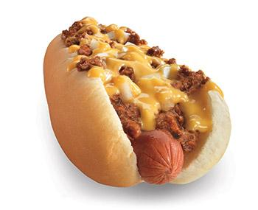

A Coney Dog one-upper.

**CONEY CHEESE DOG**

The already-delicious Coney Dog, plus creamy cheese sauce. Need we say more?

Try this delightful combination

French Fries

A&W Ampersand Logo

Root Beer

[**NUTRITION INFORMATION**](http://www.awrestaurants.com/menu)

**SHARE WITH YOUR FRIENDS**[**[facebook](http://www.facebook.com/sharer/sharer.php?u=http://www.awrestaurants.com/menu/item/coney-cheese-dog)**](http://www.facebook.com/sharer/sharer.php?u=http://www.awrestaurants.com/menu/item/coney-cheese-dog)[**[pintrest](http://pinterest.com/pin/create/button/?url=http://www.awrestaurants.com/menu/item/coney-cheese-dog&media=http://www.awrestaurants.com/sites/default/files/coney-cheese-dog-wide.jpg)**](http://pinterest.com/pin/create/button/?url=http://www.awrestaurants.com/menu/item/coney-cheese-dog&media=http://www.awrestaurants.com/sites/default/files/coney-cheese-dog-wide.jpg)**[twitter](https://twitter.com/intent/tweet?url=http://www.awrestaurants.com/menu/item/coney-cheese-dog&text=Coney%20Cheese%20Dog)**

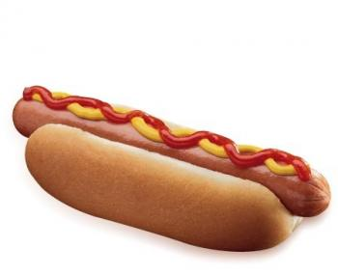

A hot dog the way it should be.

**HOT DOG**

A juicy all-beef frank with no frills. It’s just waiting for your favorite condiments.

Try this delightful combination

Box of Cheese Curds

A&W Ampersand Logo

Root Beer Freeze

[**NUTRITION INFORMATION**](http://www.awrestaurants.com/menu)

**SHARE WITH YOUR FRIENDS**[**[facebook](http://www.facebook.com/sharer/sharer.php?u=http://www.awrestaurants.com/menu/item/hot-dog)**](http://www.facebook.com/sharer/sharer.php?u=http://www.awrestaurants.com/menu/item/hot-dog)[**[pintrest](http://pinterest.com/pin/create/button/?url=http://www.awrestaurants.com/menu/item/hot-dog&media=http://www.awrestaurants.com/sites/default/files/hotdog.jpg)**](http://pinterest.com/pin/create/button/?url=http://www.awrestaurants.com/menu/item/hot-dog&media=http://www.awrestaurants.com/sites/default/files/hotdog.jpg)**[twitter](https://twitter.com/intent/tweet?url=http://www.awrestaurants.com/menu/item/hot-dog&text=Hot%20Dog)**

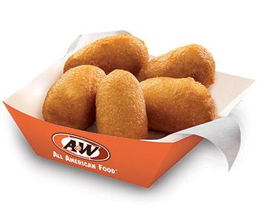

The ultimate finger food.

**5PC. CORN DOG NUGGETS®**

These little bite-sized nuggets feature mini hot dogs dipped in sweet corn meal and fried to golden deliciousness. Available at participating locations only.

Try this delightful combination

Famous Floats

[**NUTRITION INFORMATION**](http://www.awrestaurants.com/menu)

**SHARE WITH YOUR FRIENDS**[**[facebook](http://www.facebook.com/sharer/sharer.php?u=http://www.awrestaurants.com/menu/item/5pc-corn-dog-nuggets)**](http://www.facebook.com/sharer/sharer.php?u=http://www.awrestaurants.com/menu/item/5pc-corn-dog-nuggets)[**[pintrest](http://pinterest.com/pin/create/button/?url=http://www.awrestaurants.com/menu/item/5pc-corn-dog-nuggets&media=http://www.awrestaurants.com/sites/default/files/corn-dog-nuggets-5pc.jpg)**](http://pinterest.com/pin/create/button/?url=http://www.awrestaurants.com/menu/item/5pc-corn-dog-nuggets&media=http://www.awrestaurants.com/sites/default/files/corn-dog-nuggets-5pc.jpg)**[twitter](https://twitter.com/intent/tweet?url=http://www.awrestaurants.com/menu/item/5pc-corn-dog-nuggets&text=5pc.%20Corn%20Dog%20Nuggets%C2%AE)**

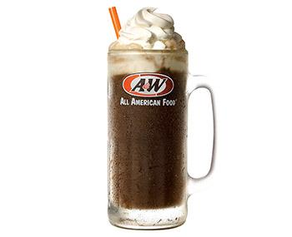

It doesn’t get better than this.

**FAMOUS FLOATS**

A frosty cold mug of world-renowned A&W® Root Beer topped with our signature creamy vanilla soft serve. A classic treat. Grab a spoon and a straw and enjoy.

Try this delightful combination

Chili Cheese Fries

A&W Ampersand Logo

Papa Burger

[**NUTRITION INFORMATION**](http://www.awrestaurants.com/menu)

**SHARE WITH YOUR FRIENDS**[**[facebook](http://www.facebook.com/sharer/sharer.php?u=http://www.awrestaurants.com/menu/item/famous-floats)**](http://www.facebook.com/sharer/sharer.php?u=http://www.awrestaurants.com/menu/item/famous-floats)[**[pintrest](http://pinterest.com/pin/create/button/?url=http://www.awrestaurants.com/menu/item/famous-floats&media=http://www.awrestaurants.com/sites/default/files/root-beer-float-new-20oz.jpg)**](http://pinterest.com/pin/create/button/?url=http://www.awrestaurants.com/menu/item/famous-floats&media=http://www.awrestaurants.com/sites/default/files/root-beer-float-new-20oz.jpg)**[twitter](https://twitter.com/intent/tweet?url=http://www.awrestaurants.com/menu/item/famous-floats&text=Famous%20Floats)**

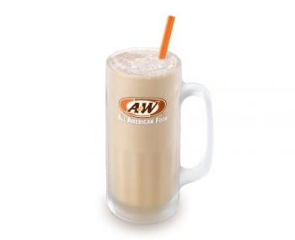

Mix it up.

**FREEZE**

The A&W® Root Beer Freeze —A&W® Root Beer blended with creamy vanilla soft serve. Smooth, tasty and refreshing.

Try this delightful combination

Box of Cheese Curds

A&W Ampersand Logo

Coney Dog

[**NUTRITION INFORMATION**](http://www.awrestaurants.com/menu)

**SHARE WITH YOUR FRIENDS**[**[facebook](http://www.facebook.com/sharer/sharer.php?u=http://www.awrestaurants.com/menu/item/freeze)**](http://www.facebook.com/sharer/sharer.php?u=http://www.awrestaurants.com/menu/item/freeze)[**[pintrest](http://pinterest.com/pin/create/button/?url=http://www.awrestaurants.com/menu/item/freeze&media=http://www.awrestaurants.com/sites/default/files/freeze.jpg)**](http://pinterest.com/pin/create/button/?url=http://www.awrestaurants.com/menu/item/freeze&media=http://www.awrestaurants.com/sites/default/files/freeze.jpg)**[twitter](https://twitter.com/intent/tweet?url=http://www.awrestaurants.com/menu/item/freeze&text=Freeze)**

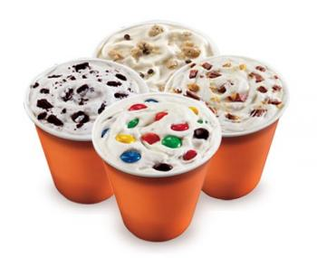

Decisions, decisions.

**POLAR SWIRLS**

Take your pick of Oreo®, M&M’s®, Reese’s® or Chocolate Chip Cookie Dough swirled with vanilla soft serve. It’s happiness by the spoonful.

[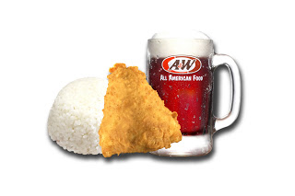](http://4.bp.blogspot.com/_vi6kdv0EC_M/TOR1yhTdy3I/AAAAAAAAACE/5T_JESt6Zeg/s1600/combo1-white.jpg)

**Combo 1 : 1 pc chicken + Rice + A&W RB or Iced lemon tea (12 oz)**

[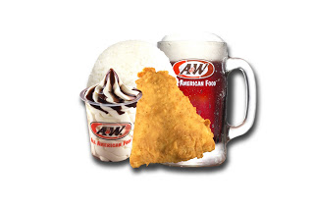](http://3.bp.blogspot.com/_vi6kdv0EC_M/TOR2OhCIn2I/AAAAAAAAACI/RVLdmXuFxms/s1600/combo2-white.jpg)

**Combo 2** **: 1 pc chicken + Rice + A&W RB or Iced lemon tea (12 oz) + Ice cream**

[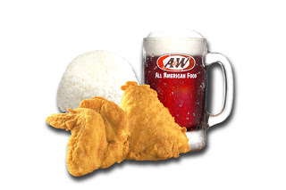](http://3.bp.blogspot.com/_vi6kdv0EC_M/TOR2c8ALNWI/AAAAAAAAACM/VOgkb5hk5dk/s1600/combo3-white.jpg)

**Combo 3** **: 2 pc chicken + Rice + A&W RB or Iced lemon tea (12 oz)**

[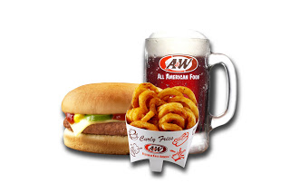](http://1.bp.blogspot.com/_vi6kdv0EC_M/TOR27cF66lI/AAAAAAAAACQ/MTjSlFCMtik/s1600/combo4-white.jpg)

**Combo 4** **: Cheese burger + Curly fries/French fries + A&W RB or Iced  lemon tea (12 oz)**