- Statement Coverage:
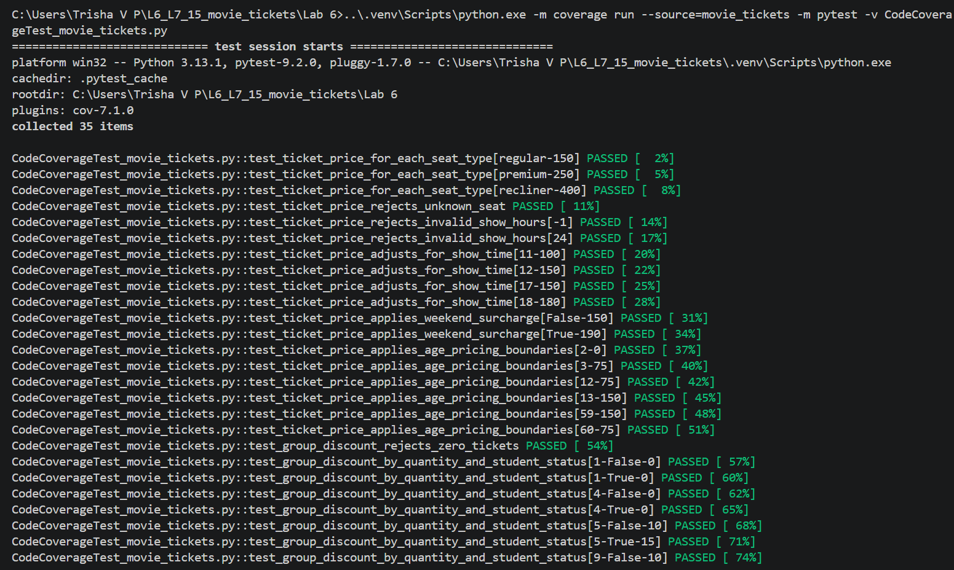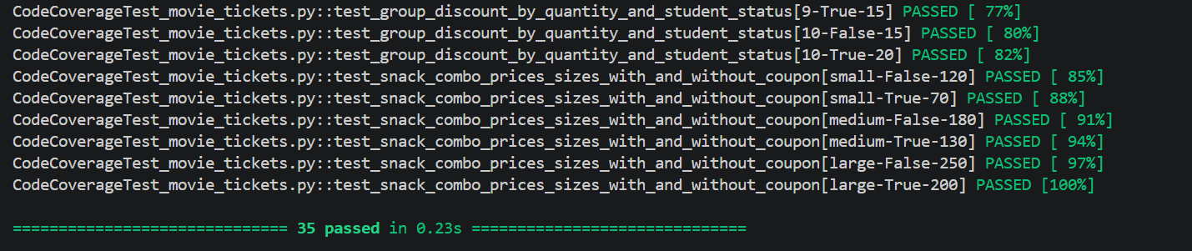
Coverage Report:
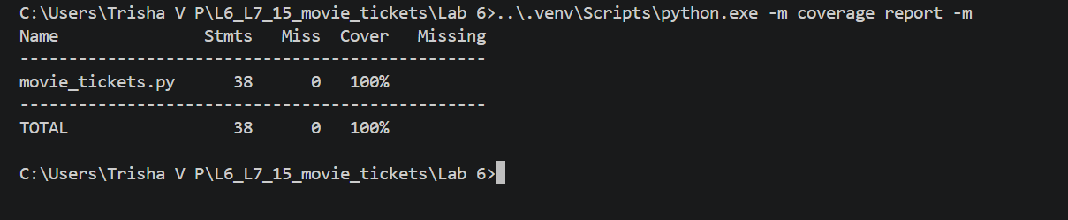
- Branch Coverage:
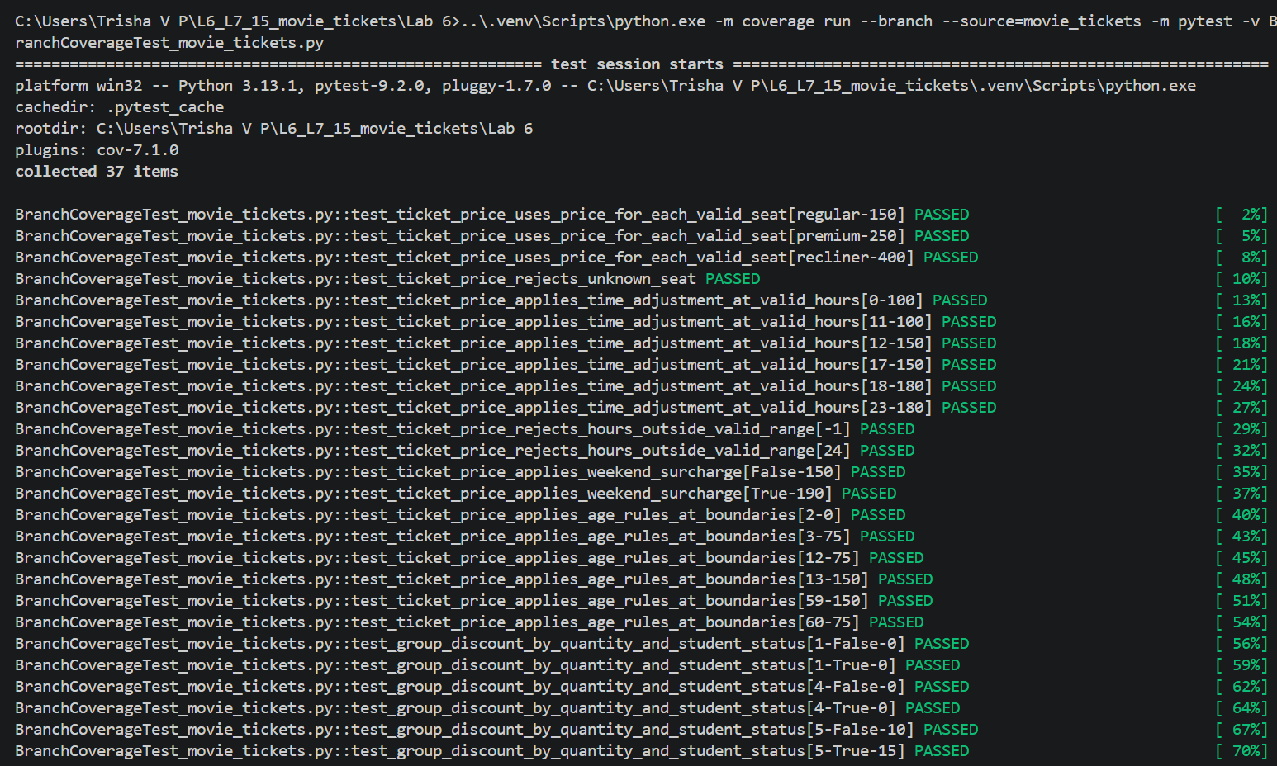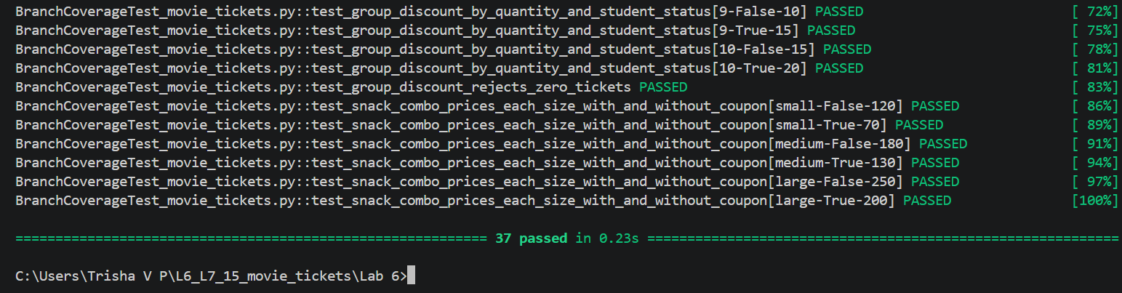
Coverage report:


