SIMATS ENGINEERING
ASSESSMENT TOOL 1

COURSE NAME: OBJECT ORIENTED ANALYSIS AND DESIGN
COURSE CODE: CSA11

COURSE OUTCOME COVERED

CO1: Apply object-oriented concepts and software development life cycle models to design structured and modular software systems. (BL2, BL3)

Assessment Tool Weightage: 60%

Dr Ramamoorthy

QUESTIONS: 12 Total Marks:60

Annexure A

CONCEPT MAPPING

Code of Conduct:

I Trisha D A (192372058) certify that this submission is my original work and that I have adhered to the guidelines specified for this assessment.
I understand that any violation of academic integrity rules will result in disciplinary action.

Signature of the student:

Annexure A

CONCEPT MAPPING
1. Construct a Concept Map
Given:
Requirement Analysis → ______ → Coding → Testing → ______ → Maintenance
Answer:
The missing concepts are:
- Design
- Deployment
Explanation:
- Design converts requirements into system architecture.
- Deployment releases the software to end users.
Analysis:
- Ensures systematic software development.
- Reduces project risks.
- Improves software quality and maintainability.

Answer:
Requirement Analysis → Design → Coding → Testing → Deployment → Maintenance

Explanation
- Design converts user requirements into software architecture and detailed design.
- Deployment releases the completed software to end users.

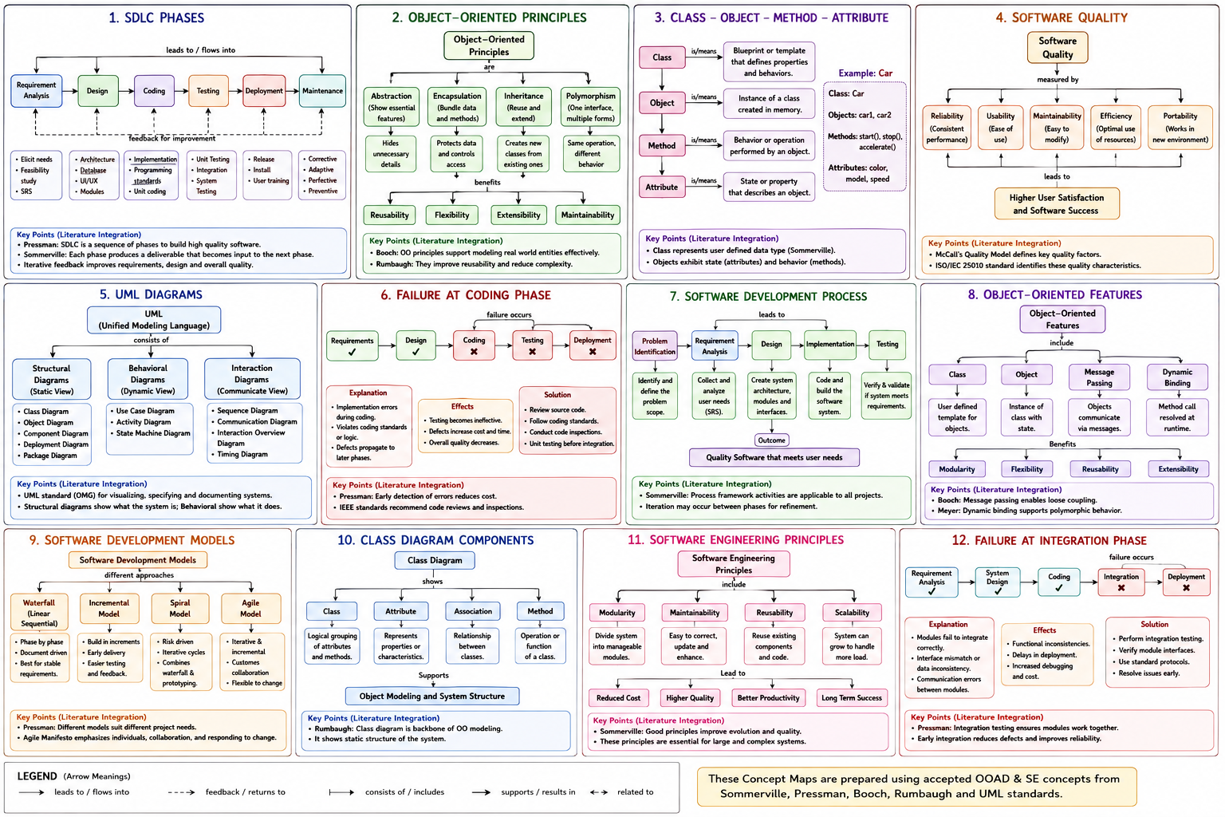

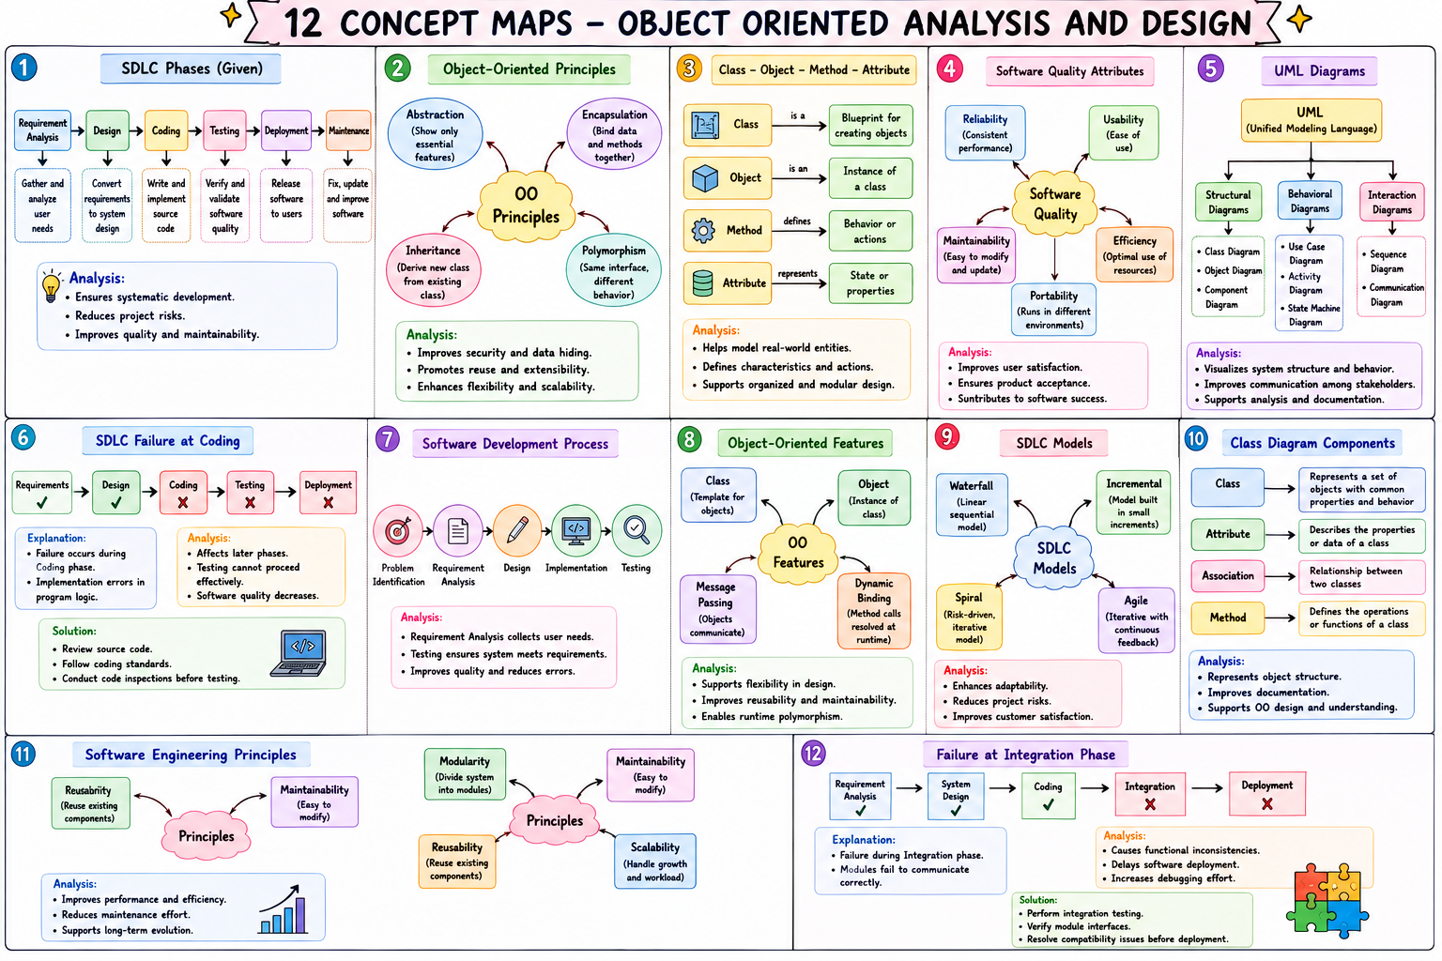
2. Construct a Concept Map
Given:
Object-Oriented Principles
→ Abstraction
→ ______
→ Inheritance
→ ______

Answer
- Encapsulation
- Polymorphism

Explanation
- Encapsulation protects data by restricting direct access.
- Polymorphism allows one interface to perform different behaviors.

Analysis
- Improves security.
- Enhances flexibility.
- Promotes code reusabil




3. Construct a Concept Map
Given:
Class → Blueprint
Object → Instance
Method → ______
Attribute → ______

Answer
- Behavior
- State

Explanation
- Methods define the behavior of objects.
- Attributes represent the state of objects.

Analysis
- Models real-world entities.
- Defines characteristics and actions.
- Improves software organization.



4. A Concept Map Shows
Given:
Software Quality
→ Reliability
→ ______
→ Maintainability

Answer
- Usability

Explanation
- Usability measures how easily users interact with software.
- Reliability ensures consistent performance.
- Maintainability makes updates easier.

Analysis
- Improves user satisfaction.
- Enhances software acceptance.
- Contributes to software success.



5. UML Concept Map
Given:
UML
→ Structural Diagrams → ______
→ Behavioral Diagrams → Activity Diagram
→ Interaction Diagrams → ______

Answer
- Object Diagram
- Communication Diagram

Explanation
- Object Diagram represents object instances and relationships.
- Communication Diagram shows message exchange among objects.

Analysis
- Improves visualization.
- Supports object-oriented analysis.
- Facilitates communication.



6. Given:
Requirements ✔ → Design ✔ → Coding ✖ → Testing ✖ → Deployment ✖

Explanation
Failure occurs during the Coding phase because implementation errors are introduced.

Analysis
- Errors affect later phases.
- Testing cannot proceed effectively.
- Software quality decreases.

Solution
- Review source code.
- Follow coding standards.
- Conduct code inspections before testing.



7. Construct a Concept Map
Given:
Problem Identification → ______ → Design → Implementation → ______

Explanation
Failure occurs during the Coding phase because implementation errors are introduced.

Analysis
- Errors affect later phases.
- Testing cannot proceed effectively.
- Software quality decreases.

Solution
- Review source code.
- Follow coding standards.
- Conduct code inspections before testing.



8. Construct a Concept Map
Given:
Object-Oriented Features
→ Class
→ ______
→ Message Passing
→ ______

Answer
- Object
- Dynamic Binding

Explanation
- Objects are instances of classes.
- Dynamic Binding resolves method calls during runtime.

Analysis
- Supports flexibility.
- Improves maintainability.
- Enables runtime polymorphism.



9. Construct a Concept Map
Given:
Software Development Models
→ Waterfall
→ ______
→ Spiral
→ ______

Answer
- Incremental Model
- Agile Model

Explanation
- Incremental Model delivers software in stages.
- Agile promotes iterative development with customer feedback.

Analysis
- Improves adaptability.
- Reduces project risks.
- Increases customer satisfaction.


10. Construct a Concept Map
Given:
Class Diagram
→ Class
→ ______
→ Association
→ ______

Answer
- Attribute
- Method

Explanation
- Attributes describe class properties.
- Methods define class operations.

Analysis
- Represents object structure.
- Improves documentation.
- Supports object-oriented design


11. Construct a Concept Map
Given:
Software Engineering Principles
→ Modularity
→ ______
→ Reusability
→ ______

Answer
- Maintainability
- Scalability

Explanation
- Maintainability simplifies software updates.
- Scalability allows handling increased workloads.

Analysis
- Improves software performance.
- Reduces maintenance effort.
- Supports long-term evolution.


12. Given:
Requirement Analysis ✔ → System Design ✔ → Coding ✔ → Integration ✖ → Deployment ✖

Explanation
Failure occurs during the Integration phase because modules fail to communicate correctly.

Analysis
- Causes functional inconsistencies.
- Delays deployment.
- Increases debugging effort.

Solution
- Perform integration testing.
- Verify module interfaces.
- Resolve compatibility issues before deployment.



