1q) #include <stdio.h>

void main() {

int a,b,opt;

printf("Enter the first Integer :");

scanf("%d",&a);

printf("Enter the second Integer :");

scanf("%d",&b);

printf("\nInput your option :\n");

printf("1-Addition\n2-Substraction\n3-Multiplication\n4-Division\n5-greater than \n 6-lesser than\n 7-equal\n 8-not equal\n 9-reminder\n 10-increment 11-exit.\n");

scanf("%d",&opt);

switch(opt) {

case 1:

printf("The Addition of %d and %d is: %d\n",a,b,a+b);

break;

case 2:

printf("The Substraction of %d and %d is: %d\n",a,b,a-b);

break;

case 3:

printf("The Multiplication of %d and %d is: %d\n",a,b,a\*b);

break;

case 4:

if(b==0) {

printf("The second integer is zero. Divide by zero.\n");

} else {

printf("The Division of %d and %d is : %d\n",a,b,a/b);

}

break;

case 5:if(a>b)

{

printf("%d > %d \n",a,b);

}

else

{

printf("%d > %d \n",b,a);

}

break;

case 6:if(a<b)

{

printf("%d < %d \n",a,b);

}

else

{

printf("%d < %d \n",b,a);

}

break;

case 7:if(a==b)

{

printf("%d = %d \n",a,b);

}

else

{

printf("%d != %d \n",b,a);

}

break;

case 8:if(a!=b)

{

printf("%d != %d \n",a,b);

}

else

{

printf("%d = %d \n",b,a);

}

break;

case 9:printf("%d mod %d = %d \n",a,b,a%b);break;

case 10:

printf("%d++ = %d \n",a,a+1);

printf("%d++ =%d \n",b,b+1);

break;

default:

printf("Input correct option\n");

break;

}

}

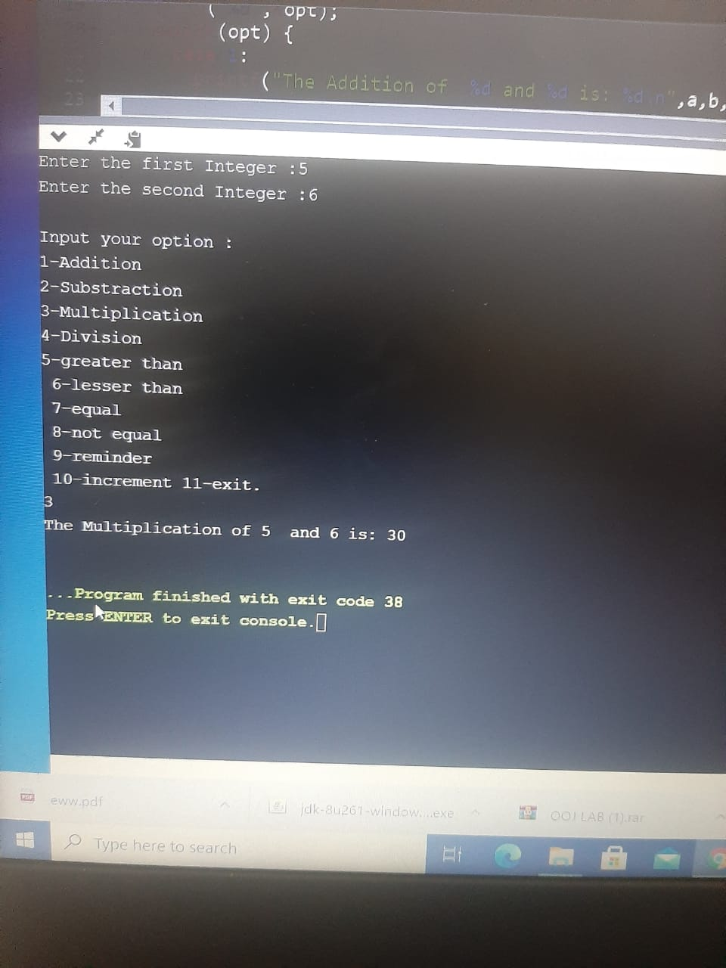

2q)

#include <stdio.h>

int sumaver(int a,int b)

{

int sum;

sum=a+b;

printf("Sum= %d \n",sum);

return sum/2;

}

void printeven(int a,int b)

{

int small,big;

if(a>b)

{

small=b;

big=a;

}

else

{

small=a;

big=b;

}

printf("Even numbers between two numbers are:\n");

int i;

for(i=small+1;i<big;i++)

{

if(i%2==0)

printf("%d \n",i);

}

}

int main()

{

int a,b,c,avg,num1,num2;

printf("Enter three numbers:\n");

scanf("%d%d%d",&a,&b,&c);

if(c<a && c<b)

{

num1=a;

num2=b;

}

else if(b<a && b<c)

{

num1=a;

num2=c;

}

else

{

num1=b;

num2=c;

}

avg=sumaver(num1,num2);

printf("Average of two numbers is : %d \n",avg);

printeven(num1,num2);

}

