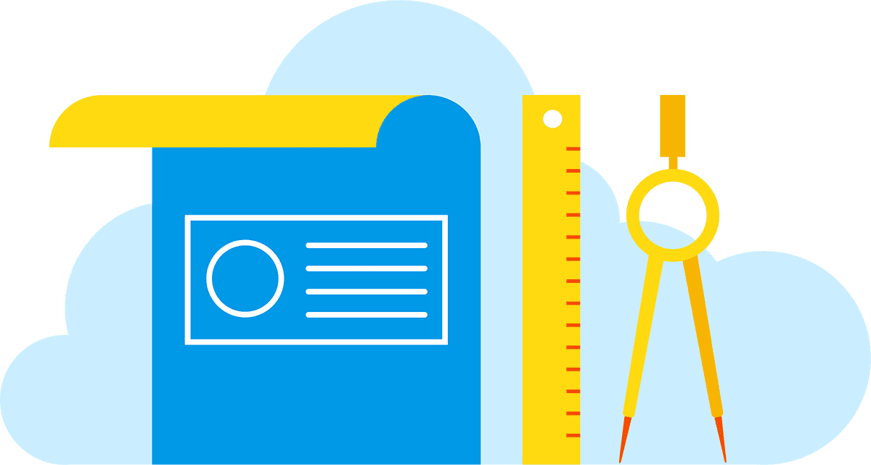

**Competency 240 – Python Flask**

*Plan*

**Leader**: L Shumlich

**Date:** 2019/04

**Overview & Purpose**

Python is a server language; one of its many strengths is a programming language for web application servers. In this section, we will learn the different techniques for serving a web application.

**Prerequisite**

* 230 - Excel
* Udemy Python and Flask  <https://evolveu.udemy.com/course/rest-api-flask-and-python/>  Do the remaining sections from 3 on. This provides some advanced topics.

**References**

* <https://www.python.org/>
* <http://flask.pocoo.org/>

**Exercise - Flask**

Do this exercise in teams of two or three. Use only one computer and close the lid of the computers you are not using.

Using your last exercise with clients, invoices, and items, create a flask application to show the info from the worksheet.

Do it in the following ways all in the same server:

* Using basic flask just dump the contents to the browser in a very simple dump
* Use a flask template that loops through the data and displays into the browser
* Create an API to send a JSON document to a React frontend (SPA)

For this exercise concentrate on functionality; we will work on the look and feel later.

https://lh5.googleusercontent.com/A2V9orgrLliGqnQZh4yvZstXO3mcmH8fpvXbHr1ueLM3UXnoWVZWy4u9mP-_ataAecIDmjk7PtXjSJP5SS9oEXaJqlRVV5-BFUuOSV_A1tvFsuQLISUmPcB1bjbC7So0zlJ-TVxe