EXPERIMENT 10 - MINI PROJECT
Dataset→Random Forest→K-Means→Flask→Web App
TokenSense – AI Token Utilization Predictor
- Your Full Name
- TE IT B - Roll No.
- Machine Learning Lab

TokenSense is a machine learning web application that predicts how many AI tokens a person will use per day and per month, based on their profession and AI usage habits. It predicts two values: input tokens, which the user feeds to the AI (prompts, chat history and uploaded files), and output tokens, which the AI generates as replies. It also estimates the cost on small, medium and large AI models and tells the user what type of AI user they are.
A Random Forest Regression model (Module 3) predicts the daily input and output tokens, and K-Means Clustering (Module 4) groups users into four usage types. A Flask backend serves the trained models through a REST API, and an HTML, CSS and JavaScript frontend lets the user enter their profile and see the prediction, cost, user type and a 7-day forecast.
GitHub Repo URL - https://github.com/jerry5379/tokensense
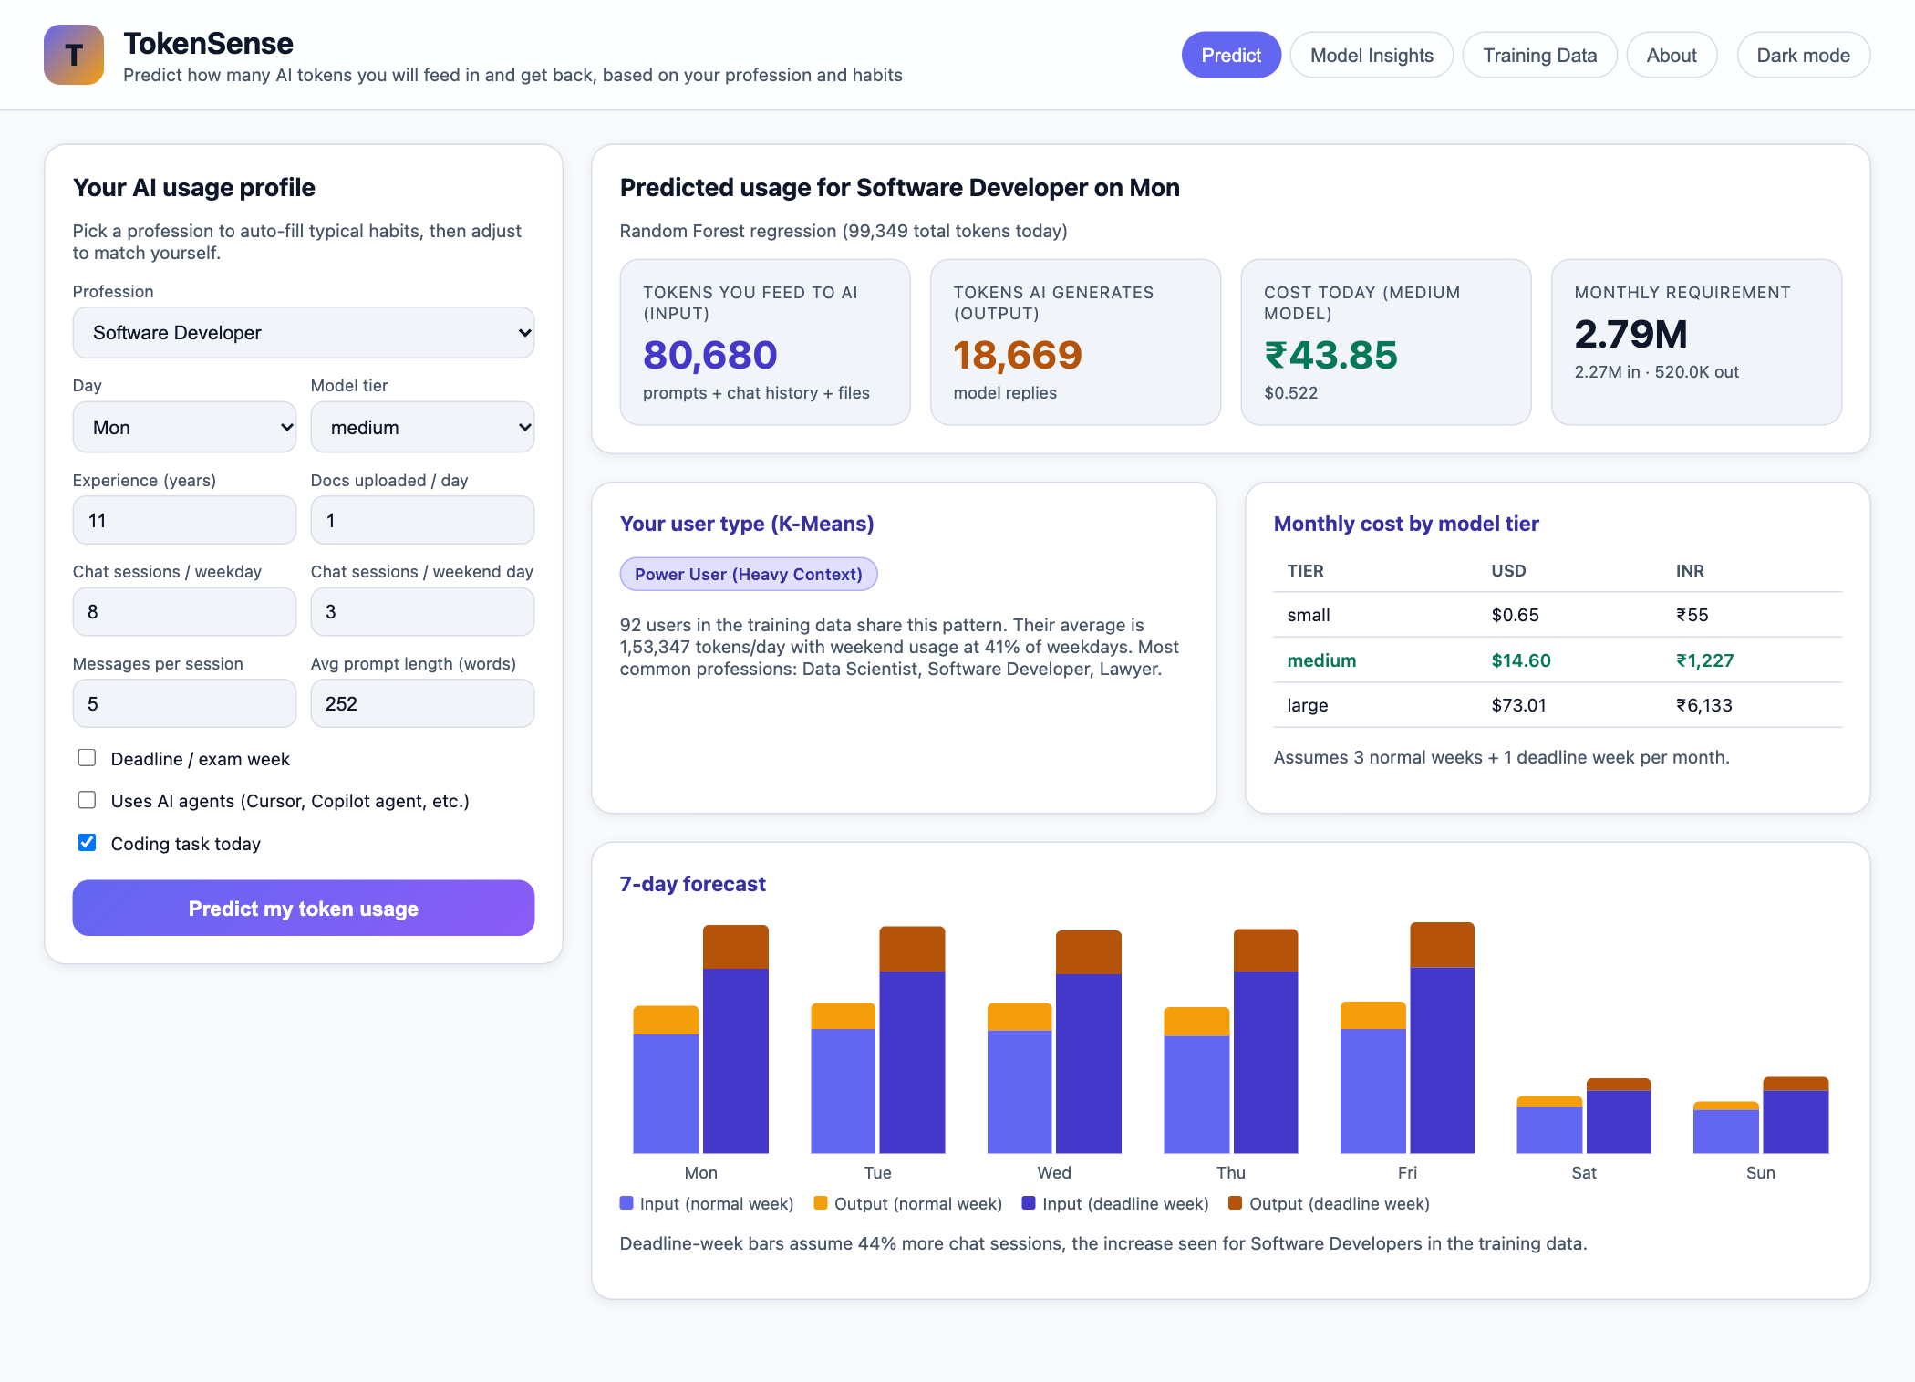
Aim -
To build a web application that predicts the AI token requirement of a person according to their profession and usage habits, split into input tokens and output tokens, estimates the cost, and groups users into usage types using machine learning.
Problem Statement -
AI assistants such as ChatGPT, Claude, Gemini and GitHub Copilot are now used every day by developers, students, writers, teachers, doctors and lawyers, and all of them bill usage in tokens (about 0.75 words per token). People cannot easily tell how many tokens they will need in a month or which model tier they can afford. Usage depends on the profession (a developer pastes code and logs, a content writer asks for long replies), on habits (chats per day, messages per chat, prompt length, uploaded files, AI agents) and on the calendar (weekends and deadline or exam weeks). TokenSense learns these patterns from data and gives each person a personal token budget.
Training Dataset -
Real per-user token logs are private, so a realistic synthetic dataset was generated in Python (src/generate_data.py, random seed 42) using the rules of LLM billing: every new message re-sends the whole conversation, so input tokens grow roughly with the square of the messages per session; each uploaded document adds about 2,500 tokens; AI agents multiply the context about 2.5 times; and ±12% random noise is added.
- File: data/token_usage_daily.csv, 9,000 rows (300 users × 30 days), 12 professions.
- Features (11): profession, day of week, model tier, experience, deadline/exam week, uses AI agents, chat sessions per day, messages per session, prompt length (words), documents uploaded, coding task.
- Targets (2): input_tokens and output_tokens.
- Split: 7,200 rows for training, 1,800 rows for testing (80/20).
Sample of the training data (15 of 9,000 rows):
User | Profession | Day | Deadline | Agents | Sessions | Msgs/ session | Prompt words | Docs | Input tokens | Output tokens
U001 | Software Developer | Sat | 0 | 0 | 4 | 6 | 268 | 0 | 60,996 | 10,805
U021 | Researcher | Thu | 1 | 0 | 11 | 7 | 175 | 5 | 1,08,947 | 17,824
U041 | Digital Marketer | Tue | 0 | 0 | 12 | 7 | 157 | 2 | 1,85,534 | 32,819
U061 | Software Developer | Wed | 0 | 0 | 2 | 8 | 328 | 3 | 63,236 | 8,830
U081 | Researcher | Wed | 1 | 0 | 8 | 8 | 288 | 3 | 1,94,399 | 21,365
U101 | Digital Marketer | Mon | 0 | 0 | 5 | 3 | 111 | 3 | 15,835 | 6,923
U121 | Software Developer | Wed | 0 | 0 | 4 | 8 | 234 | 1 | 89,685 | 11,518
U141 | Researcher | Fri | 1 | 0 | 15 | 5 | 232 | 8 | 1,16,425 | 38,005
U161 | Digital Marketer | Wed | 0 | 0 | 3 | 8 | 127 | 1 | 42,936 | 6,701
U181 | Software Developer | Fri | 0 | 0 | 8 | 8 | 232 | 2 | 1,76,851 | 22,596
U201 | Researcher | Sat | 1 | 0 | 1 | 6 | 383 | 1 | 23,874 | 2,059
U221 | Digital Marketer | Fri | 0 | 0 | 6 | 1 | 142 | 0 | 3,396 | 5,645
U241 | Software Developer | Sat | 0 | 0 | 5 | 6 | 312 | 1 | 80,505 | 20,039
U261 | Researcher | Sun | 0 | 0 | 4 | 6 | 308 | 3 | 81,760 | 8,880
U281 | Digital Marketer | Sun | 0 | 0 | 4 | 6 | 116 | 1 | 37,616 | 7,912

Algorithms Used -
1. Random Forest Regression (Module 3)
A Random Forest is an ensemble of many decision trees. Each tree is trained on a bootstrap sample of the rows and considers a random subset of features at each split, choosing the split that most reduces the squared error. The forest predicts the average of all trees, which reduces the overfitting of a single tree while still capturing non-linear patterns. This suits token usage, which is strongly non-linear: doubling the messages in a chat roughly quadruples the input tokens, and AI agents multiply everything.
One multi-output forest with 200 trees predicts both targets. Categorical features are one-hot encoded with a ColumnTransformer inside a scikit-learn Pipeline, so the same preprocessing is used in training and in the web app. On unseen test data it achieved R² = 0.915:
Target | MAE (tokens) | RMSE (tokens) | R²
input_tokens | 11,298 | 26,145 | 0.924
output_tokens | 2,116 | 3,557 | 0.906
overall | 6,707 | 14,851 | 0.915

2. K-Means Clustering (Module 4)
K-Means is an unsupervised algorithm that divides data into k groups. It picks k starting centroids, assigns every point to the nearest centroid (Euclidean distance), moves each centroid to the mean of its points, and repeats until nothing changes. Each user is described by four standardised features from their 30 days: log of average daily tokens, burstiness (std / mean), output share, and weekend-to-weekday ratio. k = 4 was chosen with the elbow method and silhouette score (0.25):
User type | Users | Avg tokens/day | Most common professions
Light / Irregular User | 53 | 36,912 | Digital Marketer, Designer, Business Analyst
Steady 9-to-5 Professional | 98 | 44,607 | Customer Support, Doctor, Teacher
Anytime Learner / Creator | 57 | 88,156 | Student, Researcher, Content Writer
Power User (Heavy Context) | 92 | 1,53,347 | Data Scientist, Software Developer, Lawyer

Working together: for a new user, the Random Forest predicts all 7 days of the week, the same four features are calculated from that forecast, and K-Means assigns the user type.
Frontend -
A single-page web interface built with plain HTML, CSS and JavaScript (templates/index.html, static/style.css, static/app.js). The Predict tab has the input form and shows input tokens, output tokens, today’s cost, monthly requirement, the K-Means user type, monthly cost per model tier and a 7-day forecast chart. The Model Insights, Training Data and About tabs show model metrics, clusters, training charts, dataset sample and architecture. Choosing a profession auto-fills its typical habits, and a Light/Dark mode button is provided.
Backend -
A Python Flask server (app.py). On start-up it loads the trained Random Forest pipeline and K-Means model (saved with joblib by src/train.py) and exposes a REST API that returns JSON: POST /api/predict (prediction, weekly and monthly forecast, cost, user type), GET /api/insights (metrics and clusters), GET /api/meta (form options and defaults) and GET /api/dataset (data preview).
Frontend–Backend Connection -
When the user clicks Predict my token usage, app.js reads the form and sends it as JSON to /api/predict using fetch(). Flask converts the JSON into a one-row pandas DataFrame, runs it through the same pipeline used in training (one-hot encoding, then Random Forest), runs K-Means on the weekly forecast, calculates the cost, and returns one JSON response. JavaScript renders it into cards, tables and charts without reloading the page. Training runs separately and only writes the model files the server reads, which keeps the ML code and the web code separate.
Browser (HTML + CSS + JavaScript)
| fetch() -> JSON over HTTP
v
Flask REST API (app.py) --> models/rf_token_model.joblib (Random Forest)
models/kmeans_users.joblib (K-Means + scaler)
models/insights.json (metrics, clusters)
Generating Data & Training the Model -
The dataset is generated and both models are trained from the terminal:
$ python src/generate_data.py
Wrote 9000 rows -> data/token_usage_daily.csv
input_tokens output_tokens
profession
Doctor 15850.0 3322.0
Designer 17742.0 4137.0
Teacher 40978.0 9010.0
Student 50630.0 8769.0
Lawyer 54849.0 8119.0
Digital Marketer 62141.0 14160.0
Business Analyst 65972.0 10729.0
Customer Support 66615.0 14334.0
Researcher 106604.0 13914.0
Content Writer 107555.0 26087.0
Data Scientist 137447.0 17210.0
Software Developer 140669.0 21590.0

$ python src/train.py
Loaded 9000 rows
[RF] input_tokens MAE= 11297.8 RMSE= 26144.7 R2=0.9239
[RF] output_tokens MAE= 2116.4 RMSE= 3556.6 R2=0.906
[RF] overall MAE= 6707.1 RMSE= 14850.7 R2=0.9149
[K-Means] k=4, silhouette=0.2547
Steady 9-to-5 Professional users= 98 avg/day= 44607
Power User (Heavy Context) users= 92 avg/day= 153347
Anytime Learner / Creator users= 57 avg/day= 88156
Light / Irregular User users= 53 avg/day= 36912
Saved models to models and figures to static/figures

Model Results -
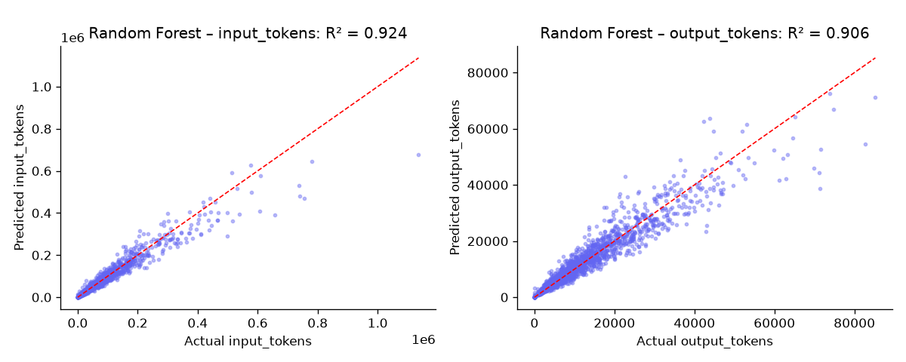
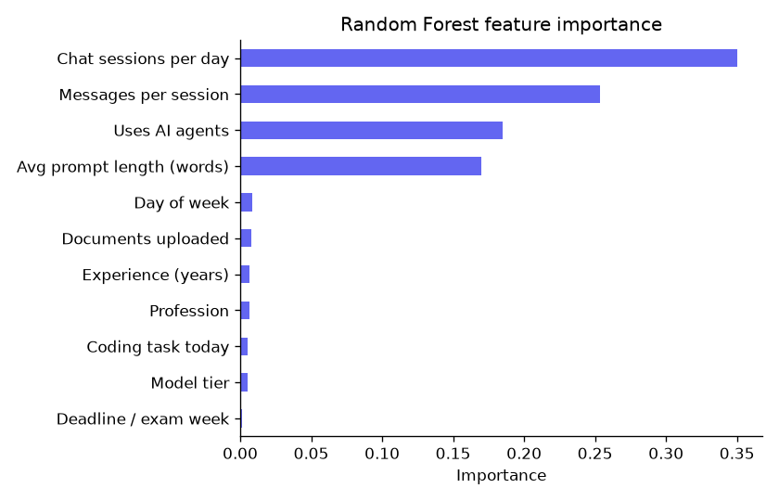
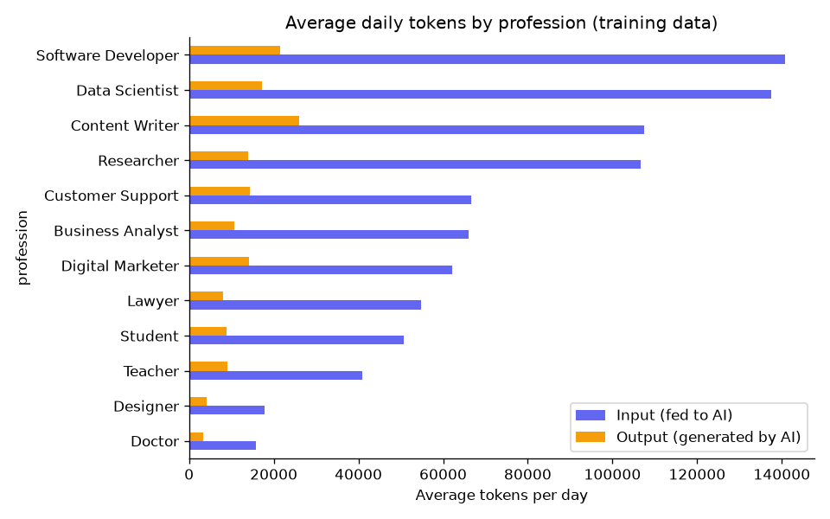
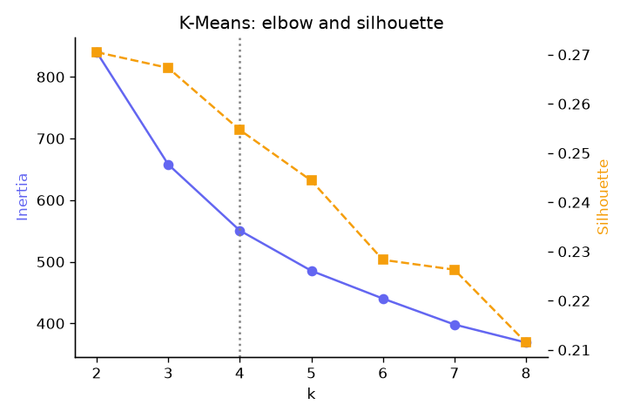
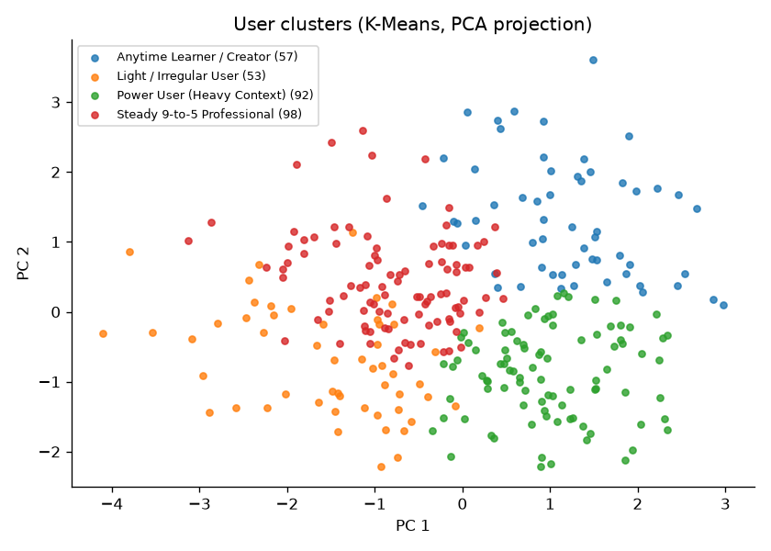
Running the Web App -
$ source .venv/bin/activate
$ python app.py
* Serving Flask app 'app'
* Running on http://127.0.0.1:5050
Press CTRL+C to quit

Predict – Software Developer:
Predict – Student in exam week:
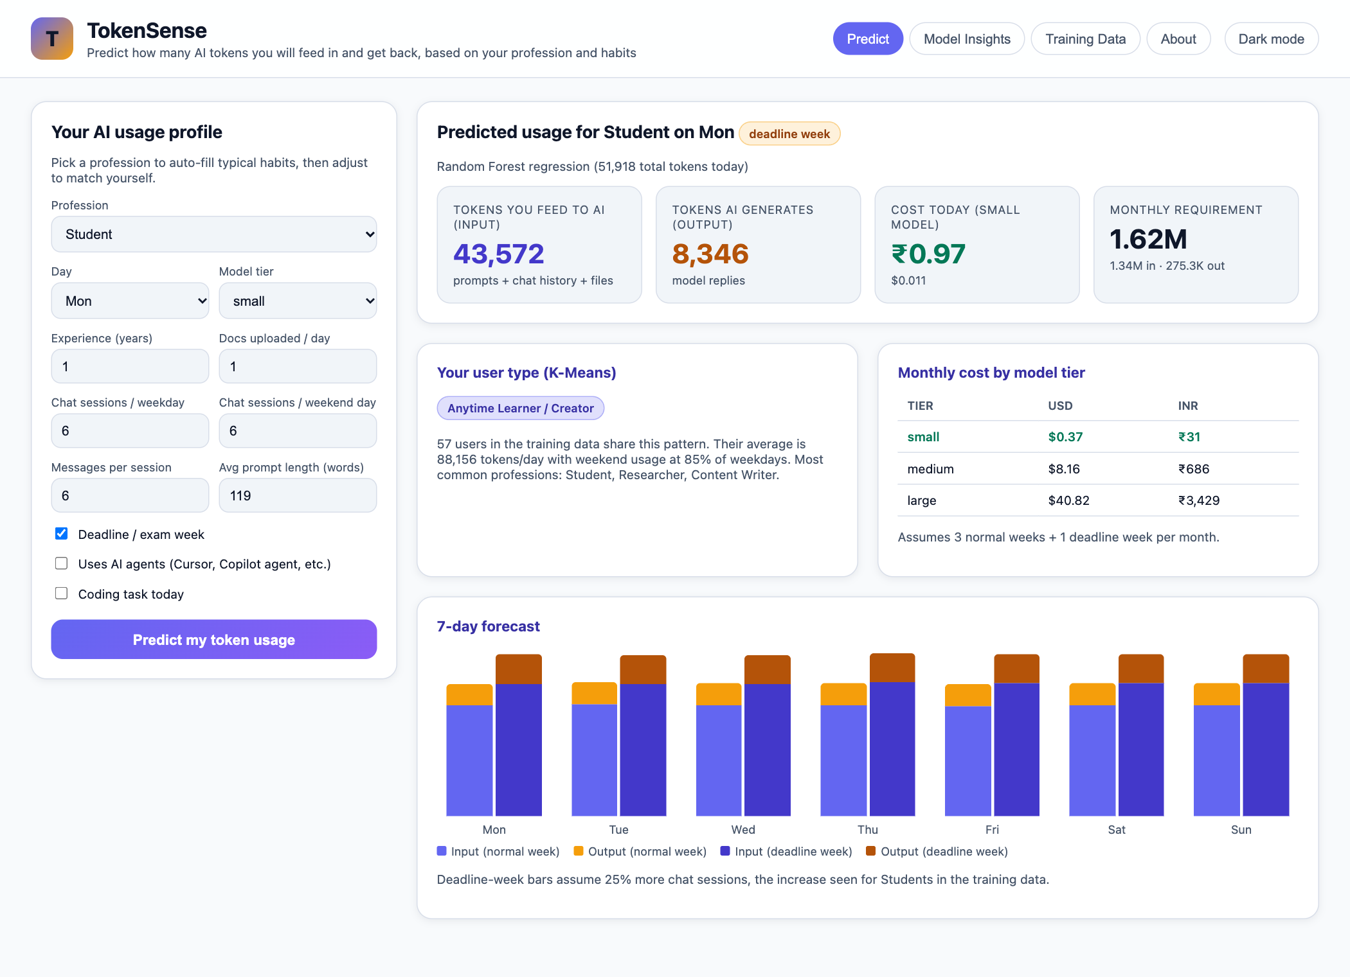
Model Insights:
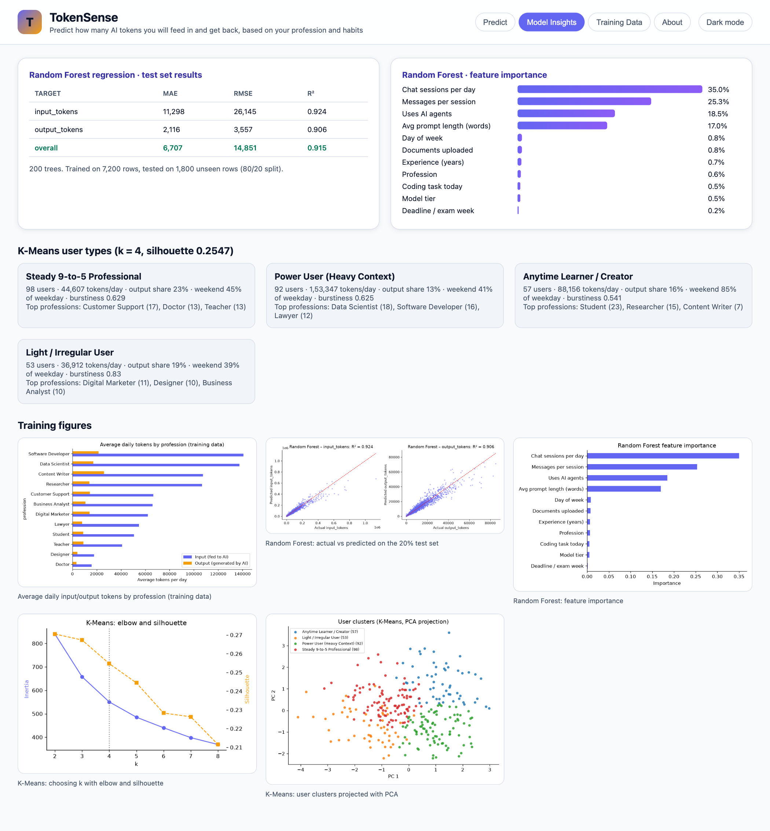
Training Data:
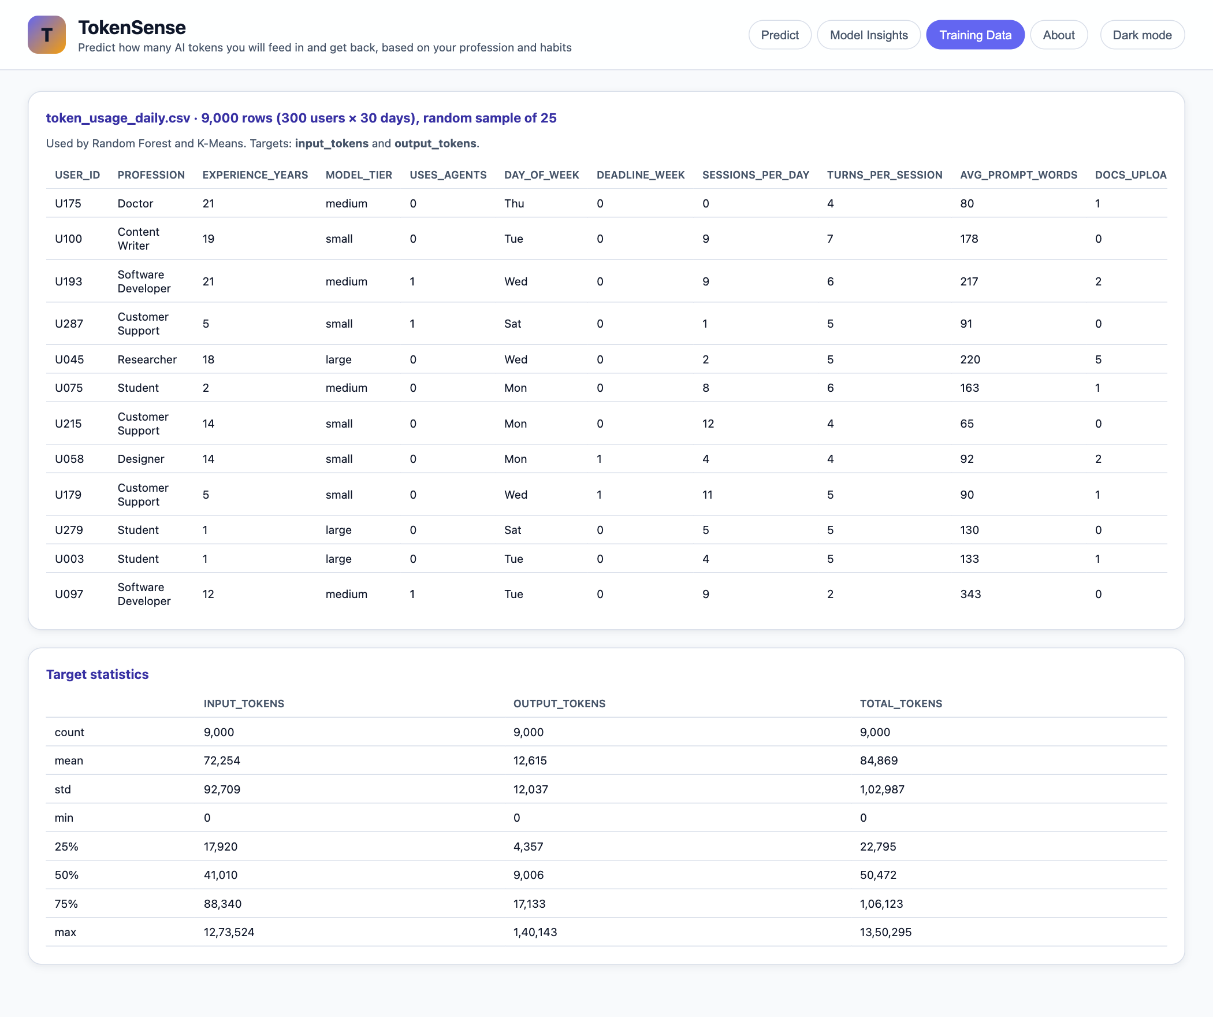
About (algorithms and architecture):
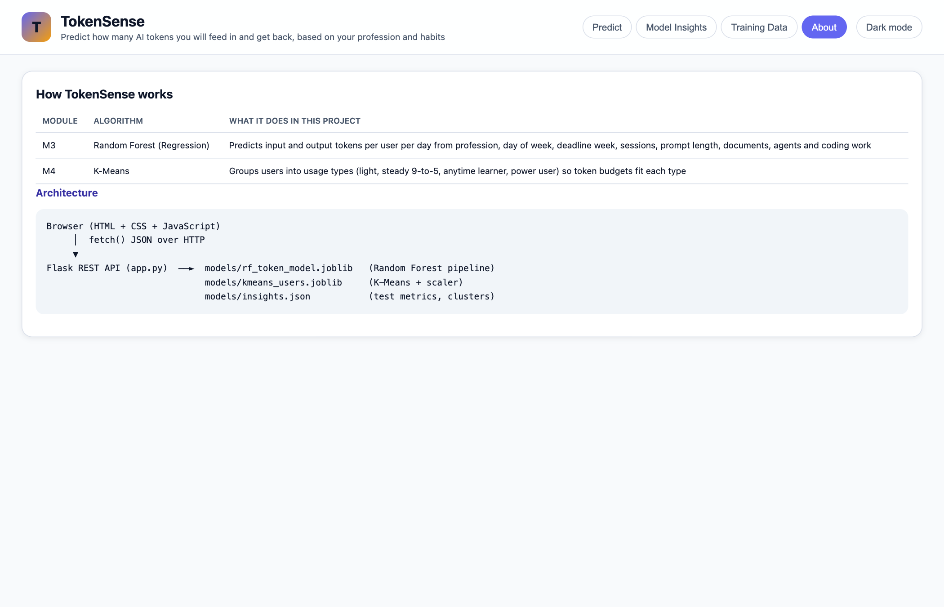
Important Code -
Random Forest training (src/train.py)
def train_random_forest(df):
X, y = df[FEATURES], df[TARGETS]
X_train, X_test, y_train, y_test = train_test_split(X, y, test_size=0.2, random_state=SEED)

pipe = Pipeline([
("prep", ColumnTransformer([
("cat", OneHotEncoder(handle_unknown="ignore", sparse_output=False), CATEGORICAL),
("num", "passthrough", NUMERIC),
])),
("model", RandomForestRegressor(n_estimators=N_ESTIMATORS, min_samples_leaf=2,
random_state=SEED, n_jobs=-1)),
])
pipe.fit(X_train, y_train)
pred = pipe.predict(X_test)

metrics = {
t: {"mae": round(mean_absolute_error(y_test[t], pred[:, i]), 1),
"rmse": round(root_mean_squared_error(y_test[t], pred[:, i]), 1),
"r2": round(r2_score(y_test[t], pred[:, i]), 4)}
for i, t in enumerate(TARGETS)
}
metrics["overall"] = {"mae": round(mean_absolute_error(y_test, pred), 1),
"rmse": round(root_mean_squared_error(y_test, pred), 1),
"r2": round(r2_score(y_test, pred), 4)}
for k, m in metrics.items():
print(f"[RF] {k:14s} MAE={m['mae']:>9} RMSE={m['rmse']:>9} R2={m['r2']}")

# Feature importance, with one-hot columns summed back into their original feature
names = pipe.named_steps["prep"].get_feature_names_out()
importance = {}
for name, imp in zip(names, pipe.named_steps["model"].feature_importances_):
col = name.split("__", 1)[1]
source = next((c for c in CATEGORICAL if col.startswith(c + "_")), col)
importance[source] = importance.get(source, 0) + float(imp)
importance = dict(sorted(((k, round(v, 4)) for k, v in importance.items()), key=lambda kv: -kv[1]))

return pipe, metrics, importance, (y_test, pred), (len(X_train), len(X_test))
K-Means clustering (src/train.py)
def train_kmeans(df):
rows = []
for uid, g in df.groupby("user_id"):
prof = build_profile(g["day_of_week"], g["input_tokens"], g["output_tokens"])
prof.update(user_id=uid, profession=g["profession"].iloc[0],
avg_daily_tokens=float((g["input_tokens"] + g["output_tokens"]).mean()))
rows.append(prof)
profiles = pd.DataFrame(rows)
scaler = StandardScaler()
Z = scaler.fit_transform(profiles[PROFILE_FEATURES])

elbow = []
for k in range(2, 9):
km = KMeans(n_clusters=k, n_init=10, random_state=SEED).fit(Z)
elbow.append({"k": k, "inertia": round(km.inertia_, 2),
"silhouette": round(silhouette_score(Z, km.labels_), 4)})

km = KMeans(n_clusters=N_CLUSTERS, n_init=10, random_state=SEED).fit(Z)
profiles["cluster"] = km.labels_
centers = pd.DataFrame(scaler.inverse_transform(km.cluster_centers_), columns=PROFILE_FEATURES)
names = name_clusters(centers)
profiles["cluster_name"] = profiles["cluster"].map(names)
silhouette = round(silhouette_score(Z, km.labels_), 4)
...
Backend prediction API (app.py)
@app.post("/api/predict")
def predict():
body = request.get_json(force=True)
try:
row = parse_inputs(body)
except (KeyError, ValueError) as e:
return jsonify({"error": str(e)}), 400
weekend_sessions = float(body.get("weekend_sessions", row["sessions_per_day"]))
rf = state["rf"]

# M3: Random Forest predicts today's input and output tokens
x = pd.DataFrame([row])[FEATURES]
inp, out = (max(0.0, v) for v in rf.predict(x)[0])

normal = rf.predict(week_frame(row, weekend_sessions, 0)).clip(min=0)
deadline = rf.predict(week_frame(row, weekend_sessions, 1)).clip(min=0)
weekly = [{"day": d, "input": int(n[0]), "output": int(n[1]),
"deadline_input": int(dl[0]), "deadline_output": int(dl[1])}
for d, n, dl in zip(DAYS, normal, deadline)]

# A typical month = 3 normal weeks + 1 deadline/exam week, scaled to 30 days
month_in = (3 * normal[:, 0].sum() + deadline[:, 0].sum()) * 30 / 28
month_out = (3 * normal[:, 1].sum() + deadline[:, 1].sum()) * 30 / 28
monthly = {
"input_tokens": int(month_in), "output_tokens": int(month_out),
"total_tokens": int(month_in + month_out),
"cost_by_tier": {t: cost(month_in, month_out, t) for t in MODEL_TIERS},
}

# M4: K-Means assigns the user type from their predicted week
km = state["kmeans"]
profile = build_profile(DAYS, normal[:, 0], normal[:, 1])
z = km["scaler"].transform(pd.DataFrame([profile])[PROFILE_FEATURES])
cluster_id = int(km["kmeans"].predict(z)[0])
cluster = next(c for c in state["insights"]["kmeans"]["clusters"] if c["cluster"] == cluster_id)

return jsonify({
"inputs": row,
"prediction": {"input_tokens": int(inp), "output_tokens": int(out), "total_tokens": int(inp + out),
"cost": cost(inp, out, row["model_tier"])},
"weekly": weekly,
"deadline_uplift": state["deadline_uplift"][row["profession"]],
"monthly": monthly,
"cluster": {**cluster, "profile": {k: round(v, 3) for k, v in profile.items()}},
})
Frontend call to the backend (static/app.js)
async function onPredict(e) {
e.preventDefault();
const btn = $("#predict-form button");
btn.disabled = true;
try {
renderResults(await api("/api/predict", { method: "POST", body: readForm() }));
} catch (err) {
toast(err.message, true);
} finally {
btn.disabled = false;
}
}
Conclusion -
TokenSense predicts the daily input and output AI tokens of a person with R² = 0.915 using Random Forest Regression, and groups users into four meaningful usage types with K-Means, without any labels. Combined with a Flask backend and a simple web frontend, it gives a practical tool for planning AI usage and cost for every profession. Future scope: train on real usage logs, add time-series forecasting, and connect directly to AI providers’ usage APIs.

