Experiment 10 – Mini Project
TokenSense: AI Token Utilization Prediction by Profession
Algorithms used: Random Forest Regression (Module 3) and K-Means Clustering (Module 4)
Name | Roll No. | Class / Division | Date
 |  | TE-B

1. Aim
To build a web application that predicts how many AI tokens a person will need per day and per month, split into input tokens (what the person feeds to the AI) and output tokens (what the AI generates), based on their profession and usage habits, and to group users into usage types.

2. Problem Statement
AI assistants such as ChatGPT, Claude, Gemini and GitHub Copilot are now part of daily work for developers, students, writers, teachers, doctors and lawyers. Every one of these services measures and bills usage in tokens (about 0.75 words per token). Users cannot easily answer simple questions such as “How many tokens will I use this month?” or “Which model tier can I afford?”. Token usage depends on the profession (a developer pastes code and error logs, a content writer asks for long replies), on habits (number of chats, messages per chat, prompt length, uploaded files, AI agents) and on the calendar (weekends, deadline or exam weeks). TokenSense learns these patterns from data and gives each person a personal token budget and cost estimate.

3. Dataset
Real per-user token logs are private, so a realistic synthetic dataset was generated in Python (src/generate_data.py, random seed 42). The rules follow how large language model billing actually works: every new message re-sends the whole conversation, so input tokens grow roughly with the square of the messages per session; each uploaded document adds about 2,500 tokens; AI agents multiply the context about 2.5 times; weekends, Fridays and deadline weeks change the number of sessions; and ±12% random noise is added to every value.
- File: token_usage_daily.csv with 9,000 rows (300 users × 30 days) covering 12 professions.
- Input features (11): profession, day of week, model tier, experience in years, deadline/exam week, uses AI agents, chat sessions per day, messages per session, average prompt length in words, documents uploaded, coding task.
- Targets (2): input_tokens and output_tokens per day.
- Split: 7,200 rows for training and 1,800 unseen rows for testing (80/20).

4. Algorithms Used

4.1 Random Forest Regression (Module 3)
A Random Forest is an ensemble of many decision trees. Each tree is trained on a bootstrap sample (rows drawn at random with replacement), and at every split it considers only a random subset of the features. A regression tree keeps splitting the data so that the squared error inside each branch becomes as small as possible, and it predicts the average target value of the rows in a leaf. The forest predicts the average of all its trees. Averaging many different trees removes most of the overfitting of a single tree while keeping its ability to learn non-linear relationships.
This is important for token prediction because usage is strongly non-linear: doubling the messages in one chat roughly quadruples the input tokens, and switching on AI agents multiplies everything. In this project one multi-output forest with 200 trees predicts both input and output tokens. Categorical features (profession, day, model tier) are one-hot encoded with a ColumnTransformer inside a scikit-learn Pipeline, so exactly the same preprocessing runs during training and inside the web application. On the unseen test rows the model reached R² = 0.915. Feature importance shows that the biggest drivers of token usage are chat sessions per day (35%), messages per session (25%), use of AI agents (18%), prompt length (17%).
Target | MAE (tokens) | RMSE (tokens) | R²
input_tokens | 11,298 | 26,145 | 0.924
output_tokens | 2,116 | 3,557 | 0.906
overall | 6,707 | 14,851 | 0.915

4.2 K-Means Clustering (Module 4)
K-Means is an unsupervised learning algorithm that divides data into k groups (clusters) without any labels. It works in four steps:
- Choose k starting centroids.
- Assign every point to its nearest centroid using Euclidean distance.
- Move each centroid to the mean of the points assigned to it.
- Repeat steps 2 and 3 until the assignments stop changing.
Each of the 300 users is summarised by four features calculated from their 30 days of usage: log of average daily tokens, burstiness (standard deviation divided by mean), output share of tokens, and weekend-to-weekday usage ratio. The features are standardised first so that no feature dominates the distance. The number of clusters k = 4 was chosen with the elbow method (inertia) and the silhouette score (0.25). The clusters were named from their centroids:
User type | Users | Avg tokens / day | Most common professions
Light / Irregular User | 53 | 36,912 | Digital Marketer, Designer, Business Analyst
Steady 9-to-5 Professional | 98 | 44,607 | Customer Support, Doctor, Teacher
Anytime Learner / Creator | 57 | 88,156 | Student, Researcher, Content Writer
Power User (Heavy Context) | 92 | 1,53,347 | Data Scientist, Software Developer, Lawyer

How the two algorithms work together: when a new user submits the form, the Random Forest predicts their tokens for all seven days of a week. The same four profile features are calculated from that forecast, and the trained K-Means model assigns the user to one of the four types.

5. System Design: Frontend, Backend and Their Connection

5.1 Frontend
The frontend is a single-page web interface written in plain HTML, CSS and JavaScript (templates/index.html, static/style.css, static/app.js), without any framework. It has four tabs:
- Predict: a form for the user’s profile, then result cards for input tokens, output tokens, today’s cost and monthly requirement, the K-Means user type, the monthly cost on small, medium and large models, and a 7-day forecast chart for a normal week and a deadline week.
- Model Insights: Random Forest test metrics and feature importance, the four K-Means clusters, and all training charts.
- Training Data: a sample of the training CSV and summary statistics.
- About: the algorithm table and the architecture diagram.
Choosing a profession automatically fills in that profession’s typical habits taken from the dataset, so a user can get a prediction with one click and then adjust the numbers.

5.2 Backend
The backend is a Python Flask server (app.py). When it starts, it loads the trained Random Forest pipeline and the K-Means model (saved with joblib by src/train.py) and exposes a small REST API that returns JSON:
- POST /api/predict: Random Forest prediction, 7-day and monthly forecast, cost in USD and INR, and the K-Means user type.
- GET /api/insights: test metrics, feature importance and cluster details from training.
- GET /api/meta: dropdown options and the default habits for each profession.
- GET /api/dataset: a preview of the training data.

5.3 Connection Between Frontend and Backend
When the user clicks “Predict my token usage”, app.js reads the form and sends it to /api/predict as JSON using the browser’s fetch() function. Flask converts the JSON into a one-row pandas DataFrame and passes it through the same pipeline used in training (one-hot encoding, then the Random Forest). It then runs K-Means on the weekly forecast, calculates the cost, and sends everything back as one JSON response. JavaScript renders the response into cards, tables and charts without reloading the page. Model training (src/train.py) runs separately and only writes the model files that the server reads, so the machine learning code and the web code stay cleanly separated.
Layer | Technology | Main files
Frontend | HTML, CSS, JavaScript (fetch API) | templates/index.html, static/app.js, static/style.css
Backend | Python, Flask REST API | app.py
Machine learning | scikit-learn, pandas, NumPy | src/train.py, src/profiles.py
Saved models | joblib, JSON | models/rf_token_model.joblib, models/kmeans_users.joblib, models/insights.json
Data | CSV (synthetic) | data/token_usage_daily.csv (generated by src/generate_data.py)

6. Result
TokenSense predicts daily input and output tokens with R² = 0.915 and an average error of 6,707 tokens on unseen data. For example, a software developer with 8 chats a day on a medium-tier model is predicted to feed about 80,700 tokens to the AI and receive about 18,700 tokens back (about ₹44 per day, 2.79 million tokens per month), and is classified as a “Power User (Heavy Context)”.

7. Conclusion
Random Forest regression learned the non-linear way AI token usage grows with chats, messages, prompt length and agents, and predicted it accurately for every profession. K-Means found four meaningful user types without any labels, which helps match each person to the right token budget or plan. Together they give a practical tool for planning AI usage and cost. Future scope: train on real exported usage logs, add time-series forecasting, and connect directly to AI providers’ usage APIs.

8. Screenshots
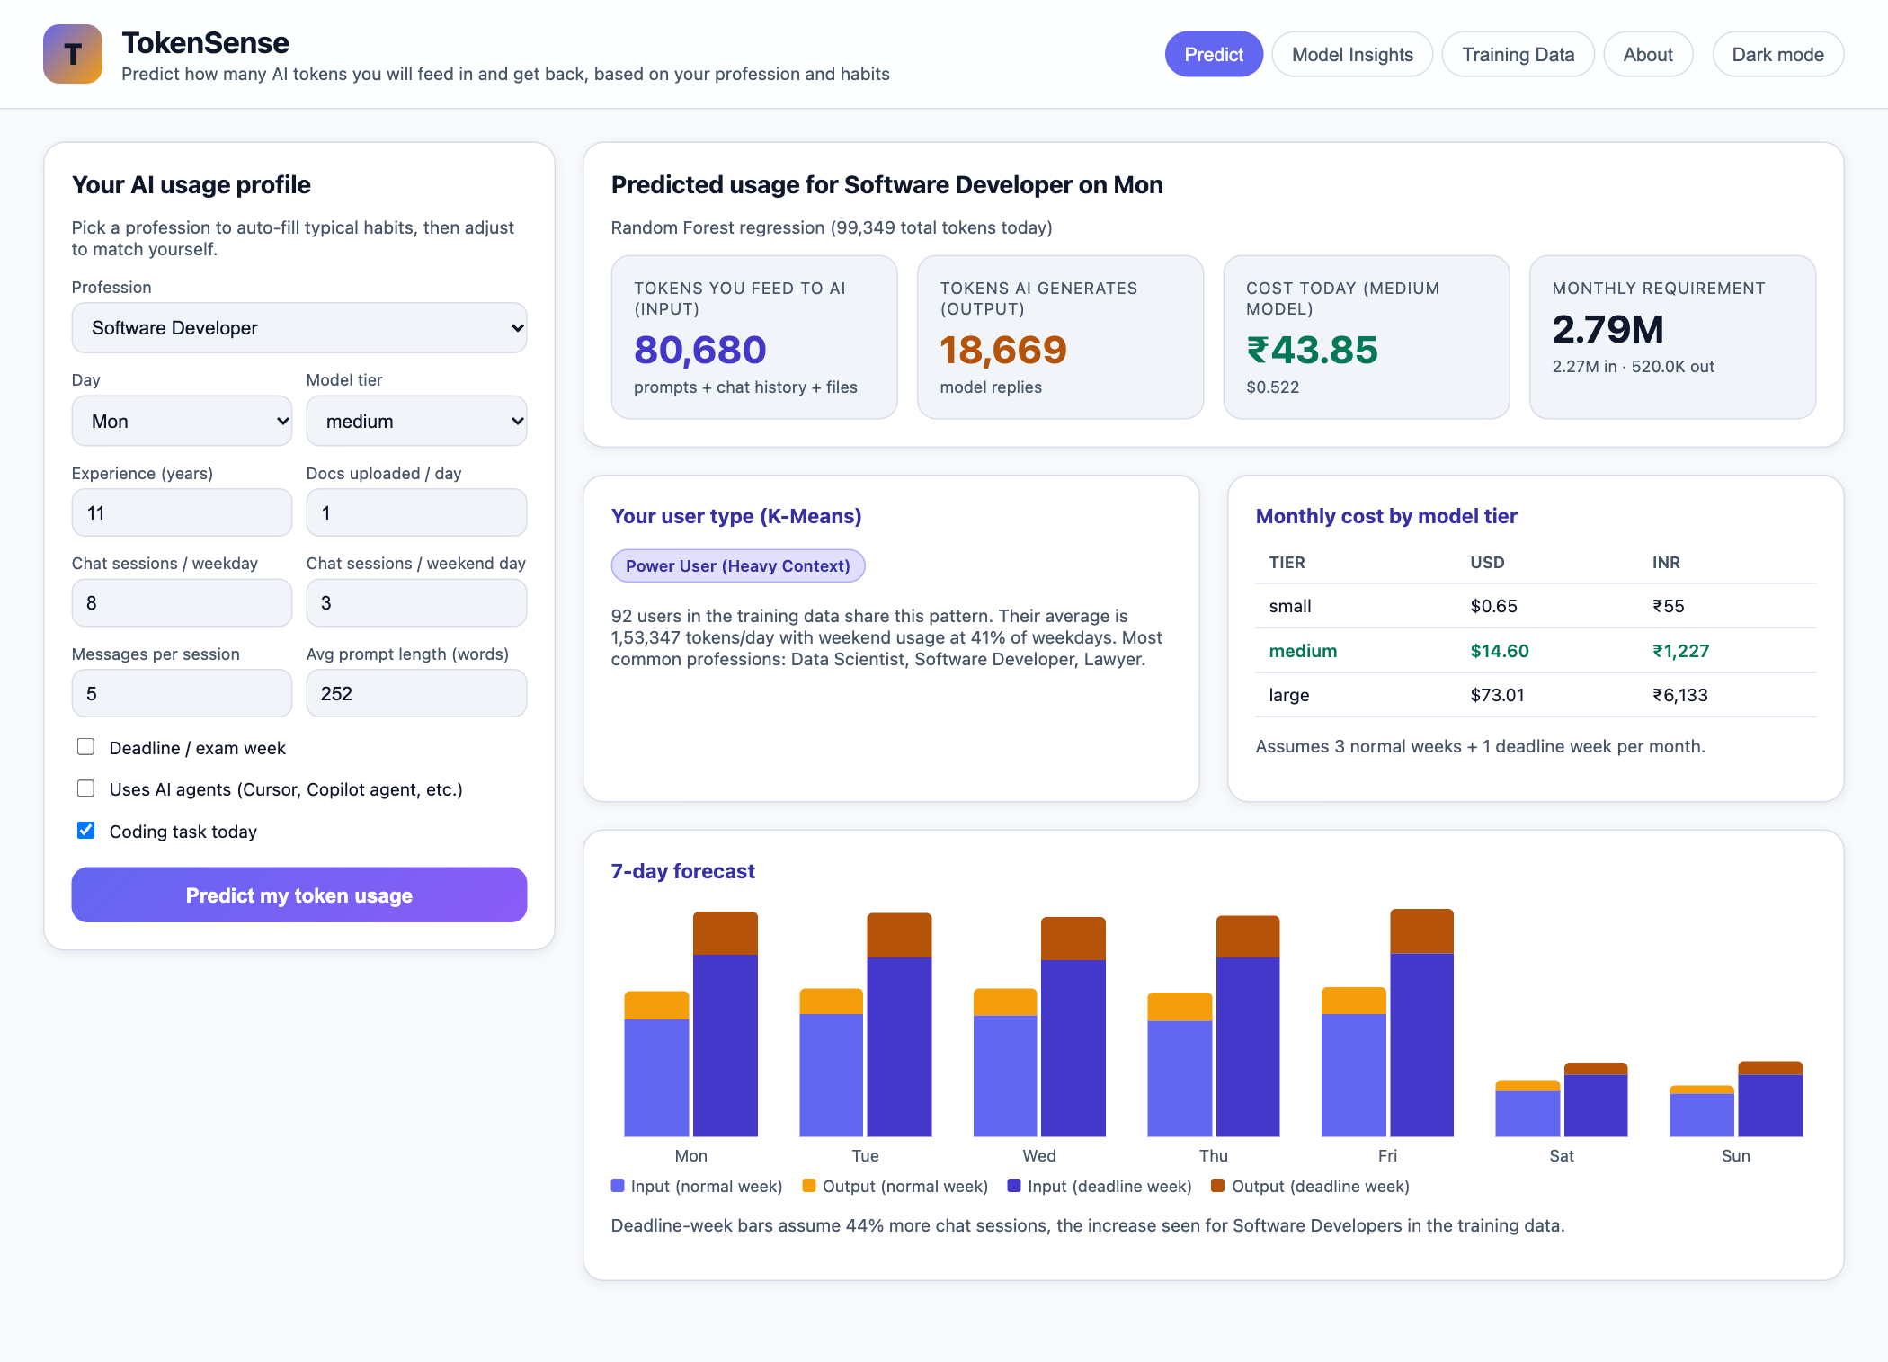
Figure 1: Predict tab – Software Developer: input/output tokens, cost, user type and 7-day forecast
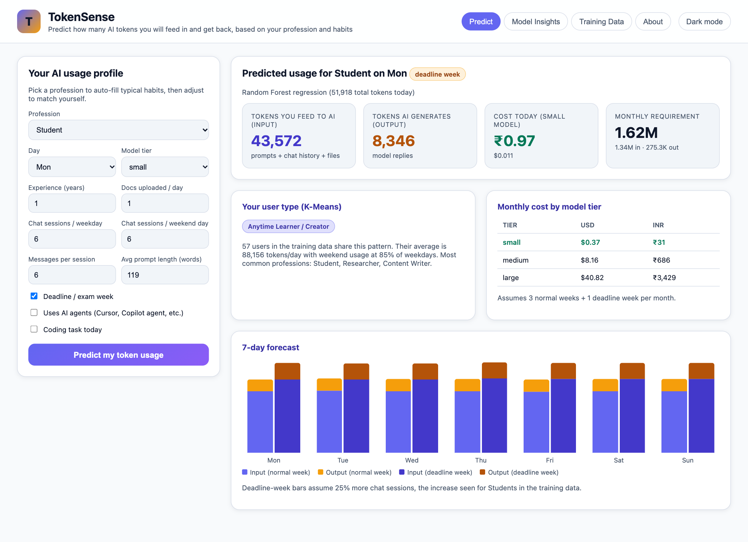
Figure 2: Predict tab – Student in exam week
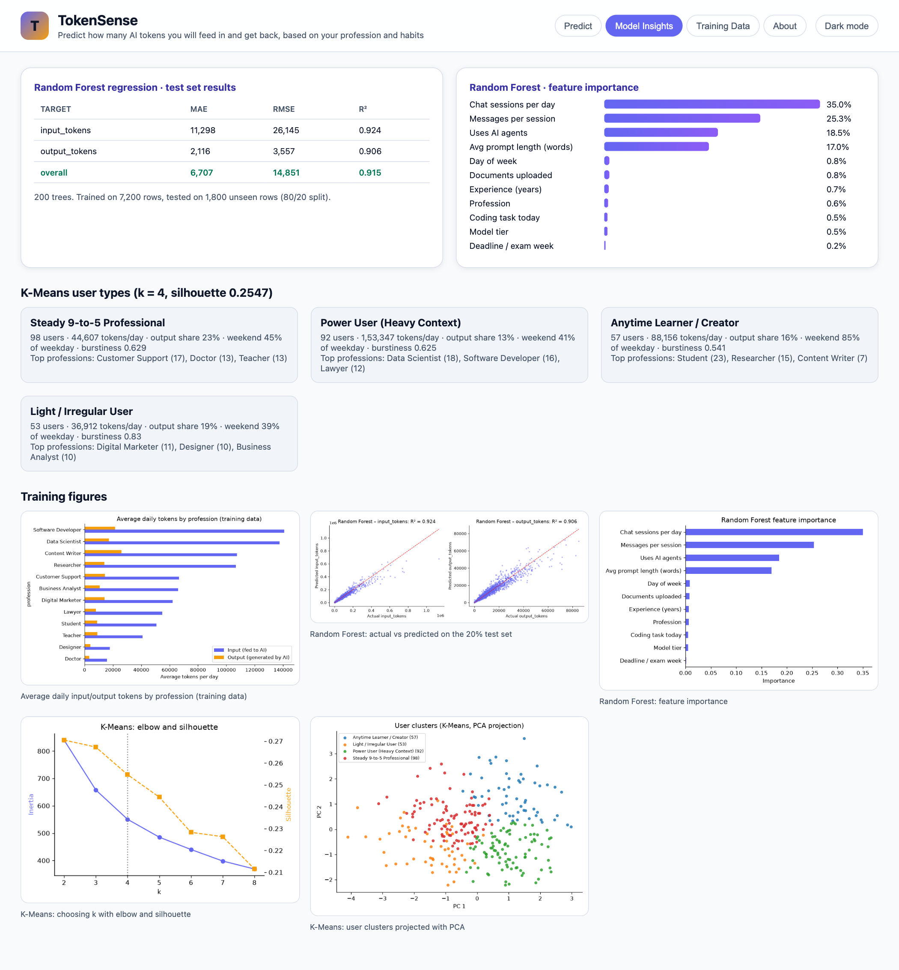
Figure 3: Model Insights tab – Random Forest metrics, feature importance and K-Means clusters
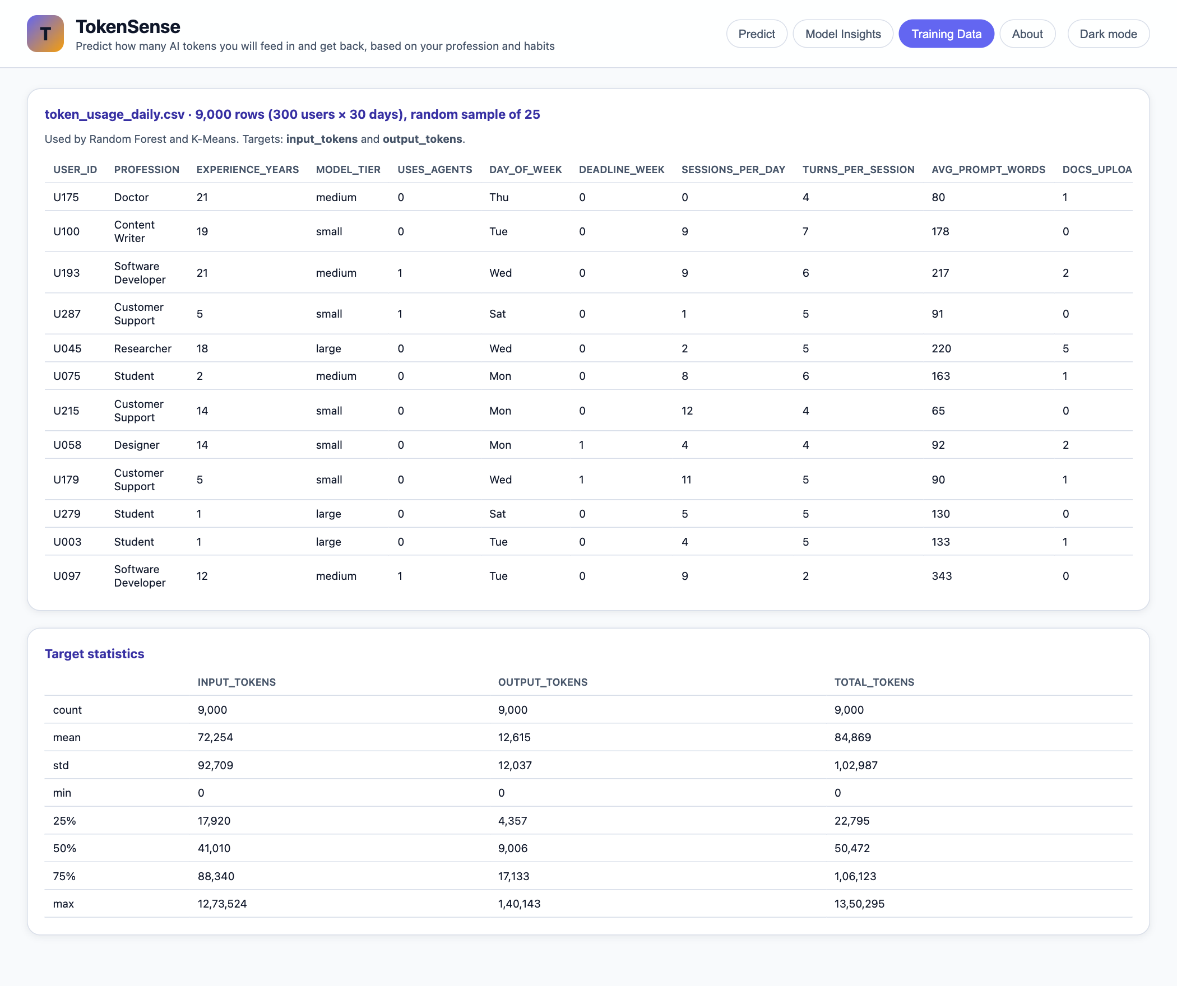
Figure 4: Training Data tab – dataset sample and statistics
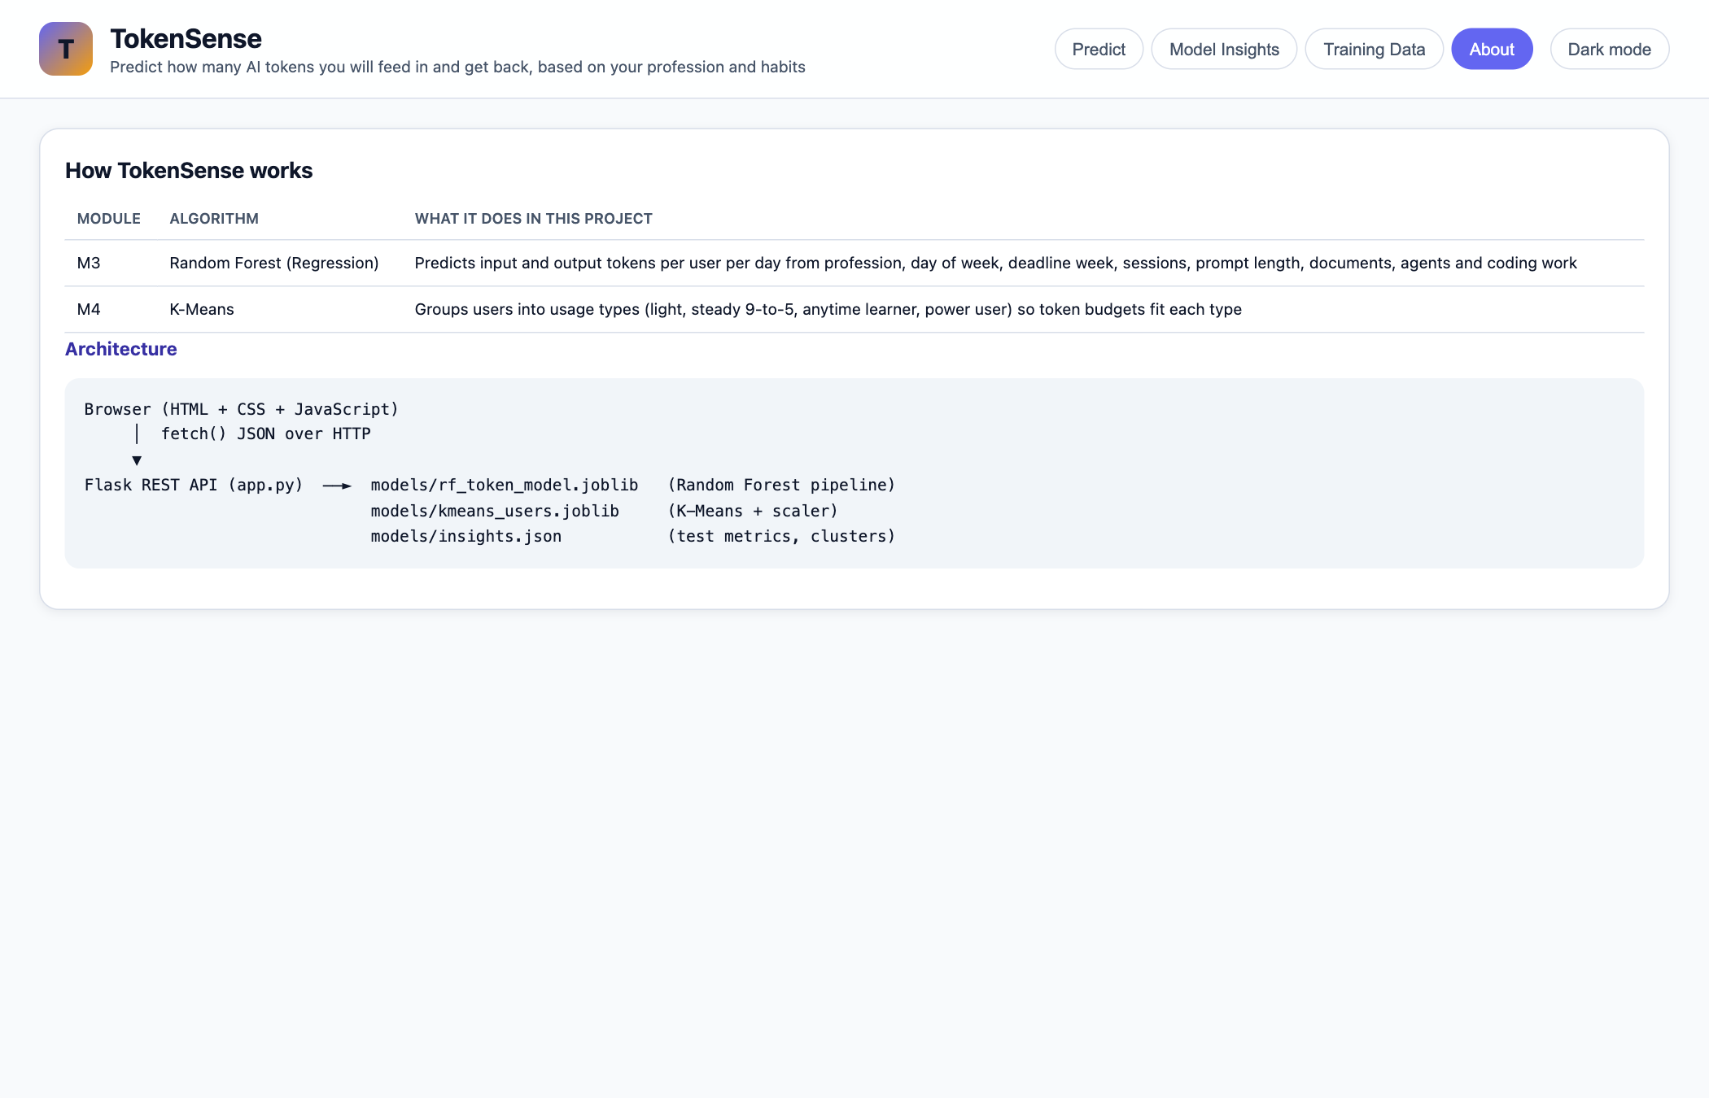
Figure 5: About tab – algorithms and architecture

9. Training Graphs
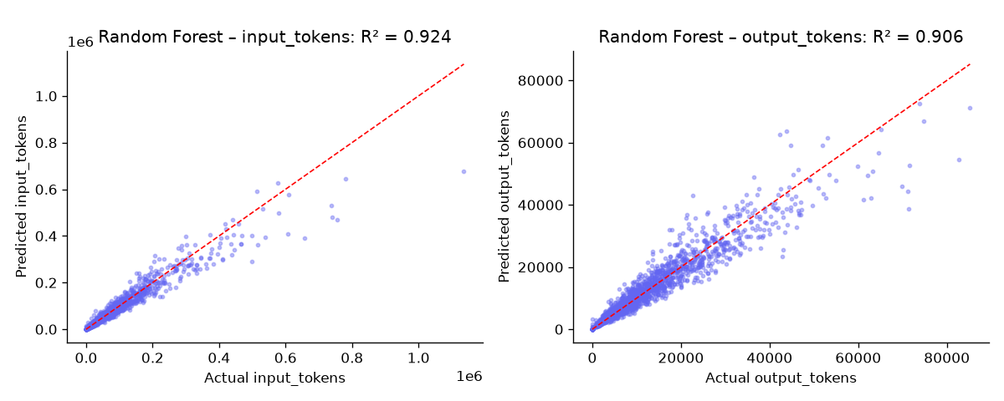
Figure 6: Random Forest – actual vs predicted tokens on the test set
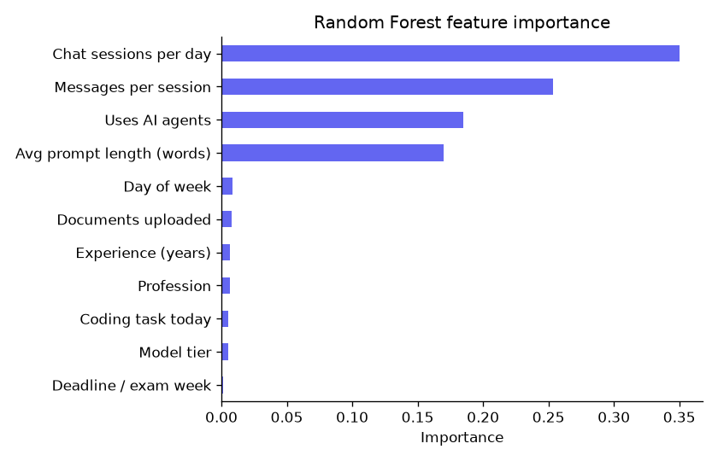
Figure 7: Random Forest – feature importance
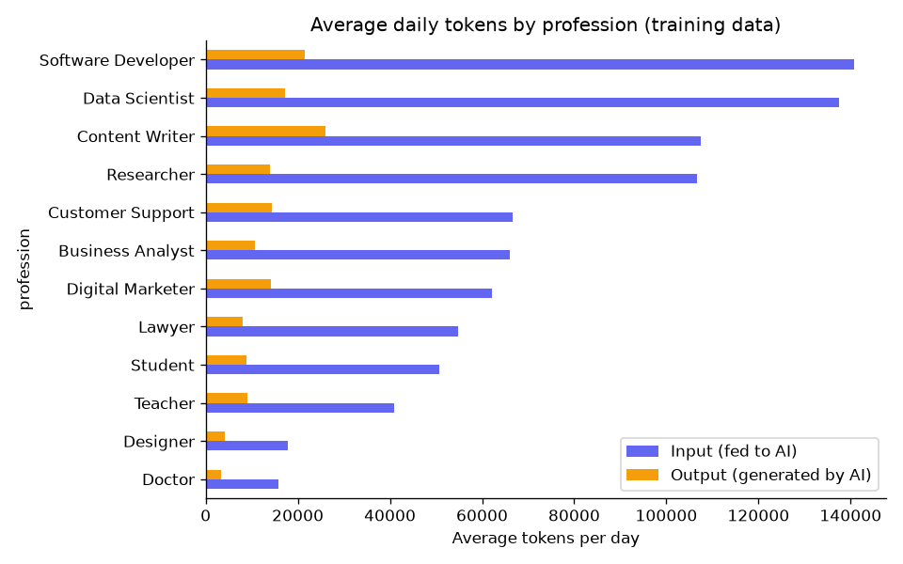
Figure 8: Average daily tokens by profession (training data)
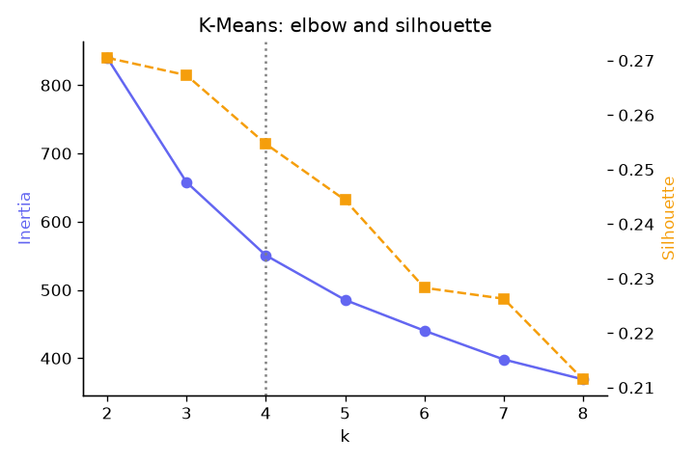
Figure 9: K-Means – elbow method and silhouette score for choosing k
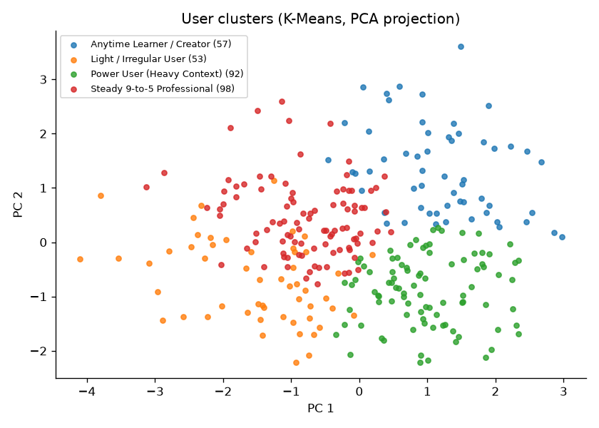
Figure 10: K-Means – user clusters (PCA projection)

10. Important Code
10.1 Random Forest regression training (src/train.py)
def train_random_forest(df):
X, y = df[FEATURES], df[TARGETS]
X_train, X_test, y_train, y_test = train_test_split(X, y, test_size=0.2, random_state=SEED)

pipe = Pipeline([
("prep", ColumnTransformer([
("cat", OneHotEncoder(handle_unknown="ignore", sparse_output=False), CATEGORICAL),
("num", "passthrough", NUMERIC),
])),
("model", RandomForestRegressor(n_estimators=N_ESTIMATORS, min_samples_leaf=2,
random_state=SEED, n_jobs=-1)),
])
pipe.fit(X_train, y_train)
pred = pipe.predict(X_test)

metrics = {
t: {"mae": round(mean_absolute_error(y_test[t], pred[:, i]), 1),
"rmse": round(root_mean_squared_error(y_test[t], pred[:, i]), 1),
"r2": round(r2_score(y_test[t], pred[:, i]), 4)}
for i, t in enumerate(TARGETS)
}
metrics["overall"] = {"mae": round(mean_absolute_error(y_test, pred), 1),
"rmse": round(root_mean_squared_error(y_test, pred), 1),
"r2": round(r2_score(y_test, pred), 4)}
for k, m in metrics.items():
print(f"[RF] {k:14s} MAE={m['mae']:>9} RMSE={m['rmse']:>9} R2={m['r2']}")

# Feature importance, with one-hot columns summed back into their original feature
names = pipe.named_steps["prep"].get_feature_names_out()
importance = {}
for name, imp in zip(names, pipe.named_steps["model"].feature_importances_):
col = name.split("__", 1)[1]
source = next((c for c in CATEGORICAL if col.startswith(c + "_")), col)
importance[source] = importance.get(source, 0) + float(imp)
importance = dict(sorted(((k, round(v, 4)) for k, v in importance.items()), key=lambda kv: -kv[1]))

return pipe, metrics, importance, (y_test, pred), (len(X_train), len(X_test))
10.2 K-Means clustering (src/train.py)
def train_kmeans(df):
rows = []
for uid, g in df.groupby("user_id"):
prof = build_profile(g["day_of_week"], g["input_tokens"], g["output_tokens"])
prof.update(user_id=uid, profession=g["profession"].iloc[0],
avg_daily_tokens=float((g["input_tokens"] + g["output_tokens"]).mean()))
rows.append(prof)
profiles = pd.DataFrame(rows)
scaler = StandardScaler()
Z = scaler.fit_transform(profiles[PROFILE_FEATURES])

elbow = []
for k in range(2, 9):
km = KMeans(n_clusters=k, n_init=10, random_state=SEED).fit(Z)
elbow.append({"k": k, "inertia": round(km.inertia_, 2),
"silhouette": round(silhouette_score(Z, km.labels_), 4)})

km = KMeans(n_clusters=N_CLUSTERS, n_init=10, random_state=SEED).fit(Z)
profiles["cluster"] = km.labels_
centers = pd.DataFrame(scaler.inverse_transform(km.cluster_centers_), columns=PROFILE_FEATURES)
names = name_clusters(centers)
profiles["cluster_name"] = profiles["cluster"].map(names)
silhouette = round(silhouette_score(Z, km.labels_), 4)
...
10.3 Backend prediction API (app.py)
@app.post("/api/predict")
def predict():
body = request.get_json(force=True)
try:
row = parse_inputs(body)
except (KeyError, ValueError) as e:
return jsonify({"error": str(e)}), 400
weekend_sessions = float(body.get("weekend_sessions", row["sessions_per_day"]))
rf = state["rf"]

# M3: Random Forest predicts today's input and output tokens
x = pd.DataFrame([row])[FEATURES]
inp, out = (max(0.0, v) for v in rf.predict(x)[0])

normal = rf.predict(week_frame(row, weekend_sessions, 0)).clip(min=0)
deadline = rf.predict(week_frame(row, weekend_sessions, 1)).clip(min=0)
weekly = [{"day": d, "input": int(n[0]), "output": int(n[1]),
"deadline_input": int(dl[0]), "deadline_output": int(dl[1])}
for d, n, dl in zip(DAYS, normal, deadline)]

# A typical month = 3 normal weeks + 1 deadline/exam week, scaled to 30 days
month_in = (3 * normal[:, 0].sum() + deadline[:, 0].sum()) * 30 / 28
month_out = (3 * normal[:, 1].sum() + deadline[:, 1].sum()) * 30 / 28
monthly = {
"input_tokens": int(month_in), "output_tokens": int(month_out),
"total_tokens": int(month_in + month_out),
"cost_by_tier": {t: cost(month_in, month_out, t) for t in MODEL_TIERS},
}

# M4: K-Means assigns the user type from their predicted week
km = state["kmeans"]
profile = build_profile(DAYS, normal[:, 0], normal[:, 1])
z = km["scaler"].transform(pd.DataFrame([profile])[PROFILE_FEATURES])
cluster_id = int(km["kmeans"].predict(z)[0])
cluster = next(c for c in state["insights"]["kmeans"]["clusters"] if c["cluster"] == cluster_id)

return jsonify({
"inputs": row,
"prediction": {"input_tokens": int(inp), "output_tokens": int(out), "total_tokens": int(inp + out),
"cost": cost(inp, out, row["model_tier"])},
"weekly": weekly,
"deadline_uplift": state["deadline_uplift"][row["profession"]],
"monthly": monthly,
"cluster": {**cluster, "profile": {k: round(v, 3) for k, v in profile.items()}},
})
10.4 Frontend call to the backend (static/app.js)
async function onPredict(e) {
e.preventDefault();
const btn = $("#predict-form button");
btn.disabled = true;
try {
renderResults(await api("/api/predict", { method: "POST", body: readForm() }));
} catch (err) {
toast(err.message, true);
} finally {
btn.disabled = false;
}
}

11. Training Data
Sample of 18 rows (every 500th row) from data/token_usage_daily.csv, which has 9,000 rows in total. The last three columns are the values the model learns to predict.
User | Profession | Exp (yrs) | Model tier | Agents | Day | Deadline wk | Sessions | Msgs / session | Prompt words | Docs | Code task | Input tokens | Output tokens | Total tokens
U001 | Software Developer | 3 | medium | 0 | Sat | 0 | 4 | 6 | 268 | 0 | 1 | 60,996 | 10,805 | 71,801
U017 | Digital Marketer | 1 | medium | 0 | Wed | 1 | 8 | 4 | 104 | 0 | 0 | 22,884 | 7,090 | 29,974
U034 | Designer | 3 | large | 0 | Thu | 0 | 5 | 3 | 113 | 1 | 0 | 9,141 | 3,296 | 12,437
U051 | Student | 3 | large | 0 | Wed | 0 | 12 | 5 | 109 | 2 | 0 | 60,842 | 14,904 | 75,746
U067 | Doctor | 3 | medium | 0 | Tue | 0 | 2 | 4 | 76 | 1 | 0 | 6,351 | 1,216 | 7,567
U084 | Business Analyst | 9 | large | 0 | Sun | 0 | 5 | 8 | 161 | 0 | 0 | 69,666 | 11,169 | 80,835
U101 | Digital Marketer | 22 | large | 0 | Mon | 0 | 5 | 3 | 111 | 3 | 0 | 15,835 | 6,923 | 22,758
U117 | Researcher | 18 | medium | 0 | Sun | 0 | 2 | 2 | 392 | 4 | 0 | 14,000 | 2,512 | 16,512
U134 | Data Scientist | 12 | medium | 0 | Mon | 0 | 6 | 4 | 168 | 4 | 0 | 33,682 | 6,978 | 40,660
U151 | Doctor | 20 | medium | 0 | Mon | 0 | 0 | 4 | 83 | 1 | 0 | 2,518 | 0 | 2,518
U167 | Customer Support | 17 | small | 1 | Sun | 0 | 1 | 8 | 67 | 0 | 0 | 10,885 | 1,970 | 12,855
U184 | Content Writer | 15 | large | 0 | Fri | 1 | 9 | 7 | 147 | 2 | 0 | 1,07,810 | 21,385 | 1,29,195
U201 | Researcher | 4 | medium | 0 | Sat | 1 | 1 | 6 | 383 | 1 | 0 | 23,874 | 2,059 | 25,933
U217 | Software Developer | 11 | small | 0 | Thu | 0 | 7 | 7 | 258 | 1 | 1 | 1,24,812 | 28,150 | 1,52,962
U234 | Teacher | 9 | medium | 0 | Wed | 0 | 6 | 5 | 132 | 1 | 0 | 36,378 | 11,920 | 48,298
U251 | Customer Support | 5 | small | 0 | Sat | 0 | 2 | 5 | 58 | 0 | 0 | 4,753 | 1,631 | 6,384
U267 | Student | 1 | large | 0 | Tue | 0 | 3 | 5 | 129 | 1 | 0 | 21,318 | 4,208 | 25,526
U284 | Lawyer | 6 | medium | 0 | Tue | 1 | 4 | 6 | 315 | 4 | 0 | 71,945 | 9,040 | 80,985

Average daily usage per profession in the full training data:
Profession | Rows | Avg input tokens | Avg output tokens | Avg total tokens
Software Developer | 750 | 1,40,669 | 21,590 | 1,62,259
Data Scientist | 750 | 1,37,447 | 17,210 | 1,54,657
Content Writer | 750 | 1,07,555 | 26,087 | 1,33,642
Researcher | 750 | 1,06,604 | 13,914 | 1,20,518
Customer Support | 750 | 66,615 | 14,334 | 80,949
Business Analyst | 750 | 65,972 | 10,729 | 76,701
Digital Marketer | 750 | 62,141 | 14,160 | 76,301
Lawyer | 750 | 54,849 | 8,119 | 62,968
Student | 750 | 50,630 | 8,769 | 59,399
Teacher | 750 | 40,978 | 9,010 | 49,988
Designer | 750 | 17,742 | 4,137 | 21,878
Doctor | 750 | 15,850 | 3,322 | 19,172

