INDEX

S.NO | DATE | TITLE
1. | 21/1/25 | Azure DevOps Environment Setup
2. | 21/1/25 | Azure DevOps Project Setup and User Story Management
3. | 28/1/25 | Setting Up Epics, Features and User Stories for Project Planning
4. | 11/2/25 | Sprint Planning
5. | 18/2/25 | Poker Estimation
6. | 25/2/25 | Designing Class and Sequence Diagrams for Project Architecture
7. | 04/3/25 | Designing Use-Case and Activity Diagrams for Project Architecture
8. | 25/3/25 | Testing – Test Plans and Test Cases
9. | 15/4/25 | CI/CD Pipelines in Azure
10. | 22/4/25 | GitHub: Project Structure & Naming Convention

EXP NO: 1 | AZURE DEVOPS ENVIRONMENT SETUP

AIM
To set up and access the Azure DevOps environment by creating an organization through the Azure portal.

INSTALLATION
1.Open your web browser and go to the Azure website: https://azure.microsoft.com/enus/getstarted/azureportal.
Sign in using your Microsoft account credentials.
If you don't have a Microsoft account, you can create one here: https://signup.live.com/?lic=1
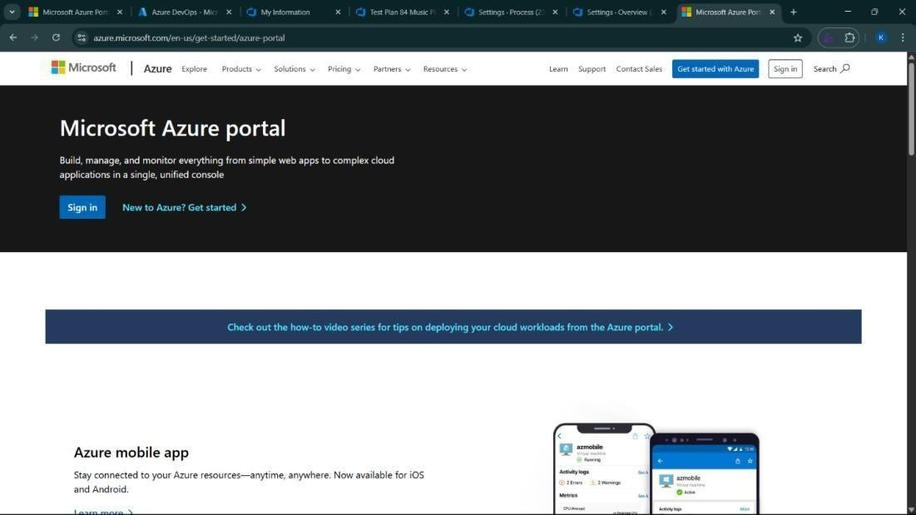

2.Azure home page
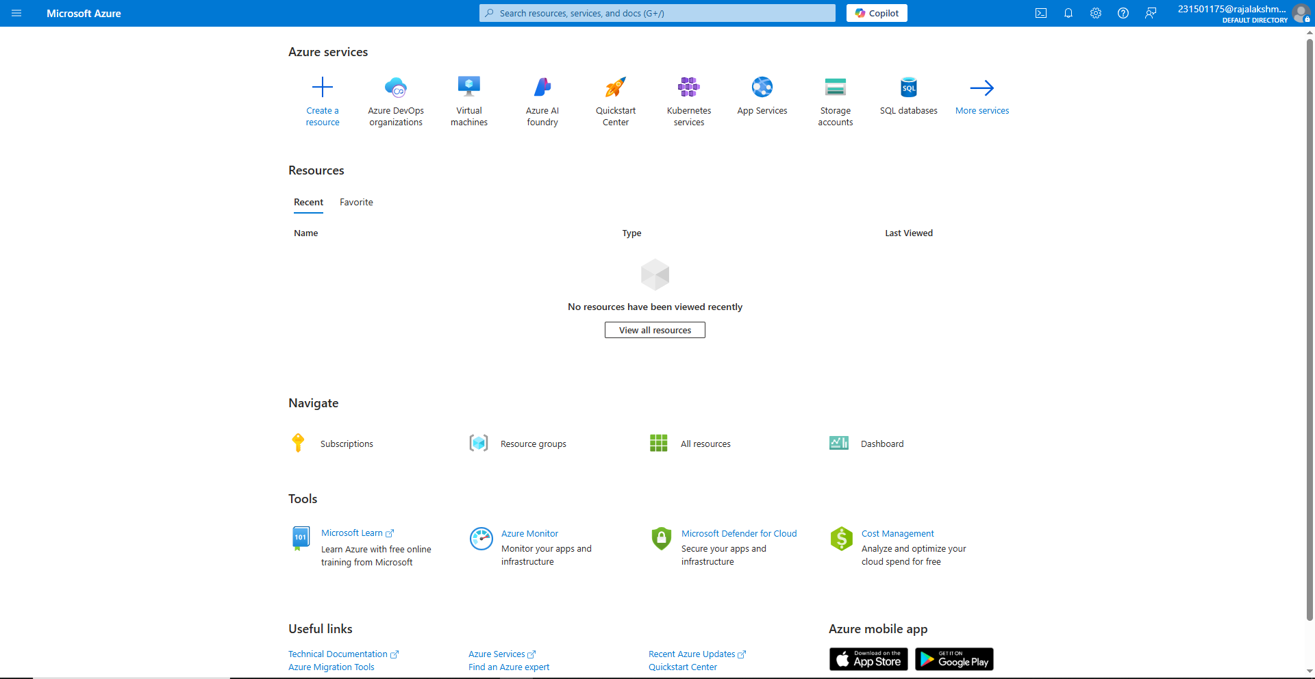

3.Open DevOps environment in the Azure platform by typing Azure DevOps Organizations in the search bar.
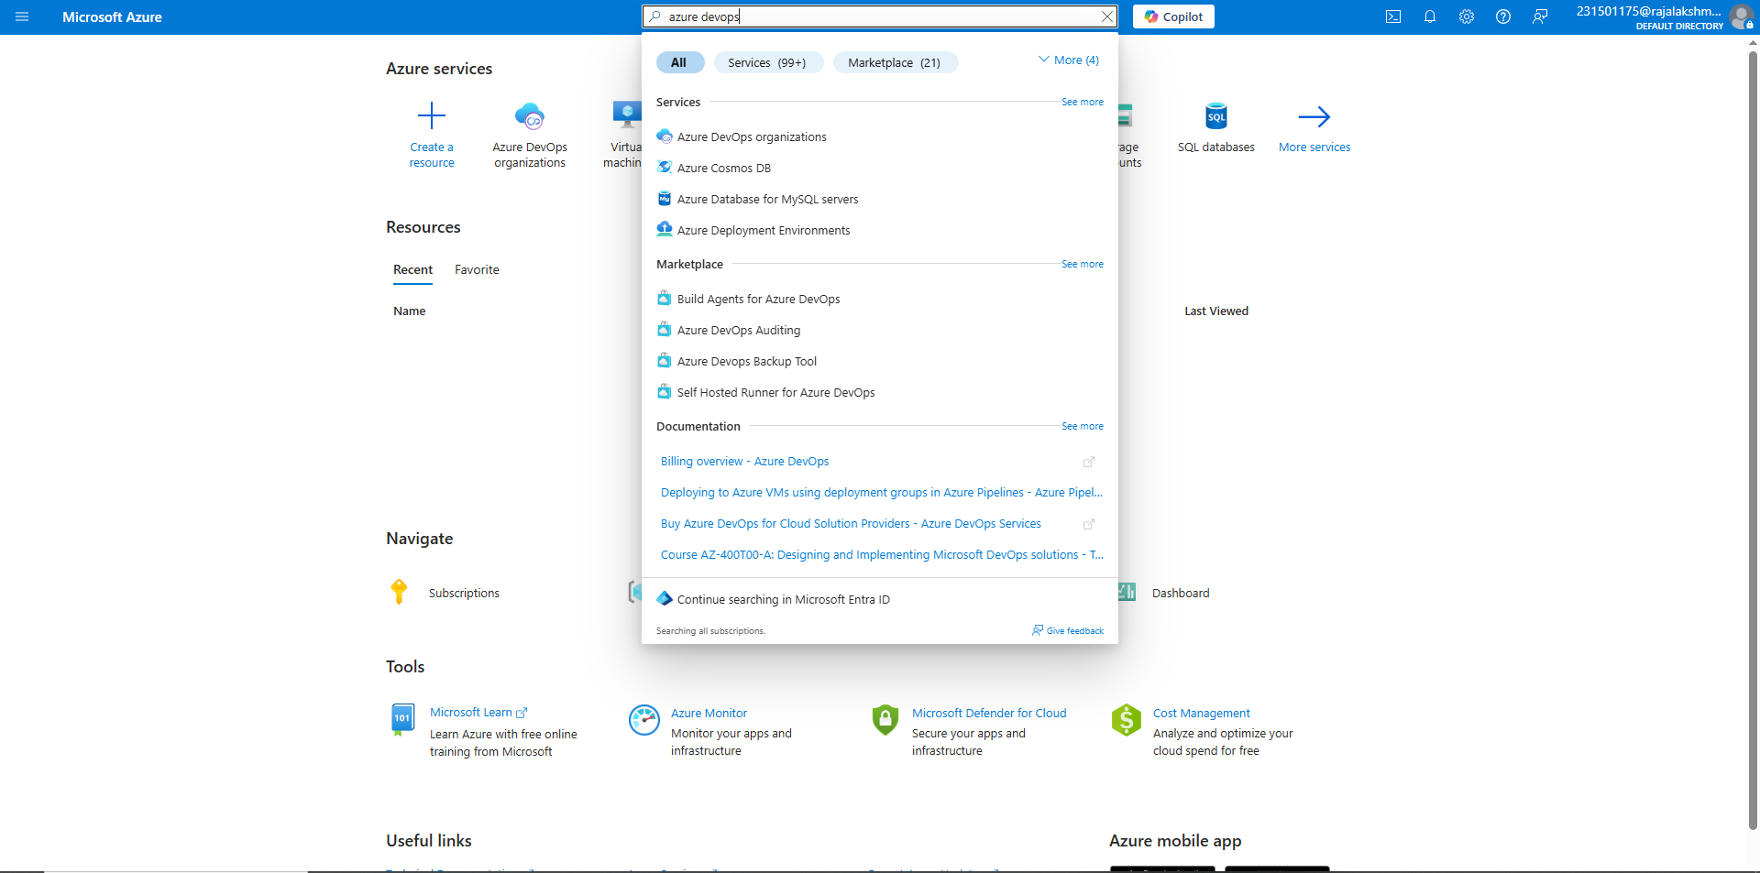

4.Click on the My Azure DevOps Organization link and create an organization and you should be taken to the Azure DevOps Organization Home page.

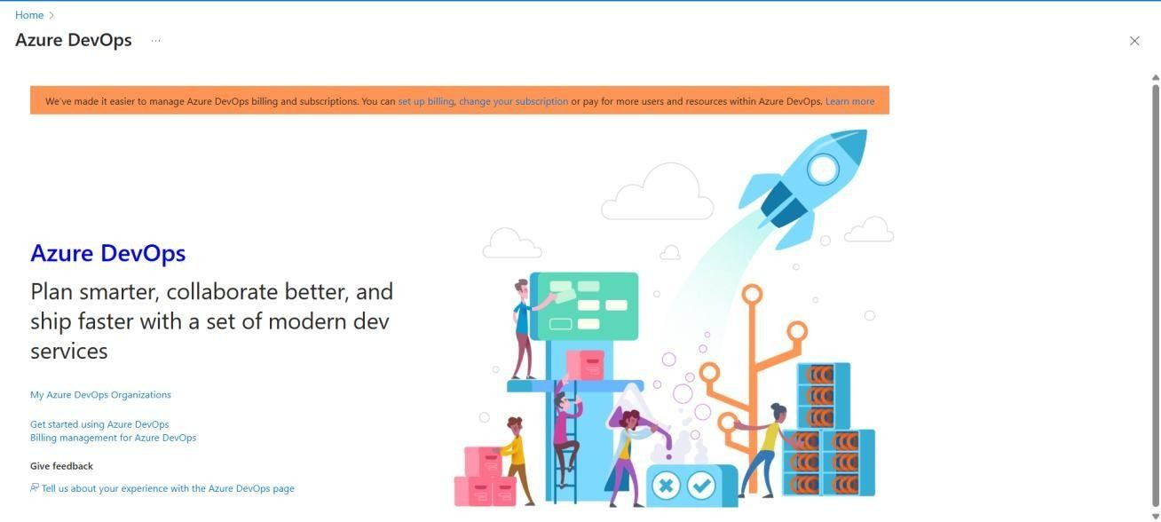

RESULT
Successfully accessed the Azure DevOps environment and created a new organization through the Azure portal.
EXP NO: 2 | AZURE DEVOPS PROJECT SETUP AND USER STORY  MANAGEMENT

AIM
To set up an Azure DevOps project for efficient collaboration and agile work management.

1.Create An Azure Account
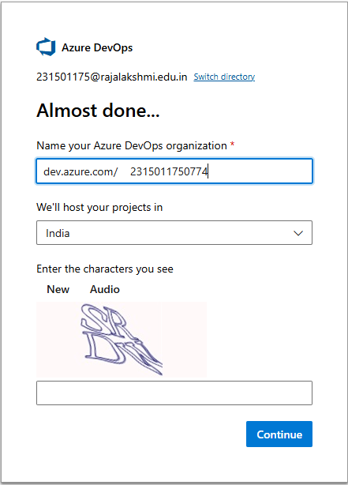

2.Create the First Project in Your Organization
- After the organization is set up, you’ll need to create your first project. This is where you'll
begin to manage code, pipelines, work items, and more.
- On the organization’s Home page, click on the New Project button.
- Enter the project name, description, and visibility options:
Name: Choose a name for the project (e.g., LMS).
Description: Optionally, add a description to provide more context about the project. Visibility: Choose whether you want the project to be Private (accessible only to those invited) or Public (accessible to anyone).
- Once you’ve filled out the details, click Create to set up your first project.
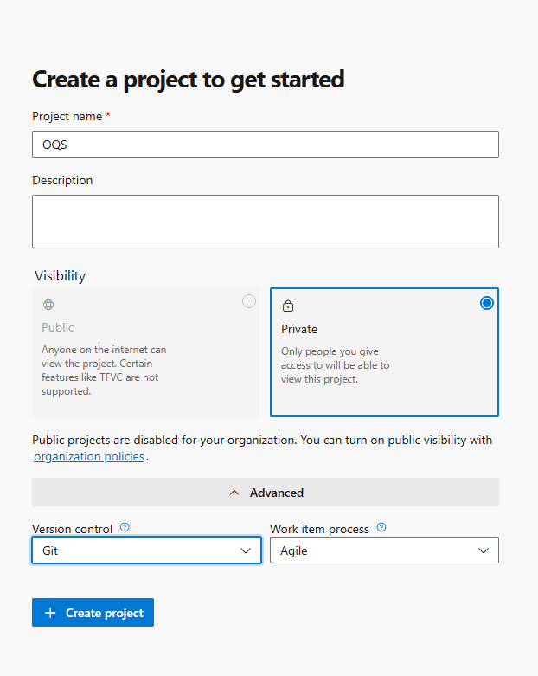
3.Once logged in, ensure you are in the correct organization. If you're part of multiple organizations, you can switch between them from the top left corner (next to your user profile). Click on the Organization name, and you should be taken to the Azure DevOps Organization Home page.
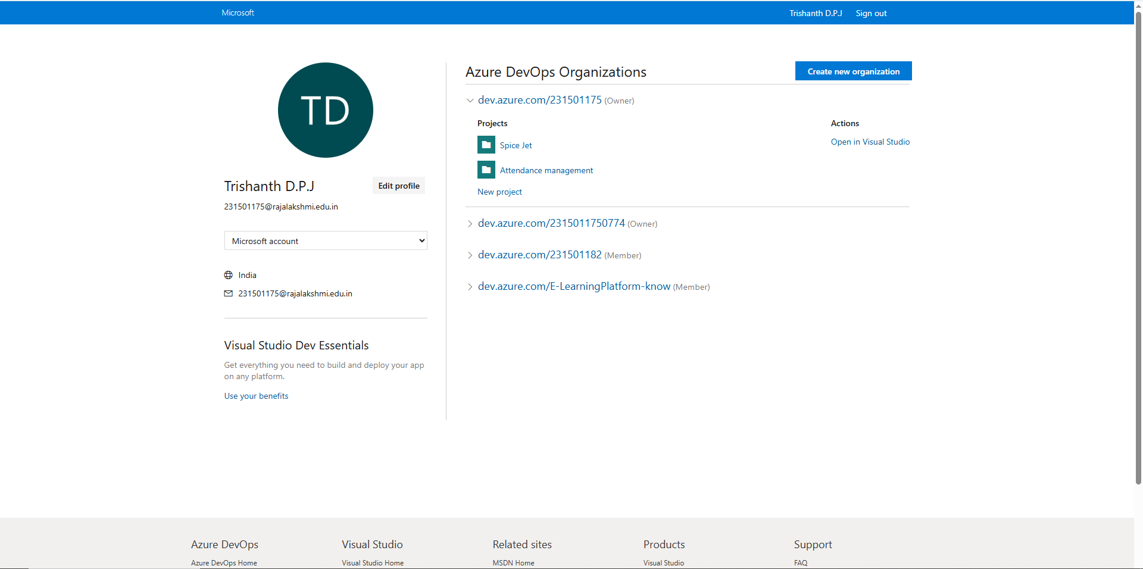

4.Project dashboard

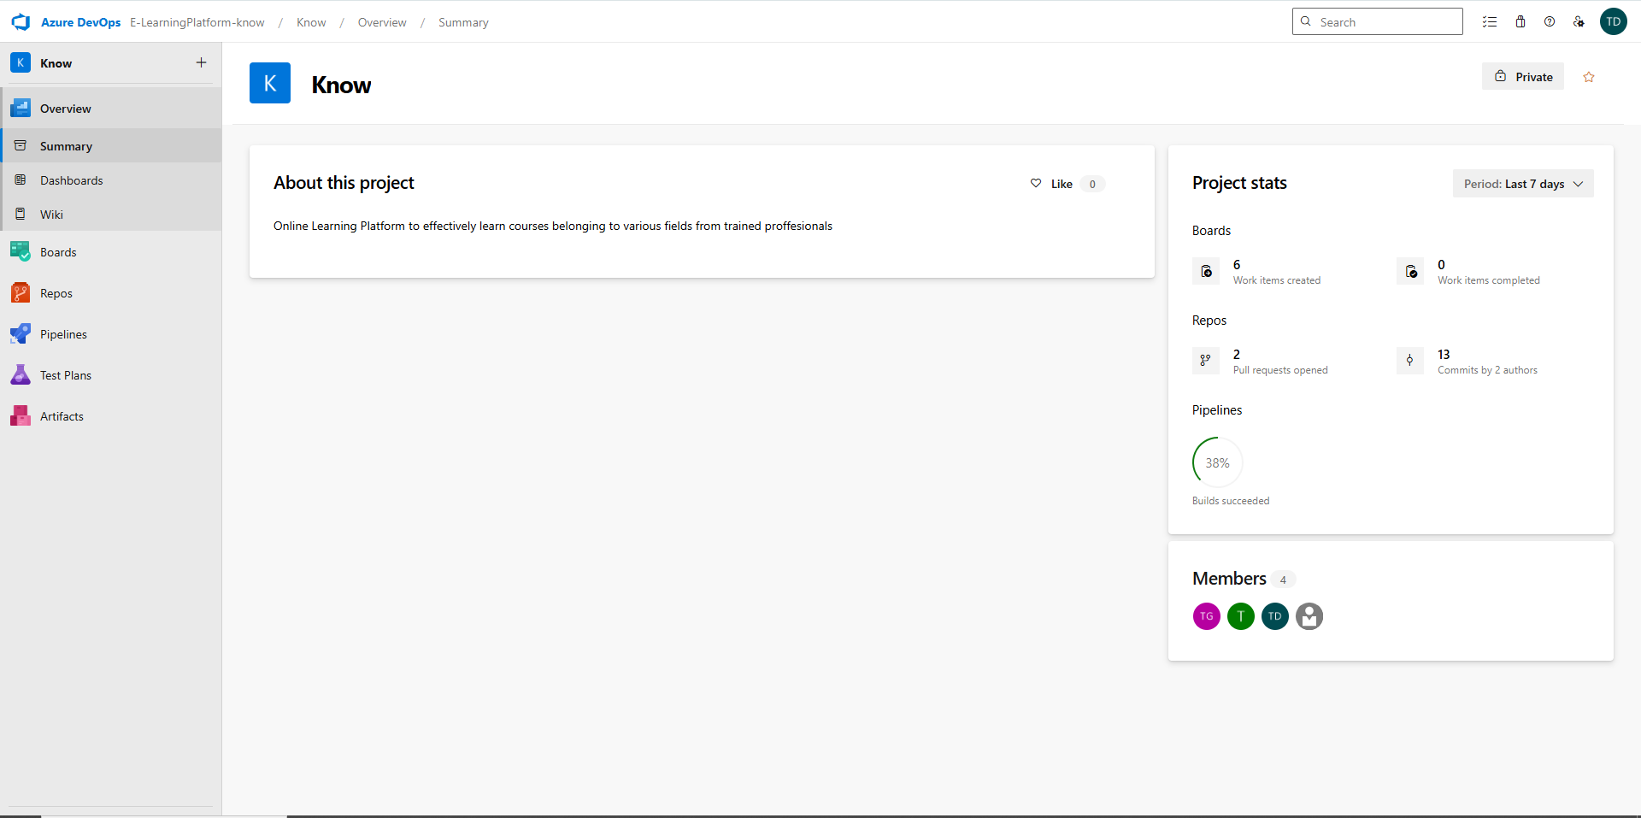

5.To manage user stories:
- From the left-hand navigation menu, click on Boards. This will take you to the main Boards
page, where you can manage work items, backlogs, and sprints.
- On the work items page, you'll see the option to Add a work item at the top. Alternatively,
you can find a + button or Add New Work Item depending on the view you're in. From the Add a work
item dropdown, select User Story. This will open a form to enter details for the new User Story.

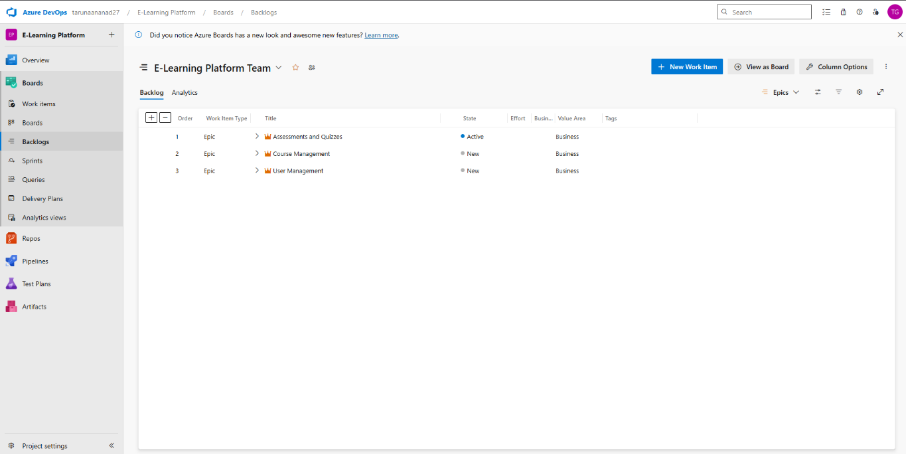

RESULT
Successfully created an Azure DevOps project with user story management and agile workflow setup.

EXP NO:3 | SETTING UP EPICS, FEATURES, AND USER STORIES  FOR PROJECT PLANNING

AIM
To learn about how to create epics, user story, features, backlogs for your assigned project.

Create Epic, Features, User Stories, Task

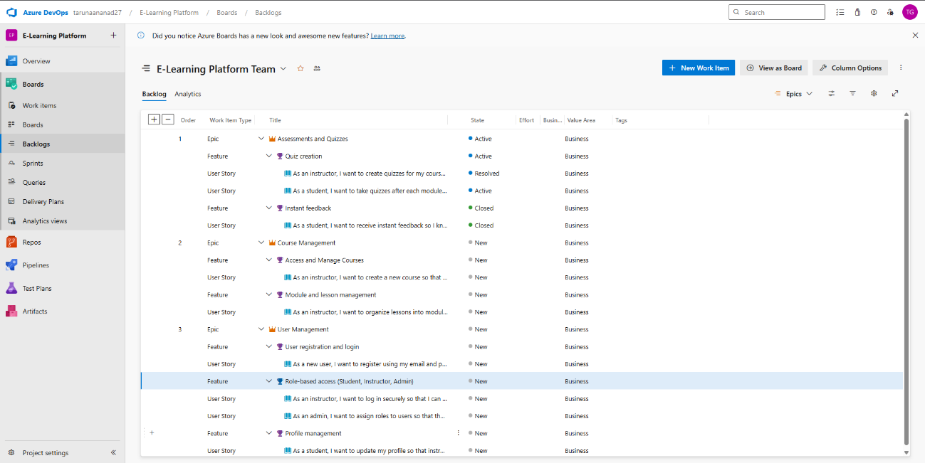

1.Fill in Epics
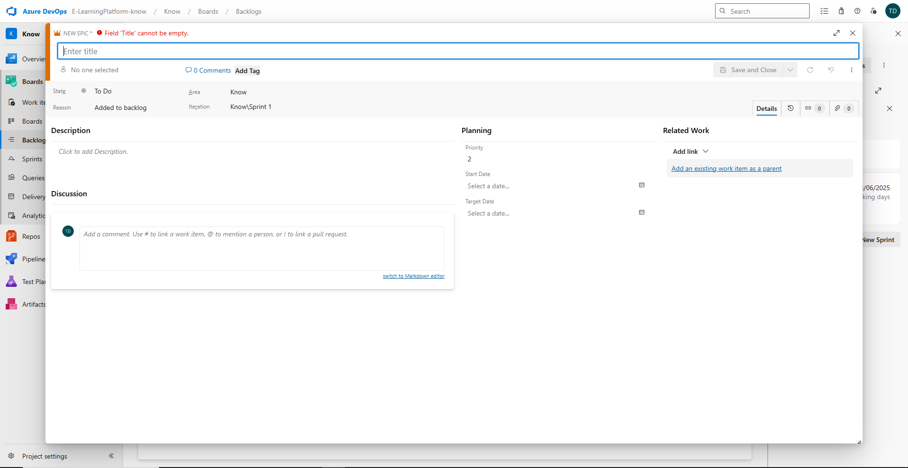

2.Fill in Features
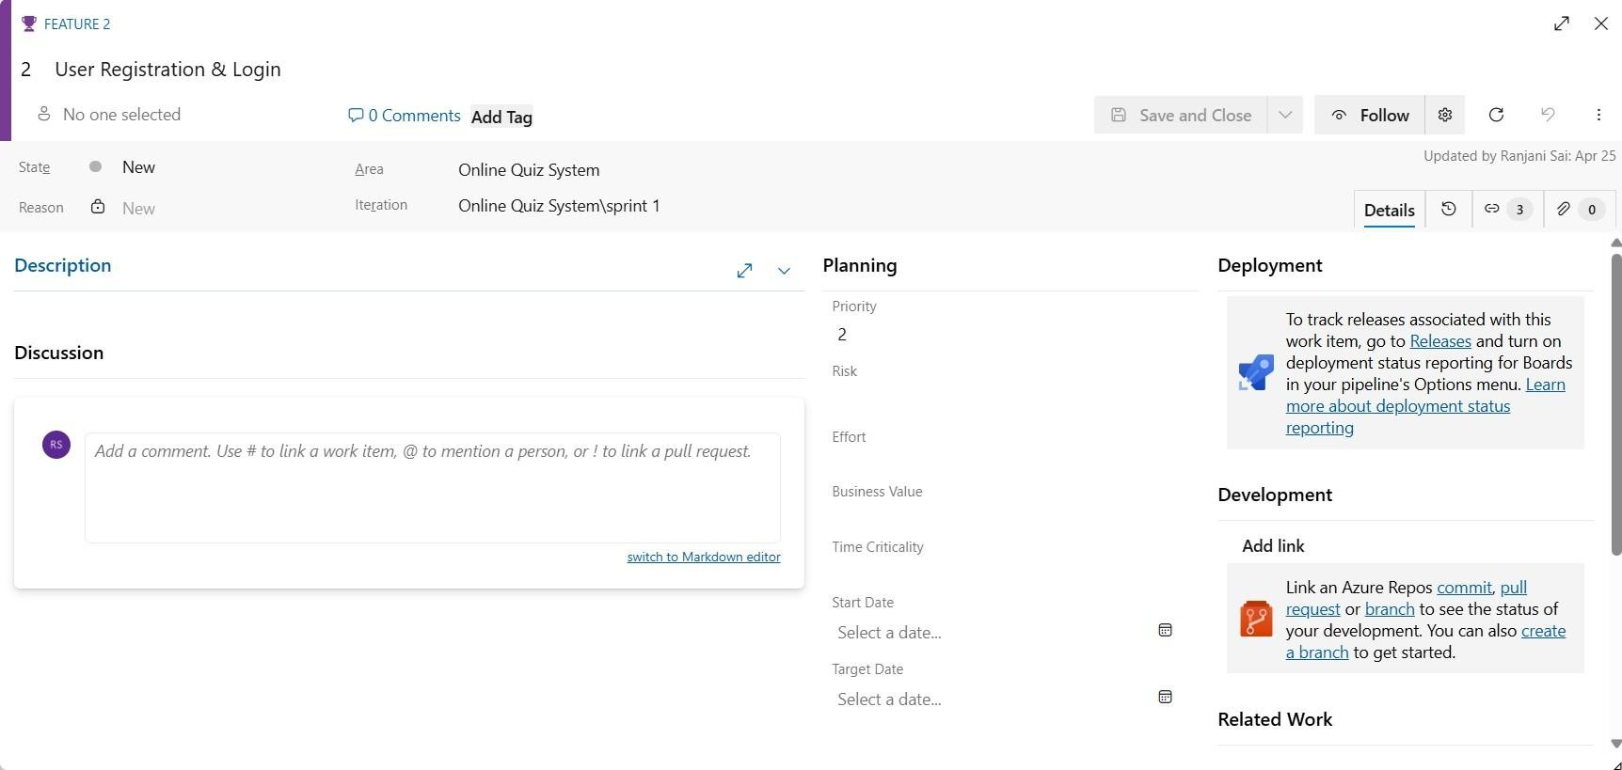

3.Fill in User Story Details

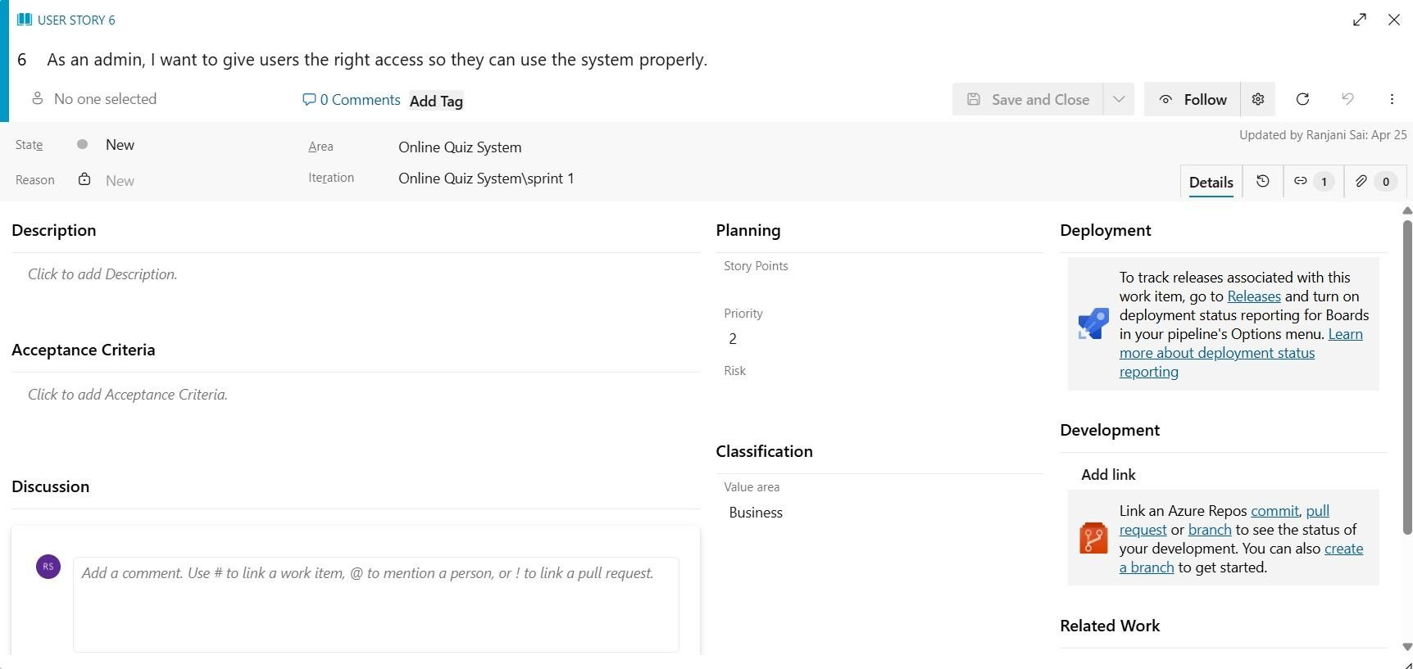

RESULT

Thus, the creation of epics, features, user story and task has been created successfully.

EXP NO: 4 | SPRINT PLANNING

AIM
To assign user story to specific sprint for the E-Learning Platform.

Sprint Planning Sprint 1
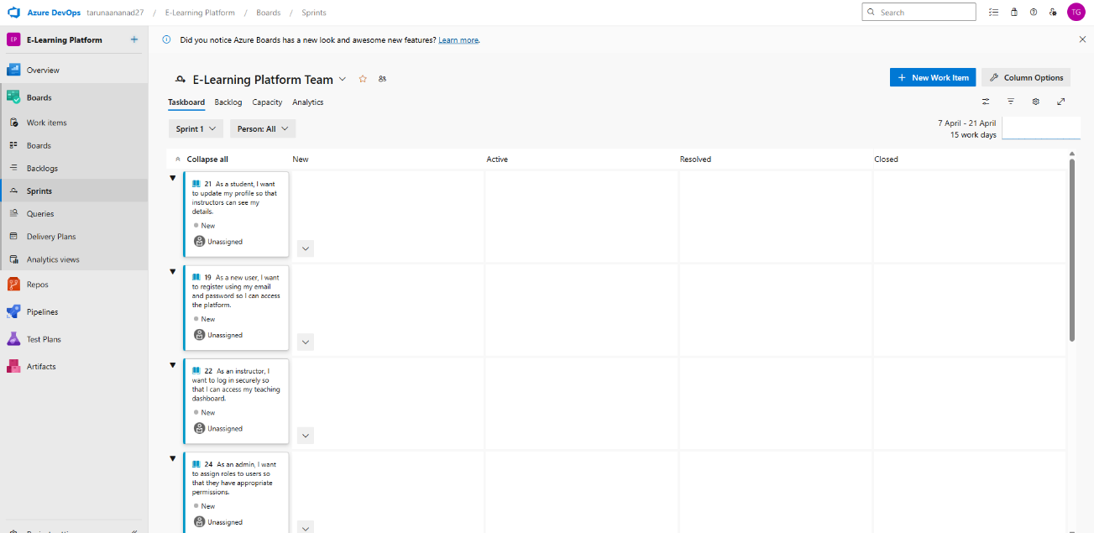

Sprint 2

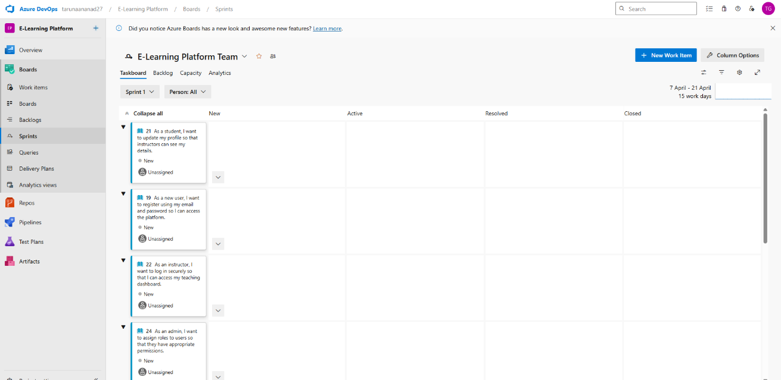

Sprint 3

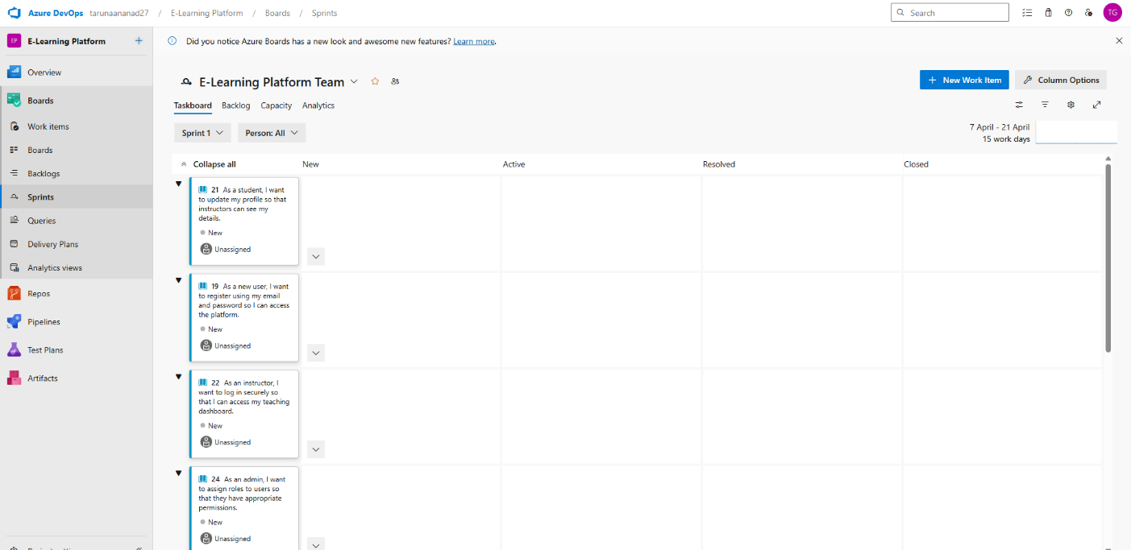

RESULT

The Sprints have been created for E-Learning Platform.
EXP NO:5 | POKER ESTIMATION

AIM
Create Poker Estimation for the user stories – E-Learning Platform.

Poker Estimation

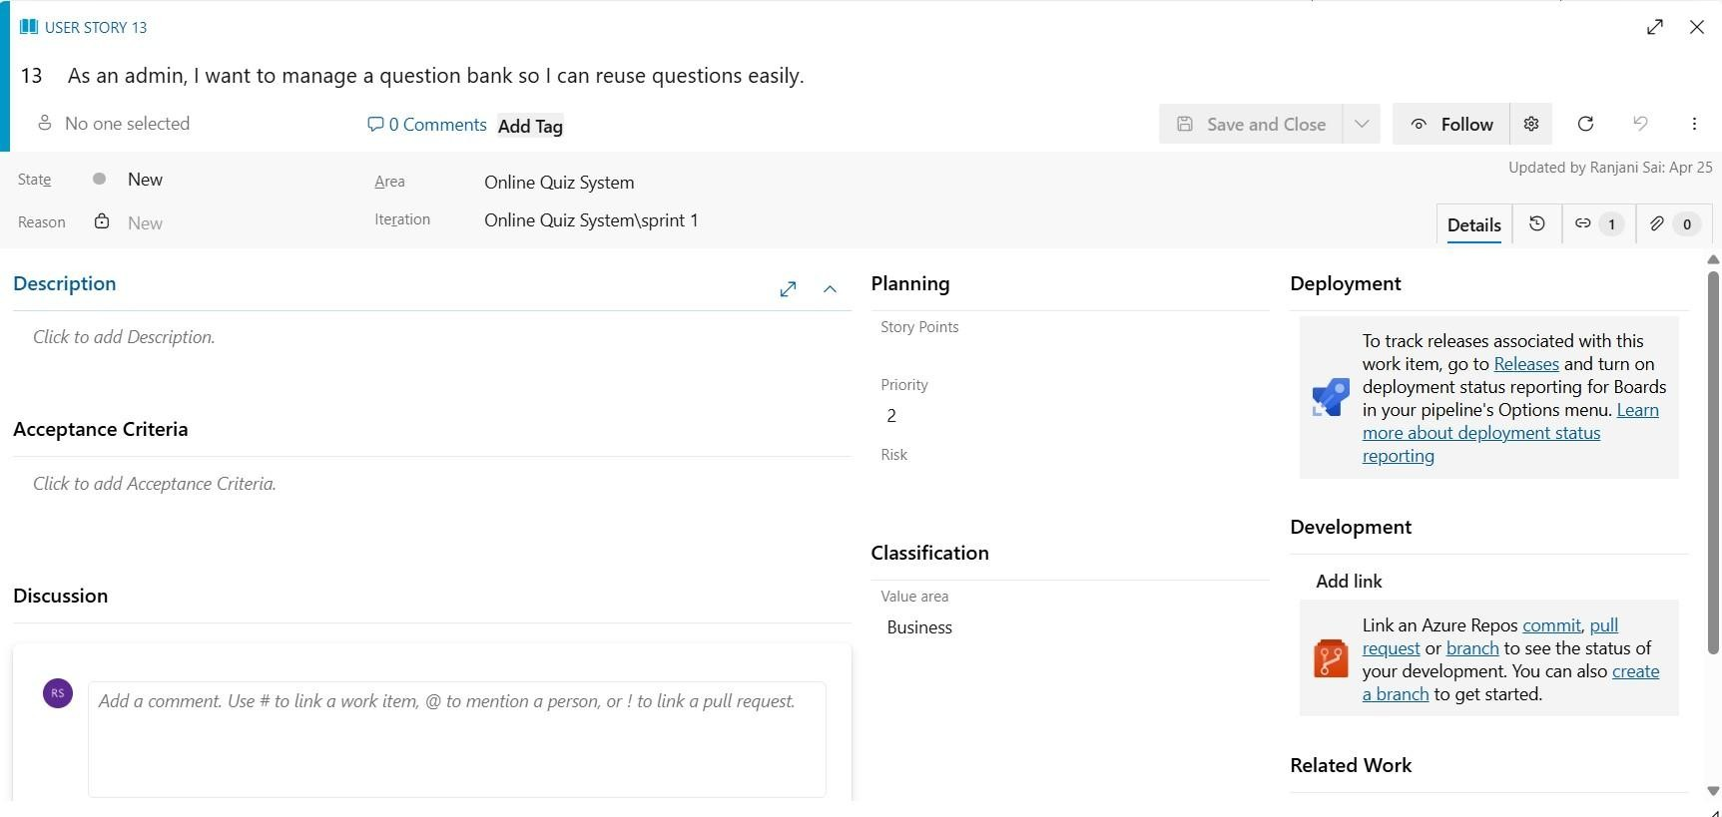

RESULT
The Estimation/Story Points is created for the project using Poker Estimation.

EXP NO: 6 | DESIGNING CLASS AND SEQUENCE DIAGRAMS FOR  PROJECT ARCHITECTURE

AIM
To Design a Class Diagram and Sequence Diagram for the given Project.

6A. Class Diagram
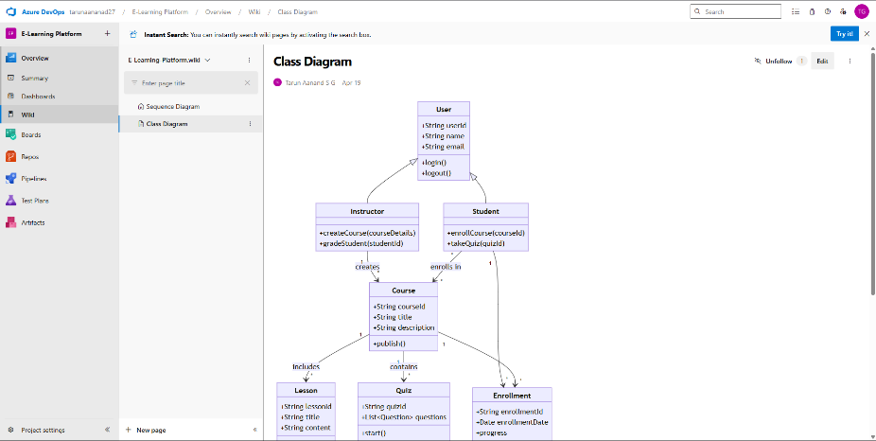

6B. Sequence Diagram

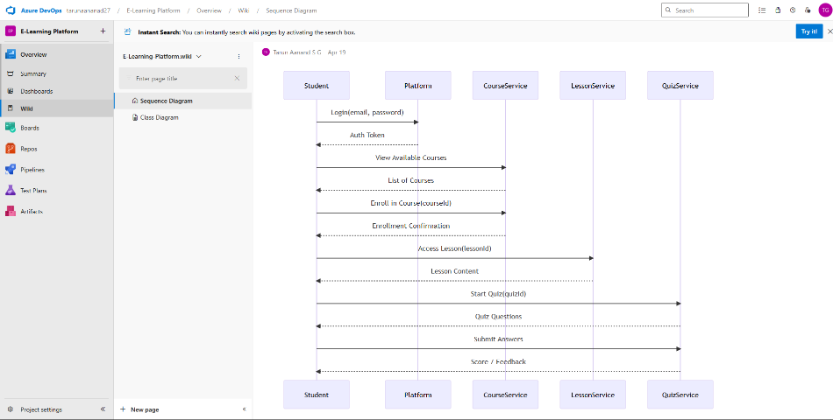

RESULT
The Class Diagram and Sequence Diagram is designed Successfully for the E-Learning Platform.
EXP NO: 7 | DESIGNING USE-CASE AND ACTIVITY DIAGRAMS  FOR PROJECT STRUCTURE

AIM
To Design an Use-Case Diagram and Activity Diagram for the given Project. 7A. Use-Case Diagram
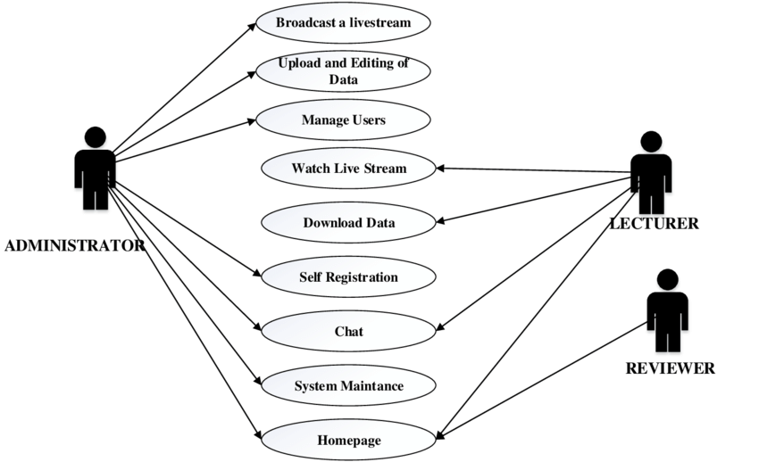

7B. Activity Diagram

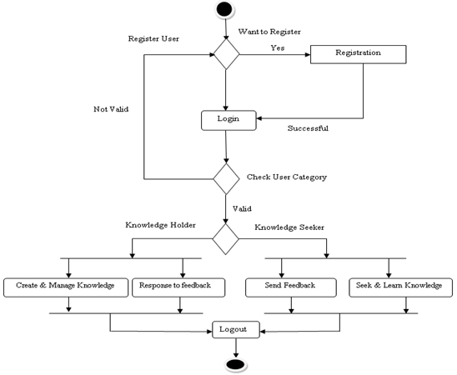

RESULT
The Use-Case Diagram and Activity Diagram is designed Successfully for the E-Learning Platform.

EXP NO: 8 | TESTING TEST PLANS AND TEST CASES

AIM
Test Plans and Test Case and write two test cases for at least five user stories showcasing the happy path and error scenarios in azure DevOps platform.

Test Planning and Test Case Test Case Design Procedure

1. Understand Core Features of the Application
• User Login

2. Define User Interactions
• Each test case simulates a real user behaviour (e.g., logging in, submitting quizzes, viewing results)

3. Design Happy Path Test Cases
- Focused on validating that all core functionalities work correctly under normal conditions
- Example: Player registers and logs in, submits quizzes and views results

4. Design Error Path Test Cases
- Simulate invalid inputs, system issues or failed actions to ensure proper error handling.
- Example: Login with invalid credentials, submission without attachments, unauthorized access to admin panel.

5. Break Down Steps and Expected Results
• Each test case includes a clear sequence of actions and expected results. • Ensures both manual testers and automation tools can follow the process easily.

6. Use Clear Naming and IDs
• Test cases are uniquely identifies (e.g., TC01 – Valid Login, TC03 –
Invalid Password).
• Facilities easy mapping to features and tracking in Azure DevOps.

7. Separate Test
• Grouped by functionality such as:
o Login and Registration
o Quizzes Submission
o Viewing Results
o Admin Functions
• Improves organization and enables focused execution in Azure DevOps.

8. Prioritize and Review
- High-priority assigned to critical workflows like login, quizzes and results.
- Reviewed for completeness, accuracy and alignment with user stories and features definition.
.

1.New test plan
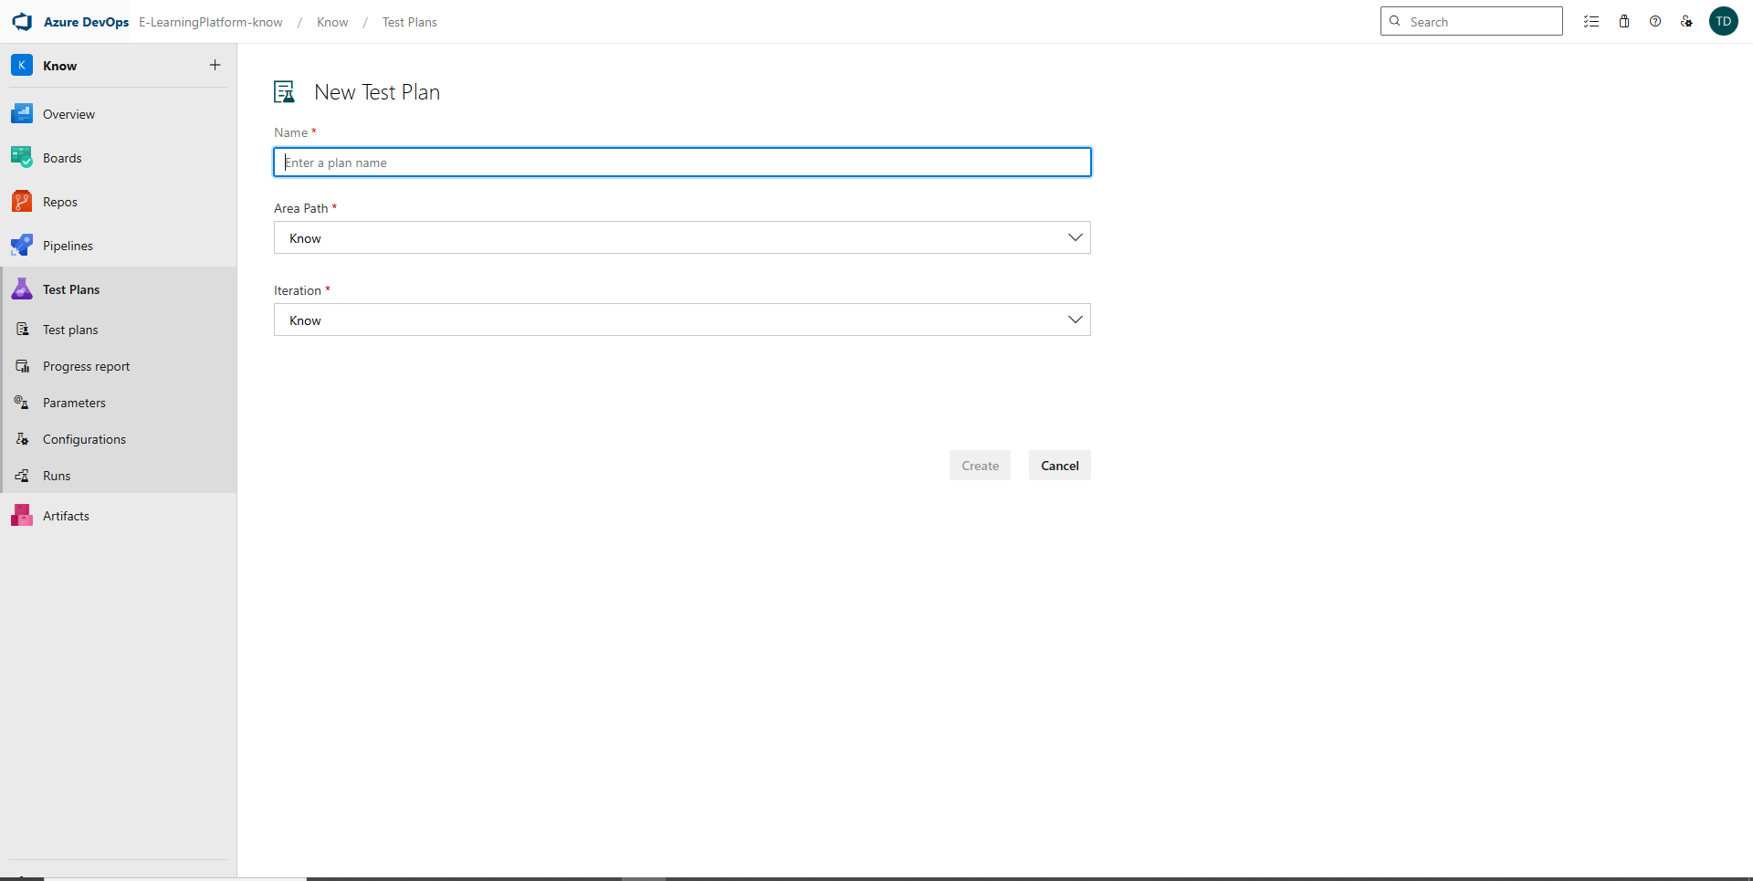

2.Test suite
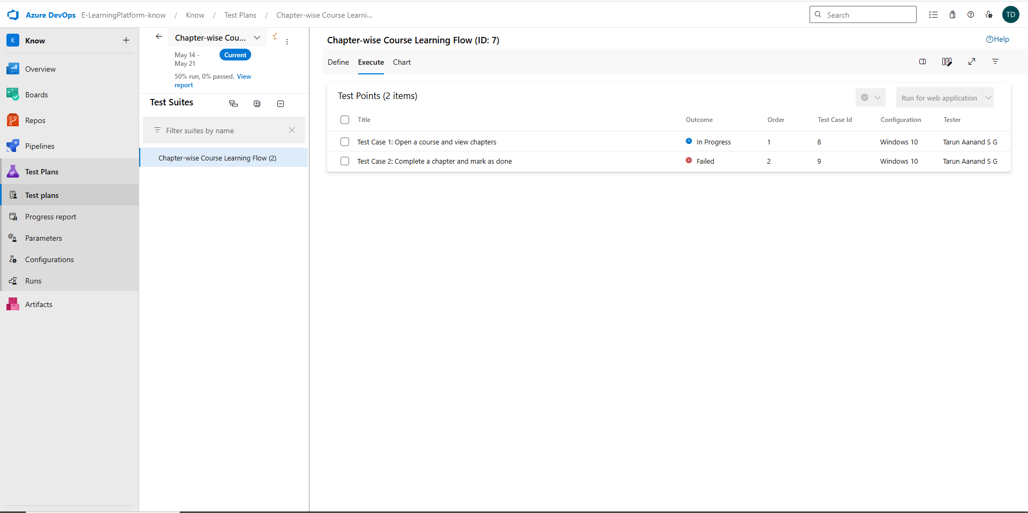

3.Test case
Give two test cases for at least five user stories showcasing the happy path and error scenarios in azure DevOps platform.
E-Learning Platform– Test Plans

USER STORIES
- As an admin, I want to log in to manage quizzes and users (ID: 3).
- As a player, I want to register and log in so that I can access quizzes securely (ID: 4).
- As an admin, I want to give users the right access so they can use the system properly (ID: 6).
- As a player, I want to see only my quizzes and progress so that it’s easy to use (ID: 7).
- As an admin, I want to create and configure quizzes with time limits so I can control quiz flow
(ID: 10).
TEST SUITES
Test Suite 1: User Registration and Login

Test Case 1.1: User Registration with Valid Details
- Action:
  - Navigate to the registration page
  - Enter valid name, email, password
  - Click "Register"
- Expected Result:
User account is created, and a confirmation message is shown.

- Type: Happy Path

Test Case 1.2: Login with Valid Credentials

- Action:
  - Go to login page
  - Enter registered email and correct password
  - Click "Login"

- Expected Result:
User is redirected to dashboard

- Type: Happy Path

Test Case 1.3: Logout from Application
- Action:
  - Click on user profile
  - Click "Logout"

- Expected Result:
User is logged out and redirected to login page

- Type: Happy Path

Test Suite 2: Course Enrollment and Access

Test Case 2.1: View Available Courses
- Action:
  - Login to the platform
  - Navigate to “Courses” tab

- Expected Result:
A list of available courses is displayed

- Type: Happy Path

Test Case 2.2: Enroll in a Free Course
- Action:
  - From course list, select a free course
  - Click “Enroll”

- Expected Result:
User is successfully enrolled in the course

- Type: Happy Path

Test Case 2.3: Access Enrolled Course Content
- Action:
  - Go to “My Courses”
  - Click on enrolled course
  - Play a video lecture

- Expected Result:
Course content loads and plays correctly
- Type: Happy Path

Test Suite 3: Assessment and Certification
Test Case 3.1: Start Quiz for a Completed Module
- Action:
  - Complete a module
  - Click “Take Quiz”

- Expected Result:
Quiz page opens with questions related to the module

- Type: Happy Path

Test Case 3.2: Submit Quiz Answers

- Action:
  - Select answers for all questions
  - Click “Submit”

- Expected Result:
Submission is accepted and score is displayed

- Type: Happy Path

Test Case 3.3: Download Certificate After Course Completion
- Action:
  - Complete all modules and pass final quiz
  - Click “Download Certificate”

- Expected Result:
Certificate is downloaded in PDF format

- Type: Happy Path

Test Cases
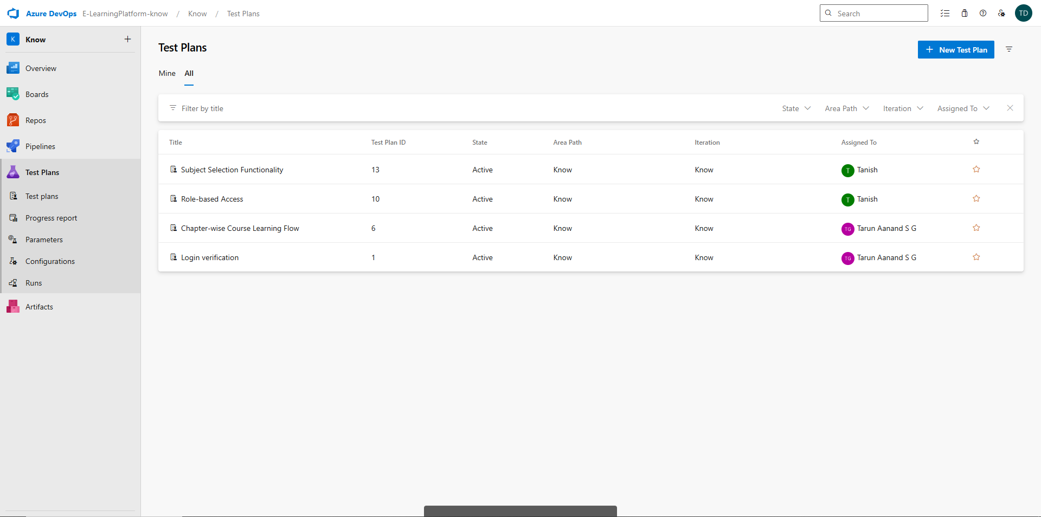



4.Installation of test
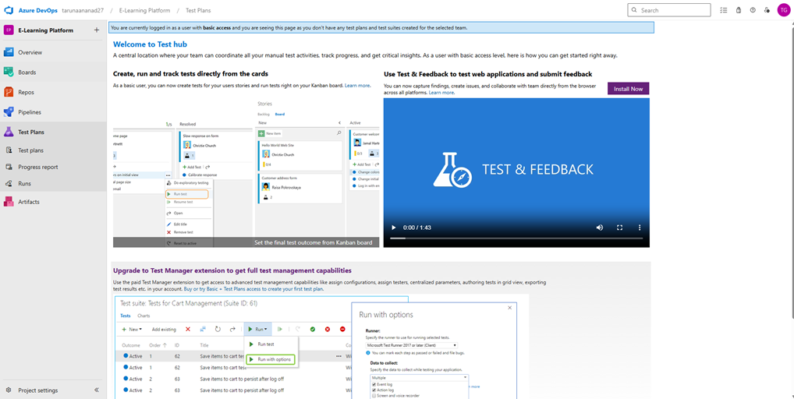

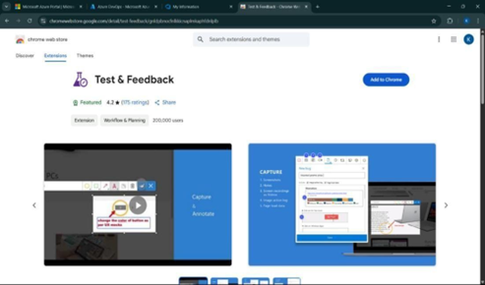

5.Running the test cases
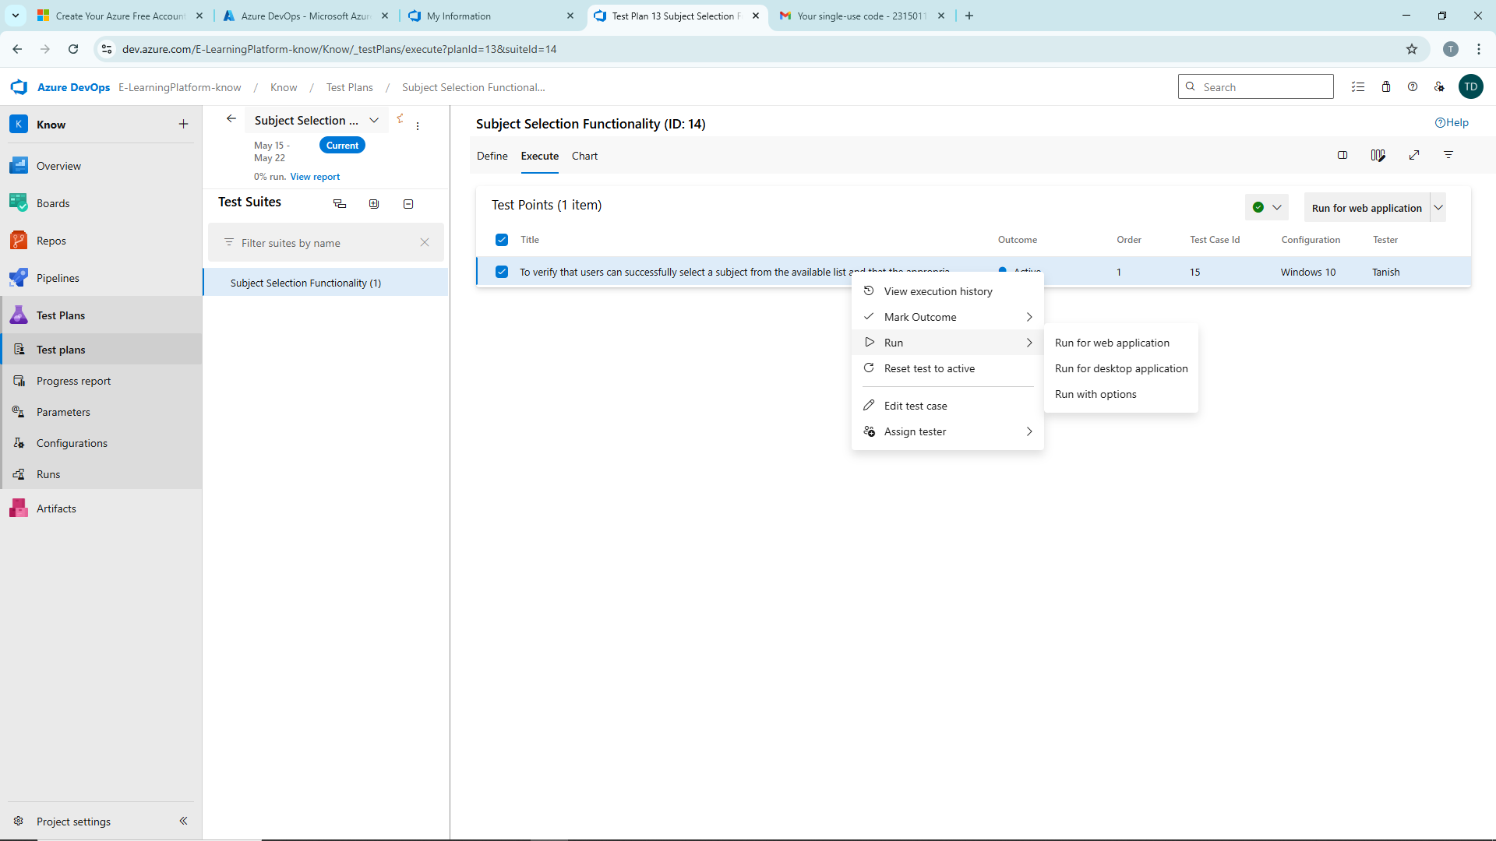

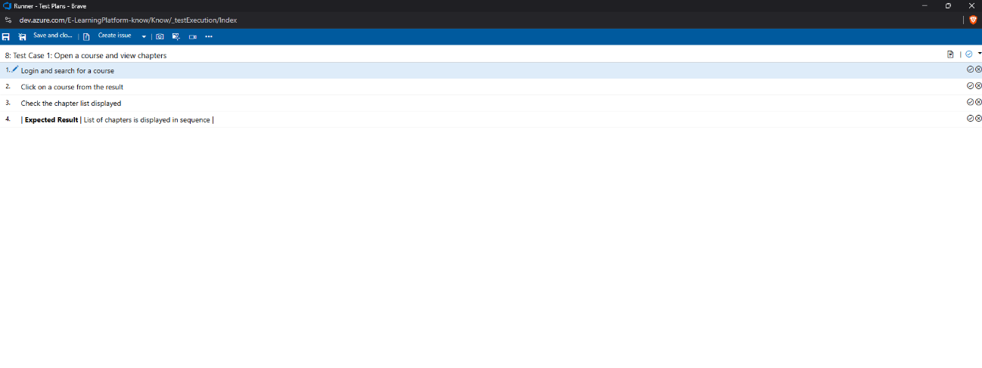

6.Recording the test case

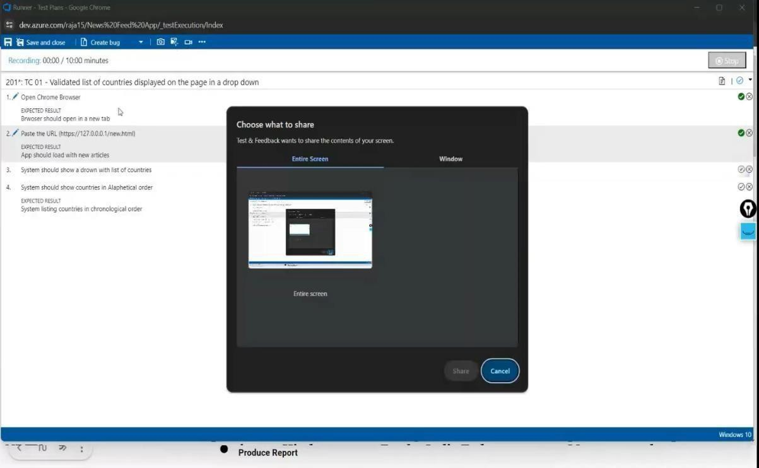

7.Creating the bug
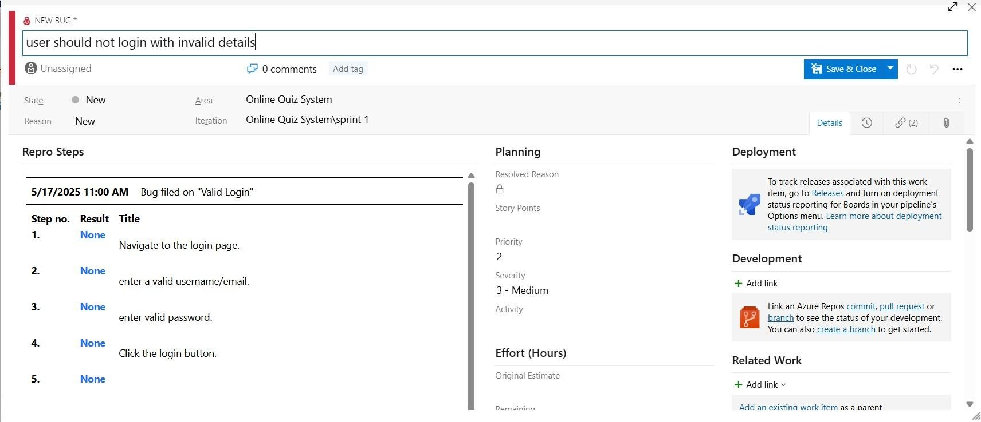

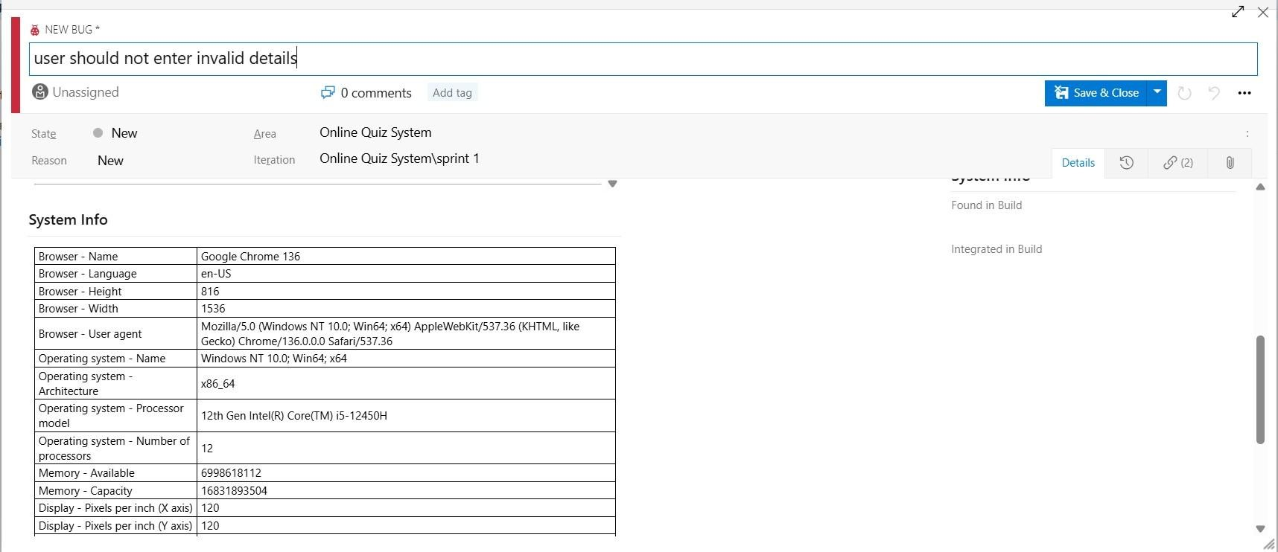

8.Test case results
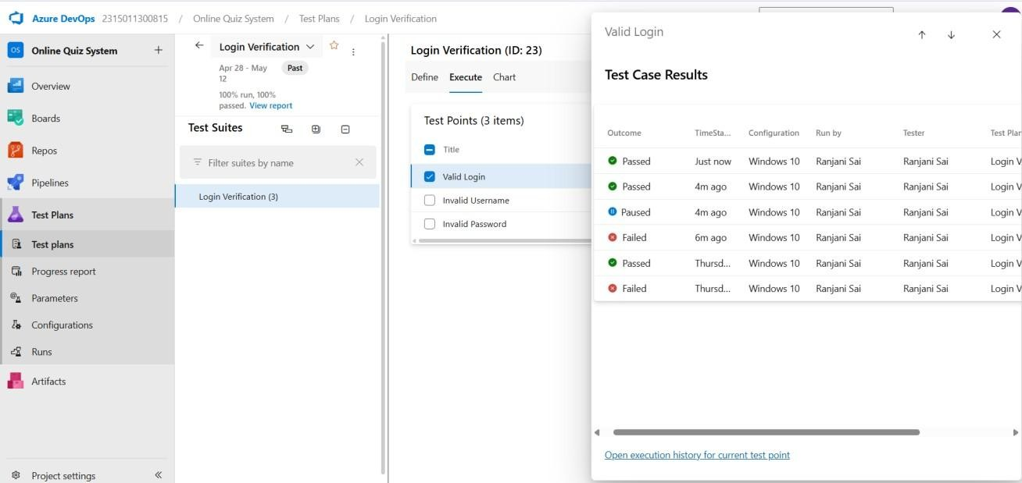

9.Test report summary
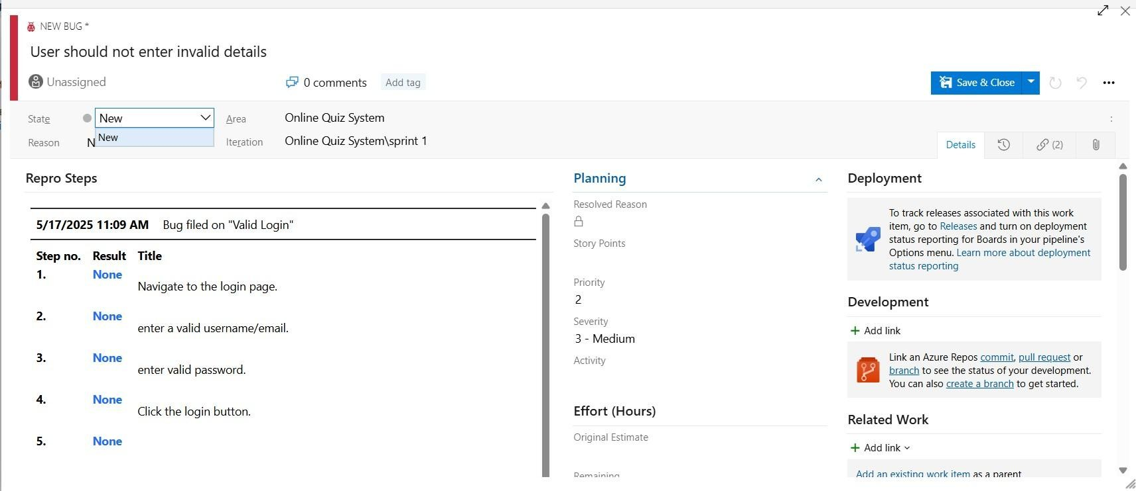
• Assigning bug to the developer and changing state

10.Progress report
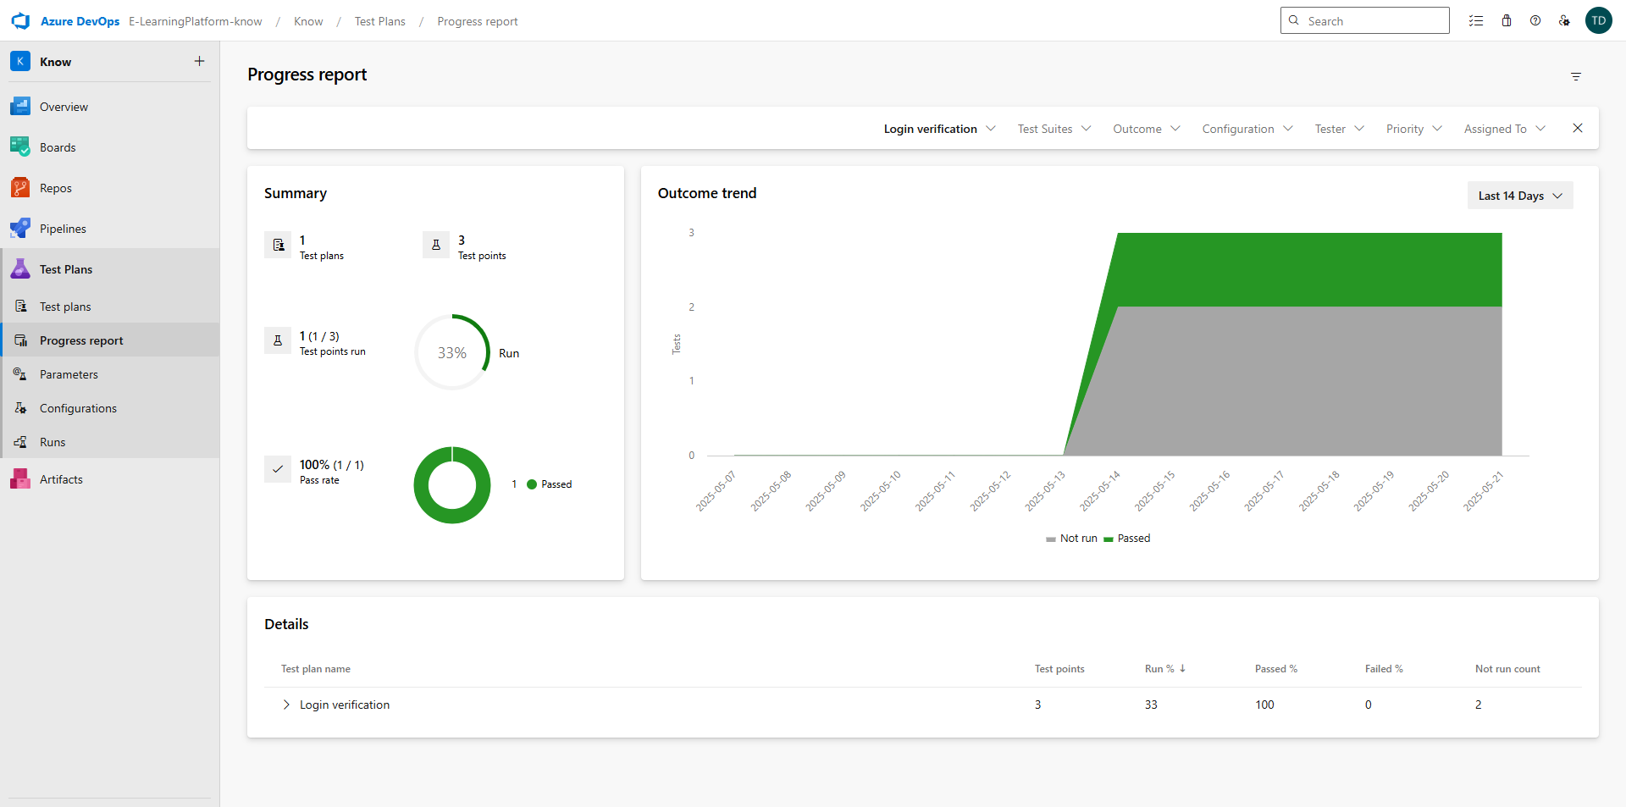
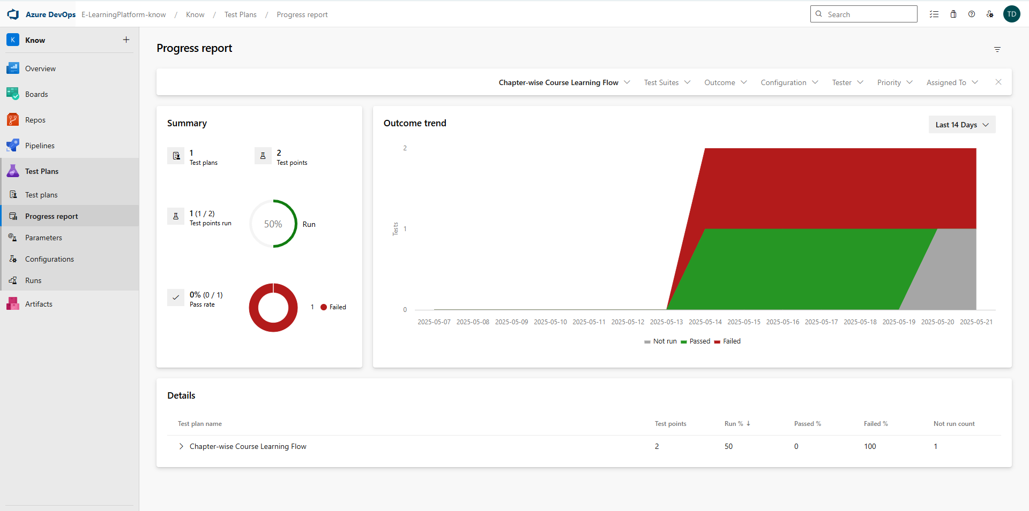

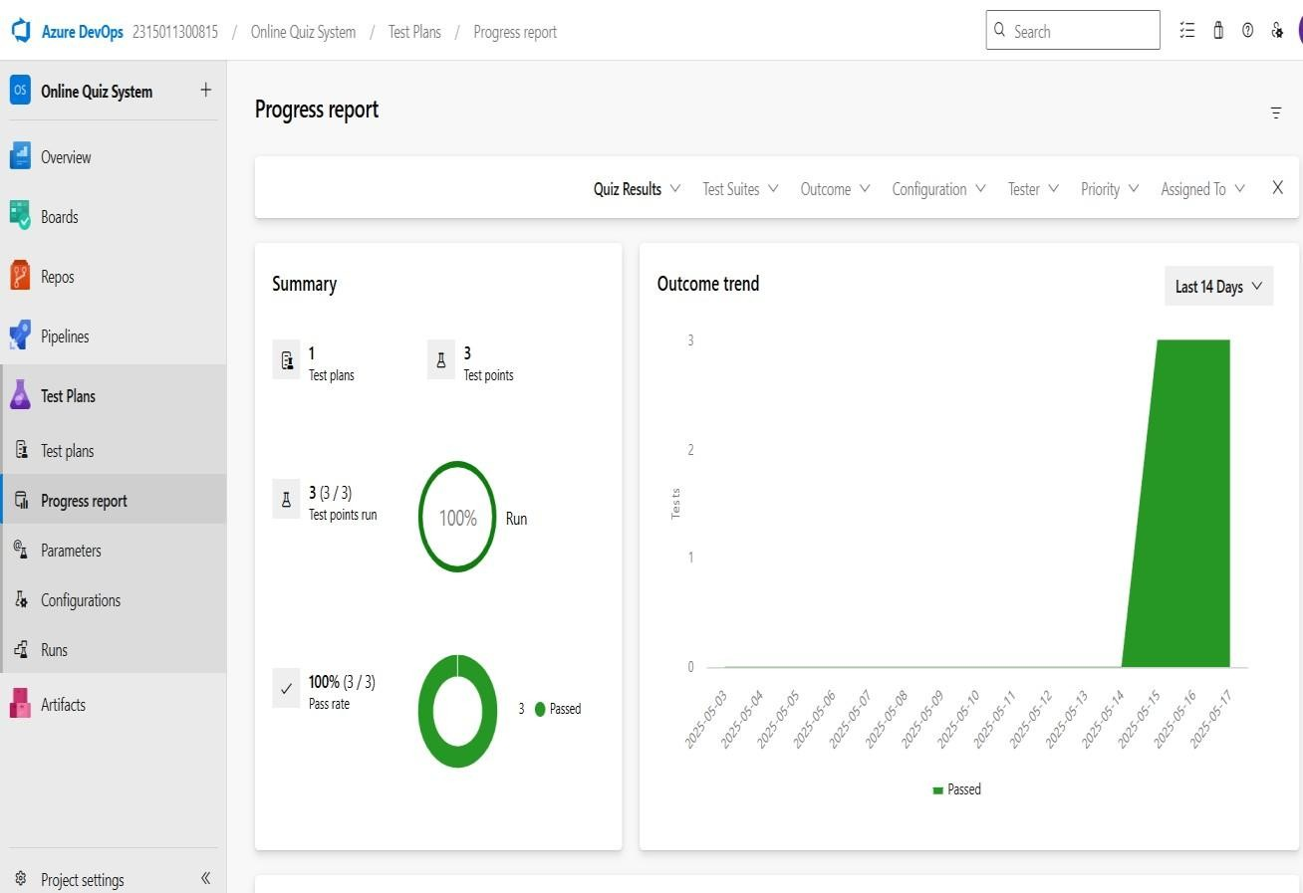

11.Changing the test template
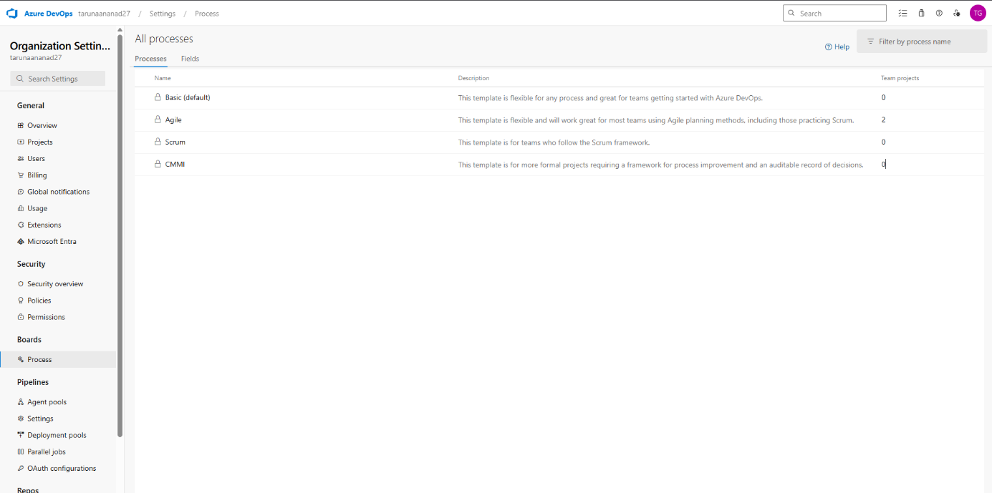

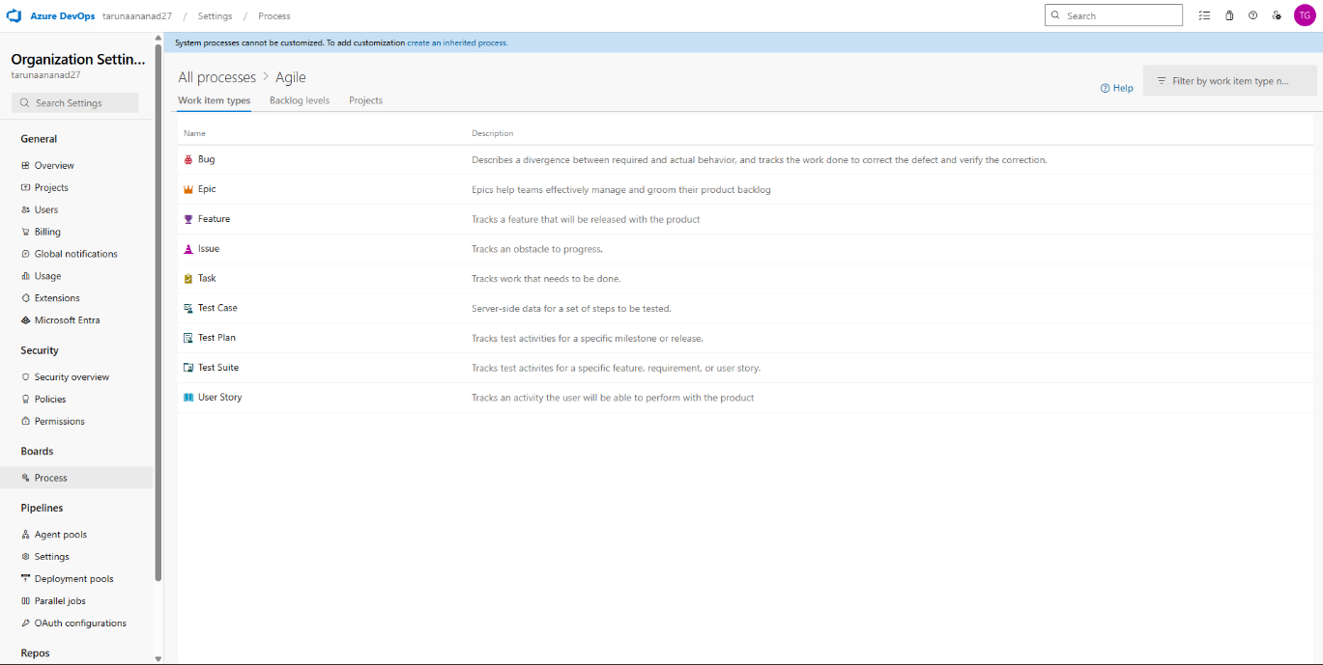

RESULT
The test plans and test cases for the user stories is created in Azure DevOps with Happy Path and Error Path.
EXP NO: 9 | CI/CD PIPELINES IN AZURE

AIM
To implement a Continuous Integration and Continuous Deployment (CI/CD) pipeline in Azure DevOps for automating the build, testing, and deployment process of the E-Learning Platform, ensuring faster delivery and improved software quality.

PROCEDURE

Steps to Create and implement pipelines in Azure:
- Sign in to Azure DevOps and Navigate to Your Project
Log in to dev.azure.com, select your organization, and open the project where your Student Management System code resides.

- Connect a Code Repository (Azure Repos or GitHub)
Ensure your application code is stored in a Git-based repository such as Azure Repos or GitHub. This will be the source for triggering builds and deployments in your pipeline.

- Create a New Pipeline
Go to the Pipelines section on the left panel and click “Create Pipeline”.
Choose your source (e.g., Azure Repos Git or GitHub), and then select the repository containing your project code.

- Choose the Pipeline Configuration
You can select either the YAML-based pipeline (recommended for version control and automation) or the Classic Editor for a GUI-based setup. If using YAML, Azure DevOps will suggest a template or allow you to define your own.

- Define Build Stage (CI - Continuous Integration) from YAML file.

- Install dependencies (e.g., npm install, dotnet restore).

- Build the application (dotnet build, npm run build).

- Run unit tests (dotnet test, npm test).

- Publish build artifacts to be used in the release stage.

- Save and Run the Pipeline for the First Time
Save the YAML or build definition and click “Run”.
Azure will fetch the latest code and execute the defined build and test stages.

- Configure Continuous Deployment (CD)
Navigate to the Releases tab under Pipelines and click “New Release Pipeline”. Add an Artifact (from the build stage) and create a new Stage (e.g., Development, Production).

- Configure the CD stage with deployment tasks such as deploying to Azure App Service, running database migrations or scripts, and restarting services using the Azure App Service Deploy task linked to your subscription and app details.

- Set Triggers and Approvals
Enable continuous deployment trigger so the release pipeline runs automatically after a successful build. For production environments, configure pre-deployment approvals to ensure manual verification before release.

- Monitor Pipelines and Manage Logs
View all pipeline runs under the Runs section.
Check logs for build/test/deploy stages to debug any errors.
You can also integrate email alerts or Microsoft Teams notifications for build failures.

- Review and Maintain Pipelines
Regularly update your pipeline tasks or YAML configurations as your application grows.
Ensure pipeline runs are clean and artifacts are stored securely.
Integrate quality gates and code coverage policies to maintain code quality.

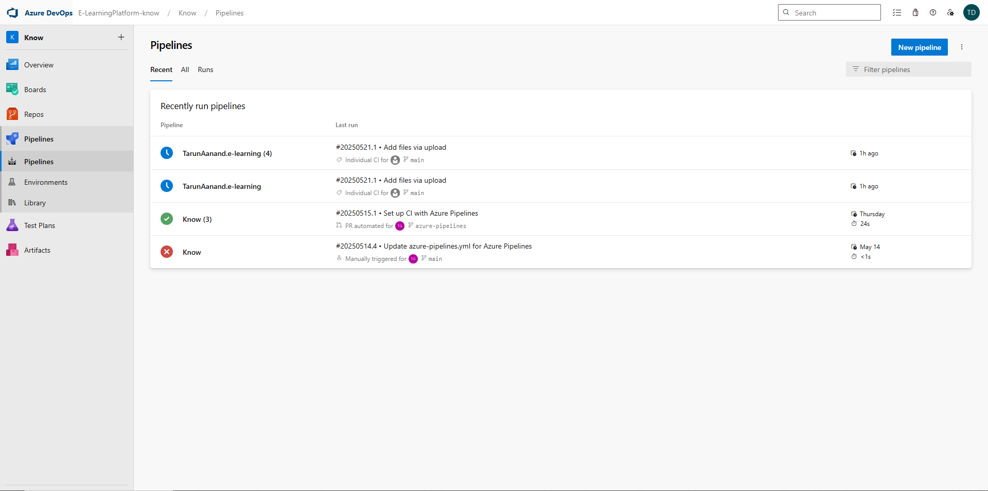

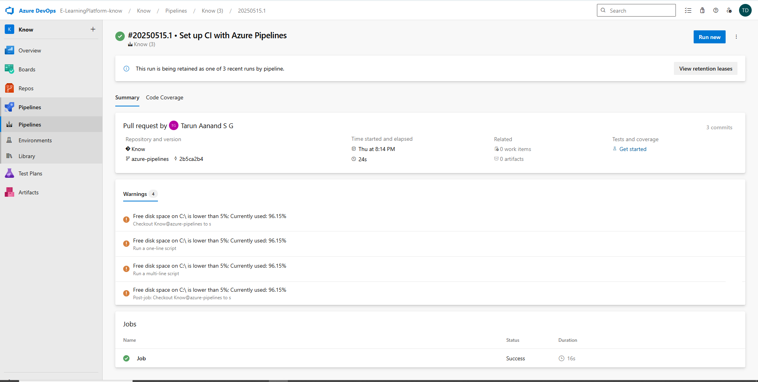

RESULT
Thus, the pipelines for the given project “E-Learning Platform” has been executed successfully.

EXP NO: 10 | GITHUB: PROJECT STRUCTURE & NAMING  CONVENTIONS

Aim:
To provide a clear and organized view of the project's folder structure and file naming conventions, helping contributors and users easily understand, navigate, and extend the E-Learning platform.

GitHub Project Structure

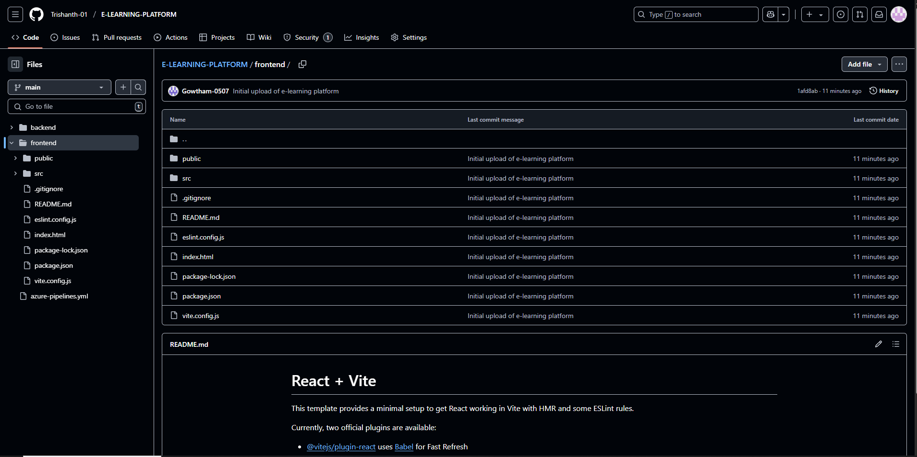

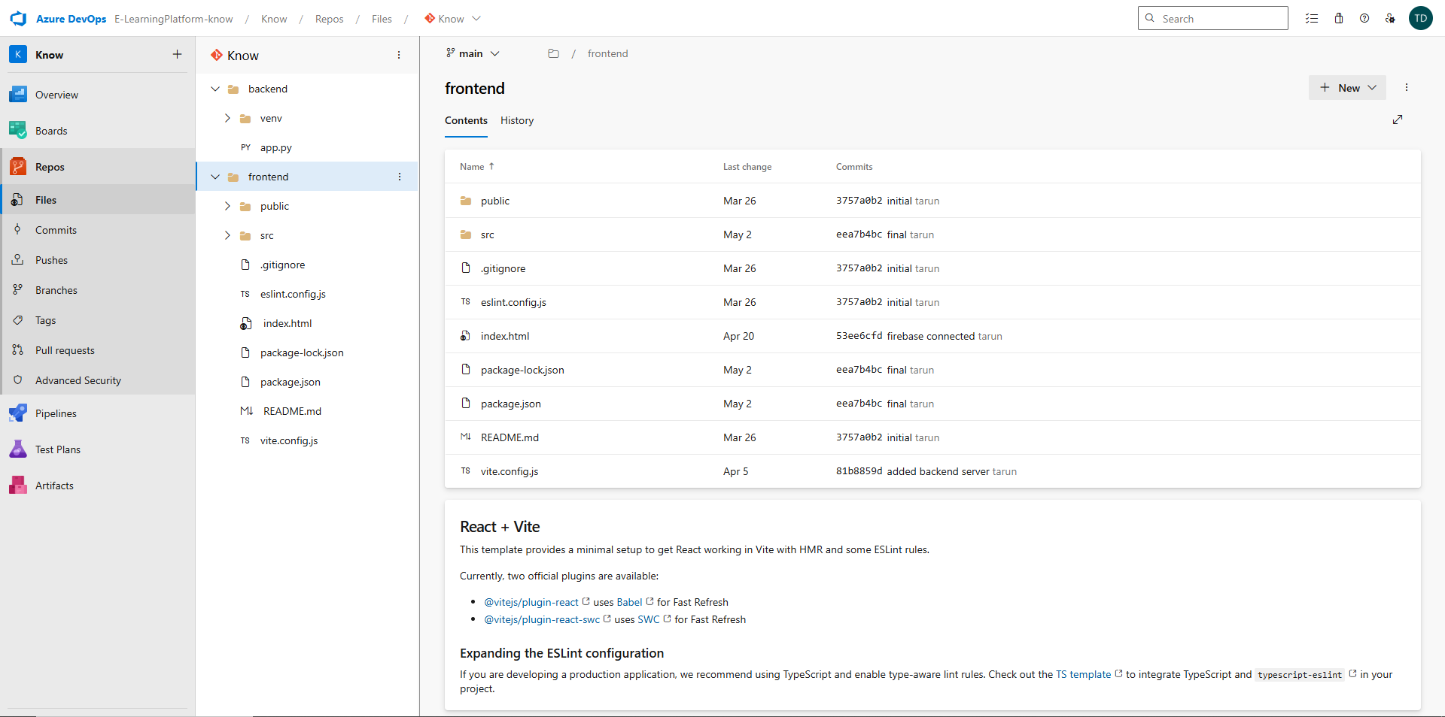

Result:
The GitHub repository clearly displays the organized project structure and consistent naming conventions, making it easy for users and contributors to understand and navigate the codebase.

