6. Writing SQL queries to filter and sort data from single table.
Createa table:
create table employees(
id int primary key,
name varchar(100),
department varchar(50),
age int,
salary decimal(10,2)
);
select*from employees;
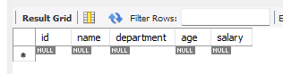

Insert some sample Data:
insert into employees (id,name,department,age,salary)values
(1,'Trisharna','HR',20,60000),
(2,'Pratiksha','TT','29',50000),
(3,'Nishant','TT',25,52000),
(4,'kiran','finance',30,48000),
(5,'Shraddha','HR',26,42000);
Select*from employees;
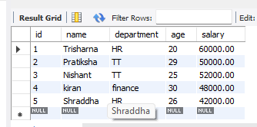

Filter Records using WHERE:
select*from employees
WHERE department='TT';
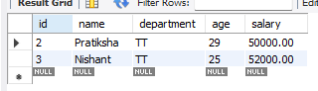

Sort Records Using ORDER BY:
Select*from employees
ORDER BY salary DESC;
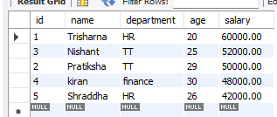

Combine Filtering and Sorting:
Select*from employees
WHERE age>27
ORDER BY age ASC;
