15. Implementing concurrency control mechanisms to handle multiple simultaneous transactions.
CREATE TABLE accounts (
id INT PRIMARY KEY,
balance DECIMAL (10,2)
);
INSERT INTO accounts VALUES (1, 1000.00), (2, 2000.00);
select * FROM accounts;
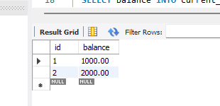
DELIMITER $$

CREATE PROCEDURE transfer_fund7 (
IN from_account INT ,
IN to_account INT,
IN amount DECIMAL (10,2)
)
BEGIN
DECLARE current_balance DECIMAL(10,2);
START TRANSACTION;
SELECT balance INTO current_balance FROM accounts WHERE id=from_account FOR
UPDATE;
IF current_balance<amount THEN
SIGNAL SQLSTATE '45000' SET MESSAGE_TEXT='Insufficient funds';
ELSE
UPDATE accounts SET balance=balance-amount WHERE id=from_account;
UPDATE accounts SET balance=balance+amount WHERE id=to_account;
END IF;
commit;
END$$
DELIMITER ;
CALL transfer_fund7(1,2,500);
select * FROM accounts;
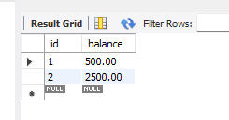
SHOW VARIABLES LIKE 'transaction_isolation';
