20. Implementing Distributed Database System and Handling Data Partitioning.
Create Database:
CREATE DATABASE college5;
USE college5;
CREATE TABLE Student(
student_id INT PRIMARY KEY,
name VARCHAR(50),
city VARCHAR(50),
department VARCHAR(50));
Create Tables:
CREATE TABLE course (
course_id INT PRIMARY KEY,
course_name VARCHAR(50),
credits INT);
Insert Sample Data :
INSERT INTO student VALUES
(1, 'Trisharna', 'Tiosa', 'Computer Science'),
(2, 'Ritesh', 'Delhi', 'Mathematics'),
(3, 'Pratiksha', 'Mumbai', 'Physics'),
(4, 'Neha', 'Delhi', 'Computer Science');

Horizopntal Partitioning
CREATE TABLE student_Mumbai AS
SELECT*FROM Student5
WHERE city='Mumbai' ;

CREATE TABLE Student_Delhi AS
SELECT*FROM Student
WHERE city='Delhi' ;

Vertical Patitioning:
CREATE TABLE Student_Personal AS
SELECT Student_id, name, city
FROM Student5;

CREATE TABLE Student_Acedemic AS
SELECT Student_id, department
FROM Student5;ical Partitioning

Check Storage engines:
SHOW ENGINES;
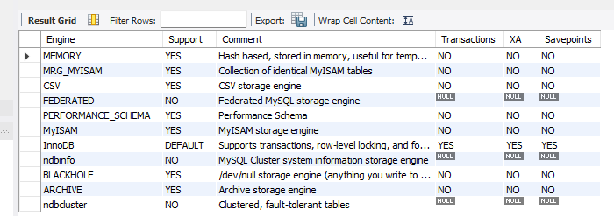

Combine Horizontally Partitioned Tables:
SELECT*FROM Student_Mumbai
UNION
SELECT*FROM Student_Delhi;
