10. Implementing transationd to ensure data integrity and consistency. ( ise BEGINTRANSACTION/STARTTRACTION, COMMIT, ROLLBACK along with other sql queries).
start transaction;
COMMIT;
ROLLBACK;
create database job;
show databases;
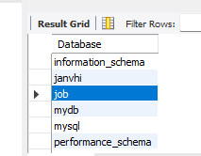
use job;
CREATE TABLE account4(
account_id INT PRIMARY KEY,
name VARCHAR(50),
balance DECIMAL(10,2)
);
INSERT INTO account4 VALUES
(1, 'Trisharna', 1000.00),
(2, 'Pratiksha', 500.00);
SELECT*FROM account4;
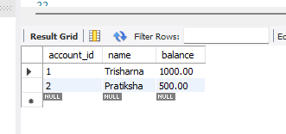

START TRANSACTION;
UPDATE account4
SET balance=balance-200
WHERE account_id=1;
SELECT*FROM account4;
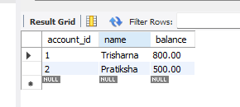

UPDATE account4
SET balance=balance+200
WHERE account_id=2;
SELECT*FROM account4;
COMMIT;
