11. Applying databases normalization techniqueto eliminate redundancy and improve data integrity in workbench query.

CREATE TABLE students_course (
student_id INT,
student_name VARCHAR(50),
Course_id INT,
Course_name VARCHAR(50),
PRIMARY KEY (student_id, Course_id)
);
INSERT INTO students_course VALUES
(1, 'Trisharna', 201, 'Math'),
(2, 'Pratiksha', 202, 'Physics'),
(3, 'Ritesh', 203, 'Computer science');
SELECT*FROM students_Course;
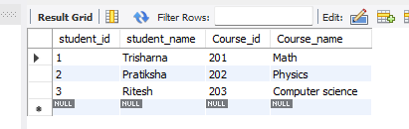

2: (Normalize to 1NF, 2NF, and 3NF);
Create Students Table (Remove redundant student info).
CREATE TABLE students(
student_id INT PRIMARY KEY,
student_name VARCHAR(50)
);

INSERT INTO students (student_id, student_name)
SELECT DISTINCT student_id, student_name
FROM students_course;
SELECT*FROM students;
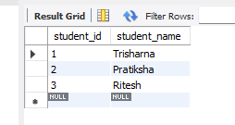
Create Courses Table (Remove redundant course info)
CREATE TABLE course(
course_id INT PRIMARY KEY,
course_name VARCHAR(50)
);
INSERT INTO course (course_id, course_name)
SELECT DISTINCT course_id, course_name
FROM students_course;
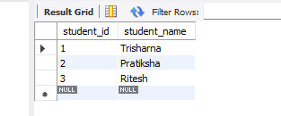
Create Enrollments Table (Mapping table between students and courses)
CREATE TABLE enrollment2 (
student_id INT,
course_id INT,
PRIMARY KEY (student_id, course_id),
FOREIGN KEY (student_id) REFERENCES student(student_id),
FOREIGN KEY (course_id) REFERENCES courses(course_id)
);
INSERT INTO enrollment2 (student_id, course_id)
SELECT student_id, course_id
FROM studentscourse;
SELECT*FROM enrollment2;
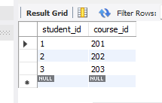
3: Test the normalized structure. (At a time execute this querry)
SELECT*FROM students;
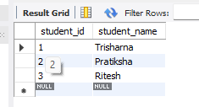
SELECT*FROM courses;
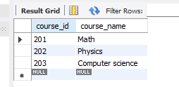

SELECT*FROM enrollment2;
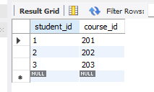
SELECT c.course_name
FROM student s
JOIN enrollment2 e ON s.student_id=e.student_id
JOIN courses c ON e.course_id=c.course_id
WHERE s.student_name='Pratiksha';
