use DBMS;
Show databases;
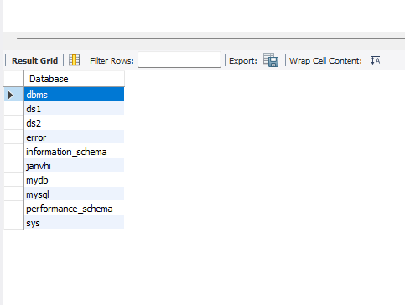

Create a table
create table employees( id INT, name VARCHAR(100), city VARCHAR(50));
ALTER TABLE employees ADD department VARCHAR(50);
Select*from employees;
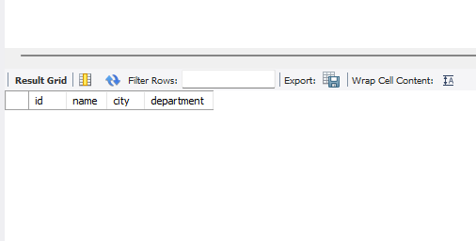

Rename coulmn
ALTER TABLE employees RENAME COLUMN name TO full_name;
select*from employees;
