17. Implementing full text search functionality in a database.
CREATE DATABASE job_portal;
USE job_portal;
CREATE TABLE jobs (
job_id INT AUTO_INCREMENT PRIMARY KEY,
title VARCHAR(255),
description TEXT,
location VARCHAR (100),
FULLTEXT (title, description)
);
INSERT INTO jobs(title, description, location) VALUES
('Software Developer', 'Looking for a developer skilled in Java, Spring Boot, and MySQL', 'Banglore'),
('Data Analyst', 'Analyze data using Python, SQL, and Power BI', 'Mumbai'),
('FUll Stack Engineer', 'React and Node is developer required for web development', 'Remote'),
('Database Administrator', 'Manage MYSQL databases and optimize performance', 'Delhi'),
('Python Developer', 'Backend Python developer with experience in Django', 'Pune');
SELECT*FROM jobs
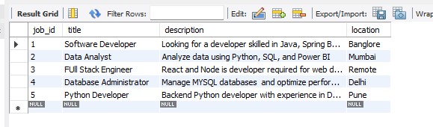
WHERE MATCH (title, description) AGAINST ('Python developer' IN NATURAL LANGUAGE MODE);
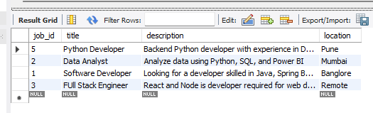

SELECT*FROM jobs
WHERE MATCH (title, description) AGAINST ('+Python + Django-Java' IN BOOLEAN MODE);
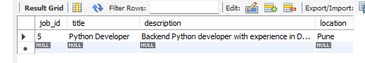
ALTER TABLE jobs ADD FULLTEXT (title, description);
SET @search = 'MYSQL developer';
SELECT *FROM jobs
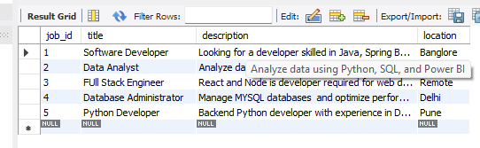
SELECT *FROM jobs
WHERE MATCH (title, description) AGAINST (@search IN NATURAL LANGUAGE MODE);
