5.Performing basic CRUD operation(Create,Update,Read,Delete) on db records.

CRUD Operation in SQL
CREATE TABLE users(
id INTEGER PRIMARY KEY,
name TEXT,
email TEXT
);
show tables;


CREATE (Insert a record)
INSERT INTO users(id, name, email) VALUES(1,'Trisharna','trisharnaingale642006@gmail.com');
select*from users;
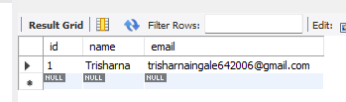
Read (Retrieve Data)
select*from users;
SELECT*FROM users WHERE id=1;
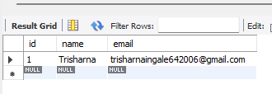
UPDATE (Modify existing record)
UPDATE users
SET name='Trisharna Ingale', email='trisharnaingale642006@gmail.com'
WHERE id=1;
SELECT*FROM users;


DELETE (Remove a record)
DELETE FROM users WHERE ID=1;
SELECT*FROM users;


