4. Implementing Primary key and foreign key constraints in database table.
Create a Database and Use it
use dbms;
show databases ;
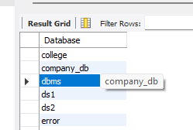

Create a Table with a Primary Key
create table students(students_id int auto_increment, name varchar(100), primary key(students_id));
select*from students;

Create Another Table with a Foreign Key
Create table Enrollments(
Enrollments_id int auto_increment,
students_id int,
course_name varchar(100),
Primary Key(Enrollments_id),
foreign key(students_id) references students(students_id)
);
Show tables;

Insert Sample Data
insert into students(name)values('Trisharna'),('Alas');
select*from students;
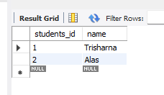

Insert into Enrollments(students_id, course_name) values(1,'math'),(2,'science');
select*from Enrollments;
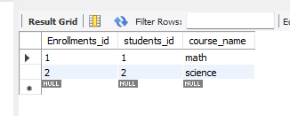

Test the Relationship
SELECT
s.name,
e.course_name
FROM
students s
JOIN
Enrollments e ON s.students_id=e.students_id;


