1. Transformation Parameters
Roll Number: 102313056

a_r=0.5*(r mod 7)
b_r=0.3*(r mod 5 + 1)
Computed values:
a_r = 3.0
b_r = 0.6
Transformation Equation: z=x+(a_r*sin(b_r*x))

2. GAN Architecture
Generator
- Input: Noise sampled from N(0,1)
- Fully connected neural network
- Architecture:
  - Linear(1 → 16)
  - ReLU
  - Linear(16 → 16)
  - ReLU
  - Linear(16 → 1)
- Output: Generated sample z_f
Purpose:
To generate fake samples that mimic real distribution of z.

Discriminator
- Input: Real or fake sample
- Architecture:
  - Linear(1 → 16)
  - ReLU
  - Linear(16 → 16)
  - ReLU
  - Linear(16 → 1)
  - Sigmoid
- Output: Probability that input is real
Purpose:
To distinguish between real samples and generated samples.

Training Details
- Loss Function: Binary Cross Entropy (BCE)
- Optimizer: Adam
- Learning Rate: 0.001
- Batch size: 64
- Epochs: 3000

3. PDF plot obtained from GAN samples
Estimated PDF using GAN samples
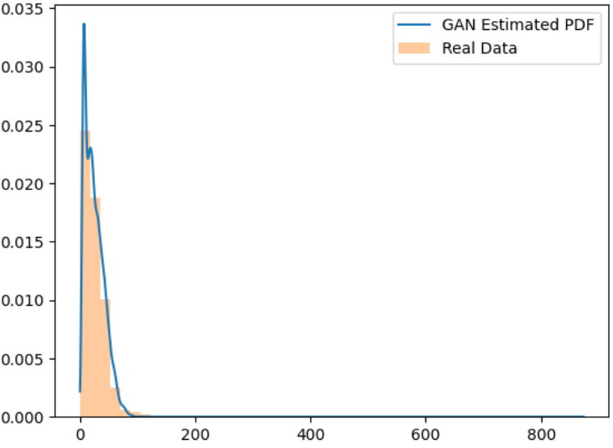

Observations
- Mode Coverage
The transformed data shows a dominant peak in the lower value range.
The GAN successfully captured this primary mode, as seen from the close alignment between the real data histogram and the GAN estimated PDF in the main density region.
No significant mode collapse is observed since the generator learned the main structure of the distribution.

2. Training Stability
During training, initial fluctuations were observed in generator and discriminator losses, which is expected in GAN training.
After sufficient epochs, the losses stabilized and the generator was able to produce samples closely resembling the real data distribution.
The overall training process was reasonably stable.

3. Quality of Generated Distribution
The GAN-generated distribution closely matches the real distribution in the high-density region (near the peak).
However, the generated samples show a longer tail extending to higher values (around 800+), which is not strongly present in the real data.
This indicates slight over-generalization by the generator in low-density regions.
Overall, the generator learned the main structure of the unknown distribution effectively.

