Tostadas

Ingredients

* 1-2 tbsp olive oil
* 2 chicken breasts, cut into chunks
* 1 bell pepper, diced
* ½ white onion, diced
* 1 cup mushrooms, sliced
* 2 tsp fajita seasoning
* 1 tsp salt
* 1 tsp cumin
* Cheese
* Lime juice
* Toppings: tomato, avocado, cilantro
* Tortillas

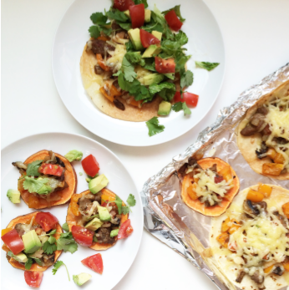

Directions

1. Heat oil in a skillet on medium high heat and add meat. Cook until browned on both sides, then add onion, peppers, mushrooms, and spices. Sauté until vegetables are tender and meat is cooked through.
2. Top tortillas with the meat mixture and cheese. Squeeze lime juice on top.
3. Place in oven until warmed through.
4. Add toppings and serve.