**16**

**17**

**8**

**7**

**9**

**13**

**14**

**19**

**2**

**5**

**1**

**4**

**18**

**20**

**10**

**6**

**12**

**11**

**Entrance**

**15**

**3**

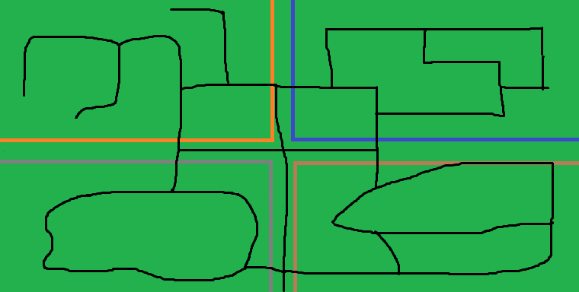

Key:

* **Path (black)**
* **Medieval zone (grey)**
* **Futuristic zone (blue)**
* **Prehistoric zone (brown)**
* **Industrial zone (orange)**

Rides:

1. Tower of Terror
2. The Iron Jaws
3. Cloister of Cruelty
4. Pony Jousts
5. Mystic Fortunes
6. Crisis at Farpoint
7. Build a Bot
8. Laser Lock
9. Trench Chase
10. Robot Conflicts
11. Rex Rampage
12. Pet a Saur
13. SauroPods
14. Raptor Races
15. Hatchling Nest
16. High Noon
17. Hall O Mirrors
18. Steampunk Cups
19. The Pain Train
20. The Descent